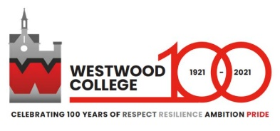

Westwood College is a mixed, non-denominational academy for students aged 13-19. Located in Leek, a market town in the beautiful Staffordshire Moorlands, it has roughly 800 students.
Set in the grounds of a stunning 17th century manor house, Westwood College is part of the Talentum Learning Trust. Made up of 9 schools within and around the town, the Trust’s mission is to support and enable all learners to believe in themselves, to succeed in life and to aspire to be all that they can be.
The ethos of Westwood College centres around ‘Respect, Resilience, Ambition and Pride’. The school has aimed to build a community based on tolerance, sensitivity and an appreciation of difference. It commits to providing a broad, varied and stimulating education that is also personalised to meet the needs of each individual student. Students are encouraged to be part of decision making in their college life, to value the opportunities offered to them by the school, and to fully engage with their learning.
Outcomes for students at Westwood College are strong. In 2019 at Level 2, 74% of students achieved English and Mathematics at grade 4 or above and 45% at grade 5 or above.
Following their short inspection in February 2019, Ofsted recognised Westwood College as a ‘welcoming, friendly school. Pupils and sixth-form students are happy here because they say that they are treated as adults and feel their voices are heard. They develop a strong sense of equality and fairness.’ Teaching was noted as being ‘engaging and creative in many subject areas, which motivates most students to work hard and achieve well. The quality of students’ work in many cases is extremely high.’
We look forward to receiving you application.

Matthew Taylor
Headteacher

