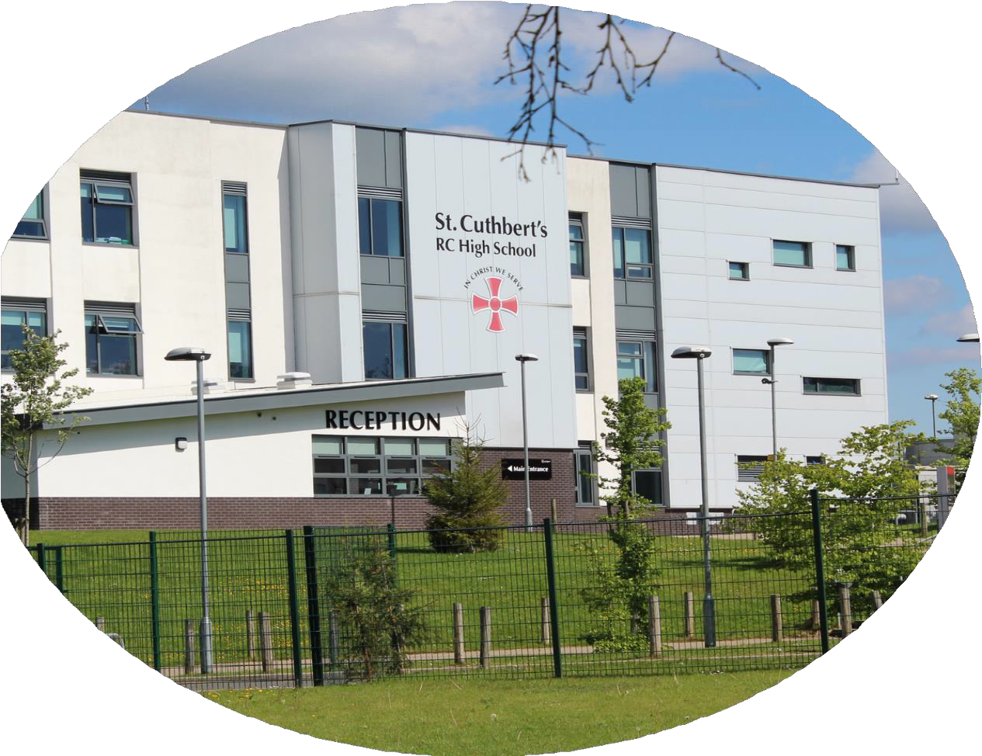

ST CUTHBERT'S

**RC HIGH SCHOOL**

*APPLICANT PACK*

***ASSISTANT HEADTEACHER***

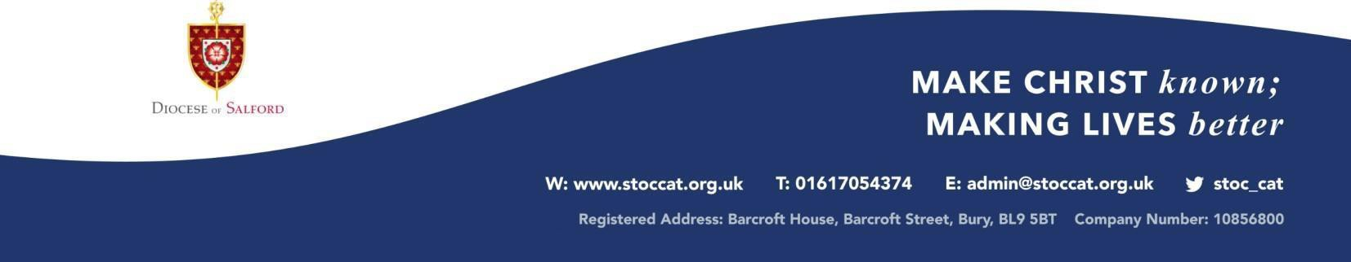

Dear Applicant

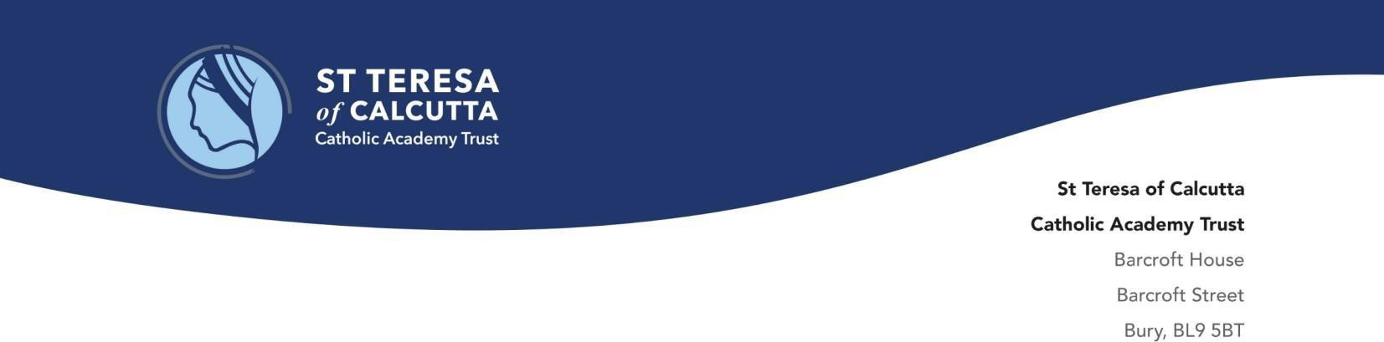

October 2024

We are delighted you have an interest in applying for an Assistant Headteacher post within the St Teresa of Calcutta Catholic Academy Trust. This role is available on a permanent basis but we would also consider a secondment arrangement or offer the role on an interim basis if that is your preference.

[St Cuthbert’s](https://www.stcuthberts.stoccat.org.uk/) presents an exciting opportunity for a first time or experienced Assistant Headteacher. We seek an Assistant Headteacher who will assume responsibility for driving further improvement in pupil behavior and attitudes, supported by our Headteacher and the resources of our Trust Central Team. Our vision places strong leadership at the heart of what we do and seeks to support colleagues in providing the very best for our pupils. The successful applicant will encounter a school full of focused and devoted fellow leaders, talented staff and pupils, all of whom wish to make lives better. They will be part of the wider Trust networks and central functions that will support them.

Our Trust currently consists of eleven primary and three high schools; and we will grow over the coming academic years. The Trust is part of the Salford Diocese and in September 2022, Bishop John Arnold confirmed that it is his intention that the Diocese work to implement a full MAT model by 2030. The new Assistant Headteacher of St Cuthbert’s will join the Trust at an exciting point in its development and can look forward to playing an important part in its continued success.

Our Trust aspires to serve, sustain and inspire our children and young people within our schools. Our vision is to be living faith communities, walking with Christ, to witness, serve and transform. Our communities model the life and teachings of Jesus. We aim to form children and young people, so they can achieve academic excellence and spiritual and moral growth. Given the challenges of the twenty first century, our responsibility is to ensure our next generation can transform society.

Whilst the children are at the heart of our Catholic mission, this cannot be achieved without investing in our staff. We are keen to employ an Assistant Headteacher who is committed to supporting and leading within a Catholic context so that young people leave us with the skills and talents needed to transform society for the common good. We love and value our children and young people and we do all we can to enable them to become successful, and we seek a like-minded leader to join our Trust who thinks and acts the same.

Once again, thank you for the interest and time you have committed to the application process so far. The children and young people in the St Teresa of Calcutta Trust need committed and passionate people to work with them so they and St Cuthbert’s can fulfil their potential. We hope this person could be you.

Yours faithfully

C:\Users\hcollier\AppData\Local\Microsoft\Windows\INetCache\Content.MSO\76BCE586.tmp

|  |  |  |
| --- | --- | --- |
| Mr C Foley | Mr C Drew |  |
| Catholic Senior Executive Leader | Interim Headteacher |  |



# WELCOME

St Cuthbert’s is a Roman Catholic High School serving the Catholic and wider community of Rochdale. While many of our staff and students are Catholic, we have many from other faiths and welcome everyone who shares our values regardless of their religious denomination.

St Cuthbert’s is a vibrant, diverse, and innovative school. Our faith is our inspiration and we aspire for all members of our community to ‘Be the best that we can be in everything that we do’. In order to achieve this we provide a truly holistic education for all of our students. We provide an excellent and rapidly improving academic experience for all.

We also have a major focus on other key aspects of growth and education. This includes personal

development, spirituality, physical

and mental wellbeing, social development and citizenship.

Our curriculum has been designed to match the needs, interests and aspirations of our community. It is broad and balanced and intended to support and prepare students with their lifelong learning. We want our students to be successful, creative, engaged learners. We want their curriculum experience to prepare them for the next phase of their lives and to give them genuine choices and opportunities to do whatever they want in life.

Our pastoral care is based upon our core values of Catholic, Aspiration, Respect, Excellence. We believe all of our students are children of God and they are treated and cared for as such. Through our interaction with students we hope to help them become the kind of citizens who make a positive contribution to society and are a credit to themselves, their families and to St Cuthbert’s.

Thank you for your interest in our school, and we hope that you will join us on our journey as we continue to improve the life chances of the young people and the community that we serve.

Mr C Drew

Headteacher



**OUR MISSION**

"The Lord God requires of us

that we should help others whenever we can, always make the right choices

And be the best that we can be In everything that we do."

# ABOUT US

St Cuthbert’s Roman Catholic High School is a caring, diverse, Catholic high school with core values centred upon the life and teachings of Jesus Christ. We ensure that God is known to every student and every student is known to us.

We welcome families from all faiths to join us and work together to create a safe, happy learning environment where all young people can achieve their full potential. We are proud to be at the centre of our local Roman Catholic community with strong, effective links with our Catholic partner primary schools and sixth form colleges.

Our diligent, talented and committed staff at St Cuthbert's work closely with parents, carers and individual students to ensure they fulfil their academic potential.

This is central to what we do; helping our students to use their God given talents so that they leave us as well qualified, well rounded, respectful citizens who have a positive contribution to make to their community.



# "THE BEST THAT WE CAN BE"

All of our students have gifts and talents that we always look to develop and celebrate. Securing a ‘good with outstanding features’ judgement from the Diocese of Salford, demonstrates our commitment to ensuring our students leave St Cuthbert’s with the skills, qualifications and confidence that they need to success in their choice of further education or employment.

We recognise that many of our students are gifted in many different ways and it’s not just in the classroom where achievement flourishes. We come together regularly as a school community to recognise and reward students for all they achieve and the positive contributions they make to our school.

# SUPPORTING THE WHOLE CHILD

At St. Cuthbert’s we pride ourselves on the excellent quality of our pastoral care. All staff are committed to supporting and caring for our students to ensure they are safe, happy and successful. We have an excellent pastoral system with Form Tutors being the focal point of contact in our partnership with parents. Each student is assigned a Form Tutor who sees the student every morning and is a consistent point of contact, taking responsibility for the student’s pastoral wellbeing.

Good behaviour and achievement are recognised through our rewards system and we regularly celebrate students who live out our four core values of Catholic, Aspiration, Respect, Excellence.

A culture of respect is actively promoted in our school. Our anti-bullying policy establishes the right for every child to feel safe and confident, making it clear that any deliberate behaviour that upsets or distresses another student will not be tolerated. Trained Peer Mentors play a crucial role in helping our younger students settle into ‘The St Cuthbert’s Way’ acting as ‘buddies’ around the school.

We are committed to preparing our students to become healthy, responsible and mature young people of the future. Our students are positive role models who are actively involved in, and consulted with, regarding all key aspects of their learning.

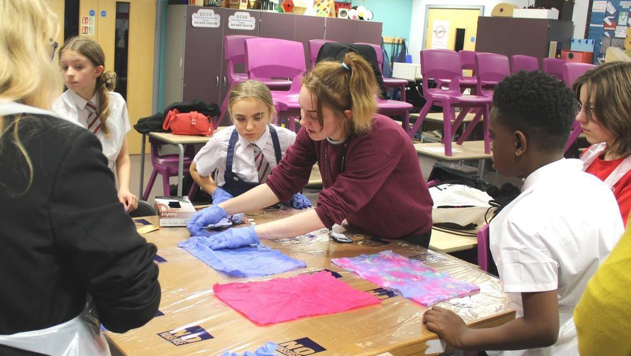

# A PLACE YOUNG PEOPLE ARE CHALLENGED AND INSPIRED

The curriculum at St Cuthbert’s provides ambitious educational opportunities for all members of our community. The curriculum equips our students with the knowledge, skills and personal characteristics they need to flourish as literate, articulate, global citizens, who fulfil the Catholic Mission to bring about the Common Good.

St Cuthbert’s RC High School prides itself on upholding the dignity and worth of all children within school, therefore the enrichment programme allows all students of God to have an equal opportunity in life. The enrichment programme aims to develop a sense of belonging to “Our School” for all students whilst developing students’ cultural capital and character education.

The aim of St Cuthbert’s Enrichment programme is to help students to develop their interests and abilities, provide valuable learning experiences outside their academic studies and promote independence and interpersonal links with students in other years. The enrichment programme has been designed to support students develop the essential skills they will need to progress onto higher education and employment.

We offer a range of enrichment activities across the school, from sport enrichments such as football, to academic enrichments such as Debate Mate as well as STEM enrichments such as Robotics and STEM club.

Our School’s Mission Statement challenges every member of the St. Cuthbert’s community to be the best that we can be. This not only means to be the best we can be academically but also to be the best that we can be spiritually. As a Catholic community, we believe that every person is created in the image and likeness of God and has a unique God-given purpose. As such, it is our duty as a Catholic School to ensure that all our students are given every opportunity to recognise God in themselves, identify what their divine purpose is and become the very best versions of themselves.

At St. Cuthbert’s, students are given every opportunity to grow spiritually, develop their moral purpose and be the reflection of God’s image in the world today. Students are invited to pray daily, attend Mass regularly, take part in religious retreats

and days of reflection, become Student and Junior Chaplains and Caritas Ambassadors, work with local and global charities such as Caritas, Mary’s Meals and CAFOD.

All of these opportunities serve to develop each student to be the spiritually aware, well- rounded individual they were created to be and help them to become global citizens who strive to bring about the Common Good.



# AN INCLUSIVE SCHOOL FOR ALL

Our SEND team ensure that all student’s individual learning needs are catered for. The specialist, knowledgeable and experienced team work alongside students, parents, carers, staff and other stakeholders to ensure that all students can access all they need to achieve their potential. Where a student's needs are shared prior to moving to high school we collaborate to ensure that students have a pupil passport so that staff know how to meet their individual needs within lessons.

Experienced staff support learning in the classroom, deliver personalised intervention programmes and promote positive attitudes and behaviour. The SEND area in school is also home to a break and lunch club where students can access activities and socialise in a quiet, supportive environment. We endeavour to support all of our students.

 

##### Assistant Headteacher

**Leadership Pay Spine 13-17**

**Start Date – 1st January 2025,**

***(or sooner if the candidate is currently available)***

The Local Governing Body of St Cuthbert’s R.C. High School are seeking to appoint two Assistant Headteachers, who alongside the existing Headteacher will play a key strategic role in building an exceptional and caring learning environment where all members of the school community can thrive.

We seek candidates for two Assistant Headteacher (Behaviour) positions, who will join the Senior Leadership Team, and work under the direction of the Headteacher and the Deputy Head (Culture and Standards), and work alongside our existing Assistant Headteacher (Behaviour). One of these two new roles will be a permanent addition to the SLT, and one may be offered in an interim capacity.

We are seeking high quality candidates who have experience of managing behaviour and of effecting improvements in behaviour over time. Previous experience of being on SLT would be welcome but is not a requirement.

We have high aspirations for our school, and we are seeking to develop a culture where excellent behaviour is the norm. At present, the vast majority of students behave very well, but a number do not, and it is those individuals who need additional support and guidance in making the right choices. We want every student to be able to learn unhindered and to fulfil their potential. We would welcome the opportunity to show candidates around our school prior to application. If you would like to arrange a visit, please contact [lbrown@stcuthberts.stoccat.org.uk](mailto:lbrown@stcuthberts.stoccat.org.uk) in the first instance.

St Cuthbert’s is a comprehensive High School situated in Rochdale; welcoming students aged 11 -16 from a wide variety of partner primary feeder schools. We are part of the St Teresa of Calcutta Roman Catholic Academy Trust. The successful candidates will work with the existing Leadership Team and the St Teresa of Calcutta Trust to provide the best possible Catholic education and opportunity for our pupils.

As a member of staff at St Cuthbert’s you will work within the school and more broadly be able to collaborate with our colleagues in other schools across our Trust. Local and central development opportunities will support the growth of the candidate. At St Cuthbert’s, we believe that we should be the best that we can be in everything that we do and this mission is at the heart of everything that we do.

St Cuthbert’s is a popular and exciting school providing a wonderful environment for learning. The successful candidate will be joining a school which is progressive, innovative and extremely ambitious. The Local Governing Body and Senior Leaders are committed to professional development and staff well-being. The successful applicant will be supported via a bespoke training and development plan appropriate to their individual needs and aspirations.

Key responsibilities will be determined according to the appointed candidates’ strengths and experience. The successful candidate will:

* Be an exemplary teacher by endorsing and following the agreed school policies
* Have excellent communication, organisational and interpersonal skills and have the ability to build happy teams in school and with external parties
* Have proven leadership skills within secondary education and experience of leading school improvement
* Demonstrate an ambitious drive for each child within the Trust to succeed in all aspects of their lives
* Have the ability to inspire, challenge and motivate both students and colleagues to meet and exceed expectations
* Plan, prepare and deliver lessons with focus on high quality, imaginative and innovative teaching
* Have strong moral and ethical principles and values
* Have a willingness to uphold our Catholic mission and values
* Be committed to enrichment

We can offer:

* A caring, happy school with a strong Catholic ethos
* Friendly and committed staff who are supportive and open to new ideas
* Close links and group support from other schools in this forward-thinking Catholic academy trust in this exciting time in our development
* An opportunity to be part of a team of dedicated, talented and hardworking individuals
* A true commitment to Continuing Professional Development
* Supportive leadership at all levels
* An inclusive learning ethos



**Assistant Headteacher Job Description**

##### St Cuthbert’s Roman Catholic School, a Voluntary Academy

*The Academy is a designated Catholic school. The Directors are accountable to the Ordinary of the diocese, or a Vicar or delegate where that is determined, to ensure that the Academy is conducted as a Catholic school in accordance with Canon law and the teachings of the Catholic Church so that, at all times, the Academy may serve as a witness to the Catholic faith in Our Lord Jesus Christ.*

This appointment is made by the board of directors of the St Teresa of Calcutta Catholic Academy Trust under the terms of the Catholic Education Service (CES) contract. It is subject to the conditions of service for Assistant Headteachers contained in the current School Teachers’ Pay and Conditions document as well as other current education and employment legislation and statutory guidance.

**The Academy Trust is committed to safeguarding and promoting the welfare of children and young people. The Assistant Headteacher must ensure that the highest priority is given to following the guidance and regulations relating to safeguarding and child protection. Appointment is conditional upon receipt of satisfactory Disclosure and Barring Service (DBS) checks in relation to criminal and child protection matters.**

JOB TITLE: **Assistant Headteacher** ACCOUNTABLE TO: **The Headteacher The Assistant Headteacher will:**

* Undertake the normal responsibilities of the class teacher;
* Be a member of the senior management team;
* Assist the Headteacher in managing the school;
* Support and represent the Headteacher at meetings as and when required;
* Undertake such duties as are delegated by the Headteacher;
* Play a major role, under the overall direction of the Headteacher in formulating and reviewing the Mission Statement, Development Plan, overall aims and objectives of the school by helping establish the policies through which they shall be achieved, managing staff and resources to that end and monitoring progress towards their achievement;

**MAIN TASKS:**

*The specific nature and balance of these responsibilities may vary from time to time and, particularly in a large school, be distributed amongst other holders of the post of deputy or assistant Headteacher.*

1. **Class teacher responsibilities**
   1. To carry out the duties of a school teacher as set out in the current School Teachers’ Pay and Conditions Document.
   2. To carry out the duties of a general class teacher as detailed in the school’s class teacher job description, including the provision of cover for absent teachers.
   3. If required, to be responsible for a specific class or age group of children to be decided on appointment.
2. **The internal organisation, management and control of the school**
   1. To have specific responsibilities to be agreed upon appointment.
   2. To contribute to:
      * Fulfilling the school’s Mission Statement
      * Maintaining and developing the Catholic ethos, values and overall purposes of the school
      * Formulating the aims and objectives of the school and policies for their implementation
      * A development plan which will translate school aims and policies into actions
      * Monitoring and evaluating the performance of the school and its achievements as a Catholic school
      * Implementing the Local Governing Body’s policies on equal opportunity issues for all staff and pupils in relation to sex, gender, race, disability and special needs
      * The efficient organisation, management and supervision of school routines
3. **Curriculum Development**
   1. To contribute to:
      * The development, organisation and implementation of the school’s curriculum
      * School policies on curriculum, teaching and learning styles, assessment, recording and reporting
      * Ensuring that the learning and teaching provided by different departments and teaching teams form a co- ordinated, coherent curriculum entitlement for individuals, including these with special educational needs
      * Ensuring that the Diocesan policy on Religious Education is fulfilled
      * Ensuring arrangements for the daily act of collective worship and the spiritual life of the school
      * Providing a curriculum for the spiritual, moral, social and cultural development of all pupils in line with the distinctive Catholic nature, purpose and aims of the school
      * Providing high quality personal, social, health education and citizenship in accordance with the teachings and doctrines of the Catholic Church
      * Ensuring that information on pupil progress is used to improve teaching and learning to inform and motivate pupils, to inform parents, to provide necessary references for other educational institutions and employers, and to aid governors in their future management of the school
      * Ensuring that the individual pupil’s continuity of learning and effective progression of achievement are provided
      * The promotion of extra-curricular activities in accordance with the educational aims and Catholic ethos of the school
4. **Pupil care**
   1. To contribute to:
      * The development, organisation and implementation of the school’s policy for the personal and social development of pupils including pastoral care and guidance in accordance with the teachings and doctrines of the Catholic Church
      * The effective induction of pupils
      * The determination of appropriate pupil groupings
      * The promotion among pupils of standards of conduct/discipline and a proper regard for authority, the encouragement of good behaviour and commitment to the common good
      * The development among pupils of self-discipline
      * The handling of individual disciplinary cases
   2. Develop effective relationships with fellow professionals, colleagues in other public services, parents/carers to improve academic and social outcomes for all pupils.
   3. Provide a safe, calm and well-ordered environment for all pupils and staff, focused on safeguarding pupils and developing their exemplary behaviour in school and in the wider society.
5. **The management of staff**
   1. To participate in the selection and deployment of teaching and non-teaching staff of the school
   2. To contribute to good management practice by ensuring positive staff participation, effective communication and procedures
   3. To participate in arrangements made in accordance with the regulations for the appraisal of the performance of teachers in school
   4. To implement and develop staff development policies appropriate to the Catholic nature of the school in relation to:
      * The induction of new and newly qualified teachers and other staff
      * The provision of professional advice and support and the identification of training needs
      * Students under training/work experience
   5. To demonstrate effective leadership, representation and liaison both within the school and other interested or involved persons or Boards.
   6. To maintain good relationships with individuals, groups and staff unions and associations.
6. **The management of resources**
   1. To contribute to the formulation of the school’s policies and procedure concerning resource management in

accordance with the school’s Mission Statement.

* 1. To allocate, control and account for those financial and material resources of the school which are delegated by the Headteacher.
  2. To promote an attractive environment which stimulates learning, enhances the appearance of the school and expresses its Catholic identity.
  3. To contribute to arrangements for the security and effective supervision of the school buildings, their contents and grounds, including aspects of health and safety.
  4. To maintain effective working relationships with external agencies and services contracted to the school and the Catholic Multi Academy Trust.

1. **Relationships**
   1. To advise and assist the Local Governing Body and Academy Trust as required in the exercising of its functions including attending meetings and making reports.
   2. To assist liaison and co-operation with Diocesan and St Teresa of Calcutta Academy Trust support services.
   3. To help in maintaining and developing effective communications and with parents, as the prime educators, and to provide positive responses to concerns and problems regarding their children’s education.
   4. To assist liaison with other educational establishments, especially other Catholic institutions, in order to promote the continuity of learning, progression of achievement and curriculum development.
   5. To assist liaison with other professional bodies, agencies and services.
   6. To develop and maintain positive links and relationships with the parish community, local organisations and employers:
      * To promote a positive image of the school
      * To ensure that the school plays a constructive role in the life of the parish and community and that its curriculum draws on the nature and resources of that community.
   7. Create outward - facing schools which work with other schools, organisations and the local community – in a climate of mutual challenge – to champion best practice and secure excellent achievements for all pupils.

###### 

###### Alongside the generic responsibilities listed above the Assistant Headteacher will be expected to provide the strategic lead and to hold oversight responsibility for one of the following areas:

* Improving Outcomes (including but not limited to Data, Assessments, Examinations)
* Staffing (including but not limited to CPD, Induction, Coaching)
* Behaviour (including but not limited to Duties, Rewards, Sanctions)
* Wellbeing (including but not limited to Attendance, Safeguarding, Admissions)
* Personal Development & Catholic Life & Mission (including but limited to Careers, Enrichment, Liturgy)

*This job description forms part of the contract of employment of the person appointed to the post. It reflects the position at the present time only and may be reviewed in negotiation with the employee in the future. The appointment is subject to the current conditions of employment in the School Teachers’ Pay and Conditions Document as they relate to Assistant Headteacher.*

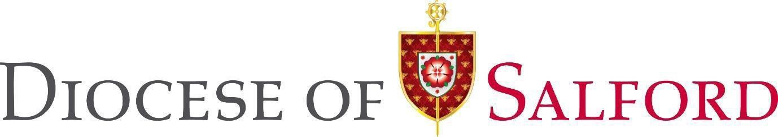

##### Person Specification/Selection Criteria for

**Assistant Headteacher in St Cuthbert’s RC Secondary School, a Voluntary Academy**

***The Academy is a designated Catholic school. The Directors are accountable to the Ordinary of the diocese, or a Vicar or delegate where that is determined, to ensure that the Academy is conducted as a Catholic school in accordance with Canon law and the teachings of the Catholic Church so that, at all times, the Academy may serve as a witness to the Catholic faith in Our Lord Jesus Christ.***

***This appointment is made by the board of directors of the St Teresa of Calcutta Catholic Academy Trust under the terms of the Catholic Education Service (CES) contract. It is subject to the conditions of service for Assistant Headteachers contained in the current School Teachers’ Pay and Conditions document as well as other current education and employment legislation and statutory guidance.***

***St Cuthbert’s is committed to safeguarding and promoting the welfare of children and young people and expects all staff to share this commitment.***

***The applicant will be required to safeguard and promote the welfare of children and young people.***

*Source Key: A = Application Form I = Interview R = References CC = Checking Certificates*

*Note:* ***Candidates failing to meet any of the essential criteria will automatically be excluded***

1. **Faith Commitment**

|  |  |  |  |  |
| --- | --- | --- | --- | --- |
|  |  | **Essential** | **Desirable** | **Source** |
| 1. | Practising Catholic |  | **D** | A/I/R |
| 2. | Involvement in parish community |  | **D** | A/I/R |

**To be able to demonstrate their knowledge and understanding of the following in the context of a Catholic school.**

|  |  |  |  |  |
| --- | --- | --- | --- | --- |
|  |  | **Essential** | **Desirable** | **Source** |
| 3. | Leading school worship |  | **D** | A/I |
| 4. | Ways of developing religious education and worship |  | **D** | A/I |
| 5. | A commitment to strategic thinking and planning that builds, communicates and carries forward a coherent and shared vision for the Catholic ethos of the school*.* | **E** |  | A/I |
| 6. | How relationships should be fostered and developed between the school, parish and its community and Diocese of Salford |  | **D** | A/I |

1. **Qualifications**

|  |  |  |  |  |
| --- | --- | --- | --- | --- |
|  |  | **Essential** | **Desirable** | **Source** |
| 7. | Qualified teacher status | **E** |  | A/CC |
| 8. | Degree | **E** |  | A/CC |

1. **Professional Development**

|  |  |  |  |  |
| --- | --- | --- | --- | --- |
|  |  | **Essential** | **Desirable** | **Source** |
| 9. | Evidence of appropriate professional development for the role of Assistant Headteacher | **E** |  | A |
| 10. | Evidence of recent leadership and management professional development | **E** |  | A |
| 11. | Has successfully undertaken appropriate safeguarding training and knowledge of legislation for the protection of young people | **E** |  | A |
| 12. | Has successfully undertaken Designated Safeguarding Lead Training |  | **D** | A/I/CC |
| 13. | Has completed a Catholic Leadership Programme or has a commitment to doing so |  | **D** | A/I/CC |

1. **School leadership and management experience**

|  |  |  |  |  |
| --- | --- | --- | --- | --- |
|  |  | **Essential** | **Desirable** | **Source** |
| 14. | To have had active and effective leadership of a team / department/ key stage/ curriculum area | **E** |  | A/I/R |
| 15. | To have taken an active involvement in school self-evaluation and development of a relevant and effective curriculum |  | **D** | A/I/R |
| 16. | To have involvement in or understanding of financial management in a school |  | **D** | A/I/R |
| 17. | To have implemented and developed a whole school initiative | **E** |  | A/I/R |
| 18. | To have had responsibility for policy development and implementation | **E** |  | A/I/R |
| 19. | To have had experience of and ability to contribute to staff development across the secondary range. (E.g., coaching, mentoring, INSET for staff) | **E** |  | A/I/R |
| 20. | Work positively with parents and carers | **E** |  | A/I/R |
| 21. | To demonstrate an awareness of current national educational policy | **E** |  | A/I/R |

1. **Experience and knowledge of teaching**

|  |  |  |  |  |
| --- | --- | --- | --- | --- |
|  |  | **Essential** | **Desirable** | **Source** |
| 22. | Experience of teaching in more than one school |  | **D** | A/I/R |
| 23. | Experience of teaching in a school in similar circumstances/ serving a similar community |  | **D** | A/I |
| 24. | Significant teaching experience and proven excellence in teaching pupils within the secondary phase | **E** |  | A/I/R |

|  |  |  |  |  |
| --- | --- | --- | --- | --- |
| 25. | To have a knowledge and understanding of all Key Stages in the secondary phase | **E** |  | A/I/R |
| 26. | Secure understanding of assessment strategies, data analysis and the use of assessment to maximise achievement | **E** |  | A/I/R |
| 27. | To be able to exemplify how the needs of all pupils have been met through high quality teaching | **E** |  | A/I/R |

1. **Professional Attributes**

|  |  |  |  |  |
| --- | --- | --- | --- | --- |
|  |  | **Essential** | **Desirable** | **Source** |
| 28. | To be able to demonstrate an understanding, awareness and empathy for the needs of the pupils at this school and how these could be met. | **E** |  | I |
| 29. | To be able to demonstrate a clear rationale for behaviour management and a proven track record of the effective implementation of a range of behaviour management strategies. | **E** |  | I |
| 30. | To have excellent written and oral communication skills (which will be assessed at all stages of the process) | **E** |  | A/I |
| 31. | To be a leader of learning demonstrating, promoting and encouraging outstanding classroom practice | **E** |  | A/I/R |
| 32. | Show a good commitment to sustained attendance at work | **E** |  | A/I/R |

1. **Professional Skills**

Applicants must be able to demonstrate that they meet the Teachers’ Standards (England) which are set out in detail in the current School Teachers’ Pay and Conditions Document. The Assistant Headteacher must be exemplary and be able to:

* + Set high expectations which inspire, motivate and challenge pupils
  + Promote good progress and outcomes by pupils
  + Demonstrate good subject and curriculum knowledge
  + Plan and teach well-structured lessons
  + Adapt teaching to respond to the strengths and needs of all pupils
  + Make accurate and productive use of assessment
  + Manage behaviour effectively
  + Fulfil wider professional responsibilities

1. **Personal Qualities**

**All of the following are considered essential for the post and will be assessed through interview and reference:**

* + Continue to promote the school’s strong educational philosophy and values
  + Inspire, challenge, motivate and empower teams and individuals to achieve high goals
  + Inspire trust in the school community
  + Communicate clearly and effectively both orally and in written English
  + Demonstrate personal enthusiasm and commitment to leadership aimed at making a positive difference to children and young people
  + Build and maintain quality relationships through interpersonal skills and effective communication
  + Demonstrate personal and professional integrity, including modelling values and vision
  + Manage and resolve conflict
  + Prioritise, plan and organise themselves and others
  + Think analytically and creatively and demonstrate initiative in solving problems
  + Be aware of their own strengths and areas for development and listen to, and reflect constructively and act upon as appropriate, feedback from others
  + Demonstrate a capacity for sustained hard work with energy and vigour

1. **Confidential References and Reports**

|  |  |
| --- | --- |
| Positive recommendation from all referees, including current employer. | **E** |

The directors/governors reserve the right in exceptional cases to seek additional references from other former employees where this seems appropriate.

1. **Application Form and Supporting Statement**

The form must be fully completed. The supporting statement should be clear, concise and related to the specific post,

***following the guidance outlined in section G above.***

***The CESEW Leadership Application Form must be fully completed. The supporting statement should not exceed 1300 words in length, be clear, concise and related to the post and setting applied for.***



**HOW TO APPLY**

To apply, please submit your applications via our [recruitment portal](https://ce1057li.webitrent.com/ce1057li_webrecruitment/wrd/run/ETREC179GF.open?WVID=38983700Dm).

Should you have any issues, please email [recruitment@stcuthberts.stoccat.org.uk](mailto:recruitment@stcuthberts.stoccat.org.uk)

**The closing date for this position is:**

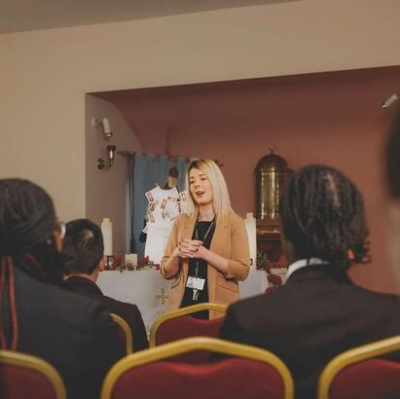Tuesday, 22nd October 2024

## Shortlisting will take place on:

Wednesday, 23rd October 2024

## Interviews will be held on:

Thursday, 24th October 2024 & Friday, 25th October 2024

### Visits to the school are warmly welcomed and encouraged and can be arranged by contacting Mrs Brown by email [lbrown@stcuthberts.stoccat.org.uk](mailto:lbrown@stcuthberts.stoccat.org.uk)



St Cuthbert’s RC High School is committed to safeguarding and promoting the welfare of young people and expects all staff to share this commitment. Appointment is subject to a satisfactory enhanced disclosure from the Disclosure and Barring Service.



St Cuthbert’s is located in Rochdale in Lancashire. Rochdale is a large town at the foothills of the South Pennines in the dale of the River Roch. It is a town steeped in history and with some stunning architecture such as the Grade 1 listed town hall which dates from 1871 and is one of the finest examples of Victorian Gothic revival architecture. It is also home to some of the most beautiful areas of nature such as Hollingworth lake.

Rochdale is most famous for being the birthplace of the modern co-operative movement, where, on 21 December 1844 the Rochdale Equitable Pioneer Society opened their store selling pure food at fair prices and honest weights and measures. The business revolution that started right here in Rochdale, now involves a billion co-operators as members of 1.4 million co-operative societies across the world.

Rochdale is also known as being home to many a famous face including Dame Gracie Fields CBE, a world-famous actress, singer and comedian, was born and brought up in Rochdale. A statue of her has been put up in the town hall square and there is a heritage trail of places associated with her around the town.

**WHERE TO FIND US**



St Cuthbert's R.C. High School is an 11-16 voluntary aided school serving the wider community of Rochdale in Lancashire

We are situated off the A671

between Rochdale and Oldham with links to the M60 and M62 for Manchester and Leeds

ST CUTHBERT'S

Roman Catholic High School Shaw Road, Rochdale



OL16 4RX

for Sat Nav use OL11 2AZ

*Phone*

#### Tel: 01706 647761

*Website*

#### [www.stcuthberts.stoccat.org.uk](http://www.stcuthberts.stoccat.org.uk/)

*Email*

#### [headteacher@scrchs.com](mailto:headteacher@scrchs.com)

@Scrchs @RcCuthberts