Candidate Information Pack
Assistant Head of School
Sycamore Academy

Contents

About the Trust | 1
About Sycamore Academy – our vision | 6
Benefits of being part of L.E.A.D. Academy Trust | 7
How to apply | 9
Job description and Person specification | 10 - 13

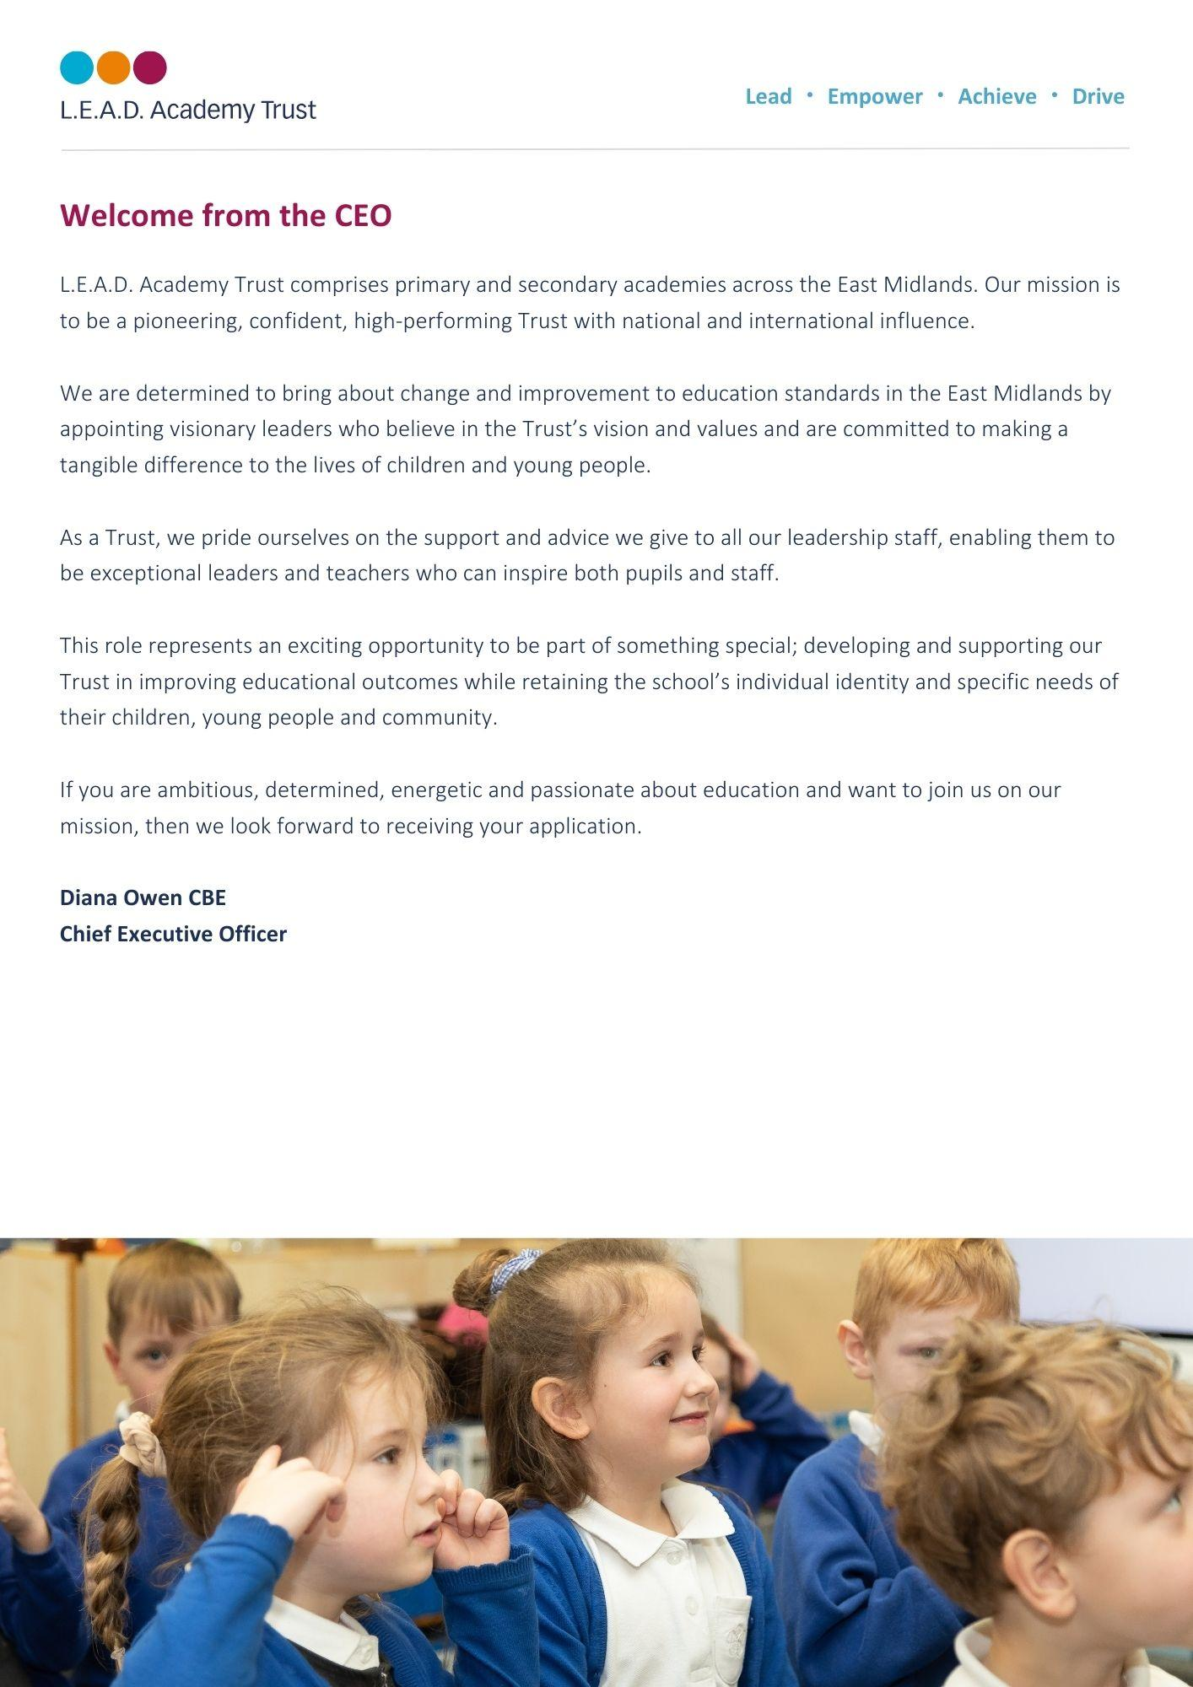
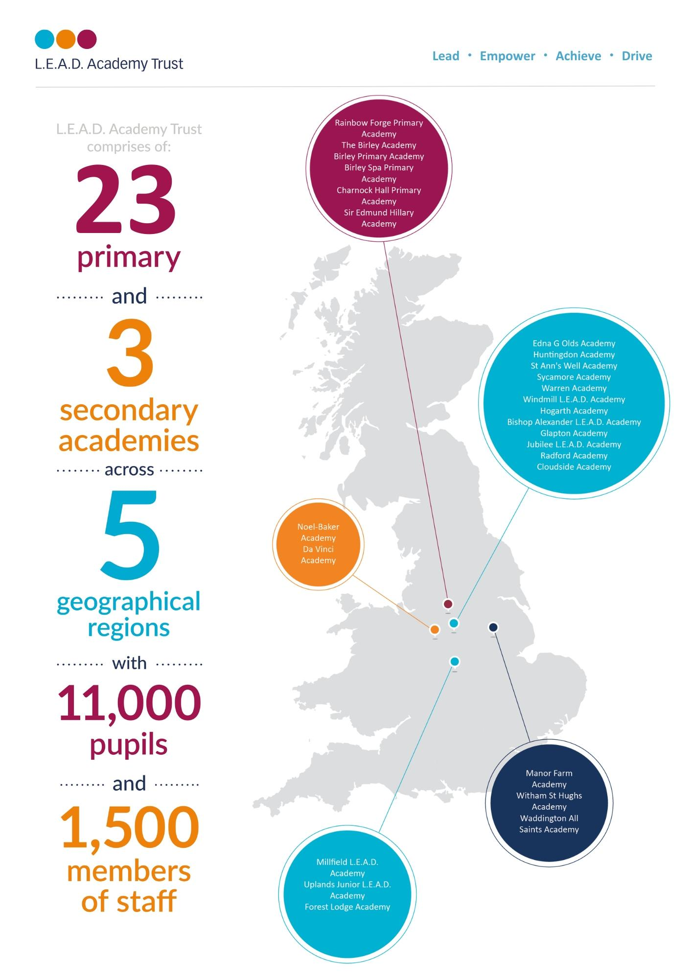
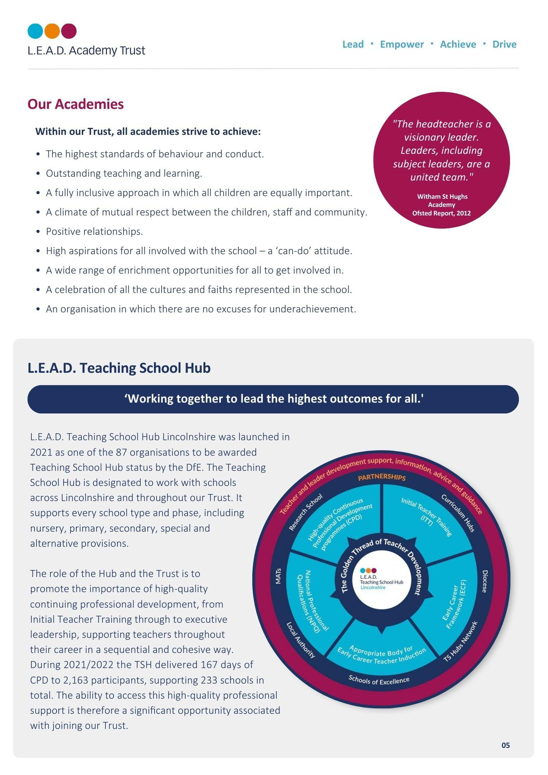

A message from the Headteacher
Our school motto is: “Learning and Caring Together” which permeates through our whole-school ethos ensuring that we nurture enthusiasm and a thirst for knowledge. Working closely with families, we target and support individual needs to ensure exemplary outcomes for all of our children.
We embrace change and relish new initiatives. Our children are taught explicitly and clearly yet are provided with the necessary skills so that they leave our school as autonomous, competent, well-rounded, individuals. We tackle problems head on and equip our children to be confident, empathic and respectful members of society.
A Sycamore Child is one that: knows right from wrong, has pride in everything they do but is also able to compliment the achievements of others, excels in learning and has a real desire to continually improve regardless of the difficult barriers which may impede them.
Photo - Headteacher (Mr Paul Worley)
About Sycamore Academy
Sycamore is a culturally diverse inner-city two-form entry primary with a nursery that includes 2 year old provision. We have extensive grounds which support us providing pupils with an excellent curriculum. This exciting opportunity would suit an outstanding classroom practitioner with proven leadership skills. You will join a dedicated team of education professionals who are committed to improving outcomes for all of our children. We work closely with our local community who are truly engaged in life at Sycamore Academy, which has also resulted in an increase of pupil numbers year on year due to the high regard we have in the community.
We benefit immensely from being a member of a very forward looking and inclusive L.E.A.D. Academy Trust where we make links with others including training through the L.E.A.D. Teaching School. Throughout the Trust, work happens together in partnership and Sycamore Academy works particularly closely with other L.E.A.D. academies in Nottingham to share good practice and provide the highest quality of education, enabling every pupil to realise their full potential.
Sycamore Vision
At Sycamore Academy we will provide every child with a curriculum that interests, motivates and inspires their learning. We will ensure that all children receive a caring and focused education that meets their needs, giving them the best future life opportunities. We will robustly deliver effective lessons which will enable our pupils to gain intellectual knowledge and skills. Sycamore pupils will leave our academy empowered, responsible, inspired, articulate and able to confidently navigate their way in the future world. All our pupils will achieve their best and be fully equipped to SHINE as successful citizens.

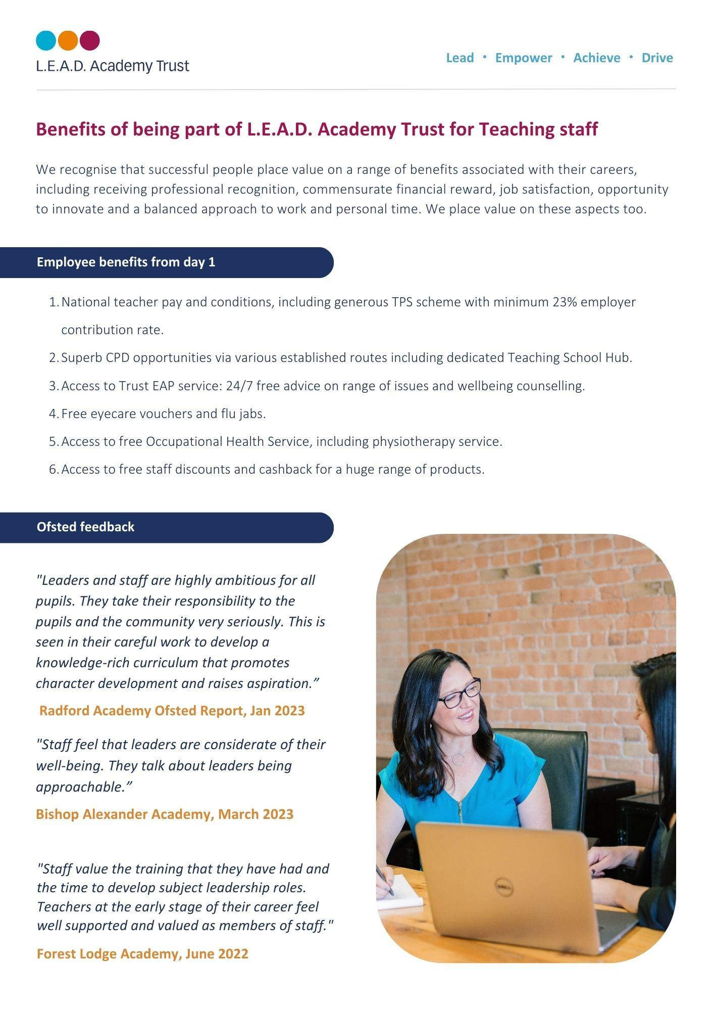

The leadership team has ensured that the school has a calm, purposeful ethos where pupils are encouraged and supported to achieve their best. Staff work hard to develop relationships with pupils that are positive and respectful, and as a result pupils are well behaved and try hard. Pupils enjoy school, look smart in their uniforms and take pride in their work.

Sycamore Ofsted Report
December 2018

How to apply
About the role
We are specifically looking for candidates who:
- have an exceptional knowledge and understanding of what constitutes an outstanding quality of education and curriculum development
- recognise and can drive exemplary teaching and learning
- are leaders of positive behaviour management
- recognise the importance of good attendance
- have a proven track record of securing outstanding pupil outcomes
- will actively contribute to the continued development of our dedicated and professional staff team
- have proven experience across KS1 and KS2
- have an in-depth knowledge of the Ofsted framework
- have experience in safeguarding procedures
- have knowledge of inclusive practice

This post offers an exciting opportunity for you to:
- develop yourself as a professional and a leader in a newly formed leadership team
- work with fantastic children who have a huge thirst for learning and a sense of fun
- influence the on-going development of the academy
- embrace the culture and ethos of LEAD Academy Trust and access high quality networking opportunities.

Please send a completed application form and covering letter explaining your interest in the role and how you meet the person specification to: Admin@sycamoreacademy.co.uk
CLOSING DATE: Thursday 15th May 2024
INTERVIEWS: We expect interviews to take place: the week commencing 20th May 2024

Applications will be reviewed upon receipt, therefore shortlisted candidates may be contacted in advance of the closing date.
L.E.A.D. Academy Trust is committed to safeguarding and promoting the welfare of children and young people and we can expect all staff and volunteers to share this commitment. This post is subject to an enhanced DBS check.
For an informal, confidential discussion about this opportunity, please email: Admin@sycamoreacademy.co.uk

Job description
Key responsibilities and accountabilities
Assistant Head of School
Salary: L4 – 8

This will be a strategic role to work closely with the Headteacher and Senior Leadership Team (SLT).

Main Responsibilities:
Strategic direction and development of the school
- As part of the Senior Leadership Team, provide inspiring, creative and purposeful leadership for the staff and pupils.
- To work in partnership with the Senior Leadership Team, the governing body, staff and parents, generating the ethos and values which will underpin the academy.
- To co-create and implement a Development Plan which will secure continuous academy improvement and support the principles of LEAD Trust.
- To keep up to date with current research into education, particularly teaching and learning and to contribute this academy improvement planning.
- To monitor and evaluate the performance of selected areas of the academy and respond and report to the Headteacher, Deputy Headteacher and the governing body as required.
- To lead on developing selected policies and practices and ensure that they take account of national, local and academy requirements and apply sound educational practice through evidence based pedagogy.
- To regularly monitor, evaluate and review the impact of selected policies, priorities and targets and take action if necessary.
- To inspire all those involved in the academy to commit to its aims, stay motivated to achieve them and involved in meeting long, medium and short term objectives to secure the educational success of the academy.

Teaching and learning
- As part of the Senior Leadership Team, continue to maintain an environment that promotes and secures outstanding teaching, effective learning and high standards of achievement, behaviour and attendance.
- Determine, organise, implement and monitor selected areas of the curriculum and its assessment and ensure that statutory requirements are met.
- Meticulously plan and teach engaging and challenging lessons to exemplify high standards of teaching and learning expected by the academy.
- As part of the Senior Leadership Team, plan and implement a policy for the personal, social and moral development of pupils.
- Monitor and evaluate the quality of teaching and learning and achievement of selected pupil groups through appropriate methods. Devise clear, rigorous and precise plans to address any weaknesses in a timely manner.
- Exemplify excellent practice in delivering inclusion, diversity and equality of access.

Leading and managing staff
- Plan, allocate, support and evaluate work undertaken by groups, teams and individuals, ensuring clear delegation of tasks and devolution of responsibilities.
- As part of the Senior Leadership Team, implement and sustain effective systems for the management of staff performance, incorporating performance management and target setting.
- Promote and monitor the continuing professional development of staff.
- Hold selected staff to account for their professional conduct and practice, both contractually and where relevant as specified in the Terms and Conditions of Service of teachers.

Efficient and effective deployment of staff and resources
- As part of the Senior Leadership Team, recruit, retain, deploy and develop staff of the highest quality.
- Monitor appropriate expenditure, allocation of funds/resources and effective administration for selected areas of responsibility in order to improve the quality of education, pupils’ achievements and ensure efficiency and secure value for money.

Accountability
- As part of the Senior Leadership Team, continue to develop an organisation in which all staff recognise that they are accountable for the success of the academy.
- Present a coherent and accurate account of the school’s performance in selected areas in a form appropriate to the range of audiences, including the Headteacher, governors, parents, OFSTED and others to enable them to play their part effectively.
- Ensure that parents/carers and pupils are well informed about the curriculum, attainment and progress and about the contribution they can make in supporting their child’s learning.

Person specification
The person specification listed below outlines the competences, knowledge and behaviour of candidates who would be suitable for this role. The two right-hand columns provide guidance as to whether these items are essential (E) or desirable (D) criteria.
 |  | E | D
Qualifications and Attainments | - Qualified Teacher Status  - Evidence of recent and relevant further professional development  - NPQSL/NPQML or equivalent | E  E | D
Skills and  knowledge | - In depth knowledge of statutory education frameworks  - Evidence of recent and successful leadership experience  - Evidence of the ability to hold staff to account in the pursuit of improving standards  - Experience of the appraisal process  - Effective strategies for promoting welfare  - Confident use of ICT communication skills  - Knowledge and understanding of data analysis and the ability to use data to set targets for improvement  - Experience in whole school self-evaluation  - Up to date knowledge & understanding of the current national education agenda  - The effective use of support structures and resources to aid student progress  - Knowledge of child protection and safeguarding legislation  - Strategies for ensuring inclusive practice across all areas of the curriculum | E  E  E  E  E  E  E  E  E | D  D  D
Experience | - Significant experience with a record of excellent teaching  - Leadership of an area or phase or inclusion including responsibility for raising standards across the whole school  - Proven track record of raising achievement  - Evidence of impact beyond own area of responsibility  - Experience of teaching in more than one key stage  - Experience of leading initiatives with in the school  - Demonstration of high expectations including leading by example as a teacher  - Evidence of contributing to effective staff training, both on an individual and whole school level  - Understanding of learning with regard to stages of basic skills development of children | E  E  E  E  E  E | D  D  D
Personal Attributes | - Approachable, enthusiastic and creative  - Leads by example, demonstrating integrity, resilience and clarity  - Passionate about education  - Ability to work under pressure, think creatively and to anticipate and solve problems  - Commitment to the encouragement, empowerment and training of all staff  - Deal sensitively with people and resolve conflicts  - Demonstrate flexibility and an ability to adapt to changing circumstances and new ideas | E  E  E  E  E  E  E
Additional Requirements | - This role is subject to an enhanced DBS  - May be required to travel to other Trust locations or third party services as part of the role  - Hold a driving licence and have access to own vehicle | E  E | D

Email address:
Admin@sycamoreacademy.co.uk
Phone number:
0115 9155804

