Assistant Head Teacher:
Teaching & Learning

Vale of Evesham School
Candidate Information Pack

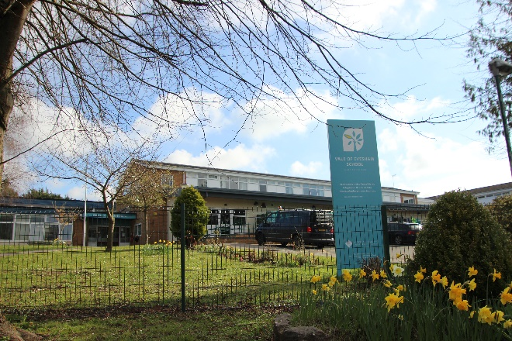

Contents

Job Advertisement 3

Welcome to our School 4

Vision, Mission and Aims of 5-6
the School

Residential Provision 7

About CLPT 8

Job Description 9

Person Specification 13

How to Apply 16

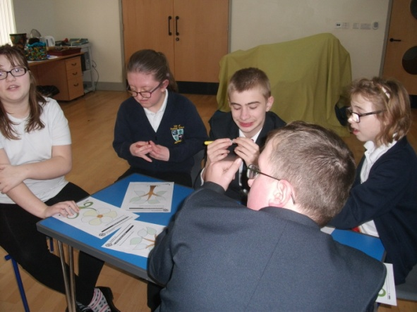

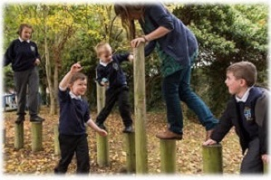

Job Advertisement
Thank you for your interest in the post of Assistant Headteacher at Vale of Evesham School, part of Central Learning Partnership Trust (CLPT). Following the advertisement of the assistant headteacher for performance, attendance, data and ICT, we are also additionally looking for an additional exceptional member of staff to join our senior leadership team, so that we have 3 additional headteachers in place. We are looking for a well-qualified, experienced and committed individual, to take this special school forward. We look forward to learning more about you, and your vision for how the school can progress and develop further.
Vale of Evesham School is a 200 place special school for children and young people with diverse additional needs from the ages of 2 to 19 years old. We have an over-subscribed assessment nursery, a thriving main school provision with high aspirations for all of our students, and a successful post 16 provision. Vale of Evesham also has a fifteen place residential provision for pupils that caters for pupils age 8-19.
The staff team is dedicated and committed to ensuring every young person can thrive by offering a tailored curriculum to meet individual needs. Our students are fabulous and inspire us every day and we need to find the right person with the drive and determination to ensure the school provides a first class education. The staff team is made up of 30 teachers and 90 support staff across all areas including classroom, administration, premises, cleaning and catering.

The new Assistant Headteacher position is to start in September 2021. The Assistant Headteacher will work closely with the Headteacher, other senior leaders throughout school, the Local Governing Body and leaders from CLPT.

The role is to specialise in teaching and learning, ensuring that our pupils across both the aga and ability range receive the very best and make the sustained progress. It will also involve an element of deputising for the Head Teacher when she is not on site. Please read the Job Description later in the pack for more details on the role.

This information pack provides information about the school and of the qualities we expect from our new Assistant Headteacher. We are seeking someone who will appreciate and cherish the strengths of the school, but who will also excite and inspire us with a vision of where the school can go next. The entire school community are looking forward to meeting applicants who share our enthusiasm, values and understand the role they could play in leading the school forward.

Rachel Perks Jackie Summerfield-Constable
Head Teacher Chair of Governors
Welcome to our School...

Vale of Evesham School
Four Pools Lane
Evesham
Worcestershire
WR11 1BN

01386 443367

The Vale of Evesham School opened in 1969 to cater for the needs of young people with learning difficulties in the local area (Hereford & Worcester). The School has places for pupils aged 2 years to 19 years and offers expertise in the education and welfare of pupils with Moderate Learning Difficulties, Severe Learning Difficulties, Profound and Multiple Learning Difficulties and pupils on the Autism Spectrum. It is a specialist school for cognition and learning and works with parents/carers, schools and other agencies in the community to share practice. Vale of Evesham School has recently joined the Central Learning Partnership Multi Academy Trust (CLPT), however it has been an academy since 2013.
The weekly residential provision offers up to 15 places for young people and is intended to provide for pupils who would benefit from consistent approaches across twenty-four hours of the day. Pupils who access the residential provision currently are also day pupils at the school.

Pupils are admitted to the school in line with the Local Authority/School Admissions Policies. All pupils have an Education, Health & Care Plan (EHCP) which names the school and the aims of the provision. Pupils are only admitted to the school when it is agreed with the local authority, that the school can meet the additional needs.

To ensure a smooth transition into our school (and boarding where relevant), a wide exchange of information takes place and every effort is made to help each young person feel at home and gain maximum benefit from the placement.
The School is managed within departments - Early Years, First, Middle and Upper School and is also managed in line with curriculums – pre-formal, semi-formal and formal. This structure allows pupils to work, wherever possible, within their ‘Year Groups’ and access their National Curriculum entitlement as well as providing integration of mixed abilities.

All classes provide individual and specialised support as needed. The teaching staff are well supported by a large team of teaching assistants. A broad, balanced and relevant curriculum is offered to all pupils and caters for the wide range of educational needs and abilities.
The Vision, Mission and Aims of the School

At Vale of Evesham School, our vision is ‘to provide an environment of excellence that enables learning for life, for children with special needs, their families and the wider community’.

Our Mission:
To create an environment in which every individual in the school is valued, celebrated and heard and where every achievement is recognised.

Our Aims:

To provide a warm and safe environment in which everyone is valued and enabled to develop as happy and confident individuals who appreciate their own worth.

To develop skills, qualities, knowledge and understanding for life
- To ensure the pupils have a voice in all aspects of school life
- To prepare our pupils for adulthood – becoming caring, confident and responsible citizens in the community.
- To enable individuals to become informed, responsible and caring through use of appropriate learning and teaching styles and practice.
- To offer at an appropriate level a stimulating, challenging and enriching curriculum in a variety of environments during school and beyond which enables the achievement of full potential.
- To promote a climate of high expectation in which the achievements and successes of all are celebrated.
- To create an environment in which individuals are empowered to accept responsibility for their own development.
- To encourage mutual respect and understanding of others so that our pupils become caring and responsible individuals both within school and the wider community.
- To have an inclusive and consultative style of leadership and management that respects and takes account of the views of all.
- To continually evaluate current working practices to ensure work/life balance, staff well-being and good continuing professional development.
- To encourage individuals to participate in the growth and development of the school environment.

Vale of Evesham School Management Structure

Assistant Head Teacher: Behaviour and Personal Development
Pastoral
Co-Ordinator

Head Teacher
Head of Care – Residential School
Assistant Head Teacher: Teaching and Learning
Business Manager
Assistant Head Teacher: Curriculum, Performance, Data & ICT
Residential Provision – Blossom House

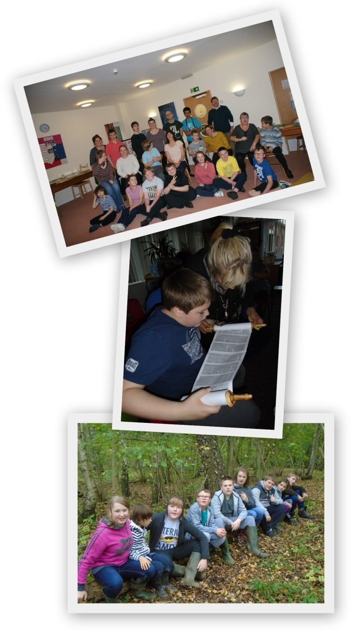
Blossom House is our residential provision. It comprises of 3 suites, Sunflower, Poppy and Bluebell Suite catering for 15 weekly boarders aged between 8 – 19 years of age.

Our team are experienced, dedicated professionals who work to provide consistency and continuity for each individual, in order to meet their educational, social, health and emotional/behavioural needs in order to reach their full potential.
The team work closely with day staff, to be able to provide a 24-hour curriculum enabling our young people to develop their communication, independent and social skills – to become happy and confident individuals.
The blossom house team work closely with the families of our young people, we find this is essential in meeting all of the needs of the individual.
We work with other professionals such as Speech & Language, Physiotherapists, Paediatricians, Psychologists and Social Services to ensure a trans- disciplinary approach.
The residential accommodation is decorated and furnished to be as homely as possible. Our young people are encouraged to personalise their bedrooms with a choice of colour and any personal belongings they wish to bring from home such as bedding, posters, family photos or toys.

Accommodation
The accommodation comprises of three suites:
- Sunflower suite has six bedrooms in total, a walk in shower, a bathroom and a social area.
- Poppy Suite has four bedrooms in total, a bathroom, separate toilet and a social area.
- Bluebell suite has five rooms in total, bathroom, shower room, separate toilets and a social area.
.
All of the social areas are central to the suite and have a large family table as well as a comfy seating area which allows the children and young people to participate in group activities or simply to socialise and relax.

About Central Learning Partnership Trust (CLPT)

The Central Learning Partnership Trust is underpinned by a moral purpose: to change lives for the better. We are committed to improving the life chances of our young people, to optimise their feeling of self-worth, to develop their resilience and in turn their capacity to embrace the challenges that lie ahead.
Above all else, we encourage pupils to be ambitious for themselves, their families and their communities.
Success is the birth-right of every individual, and schools must be relentless in their drive to ensure that this is delivered. We are determined to challenge the premise that education alone cannot break the cycle of deprivation – of low aspirations and resultant low outcomes. We want to eradicate the poverty of expectation and instil in every member of our school communities a personal resolve and drive to succeed – a ‘Yes We Can’ mentality.

Our Aim
As a Trust our main priority is to raise the attainment of young people. A significant number of pupils, of both primary and secondary age, are attending schools judged other than ‘good’ or ‘outstanding’. This fundamental failure to equalise opportunity has an adverse effect upon the life chances of these young people well beyond their school years. We are committed to addressing this inequality; believing that all schools and in turn their outcomes can improve incrementally, continually building on the improvements of the previous year.

We aim to ensure that each Academy within the Trust:
- adds value to the results of their students.
- is capable of outstanding judgements from OFSTED within 3 years of becoming an academy partner within the Central Learning Partnership Trust.
- is oversubscribed or on a significant upward trend.
- works closely with other CLPT academies to create a sustainable model of education for all students.
- fosters an inclusive culture where permanent exclusions are rare and every student leaving the school has a plan for the next stage of their learning / career.
- is recognised nationally as organisations of high quality, producing outstanding results within a culture of innovation and achievement.
- continues to develop their own unique characteristics and ethos; maintaining individual identities within their respective communities.
- produces high quality committed professionals and future leaders for CLPT academies, through our Teaching School Alliance Professional Development Programme.

ASSISTANT HEADTEACHER’S JOB DESCRIPTION

Post Title: | ASSISTANT HEADTEACHER – TEACHING & LEARNING (L10 – L14)
Conditions of Employment: | Refer to School Teachers’ Pay and Conditions Document
Disclosure level | Enhanced
Responsible to: | Headteacher
Responsible for: | Middle Leaders, Teachers and Associate/Support Staff
Liaising with: | Governing Body, Headteacher, Senior Leadership Team, Teachers, Student Support Services, Associate Staff, External Agencies, Parents and Stakeholders
PURPOSE | To be an effective, dynamic professional, who is accountable for the development of identified innovations and key areas of the school improvement plan. To ensure the curriculum provision is innovative, personalised, meets the needs of our young people as well as statutory requirements and national guidelines (as appropriate) and delivered through high quality teaching and learning that maximises all students’ potential and enables them to become enthusiastic and independent learners. In addition, you will contribute to the development and delivery of the multi academy / school, single shared trust.  To be a strategic and supportive member of the senior team, playing a key role in the development of the school as an innovative, high performing and emotionally intelligent organisation, effectively managing the agenda of change to raise standards in all areas.
Leadership Team Responsibilities | The Leadership Team is jointly responsible to the Governing Body for:  - Supporting the vision, ethos and policies of the school and to promote high levels of achievement  - Developing a school ethos which enables everyone to work collaboratively, share knowledge and understanding, celebrate success and accept responsibility for outcomes  - Setting direction, developing policy and ensuring quality in all aspects of school  - Creating a self evaluating organisation focussing on continuous improvement within the context of our mission: ‘every pupil: always in focus’  - Formulating, implementing, monitoring and evaluating the whole school improvement plan in support of agreed targets  - Monitoring and evaluating the effectiveness of teaching and learning  - Effectively implementing quality assurance systems and produce evaluative reports  - Discipline, pastoral care and guidance for all students and links with external agencies  - Safeguarding the health and safety of students on school premises and when they are engaged in authorised school activities elsewhere  - Managing the extra-curricular activities across the school and promoting the use of the schools facilities  - Secure work based learning for students  - Safeguarding the health and safety of students on school premises and when they are engaged in authorised school activities elsewhere  - Deputy DSL  - Carry out all necessary risk assessments
MAIN (CORE) DUTIES & ACCOUNTABILITIES
Strategic Direction and Development | All members of the leadership team are jointly responsible for the external outcomes of the school. In addition, individuals will have specific agreed targets based on the area of responsibility – refer to targets and appraisal process.  Strategic responsibilities include:  - Lead the development of identified areas through work with the leadership team, reviewing current provision and its responsiveness to internal and external agendas, ensuring statutory responsibilities are met and national and local initiatives are appropriately incorporated into provision  - Raise the quality of learning and teaching and in turn the achievements and standards  - Be an effective senior team member in the management of robust monitoring and quality assurance systems, ensuring high quality learning and teaching and equality of opportunity for all learners  - Be responsible for the development and review of school policies relating to the key stage and contribute to continuous school improvement strategies  - Act as the professional lead for relevant Governors’ sub-committees and provide advice and guidance as required  - Work with leadership teams and key personnel within identified schools  - Work with the Headteacher and the leadership team to ensure consistency across all key stages and continuously improve the curricular provision to raise standards  - Ensure effective strategies are in pace to evaluate the effectiveness of provision  - Be responsible for all NQT’s and School Direct candidates including Unqualified Teachers  - Be responsible for the induction of all new staff  - Work with the Headteacher and the leadership team to ensure consistency within teaching and learning  - Ensure effective strategies are in pace to evaluate the effectiveness of provision  - CEIAG Lead and monitor student work placements at Post 16
Raising Achievement | The responsibility of the Leader is to be an effective professional who provides inspiring and purposeful leadership. A Leader who secures success and improvement, ensures a high quality learning programme and monitors the progress of all students in the key stage  - Establish a positive relationship with all students within the key stage (and school) where individuals are known and nurtured  - Support policies and practices that promote inclusion and high achievement through effective teaching, learning and assessment and the creation of a culture and ethos that demands positive attitudes and respect towards each other and the community  - Secure and sustain effective learning and teaching through structured monitoring, evaluation and review processes  - Ensure a consistent and continuous focus on students’ achievement, using data and benchmarks to monitor progress in every student’s learning  - Establish and maintain effective partnerships with parents to involve them in their child’s learning  - Implement effective CPD procedures focused on enhancing learning  - Ensure appropriate support and interventions are put in place, as necessary, to secure effective learning and teaching  - Ensure students experience continuity of learning and effective progression to maximise academic potential  - Develop a programme of extra curricular activities and out of hours learning that enhance, engage and excite students of all abilities and enable individual student’s talents and interests to blossom  - Co-ordinate sharing of best practice and seek opportunities to collaborate with other innovative and high performing schools and networks to share and develop pedagogies  - Regularly advise the Headteacher and Governors on progress towards school targets
Leading and Managing Staff | - Regularly review own practice, set personal targets and take responsibility for own personal development  - Line manage middle leaders, teachers and associate staff within the team to ensure effective provision and delivery of the curriculum, securing high quality teaching, learning and assessment throughout and across the key stage  - Ensure the learning policy and performance management arrangements are effective so as to secure outstanding academic performance and effectively plan and deliver professional development opportunities to promote high quality teaching, learning and assessment  - Be responsible for and lead colleagues, acting as a positive role model in terms of pastoral care, professional and personal practice  - Develop and maintain a culture of high expectations for self and for others and take appropriate action to challenge underperformance at all levels, ensuring corrective intervention and follow up  - Build a collaborative learning culture, actively engaging across the key stages and with other schools to build effective learning communities.
Effective Deployment of Staff and Resources | - Participate in the recruitment and deployment of teaching and support staff  - Deploy staff effectively, maximising over staffing opportunities and producing individual timetables  - Deploy accommodation effectively to meet learning and teaching needs, including those for individual students and ensure accommodation promotes high quality learning and teaching  - Ensure technologies are effectively and innovatively used and developed to support students’ learning
Other Professional Requirements | - Have a working knowledge of teachers' professional duties and legal liabilities  - Operate at all times within the stated policies and practices of the school, including professional duties  - Perform duties as part of a duty team  - Maintain an up to date knowledge of good practice in teaching techniques  - Know subject(s) or specialism(s) to enable effective teaching  - Take account of wider curriculum developments  - Contribute positively and effectively to the Inclusion agenda  - Undertake professional development to enhance teaching and pupils' learning, and: apply outcomes and identify impact; share outcomes with colleagues  - Take responsibility for professional learning  - To support the Headteacher and play a full part in the life of the school. Attendance at all important school events is required as listed in the school diary ie, Parents Evening, school shows etc
Whilst every effort has been made to explain the main duties and responsibilities of the post, each individual task undertaken may not be identified. Employees will be expected to comply with any reasonable request from a manager to undertake work of a similar level that is not specified in this job description.

This post is subject to the current conditions of employment for Class Teachers contained in the School Teachers' Pay and Conditions Document, the 1998 School Standards and Framework Act, the required standards for Qualified Teacher Status and Class Teachers and other current legislation.

The school will endeavour to make any necessary reasonable adjustments to the job and the working environment to enable access to employment opportunities for disabled job applicants or continued employment for any employee who develops a disabling condition.

This job description is current at the date shown, but following consultation with you, may be changed by the Headteacher to reflect or anticipate changes in the job which are commensurate with the salary and job title.

PERSON SPECIFICATION

The Person Specification is a picture of the skills, knowledge and experiences needed to carry out the job. It will be used in the shortlisting and interview process for this post.

Aspect | Essential | Desirable | How
Qualifications and career Development | - Degree  - Qualified teacher status  - Professional-development which shows preparation for a leadership role.  - Evidence of professional development related to special education needs. | - An additional qualification relating to SEND e.g. SLD, ASD  - Trainer in relevant specialist area e.g. Manual Handling  - First Aid trained  - DSL qualifications and Safer recruitment training | - Application form  - Personal statement  - References  - Interview  - Tasks
Experience | - Knowledge of resources to support pupils with a range of special educational needs  - Able to use a range of augmented communication strategies.  - Experience working with a multi professional team including health and social care professionals  - Experience of working with children with SEND | - Taught SEND in both mainstream and special schools.  - Taught across all Key Stages - EYFS to KS5. | - Application form Personal statement  - References  - Interview  - Tasks
Skills and knowledge | - Understanding of high-quality teaching, and the ability to model this for others and support others to improve.  - Ability to differentiate the curriculum.  - Effective communication and interpersonal skills to build effective working relationships. | - Understanding of school finances | - Application form Personal statement  - References  - Interview  - Tasks  - Lesson observation.
Personal Qualities | - A commitment to getting the best outcomes for all pupils and promoting the ethos and values of the school.  - A commitment to protecting the welfare of pupils  - Ability to communicate a vision and inspire others  - Ability to work under pressure and prioritise effectively  - Able to plan and take control of situations.  - Commitment to maintaining confidentiality at all times  - Team skills: Open minded and creative, able to motivate others, reflective practitioner, approachable.  - Understands ethical issues in sharing information when working in partnership  - Able to work flexibly, attending morning and evening meetings, in addition to managing a demanding workload |  | - Application form Personal statement  - References  - Interview  - Tasks
Leadership and Management | - Significant experience of teaching in a Special School.  - Leadership and management experience in a school  - Line management experience beyond a class group.  - Experience of contributing to staff development.  - Involvement in school self-evaluation and development planning  - Knowledge of current legislation and developments in SEN education  - Strong knowledge of safeguarding. | - Open to change and fresh ideas.  - National professional qualification for middle and/or senior leadership | - Application form Personal statement  - References  - Interview  - Tasks
Curriculum | - High Expectations of pupil achievement and attainment.  - Proven ability in the implementation and development of a curriculum for pupils who have SLD/PMLD/ ASD  - Knowledge and experience of using assessment systems and tools.  - An awareness of the importance of carrying out effective observation, assessment and record keeping, and ensuring that adequate records are kept of the individual children’s progress, and that information is used as the basis for planning the curriculum.  - Ability to plan, teach and adapt lessons to pupils complex needs and have ‘outstanding’ teaching  - A good understanding of positive approaches to behaviour management and can support others |  | - Application form Personal statement  - References  - Interview  - Tasks  - Lesson observation
Relationships | - Actively encourage the involvement of parents  - To have experience of commitment to home school links and the value of warm, welcoming ethos for children and adults alike.  - Ability to work in partnership with families, the Governing Body, staff, relevant agencies and the local community  - Liaising with a range of agencies and professionals to support pupils, as well as working closely with the LA  - Ability to contribute to the wider life and ethos of the school | - Experience of working with local authority consultants and outside educational advisors. | - Application form Personal statement  - References  - Interview

Further Information

If you wish to find out more about this exciting opportunity, or would like to visit / phone for an informal discussion or arrange to attend our visit days, then please contact Kerry Liddle (PA to the Headteacher) in the first instance:

E-mail: Kerry.liddle@valeofevshamschool.org Telephone: 01386 443367 ext: 221

Visits

We would welcome applicants to attend for an informal visit. Please contact Kerry Liddle if you would like to visit.

How to Apply

Please apply using the CLPT Teaching Staff Application Form - this is available on the Vacancies page of the Vale of Evesham School website. Please provide details of age ranges taught and curriculum experience (i.e. pre-formal, semi-formal or formal) within the supporting statement on the application form.

Please return your completed application by e-mail to:

Kerry.liddle@valeofeveshamschool.org

Or by post to:

Kerry Liddle, Vale of Evesham School, Four Pools Lane, Evesham, Worcestershire, WR11 1BN

Deadline for Applications

12 noon on Wednesday 5th May 2021

Interview Dates

The interview date is Friday 14th May and will include panel interviews, presentations, and assessment tasks.

Start Date

We would like to recruit for September 2021, but would welcome a staggered start from June 2021 (where possible).

www.centrallearning.co.uk
www.valeofeveshamschool.org

