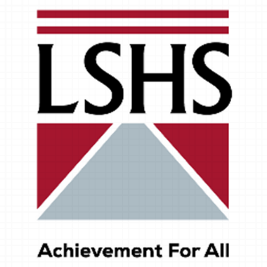
Long Stratton High School
Manor Road
Long Stratton
Norfolk
NR15 2XR
Tel: 01508 530418
E-mail: recruitment@lshs.org.uk
www.lshs.org.uk

Required: Assistant Headteacher: Teaching, Learning & Curriculum
Date: September 2021
Salary: L12 – L16
Contract: Permanent

Long Stratton High School, part of the Enrich Learning Trust, is a small (650 pupils) secondary school in Norfolk. The school is good and one of the best in Norfolk, with well behaved, motivated and aspirational pupils.

We pride ourselves on being at the forefront of both Teaching & Learning and curriculum strategies, ensuring nothing but the best for our pupils and staff. With the resignation of the current post-holder, we are seeking a suitable replacement with the same passion for developing and maintaining these areas of the school. The successful candidate will not only be an excellent teacher but will be able to demonstrate effective leadership with exceptional knowledge of current research and how to implement it. You will be an integral member of our small, yet highly effective, Senior Leadership Team who are continually striving for excellence.
The key aspects of the role are:
- To have strategic oversight of teaching, learning and curriculum;
- To drive up standards across all these areas with a direct impact on outcomes;
- To be directly accountable to the Headteacher, Governors and Trust;
- To ensure effective strategies benefit the progress of all groups so that no group is left behind;
- To model our vision of growth, excellence and achievement for all;
- To support the school in achieving “Outstanding” status.

If you wish to visit, or have an informal discussion about the post, please contact the Headteacher’s PA; Mrs Wendie Barnes, wbarnes@lshs.org.uk will arrange this.
Closing Date: 09.00 am Friday 7th May 2021
Interview Date: Monday 17th and Tuesday 18th May 2021
We are committed to offering excellent professional opportunities for our staff, through careful support and personalised CPD. We offer a structured and specific induction programme for all staff. The school welcomes applications from members of minority ethnic communities and those with disabilities. If you would like further details and an application form, please access the vacancies page on our school website. Please apply using the application form, emailed to recruitment@lshs.org.uk for the attention of Mrs Wendie Barnes.

Long Stratton High School is committed to safeguarding and promoting the welfare of children and young people and expects all staff and volunteers to share this commitment.

