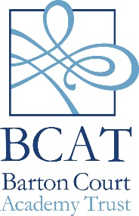

Part One

SELF DISCLOSURE FORM FOR POSTS INVOLVING CONTACT WITH CHILDREN

Barton Court Academy Trust is committed to safeguarding children from physical, sexual and emotional harm.

As part of our Child Protection policy, we require applicants for posts involving contact with children to complete the self-disclosure form.

Having a criminal record will not necessarily bar you from working with us.

This will depend on the nature of the position and the circumstances and background of your offences.

Name…………………………………………………………………………………………

Part Two

Have you ever been convicted of any criminal offences?

YES / NO

If yes please supply details of any criminal convictions in a sealed envelope.

Note: You are advised that under the provisions of Rehabilitation of Offenders Act 1974 (Exceptions) Order 1975 as amended by the Rehabilitation of Offenders Act 1974 (Exceptions) (Amendment) Order 1986 you should declare all convictions including “spent” convictions, warnings and reprimands.

Part Three

Are you a person known to any Children and Families Social Care Department as being an actual or potential risk to children?

YES / NO

Part Four

Have you ever had any disciplinary sanction relating to child abuse?

YES / NO

If yes please supply details:

…………………………………………………………………………………………………

……………………………………………

…………………………………………………………………………………………………

…………………………………………..

Declaration

I declare that to the best of my knowledge the information given above is correct and understand that any misleading statements or deliberate omission may be sufficient grounds for cancelling my appointment. I understand that I may be asked to apply for a Criminal Records Disclosure and consent to do so.

I understand that the information contained in this form and in the disclosure may be disclosed, where strictly necessary, to regulatory bodies and/or third parties who have an interest in child protection issues.

Signed…………………………………………………………………………………………

Date……………………………………………………………………………………………

