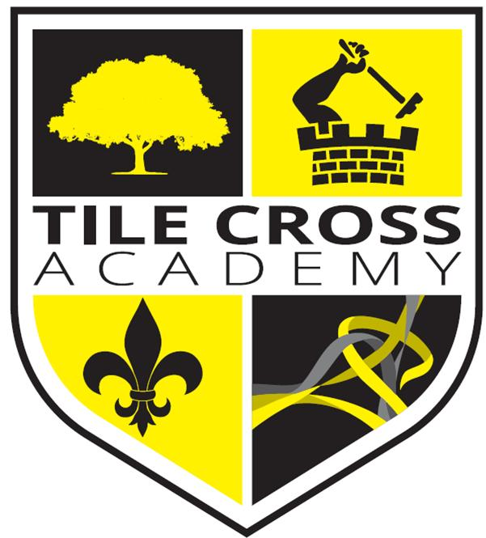
Assistant Headteacher
Candidate Pack
Tile Cross Academy

Headteachers Welcome

Welcome to Tile Cross Academy. Thank you for your interest in the role of Assistant headteacher at our School.

At Tile Cross Academy we care deeply for our students; their safety and wellbeing is our primary concern. Tile Cross Academy is the ideal environment in which to stimulate the minds of the next generation. It is a special place where both students and staff feel a real sense of belonging, with relationships at the heart of everything we do. With the wide range of backgrounds and cultures represented in our school population we celebrate diversity and difference, whilst recognising that we are all equal through a Rights Respecting ethos where students’ rights are ‘learned, celebrated and lived’. We value everyone’s opinions and beliefs, whilst also encouraging every single child to achieve their very best.
Tile Cross Academy is proud to announce that we were winners within the UK Social Mobility Awards and have been awarded the title ‘School of the Year 2020’
Tile Cross Academy opened in May 2017 as part of the Washwood Heath Multi Academy Trust. It sits on a site once occupied by Central Grammar School for boys, Byng Kenrick Grammar School for Girls, Sir Wilfred Martineau School and The International School. Our new school sits at the very heart of its community with a proud and distinguished heritage and an exciting and successful future ahead of it.
Thank you for your interest in our school and I would like to take this opportunity to wish you well in your application.
Paul Marano
Headteacher

‘Strive, Achieve, Believe’

About Our School

School Vision & Ethos

Tile Cross Academy is a small and caring 11-16 mixed comprehensive school. We have high expectations for our students in which they develop through high quality Teaching and Learning and our focus to develop the Character of every child, so they become outstanding learners and citizens.

We aim to provide a high-quality education in an atmosphere of mutual respect where everyone is valued as an important member of our school community. We strive to develop and nurture the values, skills and attributes which create good citizens and lifelong learners, so that every student can discover, develop, and achieve their full potential and be successful in whatever path they choose. Our broad and balanced curriculum prepares our students to meet the challenges of a rapidly changing society, ready and willing to grasp the opportunities available to them and positive about their futures. and Ethos S

Curriculum Overview

Our curriculum is at the heart of our school and reflects our values ‘Strive, Achieve, Believe’.

At Tile Cross Academy we aim to offer a curriculum that is ambitious and designed to give all learners the knowledge and cultural capital they need to succeed in life. We offer this through a curriculum which is sequenced towards knowledge retention and developing skills for future learning and employment. We offer a full programme of enrichment activities to engage our learners that allows them to develop experiences outside the classroom.

We offer a full, broad and balanced curriculum with a diverse range of subjects including GCSE and Vocational subjects. Within our curriculum, we strive to improve literacy across all age groups so that our learners are articulate, speak to a high standard, listen to their peers and respond with fluency and expression, read widely and write with enjoyment and confidence.

We want all our students, no matter what their background or previous social and academic experience, to leave school as well qualified, resilient, independent and confident young adults, ready to make a highly positive contribution to their community and wider society.

In a rapidly changing world we feel strongly that our students should show adaptability and resilience as well as demonstrating respect, kindness and tolerance of people from all faiths, cultures and backgrounds.

Our ambitious curriculum will engage and stimulate our learners and develop their knowledge and skills to achieve high quality outcomes.

Our learners will:
- Experience a diverse, challenging, and engaging curriculum
- Thrive by exemplary practice modelled through our Teaching & Learning cycle
- Develop their independence, collaboration, and ability to evaluate
- Be supported and challenged as they aim to reach their true potential
- Be literate and articulate enabling them to access the wider world

Pastoral Care & Wellbeing

Tile Cross Academy Provides a caring atmosphere where students feel secure and comfortable as they settle down to focus on their learning.

Form Tutors and Pastoral Managers look after the day to day needs of students and they remain with their tutor groups throughout the five years wherever possible, getting to know both students and parents very well. We value our close partnership with parents and encourage them to be actively involved in their child’s education at every opportunity.

Students build up a trusting and friendly relationship with their Tutor, Pastoral Manager, Head of Year and peers through activities in registration and assemblies. Each Year group has a weekly assembly in the Central Hall, with Form Tutors, the Head of Year and a member of the Senior Leadership Team present. Others, including outside speakers are invited during the year. Heads of Year ensure the social and academic well-being of students in their year group as well as helping to maintain good attendance and standards of behaviour. A wide range of pastoral, wellbeing and academic interventions take place with students supported to overcome challenges and develop lifelong character traits.

Our culture and environment will empower each child to develop the attitudes and their characters to thrive, enabling them to be the best version of themselves.

Our learners will:
- Understand how their behaviours and attitudes impacts on theirs and other children’s progress within a supportive, caring, and inclusive environment.
- Anticipate and experience being praised and rewarded as well as experience support and fair and effective sanctions when they fail.
- Grow through our Personal Development curriculum, modelling British Values, our ‘Character Days’ and our ethos of visible kindness.
- Understand their rights and responsibilities to themselves and others.
- Understand their roles within a cohesive, diverse community, celebrating our equalities and diversity.
- Prosper through understanding the needs and requirements of a healthy lifestyle.
- Be shaped for their future, their studies, their careers, and their lives as adults.
At Tile Cross Academy, we expect our students to be:

- On time, think smart and dress smart and be Ready to learn.
- Respectful of everyone in school; every child, every adult.
- Responsible for their learning and responsible for their actions.
- Resilient to the challenges that face them; in lessons and around school and as they grow through life.
- Reflective; understand what they do well, what they could do better and how they can all help each other grow and develop.

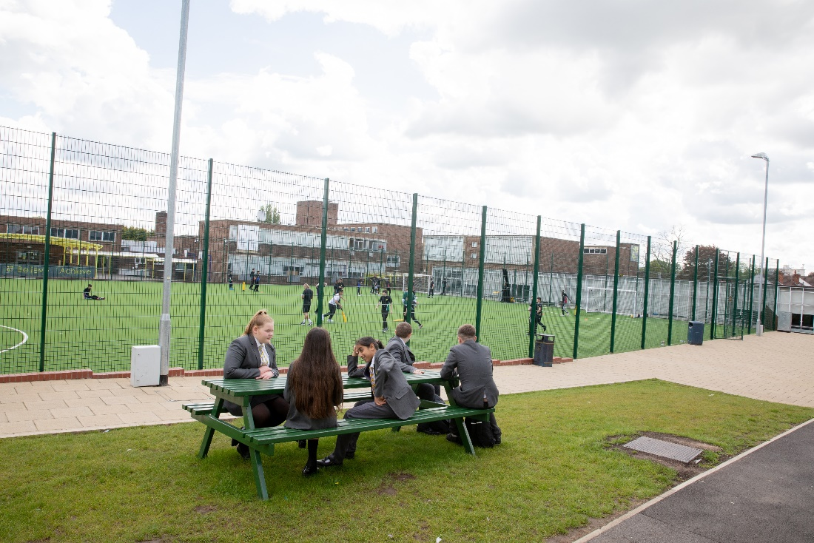
Job Description – Assistant Headteacher

In addition to the responsibilities of class teacher as set out the Classroom Teachers Job Description (taken from the school teachers’ pay and conditions document) you will also undertake the following duties and responsibilities.

To provide outstanding leadership and management in order to raise standards and achievements in all areas of the academy’s work and ensure that it is appropriately and effectively monitored and delivered.

Responsible to: Headteacher Leadership Spine: 12 - 16

Core Purpose
As a member of the Leadership Team, to play a major role, under the overall direction of the Head of Academy in:
- Formulating the aims and objectives of the Academy.
- Establishing the policies and corporate plans through which they shall be achieved
- Managing and deploying staff and resources efficiently to ensure the aims and objectives are met.
- Monitoring progress towards the achievement of the aims and objectives and taking prompt action to rectify anticipated deficiencies.
- Playing a lead role promoting the ethos of the Academy, creating and maintaining an environment which promotes and secures good teaching and effective learning, ensuring that all relevant standards of conduct are met be students and staff.
- Contributing to the monitoring and evaluation of the quality of education and standards of students’ achievements using all available local and national data and internal assessments.
- Critically reviewing all aspects of the Academy’s operation and contributing ideas to the development of improvement strategies.
- Maintaining a highly visible and authoritative presence around the Academy which secures the co-operation and respect of students and staff alike.
- Leading the organisation of events or of specific day-to-day Academy management activities, or the implementation of specific improvement initiatives, as directed by the Head of Academy.
- Providing support and coaching to staff to all levels in the Academy, encouraging and supporting their professional development and enabling them to function effectively and with confidence.
- Understanding and representing the views of staff to the Leadership Team and to represent the Leadership Team to staff seeking, through influence and persuasion, to ensure that the Academy functions as an effective and cohesive team in pursuit of the Academy’s aims and objectives
- Representing the Academy to parents, members of the local community and all other external contacts, inspiring confidence and promoting the national and local profile and good reputation of the Academy.

Context of the Post
Members of SLT work as a strong, cohesive team each contributing specific skills to enable the group to function as a single entity with a strong emphasis on teamwork and sharing expertise. The expectation is that each member will acquire the necessary skills to be able to take a lead on every aspect of Leadership and Management as it pertains to their areas of responsibility.

All members of the SLT act as the link between the Leadership Team and at least one specified academic faculty and one House pastoral team, meeting regularly and proving support, leadership, and guidance to the relevant Head(s) of Faculty on all curriculum, student and staffing matters, taking action to resolve issues of concern and reporting back to the Leadership Team on issues of relevance.

All staff working in the Academy have a duty to safeguard and promote the health, safety and welfare and all children and young people for whom they are responsible or with whom they come into contact within the course of their duties.

Responsibilities – specific:
• To be confirmed once appointment has been made

Responsibilities as a member of Senior Leadership Team – Generic Tasks
- Participate in departmental and whole academy self-evaluation.
- Carry out performance management in line with academy policy.
- Monitor and evaluate the quality and effectiveness of teaching.
- Ensure rigorous monitoring of student progress, standards and achievements. Use, understand and analyse assessment information including data.
- Ensure the maintenance of good order and discipline at all times during the academy day and when students are engaged in academy activities.
- Challenge under-performance by staff.
- Participate in arrangements for recruitment of staff.
- Devise and deliver staff training and development.
- Devise and deliver assemblies.
- Line-manage staff.
- Attend Governors meetings as appropriate.
- Manage finances and resources as appropriate.
- Promote effective relationships with bodies outside the academy.
- Fulfill the professional duties of teachers other than head teachers.
- Any other duties as required by the Head of Academy.

Whilst every effort has been made to explain the main duties and responsibilities of the post, each individual task undertaken may not be identified. Employees will be expected to comply with any reasonable request from a line manager to undertake work of a similar level that is not specified in this job description

Employees are expected to be courteous to colleagues and provide a welcoming environment to visitors and telephone callers. This job description is current at the date shown, but, in consultation with you, may be changed by the Head Teacher to reflect or anticipate changes in the job commensurate with the grade and job title.

Person Specification – Assistant Headteacher

Factor | Required | Desired | Evidenced Through
Education and Qualifications | - Good, Relevant Degree  - Qualified Teacher Status  - Knowledgeable about recent educational developments and initiatives | - Achieved, or engaged in the pursuit of, further relevant qualifications  - Range of relevant professional training | - Application form  - Letter of  application  - Interview
Experience | - Outstanding classroom practitioner  - Proven record of achievement at all levels  - Experience of management and supervision of other staff  - Experience of leading a whole school initiative which significantly improved student outcomes  - Experience of raising standards in teaching and learning | - Experience of KS3/KS4/KS5 teaching  - Experience of working as a leader in more than one school  - in depth knowledge and understanding of the Ofsted process | - Application form  - Letter of  - application  - References
Personal qualities | - Ability to lead others, yet able to work within a team  - Ability to lead by example, playing an active role in the day-to-day school life.  - Values, inspires and motivates others  - Ability to work under pressure and to challenging deadlines  - Integrity and zest for learning  - A record of good working relationships with colleagues  - Ability to achieve a balance between professional commitments and personal life | - Creative thinker, able to adapt to changing circumstances | - Letter of application  - Interview  - References
Skills | - Good communicator - well-developed writing skills and an articulate speaker  - Proven well-developed problem-solving skills  - Ability to analyse data strategically  - Able to maintain effective relationships with all stakeholders  - Relates well to pupils, has high expectations of them and inspires them to achieve | - Proficiency with use of ICT and a range of technologies to improve teaching and learning | - Letter of application  - Interview
Values | - Support for the ethos and aims of Washwood Heath Academy and Multi-Academy Trust  - High expectations and a commitment to high standards in daily school life.  - Deep commitment to make a difference to the lives of the children that we serve.  - Strong belief in helping staff to become the best they can be | - Advocacy of the difference education can make from own personal experience | - Letter of Application  - Interview
References | - Two unreserved references | - References indicate confidence, integrity, competence and effectiveness | - References

We are part of Washwood Heath Multi Academy Trust, welcoming students from 11 years old to 16 years old, providing a standard of academic excellence for secondary and education. We are very proud of the positive learning experience offered to our students and the support available to ensure they achieve their full potential. We:
- offer an excellent induction programme within a friendly and supportive environment
- offer a whole range of opportunities to further develop colleagues’ teaching skills and leadership
potential, including a Supportive NQT Induction Process & Policy, Career Pledge for Teachers to support at each stage of career, paid opportunities to upskill via apprenticeship levy (right up to masters level).
- are creative and innovative in our approach to all aspects of school life
- have motivated, vibrant, multi-ethnic students and staff
- have a strong family ethos where individuals are respected and valued
- are part of the WHA Trust that provides numerous professional development opportunities

We know you would love working at Tile Cross Academy. We have wonderful, enthusiastic students and amazing staff who always go the extra mile for their classes.

Informal conversations are warmly welcomed. Please contact Amy Hughes – PA to Headteacher ahughes@tilecross.academy

Application Packs are also available to download from our website on www.tilecross.academy

Tile Cross Academy is committed to safeguarding and promoting the welfare of children and young people and expects all staff to share this commitment. An enhanced DBS check is required for all successful applicants.

