Upton-by-Chester High School
Assistant Headteacher – Director of Key Stage Three
Assistant Headteacher – Director of Key Stage Four
Full Time and Permanent
L12-16
Closing Date: Tuesday 18th May 2021, 3pm latest.

Headteacher’s Welcome Message
I would firstly like to thank you for your interest in the posts of Assistant Headteacher: Director of Key Stage Three and Key Stage Four at Upton-by-Chester High School. The purpose of this information is to help you get to know more about our school and help you to decide if this is the right post for you.
Upton-by-Chester is a large and successful comprehensive secondary school located in Upton-by-Chester, an area on the outskirts of the wonderful city of Chester. Upton-by-Chester High School was established in 1968 and has gone from strength to strength over this time. We are a thriving, vibrant school with a proud record of academic excellence and success. Combined with our exceptional extra-curricular opportunities, we inspire our learners to flourish, no matter what their strengths and aptitudes. We are fully inclusive and open to young people of all abilities.
The school currently serves both the local community and an extended catchment area with learners attending the school from up to 40 individual primary schools. There are currently 1650 learners on roll and the school is oversubscribed in a number of year groups. The school also has an outstanding Sixth Form (Ofsted 2015, 2019).
Our school motto is 'Learning to Shape the Future'. This really does capture what is at the heart of the school. We undertake that every learner - whatever their previous attainment - will gain the life-long enrichment and learning from the time they spend with us at Upton. Our approach is to provide the opportunities that will capture the imagination of our learners and allow them to develop their knowledge, skills and understanding to be successful academically and socially. We will provide traditional academic subjects and vocational opportunities so we can support the learning needs of all our young people.
Our learners are fantastic and our greatest asset. They represent a truly comprehensive intake in terms of ability and preparedness for learning. They are committed to their learning and they are striving to succeed. We also have a very talented team of teaching and support staff who support and challenge every learner to be the best that they can be. The professional development opportunities of our staff is highly valued.
I was appointed to the school in September 2020 and am absolutely committed to both building on the strengths of the school and ensuring that the whole school community is focused on improvement. I am also committed to delivering an outstanding professional learning offer for all staff in a challenging and supportive environment.
Upton-by-Chester High School is a great place to work. It is challenging, focused on teaching and learning and dedicated to the wellbeing of our learners. We have the highest expectations of all who work here and therefore, we are only looking for the finest staff to work with our learners. We know that our school can only be as good as the workforce within it.

The school is at an exciting stage of development within the changing educational landscape in England. If, prior to submitting an application, you would like to see for yourself why we believe Upton-by-Chester High School is a great school in which to work, then please let us know.
Yours faithfully
Lee Cummins
B.Ed(Hons), M.Ed, NPQH

Information about the Post
Following the recent retirement of two members of the current leadership team, the Governing Body are looking to appoint two new Assistant Headteachers to the school. Working under the direction of the Headteacher and the Deputy Headteachers the successful candidates will oversee the progress and attainment of all learners in Key Stage Three and Four respectively, ensuring that they are engaged in high quality learning opportunities which enable them to reach their potential. The post holder will also have oversight of the Pastoral areas of each key stage. Both posts are important in ensuring that we have cohesive and well-planned provision across the school.
The leadership team is in the process of being restructured for September 2021. Whilst these posts arise from the retirement of previous members of the leadership team, they are not direct replacements into the role.
The purpose of the posts are to provide high quality Pastoral Support to our learners whilst also providing the successful candidate with the opportunity to gain experience in whole school responsibilities. We feel that each of these roles will provide the successful candidate with the opportunity to grow and develop a whole school perspective on school improvement. There is an attempt to create a structure which the people within are able to demonstrate both high alignment and high autonomy.
The successful candidate will have the opportunity to develop the role in consultation with the Headteacher.
The proposed new structure is outlined on the following page.
The Senior Leadership Team all have the following generic responsibilities:
- Being highly visible particularly at lesson changeover, before, after school, break and lunchtime, ensuring pupils arrive on time to school and class.
- Touring the school site regularly taking the necessary action to ensure the schools ethos is maintained and any areas of concern are followed through on and dealt with.
- Ensuring that the school vision is enacted by all staff in the school.
- Evaluating school performance and identifying priorities for improvement.
- Participating in quality assurance activities to support the development of learning and teaching in the school.
- Demonstrate a commitment to improving the quality of learning and teaching and pastoral care across the school.
- Promoting excellence, equality and high expectations for all learners.
- Promoting a safe and productive learning environment, which is engaging, motivating and inspiring for all learners.
- The effective leadership of any meetings chaired / attended including the preparation of an agenda and appropriate actions resulting from meetings.
- Undertaking day-to-day management, organisation and administration tasks.
- Line managing curriculum areas/pastoral teams and service areas as required. To line manage non-teaching areas of the school as required.
- Communicating effectively with the Headteacher on a daily basis to ensure that the school is running well.
- Their own professional development ensuring that they have the appropriate skill set for the role they are expected to undertake.
The above are considered essential in terms of undertaking a leadership role in our school. As Senior Leaders we understand the importance of being highly visible and taking responsibility for the day to day running of the school.
The current leadership team are committed to the incremental improvement of the school. We are a strong team, both in terms of experience and abilities. We are looking for people who will bring more divergent thinking to the team whilst being a team player. This is really important as the strength of our work is our ability to share ideas and then agree a way forward.
The specific whole school responsibilities will be agreed between the Headteacher and the successful candidates. These may be changed throughout the duration of the post to support the professional development of all members of the leadership team.
These posts are fairly unique in terms of their emphasis as they provide both a pastoral and academic role. Ideally we are looking for candidates who have a strong background in both areas.
Further information about the school can be gained from the schools website www.uptonhigh.co.uk

The Proposed SLT Structure
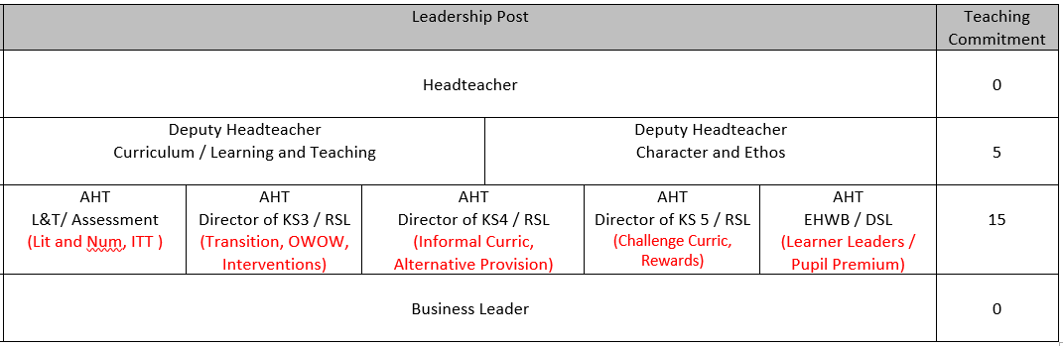
The responsibilities in red are provisional.

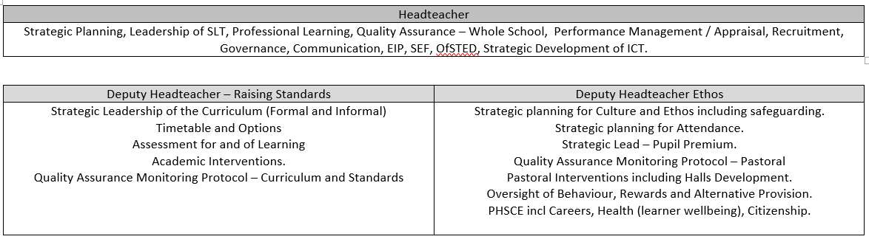
The provisional roles of the Deputy Headteachers are outlined below.

The Governors of Upton-by-Chester High School are seeking to appoint,
two exceptional leaders:

Assistant Headteachers
Director of Key Stage Three & Director of Key Stage Four
(Two Posts)

Leadership Range L12 - 16
With the ability and vision to build upon and drive forward the progress and attainment of all learners in Key Stage Three and Four respectively
The post holder will also have oversight of the Pastoral areas of each key stage and the academic development of learners within each key stage. The successful candidates will also have whole school responsibilities agreed on appointment. Both posts are equally important in ensuring that we have cohesive and well-planned provision across the school.
Ofsted short inspection in May 2019 was highly successful, endorsing our previous judgement, ‘This is a good school with an outstanding sixth form’ (May 2015)

This is a fantastic opportunity for experienced Senior and Middle Leaders with a proven track record to further develop their career and to demonstrate they are able to take on the responsibilities and demands of a high profile role successfully in a larger secondary school.

Download an application form for our website www.uptonhigh.co.uk
Electronic applications should be returned to lloyds@uptonhigh.co.uk
CVs alone will not be accepted
Closing date: Tuesday 18 May 2021, 3pm latest
The post is subject to suitable references and the successful applicant will be required to obtain an Enhanced Disclosure from the DBS (Disclosure & Barring Service). Further information can be found at www.gov.uk

Our school is committed to Safeguarding and promoting the welfare of children and young people and expects all staff
Person Specification
 | ESSENTIAL | DESIRABLE | EVIDENCE
Qualifications and Training | An appropriate degree and QTS.  - Evidence of sustained continuous professional development  - Appropriate leadership training for the role  - A commitment to further relevant professional development. | - Further degree based qualification focussed on education.  - Extended CPD related to pedagogy/research / pastoral matters. | - Application form  - Certificates to be provided at Interview  - Interview
Experience | - Successful middle Leadership experience within an 11-16 or 11-18 school  - Evidence of impact and a proven track record of raising standards and using data effectively  - Experience of leading impactful collaboration within and beyond a department / pastoral team.  - Extensive knowledge of and experience of implementing evidence informed practice to improve the standards achieved by learners and the impact of pastoral support for learners.  - Highly competent in the use of information technology systems to support the effective delivery of learning, teaching and leading a school.  - Experience of using whole school data intelligently to raise standards | - Senior pastoral or curriculum experience  - Experience in more than one school  - Significant relevant experience of contributing to whole school issues  - Working knowledge of SIMS and data analysis software.  - Some understanding of curriculum construction. | - Application form  - Interview
Leadership & Management | - First class communicator and a strong, visible team leader  - Experience of managing and motivating staff  - Effective use of all resources and budgets  - Willingness to accept delegated responsibility  - Mentoring / coaching staff to improve outcomes | - Mentoring/coaching of learners and NQTs  - Experience of leading on pastoral and / or curriculum themes and establishing effective procedures within a team  - Participation in working groups and/or leadership of specific projects  - Capacity to identify pastoral trends and devise preventative or reactive strategies as required  - Experience of leading enrichment programmes | - Application form  - Interview
Personal Qualities | - A confident and inspirational leader with clarity of purpose and vision  - Exceptional communication and interpersonal skills – approachable  - Highly professional approach, demonstrating emotional intelligence and integrity at all times.  - Ability to lead, empathise with and motivate young people  - Outstanding discipline  - Ability to motivate, inspire and lead.  - Reflective and positive thinking.  - An affinity with young people and an empathic, student-centred emotionally intelligent approach | - Ambitious for further career development  - A lifelong learner  - An interest in educational research  - Open to innovation | - Application form  - Interview
Other | - A commitment to high standards  - A belief in, and commitment to, the school’s vision ‘learning to shape the future | - Strong commitment to providing extra-curricular activities, weekend events as well as after school sessions | - Interview

Safeguarding Young People.
We are committed to the safeguarding and promotion of the welfare of children. In this light, we would like to draw the following matters to your attention:
1. All appointments are made subject to:
- An enhanced DBS disclosure;
- Checks of professional status;
- Confirmation of professional qualifications;
- Receipt of strong references (if not received by the time of interview); and
- Medical clearance
2. We only accept applications completed on the Cheshire West and Chester Application Form with a covering letter. Please do not send CVs or open testimonials.
3. Please ensure that the application form is completed in full. In particular, you must ensure that a full work history is provided and that any gaps in your employment are fully explained.
4. The referees cited in your application form must include your employer from the last occasion in which you worked with children. If your last employment was in a school, we would expect a reference from the Headteacher and/or Deputy/Assistant Headteacher.
5. When seeking references, we will request information about your suitability to work with children.
6. If you are shortlisted, any anomalies in your application will be discussed with you at interview.
We encourage you to pay close attention to these matters so that your application is not excluded unnecessarily.

Procedure for Application.
If you wish to be considered for this vacancy you should complete the application form, giving the names and addresses of two referees, and submit a concise letter of application. This should be typed or word-processed and should include the following information:
1. A brief outline of what you have achieved in your present post
2. A statement about why you want this job.
3. An indication of the strengths and expertise you could offer the school.
All points should address the detail in the person specification and other points made within the information sent to candidates.
Candidates are kindly requested not to submit a CV instead of the application form. Additional sheets may be attached to the back of the application form if there is insufficient space.
Completed applications should be returned to Mr L Cummins (Headteacher), to arrive no later than 3pm on Tuesday 18 May 2021.
Please ensure that you put the correct postage on the envelope as this could result in your application not being considered due to late arrival. Please note that we will only consider applications submitted on the Cheshire West and Chester application form.
Interviews are planned to take place during the following week.
For shortlisted candidates who are invited for interview, the interview will consist of the following activities spread over two days:

- A presentation outlining a school improvement project that you have delivered and the impact of this on the whole school. The presentation will be to the Headteacher and Governors. Follow up questions will be asked.
- A letter to parents - Given a specific scenario you will be asked to write a letter to parents.
- A data analysis exercise - Given some whole school data / or some departmental information you will be asked to infer some areas for improvement and how you would go about this.
- A short interview on Leadership and Management and a separate short interview on Pastoral Support.
- An evaluation of learning and teaching - Following a review of some learning and teaching you will be asked to provide feedback on strengths and areas for improvement.

We work very hard to inform applicants of the progress of their application, however, if you have not heard from us within two weeks of this date, regretfully you must assume that your application has been unsuccessful on this occasion, in which case the Governors would like to thank you for your time and your interest in the school.
Please note that we are happy to arrange risk-assessed informal visits for prospective candidates before short-listing has taken place, also if you wish to have an informal discussion about the post in advance of your application, or if you require any further details, please contact Mrs S Lloyd, HR Manager
Tel:
E-mail: LloydS@uptonhigh.co.uk

