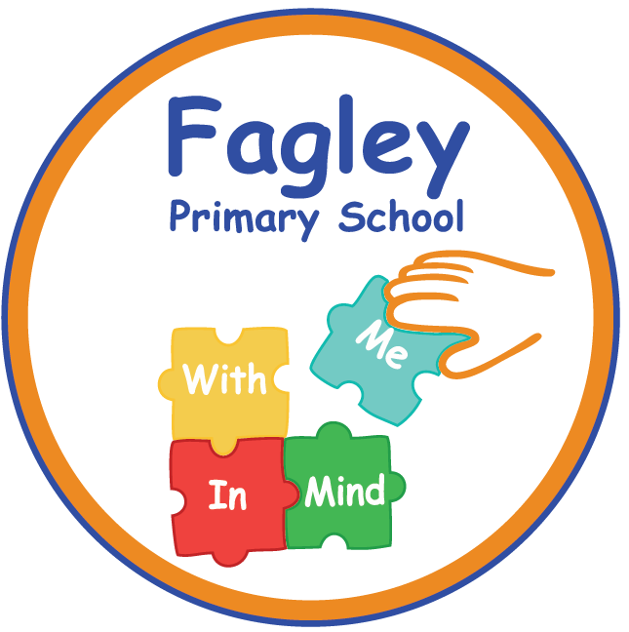

**Assistant Headteacher – Year 6 Teacher**

Contract : Permanent - Full time

Pay scale : L4 – L7

Closing date : Tuesday 3rd December 2024

Interview dates : Week beginning 9th December 2024

Start : ASAP

Are you passionate about improving educational and life outcomes for the children in Bradford? Do you have the drive, determination and commitment to support young people in a disadvantaged community? If so, joining Fagley Primary School might just be the best career move you can make.

This is your opportunity to join a dedicated team of staff who are committed to providing the best possible education for our pupils. We are an outstanding, vibrant and inclusive one-form entry community school situated in Bradford.

The governors of Fagley Primary School are looking to appoint an enthusiastic and highly skilled Assistant Headteacher. As Assistant Headteacher, you will form part of the Senior Leadership Team and be responsible for leading English and Inclusion across the school.

**The successful candidate will:**

* Be an outstanding teacher with high expectations of what can be achieved and a proven track record in raising pupil attainment.
* Have high expectations of all groups of children no matter what challenges they may face.
* Can effectively coach, mentor and lead others
* Have strong communication skills and is able to work as a member of a dynamic school team.
* Have a passion for inclusion and the best ways to support pupils with additional needs.

**In return we can offer the successful candidate:**

* A positive, safe and caring environment with a learning culture for all
* A commitment to your professional development
* A committed and dedicated staff team who are working together to develop excellence and enjoyment and a curriculum where every child matters
* A positive school ethos that celebrates success and is committed to inclusion

Visits to the school are encouraged and welcomed and should be made by contacting Catherine Boddy, School Business Manager, in the office on 01274 771124

Closing Date: Tuesday 3rd December 2024

Shortlisting: Thursday 5th December 2024

Interviews: Week commencing 9th December 2024

***At Fagley Primary School we are committed to the safeguarding and welfare of***

***our children and therefore this post is subject to an enhanced DBS check.***