“Be Brilliant Today” | Assistant Principal - Designated Safeguarding Lead  Required September 2022
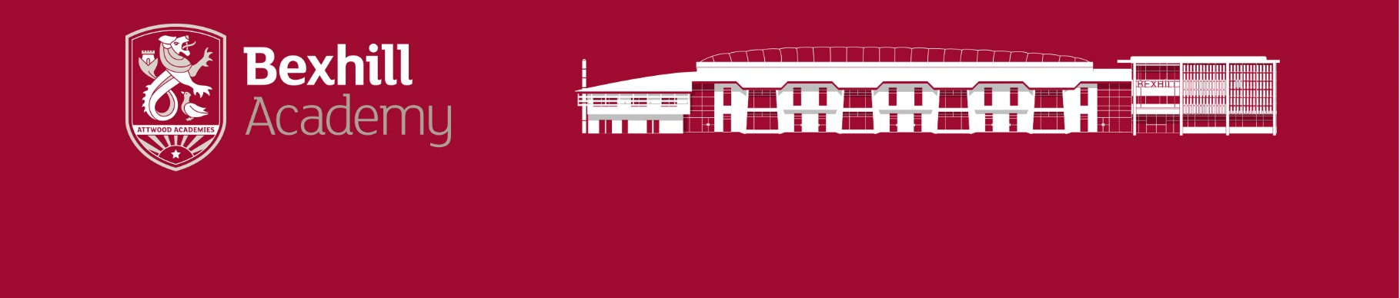
Due to the internal promotion of our Designated Safeguarding Lead who has stepped down after 15 years in role, we seek our new DSL with the stamina and hunger to keep us safe. Our pupils and staff are highly committed and this is a place, where children are happy and grow into well-rounded, successful adults of the future. We are committed to recruiting the most dedicated, compassionate, skilled, and driven professionals and our new DSL will join a warm and driven team with two strong safeguarding administrators to support effective use of My Concern and record keeping.
Bexhill Academy is an 11-16 serves families in and around the Bexhill area of East Sussex. We are part of the family of schools in the Attwood Trust and are on an exciting journey to raise standards and ensure we do all that is needed to help the young people we serve succeed; they deserve an exemplary education, and we’re committed to delivering it! Here at Bexhill Academy, we expect the best for and of every student and this is made possible through our knowledge-rich curriculum offer and excellent extra-curricular provision. RESPECT and being ‘Brilliant every day!’ are the foundations of our culture across the Academy.
We are looking to recruit an Assistant Principal to lead on the key areas of Safeguarding. The ideal candidate will have extensive experience of Safeguarding alongside a passion for keeping all children safe and willingness to go to all extents to ensure this happens. This role involves being the DSL for the Academy and leading a team of 8 others. The role is an exciting one as the Academy as we grow to meet the daily demands of the Academy and Keeping Children Safe in Education 2021. The position is a Leadership post due to its importance to the Academy, so some experience of leading larger teams would be preferable. The teaching expectation in this role would be minimal.
If you love a challenge, are passionate about improving the life chances of children and would like to join us on this next exciting phase of the Academy’s journey then we would love to hear from you. This really is a great place to work.
As an employee of Bexhill Academy, you will benefit from a highly competitive career package, which includes:
• high quality professional development
• regular training to develop your skills and knowledge
• a tailored induction programme to meet your needs and ongoing support from an experienced and skilled team
In addition to the opportunities for training and development, we also offer a competitive rewards and benefits package, which includes access to:
• Employee benefits, discounts, wellbeing, and staff recognition
• Access to Employee Assistance Scheme provided by Health Assured
• Bike2Work Scheme - where you can save up to 42% on the cost of bicycles and/or equipment
Salary: L12-L17 currently £56,426-£63,802 per annum
Closing Date: 9.00am Monday 16th May 2022
Interviews: Wednesday 18th May 2022

For further information about the role please see the Academy website www.bexhillacademy.org or for an informal pre application chat, please contact Catherine Davies, Executive Principal executiveprincipal@bexhillacademy.org

Please send or email completed Academy application forms to academyhr@bexhillacademy.org noting that we do not accept CVs or applications via agencies.

Bexhill Academy is committed to safeguarding and promoting the welfare of children and young children, therefore all positions are subject to an Enhanced Disclosure and Barring Service check (DBS).

