Dear Applicant
Thank you very much for your interest in the position of Assistant Principal: Inclusion (DSL & SENDCo) at The King’s.
If appointed, you will be joining The King’s at an extremely exciting time as we prepare for the next stages in our growth and development. You will see from our website (www.thekings.staffs.sch.uk) that we have a clear vision to provide exceptional education and opportunities for all of our students. Through our Vision and Values our aim is to inspire students to achieve beyond their expectations whether that be into further or higher education, training or employment and to aspire to make exceptional use of their God-given talents. The successful candidate for this position will be joining an experienced team who share and place high value on the collective benefits of working collaboratively to meet this challenge. The successful candidate will also be joining a broader group of colleagues who understand that The King’s has a very special place in the local and wider community.
We are rightly proud of the inclusion team at The King’s. Safeguarding and SEND work together, led by the Assistant Principal: Inclusion. Whilst the post holder will be the academy’s lead DSL and lead SENCo – enhanced training in one of these areas will be provided. The successful applicant will be ably supported by two named Deputy DSLs (one member of support staff, and an Assistant Principal (responsible for behaviour and relationships), a Designated Teacher for Looked After Children, a Deputy SENDCo (who manages all elements of access arrangements) and an Assistant SENDCo (with responsibility for students with medical needs) as well as a wider team of pastoral staff and inclusion support assistants. There is also the support of a dedicated administrative colleague. The postholder will be supported by colleagues in school and by the Director of Safeguarding and SEND from the central team of Three Spires Trust. The academy and the trust are committed to supporting colleagues to develop professionally.
There are exciting and broader challenges ahead: recruitment and selection of exceptional staff with the right blend of skills, talents, experience and values is therefore crucial as our journey at The King’s continues. If you share our Vision and if you believe that you have the exceptional qualities to help, then I would be delighted to hear from you.
To apply for this position, please complete the application form. You should also include a covering letter in which you explain how your values, knowledge, experience and skills/abilities meet the requirements of the Job Description and the Person Specification.
Applications must be returned to my PA, Miss Megan Till, at the school, or via email: mtill@thekings.staffs.sch.uk. Please also contact my PA, in the first instance, if you would like to discuss the role further or you would like to visit the academy. The closing date is 8.00am on Friday 24th September 2021
Good Luck with your application!
Will Wilson
Principal
The King’s Church of England Academy
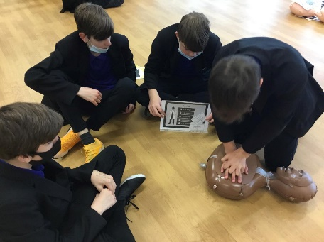
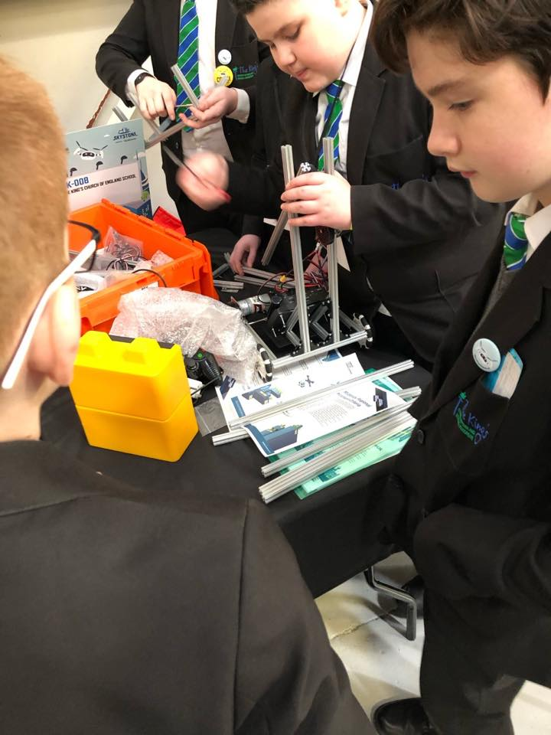
About our Academy
Our academy is a superb place to grow, to learn, to work and to flourish. As a relatively new academy (we opened in January 2016 and moved into our superb new build in November 2016), we are keen to retain our place as ‘the school of choice in Kidsgrove’.

Our motto ‘Learning with truth and love’ epitomises the values towards which our governors, our staff and our students strive to embody. Students are consistently inspired and encouraged to become everything that God has created them to be, through a wide ranging and inclusive curriculum and a wealth of exciting enrichment opportunities. We work hard to create a vibrant, mutually supportive climate for learning in which everyone can thrive.

Staff lead by example and are passionate about encouraging, inspiring, challenging and stretching every individual in their care, so that they can achieve at the highest levels. We do our utmost to maximise the attainment of each student, placing great emphasis on individual character development and personal growth.

We are an inclusive school with students of all abilities and social backgrounds. For those students with individual learning and physical needs, we have an extensive inclusion team. Our staff make every effort to get to know each student as an individual.

Our well embedded ‘Behaviour for Learning’ policy is designed to encourage positive attitudes to lessons and to ensure students’ behaviour underpins their learning. A recent external assessment describes behaviour in lessons as 'exemplary'.

Our mission is to enable students to leave The King's with outstanding results and life changing experiences, equipped to be responsible and caring citizens ready to make their mark on the world in which they live.

Staff turnover at The King’s is really low: people want to stay and work here. The academy is a community of its own. Colleagues join us from the local area and from further afield - it is a place where professionals want to work.

Ofsted graded our school as good with outstanding features in 2017; we are on our own journey to be outstanding.

Would you like to join us?

The King’s Church of England Academy
Job Description
JOB TITLE Assistant Principal: Inclusion (DSL & SENDCo)
Accountable to Principal
Responsible for DDSL (Support staff) ¦ Deputy SENDCo ¦ Assistant SENDCo
Relationships with Assistant Principal: Behaviour and Relationships ¦ Vice Principal: Curriculum ¦ Vice Principal: Teaching and Learning ¦ HUB Leaders ¦ Heads of Year
Salary range L10 - 14
Date January 2022 (or sooner)

Job Role:
To lead the rapid and sustained improvement of the academy through high quality leadership and communication skills and an up to date knowledge and understanding of educational theory and practice.
To have a relentless focus on raising standards in teaching and learning and provision so that all students make at least expected levels of progress with many making above expected levels of progress.
To lead on safeguarding and child protection policy and strategy, SEND policy and strategy, the tracking and monitoring of student attendance and appropriate intervention to enable all students to achieve beyond their potential.
To undertake a teaching commitment commensurate to the role.
Other, specific, according to strengths identified and determined at interview.
Roles and responsibilities specific to the role of the assistant Principal: Inclusion
- Lead the inclusion team effectively
- Keep up to date in regards to good practice
- Line manage and performance manage the DTLAC, Deputy SENDCo, the Assistant SENDCo and the DDSL (support staff)
- Contribute to the recruitment, retention and effective deployment of staff and manage their workloads to achieve the academy’s vision and values
- Support the management and organisation of the academy environment efficiently and effectively to ensure it meets the needs of staff, students and statutory obligations and legislation.
- Offer supervision to the Deputy SENDCo, Assistant SENDCo and both DDSLs
- Represent the school at the SEND and Inclusion Hub
- Chair PAWS (pastoral, achievement, welfare and safeguarding) meetings
- Quality assure documentation completed by other members of the inclusion team
- Contribute to the school’s development plan and evaluation
- Produce reports for Governors, SLT and the Trust as required
- Develop review systems that provide a robust and accurate evaluation of academy performance and priorities for improvement
- Demonstrate the vision and values in everyday work and practice
- As part of the Senior Leadership Team, ensure that the range, quality and use of all available resources is monitored, evaluated and reviewed to improve the quality of education for all students and provides excellent value for money
- Lead regular reviews of academy systems, appropriate to the role, to ensure statutory obligations are met and current practice is improved on where appropriate
- Treat people fairly, equitably and with dignity and respect to create and maintain a positive academy culture and ethos
- Ensure effective planning, allocation, support and evaluation of work undertaken by teams and individuals ensuring clear delegation of tasks and devolution of responsibilities
- Review own practice, set personal targets and take responsibility for personal professional development
- Be an excellent role model for staff and students by reflecting on own skills and demonstrating a desire to improve and learn
- Manage own workload and that of others to promote appropriate work/life balance
Safeguarding and Child Protection
- Hold the lead responsibility for safeguarding and child protection (including online safety)
- Hold the lead responsibility for all referrals and actions taken in line with safeguarding and child protection policies
- Ensure that all staff are adequately trained and updated in regards safeguarding matters
- Ensure that either the DSL or a deputy is available at all times when students are engaged in regulated activities
- Case manage the most complex child protection cases in the academy
- Liaise effectively with external agencies
- Liaise with parents and carers
- Quality assure entries in MyConcern
- Produce reports for SLT and Governors in order to advise about trends in concerns raised by colleagues and matters affecting students
- Ensure that all files are transferred between educational institutions in a timely manner
- Liaise with the Head of Year 7 about transition
Special Educational Needs and / or Disabilities
- Hold the lead responsibility for the coordination of all Special Educational Needs and / or Disabilities (SEND) provision in school
- Maintain the SEND register
- Ensure that all staff have access to appropriate training about SEND
- Ensure that a graduated response is in place for all students on the SEND register
- Liaise with parents and carers
- Case manage the most complex SEND cases in the academy
- Liaise effectively with external agencies
- Complete EHCNA documentation as required
- Produce reports for SLT and Governors in order to advise about the make up of the SEND register
- Produce reports for SLT and Governors in order to advise about the impact of interventions
This job description is not necessarily a comprehensive definition of the post. It may be reviewed and it may be subject to modification at any time following consultation with the post holder.

The King’s Church of England Academy
Person Specification
JOB TITLE Assistant Principal: Inclusion (Safeguarding and SEND)
The below person specification is designed to support applicants to identify their suitability for the role. Applicants are expected to address the elements that are identified via the application in their supporting letters. Those who do not demonstrate these essential criteria will be discounted at shortlisting.
Criteria |  | Essential or desirable | How identified*
Qualifications | QTS | Essential | A
 | Good honours degree or equivalent | Essential | A
 | Recent participation in high level training | Essential | A
 | Relevant leadership training | Desirable | A
Background and experience | Substantial and recent teaching experience in a secondary setting | Essential | A R
 | An outstanding practitioner | Essential | R
 | Experience as a member of a pastoral team | Essential | A
 | Experience of at least middle leadership in a pastoral role | Essential | A
 | Experience of leading and managing teams of staff | Essential | A
 | Experience of leading support staff | Desirable | A
Professional knowledge and understanding | Excellent understanding of KCSIE | Essential | I
 | Good understanding of the SEN Code of Practice | Essential | I
 | Understanding of the characteristics of quality first teaching, learning and achievement for all students | Essential | I R
 | Understanding of the wider characteristics that form a successful and vibrant school | Desirable | A I R
 | Clear understanding of school accountability processes including Performance tables, and Ofsted | Essential | I
 | Understanding about the challenges of cross-border working in regards safeguarding / child protection and SEND | Desirable | I
Skills | Able to explore the meaning of challenging behaviour and to support colleagues as well as students | Essential | I R
 | Creative and imaginative thinker, able to anticipate problems and find solutions | Essential | A I R
 | Excellent communication skills, confident and motivational public speaker | Essential | I R
 | Have high expectations of self and others and provide a role model for students and staff | Essential | A I R
 | Experience of managing fixed term exclusions | Desirable | I
 | Experience of leading and managing change at whole school level | Desirable | I R
Personal attributes | Cares deeply about the success of every child and every member of staff | Essential | R
 | Able to uphold and contribute to the school’s distinctively Christian ethos, vision and mission | Essential | A I
 | Credibility, presence and capacity to provide leadership at senior level | Essential | R
 | Able to gain respect of students, parents, staff and governors | Essential | I R
 | Can take difficult decision and manage challenging conversations with inner strength and resilience | Desirable | I
 | Open to advice, feedback and professional development | Essential | R
 | High integrity: honest, trustworthy and reliable | Essential | R
Attitude and values | Equality of opportunity and inclusivity | Essential | R
 | Creative approach to problem solving | Essential | A I R
 | An educational philosophy that complements that of the Governing Body and Leadership Team | Desirable | A I
 | Tactful and discreet | Essential | R
 | Values collaboration | Essential | A I R

The successful candidate would be expected to maintain a well-organised, creative, safe and friendly environment for living and learning and hence enhance the ethos of the school. Candidates are asked to address as many of the person specifications as possible in their application.

* A denotes ‘application’; I denotes ‘interview’; R denotes ‘references’

