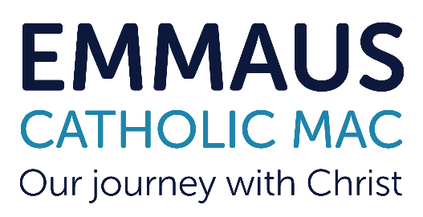
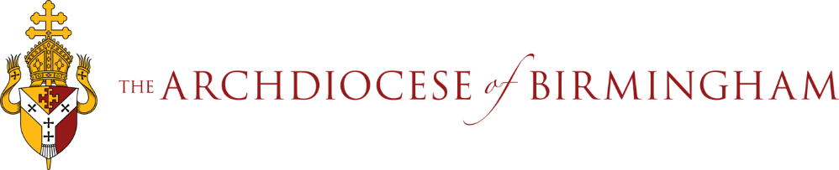
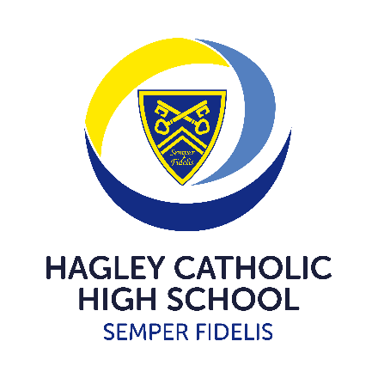

A fabulous opportunity has arisen on the Senior Leadership Team at Hagley Catholic High School.

The successful candidate will be responsible for Pastoral Care and Personal Development and join a Team of 6 on the current SLT. In this role the successful candidate will be the strategic lead for pastoral care and in doing so will line manage the Heads of Year. In addition they will lead on personal development and be the strategic lead for the Character and Culture (PSHE) curriculum, careers, British Values and enrichment.

This is the perfect opportunity for a middle leader looking to develop and progress their career or a current Assistant Principal looking for a new challenge.

You will join a strong and committed team with years of experience and the values and virtues of the school firmly at its heart, which alongside the Principal consists of a Vice-Principal: Quality of Education, Assistant Principal: Curriculum, Assessment & Timetabling, Assistant Principal: Behaviour & Attitudes, Assistant Principal: Inclusion & SENDCO and a School Business Manager.

Assistant Principals at Hagley have a 40% teaching commitment (18 lessons over a 40 lesson fortnight). In addition the whole Senior Leadership Team take on additional duties before school, at break, lunch, and after school, as well as supporting “on call”.

Please note this is not a protected post and we welcome applications from all faiths, or no faith at all. However, it is integral that the successful candidate can align with our values and beliefs and support our vision and mission.
We are recruiting for an
Assistant Principal: Pastoral Care & Personal Development
Required for January 2025
Salary Range: L10 - 14 Hours: Fulltime/permanent
Contact Us
A full application pack is available from Hagley Catholic High School, by contacting the Principal’s PA or downloading the pack from the Emmaus website:
Email : principalpa.hchs@emmausmac.com
Phone: 01562 883193
Online: https://www.emmausmac.com/Page/Detail/vacancies
We warmly welcome visits to the school. For specific questions about the role and/or to request a visit, please contact Mr J Hodgson, (Principal) via Mrs K Taylor (PA) at: principalpa.hchs@emmausmac.com
Closing Date: 30th September 2024 at 9.00am
Interviews: Monday 7th October 2024
Emmaus Catholic MAC is committed to safeguarding and promoting the welfare of children and young people. This position is subject to an Enhanced Disclosure check under the Rehabilitation of Offenders Act 1974.
All applicants must be able to provide documentation to prove their right to work in the UK.

Effective from September 2022, KCSIE states as part of the shortlisting process school and colleges should consider
carrying out online searches, as part of the due diligence on shortlisted candidates. This is to determine suitability
to work with children and keep them safe. All shortlisted candidates are now subject to an online check and if
there is anything concerning, then the shortlisted candidate will be asked to comment on it at interview.

