

Assistant Principal – Personal Development

APPLICANT INFORMATION
PACK

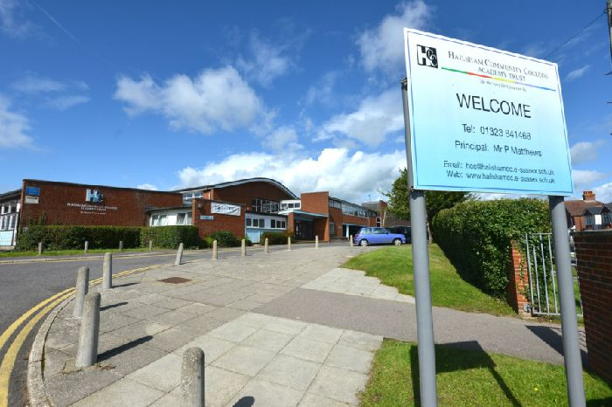

Battle Road, Hailsham, East Sussex, BN27 1DT
Tel: 01323 841468
E-mail: job.vacancies@hccat.net



Assistant Principal – Personal Development

Please find enclosed:

- Letter from the Head of School

- Job Description

- Person Specification

- Department Information

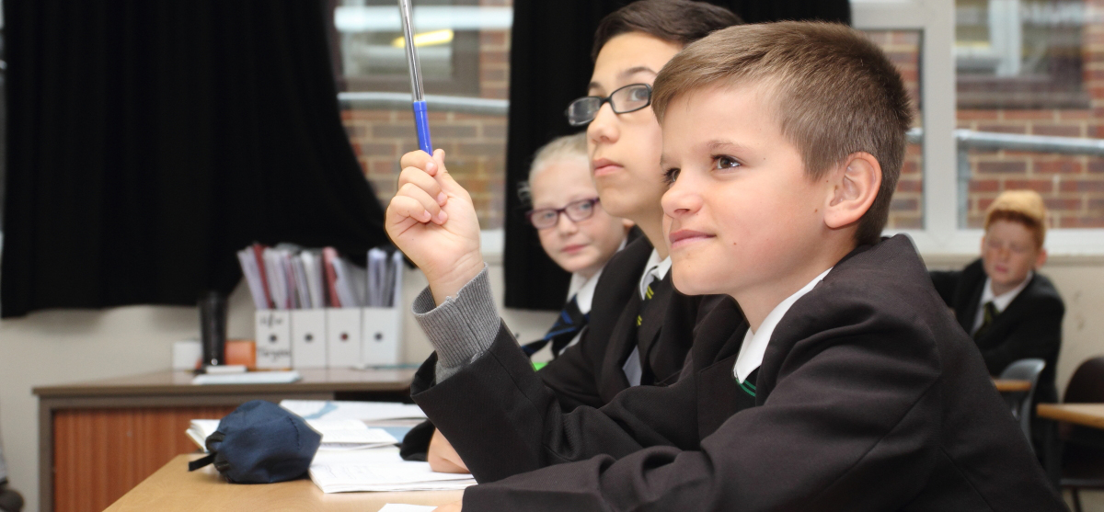

Dear Applicant

Thank you very much for your enquiry for the post of Teacher of Humanities at our College. We hope that you will decide to apply for the opportunity to play a key role in the development of education in Hailsham and we hope that the information below will be helpful to you.

Hailsham is an historic market town close to the large and vibrant towns of Eastbourne and Brighton, with some of the most spectacular scenery in England on its doorstep.

Hailsham Community College has been on an incredible journey over the past few years. Since becoming a Converter Academy in 2012 the college has grown significantly and in 2019 we became a 2-19 all-through school, with our Primary and Pre-school provision situated approximately a mile from the Secondary site.

The Academy has benefited from significant investment over recent years. New facilities include a state-of-the-art three-storey teaching block containing 22 classrooms and SEND hub, a fully refurbished Post 16 Learning Centre and a floodlit all weather sports pitch to complement our already extensive sporting facilities.

The college motto, ‘Be the very best you can be!’ is very simple but encapsulates everything we believe in for the entire college community, learners and staff alike.

You will find our values and principles put into practice in a busy, cheerful community based on friendly relationships; the atmosphere is positive and full of purpose and endeavour. Our focus is on learning; we take pride in nurturing and supporting the personal, social and academic development of each individual.

The college underwent inspection by Ofsted on 1 March 2017 and was judged to be ‘good’ throughout.

We hope that you will decide to apply. We have always actively encouraged candidates to visit the Academy prior to completing an application form. Please call us on 01323 841468 If you would like any further information or would like to arrange an informal visit.

I hope to have the pleasure of meeting you soon.

Yours faithfully
Dave Miller
Head of School – Secondary/Post 16

Job Description
Job Title: | Assistant Principal – Personal Development
Job Holder:
Line Managed by: | Vice Principal – Aspirations and Ethos
Pay Range | Leadership 12 to 16
Date: | April 2023
Job Purpose
- To lead the development of aspects of the college curriculum that provide for pupil’s broader development particularly spiritual, moral social and cultural aspects.

- To consistently promote the extensive personal development of pupils giving them access to a wide, rich set of experiences and opportunities that develop talents and interests of exceptional quality thus promoting confidence resilience and strength of character.

- To ensure equality of opportunity and diversity is promoted effectively; that pupils respect differences in the world and people, show respect for protected characteristics and that no forms of discrimination are tolerated.

- To lead in the preparation of students for life in modern Britain and the global society as well as ensuring they know how to remain physically and mentally healthy.

Principal Accountabilities
- To lead all through college improvement planning for personal development and work closely with the Vice Principal - Aspirations and Ethos, to ensure that curriculum intent and implementation create impact.

- To produce, update and continually review an impactful mentoring and assembly programme.

- To implement the Action Your Potential programme across the college.

- In liaison with the VP Aspirations and Ethos ensure student voice and student leadership are embedded in all aspects of college life.

- To establish a diverse extra-curricular provision that enriches the school day and is well attended by students including the most disadvantaged.

- To oversee an impactful cross curricular provision for Relationships Health Sex Education, Spiritual Moral Social Cultural development and Personal, Social Health and Economic education.

- To lead the planning and delivery of a year 6 into year 7 summer school.

- To ensure a highly inclusive environment that meets the needs of all pupils and is anti-discriminatory.

- To ensure all pupils develop excellent character and become responsible, respectful citizens who contribute positively to society.

- As part of the Senior Leadership team, to support the day to day running of the college e.g. walkabout, breaktime/lunch duties, etc.

Competencies
Knowledge

- A deep understanding of the personal development curriculum.

- A working knowledge of strategies to deliver outstanding personal development with a particular focus on vulnerable students.

- How to lead an improvement planning process and how to evaluate impact effectively.

- Up-to-date knowledge and understanding of the professional duties of teachers and the statutory duties to which they must adhere.

- A deep understanding of how to work effectively with relevant colleagues to support pupils’ character development.

- Best practice in providing an excellent personal development for the most disadvantaged.

- An understanding of the difficulties that pupils may face and how to empower staff to deliver high quality pastoral support.

Skills

- To be able to provide rigorous line-manage of colleagues to support/challenge them in having high expectations and set themselves high standards.

- To be able to adapt to new situations, circumstances and challenges.

- To be able to develop the understanding of subject area DOLs such that their work impacts successfully on learner outcomes.

- To demonstrate high quality leadership with regard to whole college initiatives.

- To ensure the development of strong effective working relationships with all staff.

- To always provide leadership that is solution focussed, unflinchingly positive, creative and inspirational.

- To be able contribute to wider strategic priorities of the College Improvement Plan.

- The ability to create a positive ethos allowing staff to feel informed, motivated and valued.

- To be able to communicate effectively and sensitively with relevant parties inside and outside of college in safeguarding matters.

- Identification of the potential of colleagues and the ability to support their career progression.

Attitudes, motives and behaviour

- A deep commitment to developing and maintaining a culture of the highest aspirations for all pupils.

- A desire to continue to research and explore best practice in personal development and establish appropriate practice in the all through school.

- Demonstrate a passion for making Hailsham Community College excellent every day.

- Be a strong, positive and supportive role model for colleagues and learners.

- Demonstrate the ability to inspire, motivate, lead by example and set high and robust standards.

- Hold staff to account when their practice falls below the expected high standard.

- Empower and enable colleagues by encouraging, praising where appropriate and instilling a sense of purpose.

- Demonstrate the ability to be a creative and innovative leader.

- Show perseverance and resilience, whilst being solution focused when presented with challenge.

- A desire to develop a culture of listening to pupils and taking account of their wishes and feelings.

Teachers are expected to undertake any other duty as the Executive Principal may determine within the remit of the National Pay and Conditions document or within any other national or local agreement it may supersede.

This job description sets out the duties of the post at the time it was prepared. Such duties may vary from time to time without changing the general character of the duties or level of responsibility entailed. Such variations are a common occurrence and cannot of themselves justify a regrading of the post

Person Specification

Job Title: | Assistant Principal – Personal Development
Line Managed by: | Vice Principal – Aspirations and Ethos
Date: | April 2023

 | Essential | Desirable
Qualifications | - Good honours degree  - PGCE or equivalent  - Evidence of further professional development pertinent to the role
Knowledge and Experience | - Track record of success in teaching  - Evidence of effective strategic planning  - Evidence of leading whole school initiatives  - Evidence of keeping up to date with new initiatives pertaining to education in general  - An understanding of the range and levels of support available to meet individual needs  - An understanding of key aspects of the personal development curriculum | - Demonstrate ability to manage a budget  - Current senior leadership experience
Skills | - Outstanding classroom practitioner  - Ability to communicate clearly and effectively  - Ability to motivate colleagues  - Ability to monitor student development and achievement and intervene appropriately  - Ability to set aspirational standards, provide professional direction and develop high performing teams  - Ability to think creatively, problem solve and identify opportunities  - Demonstrate ability to promote and maintain strong links with parents/carers, Governors and the wider community  - Ability to facilitate/lead staff CPD
Attitudes, Values and Personal Qualities | - Commitment to improving the lives of young people  - An evaluative and reflective approach to own practice  - High expectations of self, colleagues and students  - Commitment to inclusive practice  - Vision, empathy and flexibility  - Ability to maintain emotional resilience  - Team player  - Ability to meet deadlines  - Ability to work under pressure

