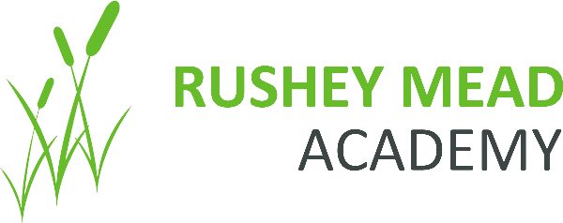





Applicant Pack
INSERT JOB TITLE

Welcome from the Principal

Dear Prospective Applicant,
We are delighted that you have shown an interest in joining the team at Rushey Mead Academy. We are a happy school where we want staff to feel fulfilled in their work, enjoying a good work-life balance as we realise that they are our most valuable asset, so we aim to look after them from day one.
Our vision is to make a positive difference by creating a vibrant, principled community of learners in pursuit of educational excellence and fulfilment for all. This underpins everything we do and helps us to achieve the best outcomes for all students.
The Rushey Mead Academy curriculum aims to give pupils access to the best which has been thought, said, written and created in every field of human endeavour, so that they are knowledgeable, critical and enriched. Within this broad, balanced, inclusive and rich curriculum, the primacy of knowledge and critical thinking is emphasised with a special focus on the EBacc. So we aim to recruit teachers who are enthusiastic about their subject and want to pass on a love and understanding of the beauties and intricacies of their subject to young people.
Rushey Mead Academy is characterised by high expectations, doing the simple things well, and the belief that all children can succeed regardless of their gender, background or ability. We are therefore looking for team players who are prepared to work hard and go the extra mile so that we continue to provide an outstanding educational experience for all of our children.
Our Rushey 1-2-3 expectations of Be Kind, Work Hard, Develop your Whole Self provides a framework for personal conduct and development for students. From the moment a student arrives at Rushey Mead Academy we ask them to live these expectations, so they develop exemplary learning habits and allow our teachers to be uninterrupted in their teaching.
We are fiercely ambitious for each one of our students, so if you share our vision and you have high aspirations for all children and the experience of delivering educational excellence, we would like to hear from you.
Please take a look at our website, out Facebook page @RusheyMeadTMET and twitter account @rusheynews to get a flavour of what Rushey Mead is all about.
If you want to have an informal discussion about the post or you would like to visit, please email rmrecruitment@rushey-tmet.uk
I look forward to hearing from you.

Gulbanu Kader
Principal, Rushey Mead Academy

Why work with TMET?

The Mead Educational Trust (TMET) is a growing partnership of primary and secondary academies in Leicester.
We exist to improve the life chances of children and young people by having high aspirations, pairing the highest quality teaching with the widest possible educational opportunities.
Building on Rushey Mead Academy’s outstanding track record, we have grown to 8 partner schools and established the Leicester Teaching School Alliance as well as our School Based Initial Teacher Training Centre. Through this, we are able to draw on first class leadership and outstanding teaching and learning practices to support each learner, making sure that they have every opportunity to achieve. Our collaborative approach ensures that exceptional practices are fostered and encouraged within each of our pupils to provide the best learning experience we can.
At the heart of everything we do is our commitment to academic excellence and pastoral care – enabling success for all regardless of background. Our pupils are encouraged to become articulate, independent, well-rounded members of society with a passion for lifelong learning and a determination to make a positive difference in the world.
By providing access to a first-class education network, strong school-to-school support and high quality assessment, governance and financial business management, our schools can in turn focus on equipping our pupils with the exciting and inspiring learning experiences they need and deserve.
The expertise within the Trust is without doubt our greatest asset; the collective dedication and passion for learning exhibited by staff ensure that each of our pupils reach and fulfil their potential. Our ongoing coaching, mentoring and support programmes maximise the skills and talents of our team to consistently deliver outstanding teaching and learning.

The work at TMET is underpinned and driven by the following values:
Challenge: Providing an excellent education by having high aspirations for all young people and giving them confidence in themselves, so they can become the best they can be and contribute actively to society.
Collaboration: Working effectively and harmoniously together across phases and accepting our shared accountability for meeting our aims.
Culture: | Respecting and celebrating diversity and enabling students to participate in, and respond to, artistic and cultural experiences.
Community: | Building a safe and stimulating environment where caring relationships and kindness are consistently developed and communication is excellent.
Courage: | Making sure all decisions are based on clear high moral values and commitment to doing the right thing with compassion and integrity.
Creativity: | Providing pioneering, innovative, vibrant and enjoyable learning experiences that are open to all and based on research, so that the curriculum sits at the forefront of education.
Character: | Nurturing positive character attributes such as perseverance, resilience, confidence, optimism, tolerance, respect, community spirit, honesty, integrity and dignity.

TMET Schools
 | 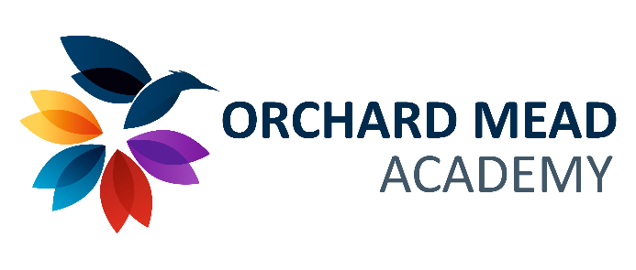
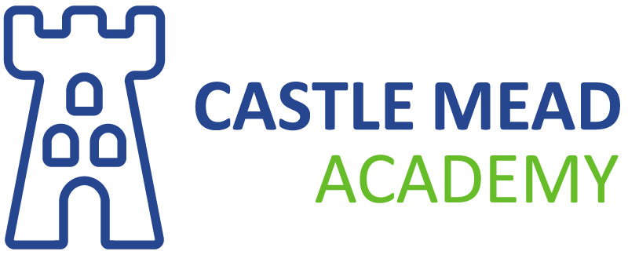 | 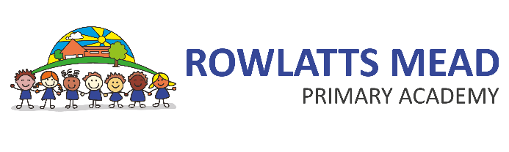

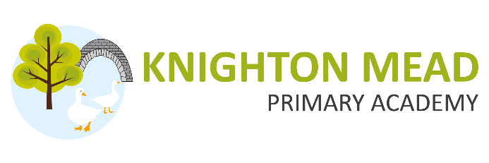 | 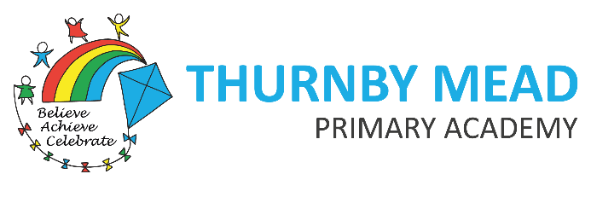
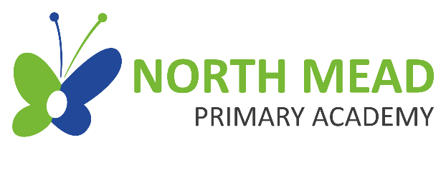 | 

Why Rushey Mead?

- Rushey Mead Academy is a community of professionals who strive for excellent practice and constant improvement.
- Students are keen to learn and families value education;
- Results in subjects have been significantly above national averages for many years;
- Departments are led by experienced and supportive subject experts;
- Subject teams are friendly, welcoming and work collaboratively;
- Staff wellbeing is a priority and timesaving feedback methods are in place. Click here to see how we manage workload at Rushey Mead Academy.
- The progress 8 score is significantly above average at 0.7, placing the school in the top 5% nationally;
- Professional learning is research based and integrated with our Teaching School.

- There is a strong academic ethos and high expectations of students;
- Behaviour management is centralised and teachers are enabled to flourish;
- We provide regular high quality training and development for all of our staff.
- All of our staff are encouraged to think strategically and we listen to ideas on where we can make improvements.
- We are committed to developing everyone who takes on leadership positions within the school. We run leadership-focussed training sessions and offer one-to-one support.
- We always strive to reduce unnecessary workload, developing practices, which are low effort and high impact.
- Our staff work with colleagues across TMET - from different subjects, schools and phases.

Why Rushey Mead?

Student Enrichment
At Rushey Mead Academy, we are committed to developing the wider personal development of our students, so that we prepare them for all aspects of life, not just exams. Our bespoke Rushey 3 Passport programme ensures that all students are properly recognised and rewarded for their non-academic achievements, so that we can celebrate their successes beyond results.
Students have a wealth of clubs and extra-curricular opportunities available to them; from public speaking competitions and debate club, to dance and orchestra club. We encourage all students to develop themselves through our extra-curricular provision so that they leave Rushey Mead as well-rounded citizens who are equipped with the skills they need for life.


Sports and Performing Arts
We have many high achieving sports teams including, basketball, netball, cricket and football who regularly reach county final championships.
The PE faculty also offers a whole range of sporting clubs including rugby, tennis, badminton and fitness development. No matter the prior standard or experience of students, there is something for everyone. Our thriving Performing Arts faculty produce a popular and successful annual academy production and there are similarly numerous opportunities for students to perform through drama, dance, bands and orchestra. There are also music lessons and clubs available, giving our students the opportunity to learn to play a variety of instruments or to sing.

Citizenship
Rushey Mead students are also expected to consider their place in society and to understand what it means to be a good citizen. Through our divisional system, the academy is extensively involved in charitable activity and students fully participate not only in fundraising for good causes but also in actively helping others. Staff and students work together to increase student awareness of and raise money for local, national and international charitable causes. Beneficiaries in recent years have included the British Red Cross, Oxfam, Teenage Cancer Trust, Comic Relief, Sport Relief, Rushey Mead Foundation, Rainbows and LOROS.

Personal development
We know that the opportunity to lead others, develops students’ self-esteem, confidence and future success. As such, all students have the opportunity to lead activities throughout the school in lessons, clubs and groups, which is recognised through our leadership development programme. We have a thriving student council who is actively involved in school life and the Duke of Edinburgh award is available for older students.
Overall, we are committed to ensuring that our students leave Rushey Mead as well rounded individuals, who are best placed to become successful citizens of the future.

How to apply

Method of Application
- Complete the TMET Application Form
- Letter of application (addressed to Gulbanu Kader, Principal)
A maximum of two sides of A4 (font size no smaller than 11)
Your letter should outline:
- Your experience which will help in successfully undertaking the role;
PLEASE DO NOT INCLUDE
ANY PERSONAL DETAILS ON THE LETTER (NO NAME, ADDRESS, NUMBER OR EMAIL)

Closing date for applications:
INSERT CLOSING DATE AND TIME

Proposed Interview date:
INSERT CLOSING DATE AND TIME

Application forms and letter of application should be submitted either via eTeach or via email.
By Email:
You may save the form to your computer and when you have completed it, you may attach it along with a cover letter and email it to:
rmrecruitment@rushey-tmet.uk

We look forward to hearing from you.

Rushey Mead Academy is committed to safeguarding and promoting the welfare of children and young people.
All applicants must be willing to undergo child protection screening, including checks with past employers and the Disclosure and Barring Service.

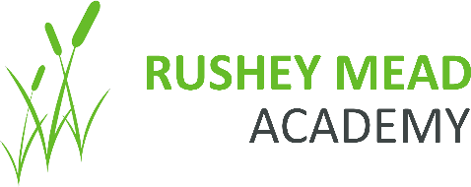

Rushey Mead Academy
Melton Road
Leicester
LE4 7AN

www.rushey-tmet.uk
@RusheyMeadTMET
@rusheymeadnews

