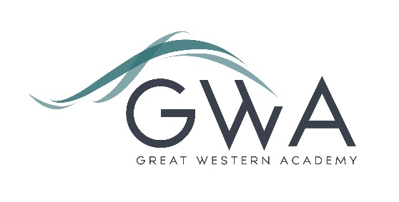

# Information for Applicants

**Assistant Business Manager**

**NJC Scale Point 25 – 28 £33,944 - £36,648 Full Time Equivalent** (pay award pending)

As stated in the main advert, this role is being created to split the workload of the current Business Manager, which has grown beyond the original expectation now that Great Western Academy is full in every year group (although with further expansion likely in the Sixth Form). We are particularly looking for a candidate who can enthusiastically lead our recruitment processes, from contributing to our overall recruitment strategy, to looking for creative ways to attract, recruit and retain staff, to drafting and posting advertisements, dealing with enquiries, and setting up interview days. The successful candidate would work with our HR lead, whose focus is on matters affecting existing staff but who, with others in the main office, currently supports the Business Manager and wider Senior Leadership Team with recruitment. Some experience of successful recruitment strategies would support a successful application. However, the role would equally suit a recent graduate seeking to gain experience in this area.

The role will also provide the opportunity to act as line manager for some of our excellent team who work in the main office. Those in the main office include our Finance manager, Finance Assistant, Personnel Assistant, two Receptionists, Attendance Officer, Trips and Events Co-ordinator and the PA to the SLT. This team contributes significantly to the success of Great Western Academy.

The successful candidate will also support our Business Manager in other aspects of their work, so providing valuable experience for future possible career progression. We expect the appointed person to be ambitious for their career, and we would support any request to undertake School Business Management or other relevant qualifications.

The role is planned to be year-round, 36.5 hours per week, 8.30 - 4.30pm (3.30pm Friday) with 30 minutes for lunch. Alternatively, we will consider a term-time only role, in which case the salary would be pro-rate that stated above. We could also consider some flexibility over the exact working hours.

Great Western Academy aims to radically improve the life chances of every student who attends. Our new building and state-of-the-art facilities help us to achieve this, but it is the fantastic team of staff who turn our vision into reality. If you have the drive and ability to support the successful running of this school then this provides you with an exciting opportunity to shape and develop your career.

Additional benefits of working at GWA include:

* Excellent CPD opportunities
* State of the art facilities
* Free Health and Wellbeing Support Service
* Staff wellbeing activities and events
* Cycle to work scheme through Cyclescheme
* Access to EV charging on site. Electric Vehicle Salary Sacrifice scheme
* Easy access to the A419, and free parking

Further details are available on the Academy website [www.gwacademy.co.uk](http://www.gwacademy.co.uk/) and in the information documents attached.

Application process

Please complete the application and equalities forms supplied and enclose a supporting letter, either in the space provided on the application form or as a separate document. The application form should be completed in full in black ink or type. A CV is not requiredand should not be submitted as part of the application.

Your supporting letter should be no more than 2 sides of A4 (with a font size no smaller than 11) and should enhance your application by providing further information, matched to the person specification, about your suitability for the post.

Applications should be submitted electronically to [recruitment@gwacademy.co.uk](mailto:recruitment@gwacademy.co.uk) by 9.00am **on Monday 7th October 2024**. Interviews will take place as soon as possible after this date.

*Great Western Academy is committed to safeguarding and promoting the welfare of children, young people and vulnerable adults and we expect all staff to share this commitment and undergo appropriate checks. All posts within the Trust are therefore subject to an Enhanced DBS and barred list check.*

**References:** References will be taken up prior to interview.