BROUGHTON HALL CATHOLIC HIGH SCHOOL
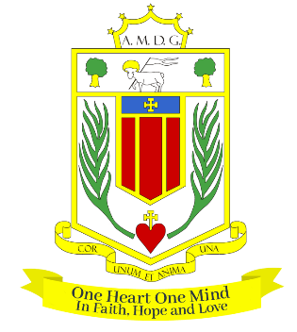
Yew Tree Lane

Liverpool, L12 9HJ

Telephone 0151 541 9440 / Fax 0151 259 8448
E.mail: smithg@broughtonhall.com
Head Teacher: Mrs S O’Rourke B.A. (Hons), PGCE

Role: ASSISTANT SENDCO & TEACHER OF NURTURE
Additional Allowances: TLR (Appropriate to experience)
Contract: Permanent/Full-Time
Closing Date: 6th March 2025
Interview Date: As soon as possible after the closing date
Start Date: 1st September 2025 or as soon as possible

Suitable for: MPS/UPS

Our Governors are seeking to appoint an outstanding and enthusiastic Assistant SENDCo and Nurture Base Teacher with the ability to deliver effective teaching and learning at Key Stage 3 across all curriculum areas. You will need to be a practitioner who consistently delivers high quality teaching with the ability to inspire, engage and motivate students. You will also need to have excellent communication skills, be ambitious and be a strong team player and above all else, you will need to be dedicated to excellence in all that you do.

This role is suitable for both ECTs and colleagues with one or more years teaching experience, those with experience of working as an assistant SENDCO or a passion to learn a new skill and join a thriving team.

This position is a new role which will expand our team and allow for capacity to support our growing SEND cohort. A successful candidate would lead on key areas of SEND across whole school which would be decided based on experience.

About Broughton Hall Catholic High School
Broughton Hall is a Catholic High School is an Ofsted rated Good provider (2022), which is proud of our strong Catholic ethos and values. The school has an excellent reputation and promotes an inclusive education which develops creativity, confidence and independence. The school is committed to the continuous professional development of all staff including Aspiring Leaders, NPQML and NPQSL programmes.

For further information about the school and Application Pack please visit the school’s website www.broughtonhall.com

Broughton Hall Catholic High School is committed to safeguarding and promoting the welfare of children and we expect all staff and volunteers to share this commitment to keeping children safe. Any offer of employment will be subject to statutory pre-employment checks including satisfactory references and Enhanced DBS and Barred List checks. This post is exempt from the provisions of the Rehabilitation of Offenders Act - accessed here - and shortlisted candidates will be required to disclose any relevant criminal history prior to interview.

