**Contract Term:** Permanent/Full-Time

**Headteacher**

**Salary Scale:** MPS/UPS and TLR

**Headteacher**

**Interview Date:** TBC

**Headteacher**

**Shortlisting Date:** Friday 7th March 2025

**Headteacher**

**Closing Date:** Thursday 6th March 2025

**Headteacher**

**Preferred Start Date:** 1st September 2025 (or as soon as possible)

**Headteacher111**

**Role:** Assistant SENDCo and Nurture Teacher

**Broughton Hall Catholic High School**

Founded in 1928 under the trusteeship of the Sisters of Mercy, Broughton Hall Catholic High School, an all-girls Catholic secondary school in Liverpool, provides the very best in modern education based on the Gospel values of mutual respect and care.

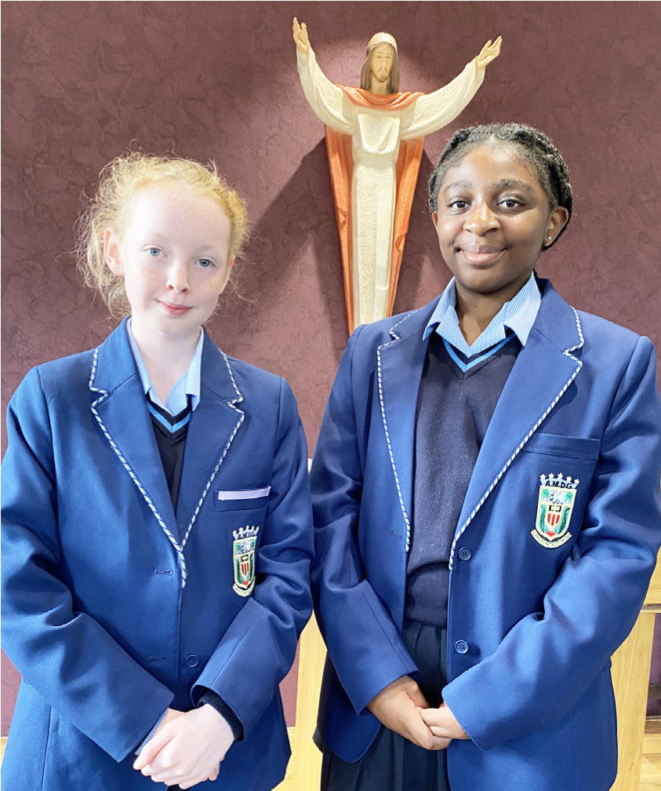

The central aim of our school is to provide excellent educational opportunities enabling each pupil to develop their God given talents, to grow in confidence and self-esteem and to fulfil their potential.

As a Catholic school Broughton Hall centres its mission on the person of Jesus Christ, and promotes the Gospel values throughout the school community and in all aspects of school life: spiritual, academic, pastoral, and personal. By proclaiming and living out the faith of the Catholic Church, we support each other in shared experiences of teaching and learning, prayer, worship and charity. Our mercy values permeate throughout our community.

Broughton Hall is Ofsted rated as a “Good” provider (November 2022).

Our facilities are bright, spacious, high tech and designed to meet the needs of all our pupils. We have a separate 6th Form facility, which is shared with our neighbouring boys school Cardinal Heenan Catholic High School. A full range of extra-curricular activities are provided to further the creative, sporting and academic talents of each pupil and offer Outward Bound and Duke of Edinburgh Award schemes as well as the opportunity to attend educational visits and residential trips.

We pride ourselves on our high expectations of all pupils and have an **‘Ambition for All’** policy. Whatever your role within the school, you will share these values and be able to encourage and motivate pupils with your passion, presence and personality.

Our school motto ‘**Cor Unum et Anima Una’** - One Heart and One Mind, reflects the strong sense of community amongst pupils, staff, parents and Governors.

School has a weekly Newsletter – please **click here** to view our latest edition. <https://www.broughtonhall.com/newsletter/>

**Welcome**

Thank you for your interest in the position of Assistant SENDCo and Nurture Teacher.

This position in a new role which will expand our team and allow for capacity to support our growing SEND cohort. The successful candidate would lead on key areas of SEND across school.

This pack has been designed to help you should you choose to submit an application form, which we sincerely hope you do. We hope it answers your initial questions, but if not, please do not hesitate to contact us and we will endeavour to help you through your application process.

Broughton Hall Catholic High School is the largest all-girls school in Liverpool and serves many different areas making us a vibrant a diverse school. Our aim is to be a good school in all areas and we are seeking staff to apply to work with to be of that journey. Ofsted rated the school as “Good” in November 2022.

We work hard to ensure Broughton Hall Catholic High School remains a friendly and welcoming environment for all those who work, study or visit here and hope that you are the person we are looking for to bring creativity and innovation to the role.

The school actively supports the training of middle leaders through well-respected Teaching Leaders’ programme. Opportunities for promotion exist for suitable candidates. Our staff are passionate about teaching and are committed to develop exciting and stimulating lessons that not only engage students.

We look forward to hearing from you.

**Sarah O’Rourke**

**Head Teacher**

**We Offer**

* Pensions Scheme – Teacher Pension Scheme for teaching staff or Merseyside Pension Fund for support staff
* Regular training and development programme
* Access to occupational health
* An enhanced Occupational Health & Well-Being App (Smart Clinic) with access to a wide variety of services e.g.
* Virtual GP
* 24 hour employee assistance line
* Physiotherapy
* Mental Health Services
* Self-support and guidance tools
* Cycle2Work Scheme
* Tax Free Childcare Vouchers
* Supportive work environment where all staff are valued
* Continuous professional development for all staff and follow a whole school approach to staff performance and development

And that’s not all, we place the outcomes of the children in our school at the heart of everything we do, so you’ll wake every day in the knowledge that your role will have a significant positive impact on the lives of others.

**Equal Opportunities**

Broughton Hall Catholic High school is an equal opportunities employer.

We welcome applicants from all backgrounds and value everyone as an individual. We are committed to organisational practices, which promote diversity and inclusion for all employees and volunteers regardless of age, gender reassignment, marriage or civil partnership status, pregnancy and maternity status, disability, race (including colour, nationality, ethnic or national origin), religion or belief, sex, or sexual orientation. Connecting these differences creates a productive environment in which everyone feels valued.

Monitoring information in relation to job applicants will be to assist us in equality monitoring. The recruitment panel will not have access to job applicant’s monitoring information.

To assist us in monitoring the operation of equal opportunities policy, and for no other reason, please ensure you complete and submit the Equal Opportunities Monitoring Form with your application form.

**Safeguarding & Enhanced DBS Checks**

Broughton Hall Catholic High School is committed to safeguarding and promoting the welfare of young people and expect all pupils, staff, volunteers and visitors to share this commitment

All posts are subject to an enhanced DBS check and full pre-employment checks to comply with the current Keeping Children Safe in Education statutory guidance for schools.

All staff will be expected to follow Broughton Hall Catholic High School’s child protection policies, code of conducts and managing allegations against staff procedures.

All roles in school, including this post, are exempt from the Rehabilitation of Offenders Act (ROA) 1974. The Ministry of Justice’s guidance on Rehabilitation of Offenders Act 1974 and the Exceptions Order 1975 provides information about which convictions must be declared during job applications and can be accessed [here](https://www.gov.uk/government/publications/new-guidance-on-the-rehabilitation-of-offenders-act-1974).

All applicants must therefore declare all previous convictions and cautions, including those which would normally be considered ‘spent’ except those received for an offence committed in the United Kingdom if it has been filtered in accordance with the DBS filtering rules. Information about filtering offences can be found in the DBC Filtering Guide, which can be accessed [here](https://www.gov.uk/government/publications/dbs-filtering-guidance).

By engaging in this recruitment process, shortlisted candidates consent to an online search in line with the Keeping Children Safe in Education Statutory Guidance 2022.

# **Role: ASSISTANT SENDCO & TEACHER OF NURTURE**

**Advert**

**Additional Allowances: TLR (Appropriate to experience)**

**Contract: Permanent/Full-Time**

**Closing Date: 6th March 2025**

**Interview Date: As soon as possible after the closing date**

**Start Date: 1st September 2025 or as soon as possible**

# **Suitable for: MPS/UPS**

Our Governors are seeking to appoint an outstanding and enthusiastic Assistant SENDCo and Nurture Base Teacher with the ability to deliver effective teaching and learning at Key Stage 3 across all curriculum areas. You will need to be a practitioner who consistently delivers high quality teaching with the ability to inspire, engage and motivate students. You will also need to have excellent communication skills, be ambitious and be a strong team player and above all else, you will need to be dedicated to excellence in all that you do.

This role is suitable for both ECTs and colleagues with one or more years teaching experience, those with experience of working as an assistant SENDCO or a passion to learn a new skill and join a thriving team.

This position is a new role which will expand our team and allow for capacity to support our growing SEND cohort. A successful candidate would lead on key areas of SEND across whole school which would be decided based on experience.

**About Broughton Hall Catholic High School**

Broughton Hall is a Catholic High School is an Ofsted rated Good provider (2022), which is proud of our strong Catholic ethos and values. The school has an excellent reputation and promotes an inclusive education which develops creativity, confidence and independence. The school is committed to the continuous professional development of all staff including Aspiring Leaders, NPQML and NPQSL programmes.

For further information about the school and Application Pack please visit the school’s website www.broughtonhall.com

*Broughton Hall Catholic High School is committed to safeguarding and promoting the welfare of children and we expect all staff and volunteers to share this commitment to keeping children safe. Any offer of employment will be subject to statutory pre-employment checks including satisfactory references and Enhanced DBS and Barred List checks. This post is exempt from the provisions of the Rehabilitation of Offenders Act* - *accessed* [*here*](https://www.gov.uk/government/publications/new-guidance-on-the-rehabilitation-of-offenders-act-1974) *- and shortlisted candidates will be required to disclose any relevant criminal history prior to interview.*

**Job Description**

**ASSISTANT SENDCO AND NURTURE TEACHER**

|  |  |
| --- | --- |
| Purpose | * To contribute to the distinctive Catholic ethos of the school, as laid down in its Mission Statement, in all areas of contact and responsibility, in relationships with staff and pupils. * To teach our nurture provision across the KS3 curriculum, ensuring a bespoke and differentiated curriculum that is accessible yet ambitious for our students. * To support and follow policies and procedures set out in the Staff Handbook and as directed by the Governing Body. * To deputise in the absence of the Head of Department; SENDCo. * To support and assist the SENDCo in raising standards of SEN pupil attainment and achievement across the school and to actively monitor and support SEND student progress. * To support the SENDCo in ensuring the provision of an appropriately broad, balanced, relevant and differentiated curriculum for SEND pupils studying in the department, in accordance with the aims of the school and the curricular policies determined by the Governing Body and Head Teacher of the school. * To be accountable for leading, managing and developing the department in the absence of the SENDCo, * To effectively manage and deploy teaching/support staff, financial and physical resources within the department to support the designated curriculum portfolio in the absence of the SENDCO * To develop interdisciplinary approaches with other departments to embed lifelong learning skills. * To promote and monitor high quality teaching, effective use of resources and high standards of learning and achievement for all pupils. * To support in referrals and reviews of students with Special Educational Needs. * To record and report on students in a formal manner including; LAC reviews, PEPS, EHCP reviews etc. * To liaise with a variety of external agencies including Children’s services, Educational Psychologists, SEND casework officers, Health care professionals. * To engage and promote working relationships with parents. |
| Location | Broughton Hall Catholic High School, West Derby, Liverpool |
| Reporting to | Assistant Headteacher (SENDCO) |
| Responsible for | Teaching assistants and other relevant personnel within the department. |
| Working Time & Conditions | These will be as specified in the latest School Teachers Pay and Conditions Document. Attendance at school functions beyond the working day including Parents/Awards Evenings will be required. |
| Safeguarding children | The post holder must safeguard and promote the welfare of the children and young people at Broughton Hall Catholic High School |
| Salary | MPS/ UPS Plus TLR (appropriate with experience) |

**Person Specification**

|  |  |
| --- | --- |
| **Criteria** | |
| **Knowledge and Experience** |  |
| * Experience of teaching across KS3 | E |
| * Knowledge and experience of planning and leading teaching and learning activities with groups of students (such as a nurture class/ intervention group) | E |
| * Experience of supporting student achievement, social, emotional development & well being | E |
| * Experience in effective use of planning, assessment and analysis in raising standards | E |
| * Awareness of the barriers to learning experienced by students and strategies to overcome these | E |
| * Knowledge of how to support learners in accessing the curriculum in accordance with the SEND code of practice | E |
| * Experience of working with students in an educational setting | E |
| * Experience of differentiating to provide appropriate challenge for all learners | E |
| * Experience of utilising LSAs in a classroom to ensure Quality First Teaching | E |
| * Evidence all of the Teaching Standards in routine practice | E |
| * Experience of leading on whole school training | D |
| * Experience of using diagnostic tools such as Boxall, PIVOTS, Blank Levels etc. | D |
| * Experience of referring students to pathways such as ASD, ADHD, CAHMS, OT | D |
| * Evidence of leading strategic change | D |
| * Experience of leading others | D |
| * Experience of teaching across the curriculum | D |
| * Experience of designing and delivering a bespoke curriculum | D |
| **Qualifications and Training** | |
| * Good standard of Education up to GCSE or equivalent including Maths and English - Excellent literacy and numeracy skills | E |
| * Good degree or equivalent in relevant subject area | E |
| * PGCE in relevant subject area | E |
| * QTS | E |
| * A qualification in SEND e.g. NPQSEN, NASENCo or willingness to complete in 3 years | D |
| * Evidence of further professional development | D |
| * Training in Literacy and Numeracy strategies | D |
| * Training in special education needs and interventions | D |
| * Good ICT skills to support learning | D |
| * Understanding of JCQ guidance & ability to apply for access arrangements | D |
| **Skills and attributes** | |
| * Excellent time management and organisational skills | E |
| * Ability to build and maintain effective working relationships with all pupils and colleagues | E |
| * Knowledge and understanding of the principles with regard to the safeguarding of children and Child Protection | E |
| * Commitment to safeguarding students’ wellbeing and equality | E |
| * Commitment to our Catholic ethos and mission statement | E |
| * Ability to promote a positive ethos and role model positive attitudes | E |
| * Ability to work effectively under pressure | E |
| * Ability to communicate effectively at all levels | E |
| * Ability to reach and justify difficult decisions | E |
| * Ability to influence and negotiate | E |
| * Planning own workload to meet deadlines | E |
| * Ability to work effectively within a team environment, understanding classroom roles and responsibilities | E |
| * Ability to work with children at all levels regardless of specific individual need and identify learning styles and independent learning as appropriate | E |
| * Effective Behaviour Management skills | E |
| * Ability to foster strong working relationships with key stakeholders such as parents, SEND caseworker, OT, Educational Psychologist and other external agencies. | E |
| * Resilience and a sense of humour | E |
| * An excellent attendance and punctuality record | E |
| * Maintain and record accurate information in line with Compliance, GDPR and Freedom of Information regulations. | E |
| * Data analysis skills and the ability to use data for target setting and to inform provision planning | D |
| **Commitment to equal opportunities** | |
| * Ability to understand and demonstrate commitment to equality and diversity | E |
| * A proven commitment to inclusion | E |
| * A commitment to curriculum access and opportunity | E |

E = Essential element D = Desirable element

