INFORMATION PACK
ASSISTANT VICE PRINCIPAL: CURRICULUM & ACHIEVEMENT
Required from September 2023 (or January 2024)
Full time and Permanent
Overview of the Role

A highly successful and experienced middle or senior leader is required to join our outstanding school. The successful candidate will have a proven track record of effective leadership within a school. They will have a clear understanding of the elements of an effective curriculum and knowledge of how assessment can be used to support students’ learning. The postholder will be responsible for the leadership of the curriculum, the achievement of students, admissions, examinations and the timetable, as well as contributing to the wider strategic leadership of the school.

The full job description and person specification are at the end of this pack.

Contents of this pack
Bright Futures Educational Trust | Page 1-2
Altrincham Grammar School for Girls | Pages 3-4
Why work for us? Terms and conditions and how to apply | Page 5
Job Description | Pages 6-8
Person Specification | Pages 8-9

Bright Futures Educational Trust
Bright Futures Educational Trust (The Trust) is a multi-academy trust set up in 2011. The Trust is made up of a richly diverse group of schools in Greater Manchester and Blackpool. We are passionate about working together within and beyond the Trust to achieve our aspirational vision: the best for everyone, the best from everyone. We are an organisation that is underpinned by values of: community, integrity, and passion. In everything we do, we remember that we are accountable to the children, families, and communities that we serve.
Our schools have their own identities, form one organisation and have one employer, Bright Futures Educational Trust. Bright Futures’ Board of Trustees maintains strategic oversight of the Trust and delegates some of its responsibilities to the Executive Team, Heads of School and local governing bodies. We place a high value on integrity and probity and take seriously our accountabilities for making the best use of public money. How decisions are made is described in our delegation framework. You can find out more about the Trustees and the Executive Team on our website: About Us - Bright Futures Educational Trust (bright-futures.co.uk)
The central team includes the Executive Team: John Stephens, CEO; Edward Vitalis, Chief Operating Officer; Gary Handforth, Director of Education; Lisa Fathers, Director of Development, Partnerships and Teaching School Hubs and Lynette Beckett, Director of People & Strategy. The focus of these roles is to work with schools, providing high quality and timely guidance, leadership, challenge, and support. In addition to the executive team, we have central operations for finance, communications and marketing, HR, educational psychology, and digital technologies. Please see our website brochure which explains our central operations: Why-Join-Bright-Futures

Bright Futures Professional Development Institute is an important part of the Trust. The Institute is the home of all professional development and school improvement resource in Bright Futures. The Institute is also where all of our outward facing work happens. Underneath this umbrella we have several hubs. The Alliance for Learning (AFL) which provides school improvement services and CPD to over 700 schools, a North West Maths’ Hub NW1 Maths Hub, providing mathematics training and coaching to 500 schools, and a SCITT (School Centred Initial Teacher Training) Bright Futures SCITT, which is the largest in the North West. Within the Institute, Bright Futures also has two Teaching School Hubs, serving Manchester, Stockport, Salford, and Trafford. Bright Futures Send Outreach is another service which we provide across the Northwest. We have also been designated as an Early Years Stronger Practice Hub under the name of Bright Futures North West Early Years Stronger Practice Hub providing guidance and support to settings across the region.

Collaboration and strong relationships form one of the ‘commitments’ in our Strategy and all components of the Bright Futures’ family work closely together. Our Strategy was developed collaboratively and can be found on our website: Our Strategy.

Altrincham Grammar School for Girls
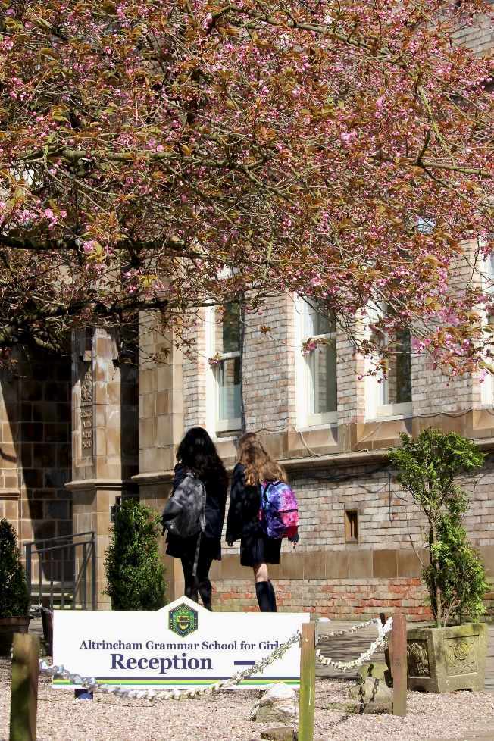
Altrincham Grammar School for Girls (AGGS) is a highly successful single sex 11 -18 academy in the South Trafford area. AGGS was in the first cohort of schools to be designated a national teaching school in 2011. AGGS is the lead school in ‘The Alliance for Learning’, which comprised schools of every type and phase, plus universities, throughout a wide geographical area. The impact of teaching school activities has been felt within the Trust and far beyond. We have a reputation for excellence regionally and nationally, of which we are very proud.

AGGS is committed to providing equal opportunity in recruitment and employment to all individuals. We will consider candidates without regard to race, ethnicity, gender, religion, sexual orientation and identity, national origin, age, military or veteran status, disability or any other legally protected status; and without discrimination based on socioeconomic, marital, parental or caregiving status, or any of the previously listed characteristics or statuses.

We value the diversity of our staff and reject any form of harassment, discrimination or victimisation. The Bright Futures Educational Trust vision is: ‘the best for everyone, the best from everyone’. To achieve this, we create and maintain a work environment and culture where people from different backgrounds, and with varying lifestyles, interests, opinions and responsibilities, treat each other with dignity and respect. It is a climate in which our staff feel safe and are inspired and motivated to be their best.

Our school is dedicated to sustaining and promoting diversity with respect to recruitment, promotion, training and general treatment during employment. We are actively seeking to extend the diversity of our staff. Furthermore, we welcome candidates who have not had previous experience of working in a grammar school.

We aim to ensure that our recruitment processes set up all candidates for success. At interview our aim is to provide a positive experience. We don’t want to catch anyone out, but rather to provide the opportunity for all candidates to be themselves and show us what they are capable of.

WHY WORK FOR US?

We offer a great opportunity to join an organisation which really lives its values. Our working environment is very inclusive and whilst you can expect to be challenged in your role, you will be supported through professional learning, treated fairly and with dignity and respect. Please see the Equality,
Diversity, an Inclusion statement on our website.

Terms and Conditions
Salary: NJC scale points L16 to L20 (Bright Futures Leadership scale). The full-time equivalent pay is £64,538 rising to £71,080 per annum.
Pension: Teachers Pension Scheme: https://www.teacherspensions.co.uk/

Other: We offer salary sacrifice schemes for purchasing bikes used for travel to work and technology for personal use, through monthly interest free salary deductions.
We also offer opportunities for professional development.

For a full explanation of our employment offer please see the booklet on our website:
Our-Employment-Terms-November-2022.pdf (bright-futures.co.uk)

How to Apply
We can only accept completed application forms, rather than CVs. This is because the regulatory guidelines of
Keeping Children Safe in Education (2021), require us to check various details of job applicants and an identical
application format for each candidate enables us to do this. We use a process that does not identify personal
characteristics to the shortlisting panel. This is part of our commitment to equalities and diversity.
NO AGENCIES PLEASE.

Our application form is available online, along with the disclosure of criminal background form. The portal link is HERE. Alternatively, you can click Apply Now on this role via the current vacancies page of our website. Please upload the forms by 9 am on 5 June 2023.

The selection will take place during the week commencing 12 June. You will be notified after the closing date whether you have been shortlisted.

Keeping Children Safe in Education
Bright Futures Educational Trust is committed to safeguarding and promoting the welfare of children and young people and we expect all staff and volunteers to share this commitment. This post is exempt from the Rehabilitation of Offenders Act 1974; pre-employment checks will be carried out and references will be sought for shortlisted candidates and successful candidates will be subject to an enhanced DBS check and other relevant checks with statutory bodies.

Data Privacy
You can read the details of how we use the personal data that you provide us with in our Job Applicants’ privacy notice on our website: Applicant Privacy Notice
JOB DESCRIPTION

ASSISTANT VICE PRINCIPAL: CURRICULUM & Achievement

JOB SUMMARY
The Assistant Vice-Principal: Curriculum and Achievement, responsible to the Principal, has responsibility for the strategic development, implementation and evaluation of the curriculum, student achievement, admissions, examinations and the timetable. The postholder will demonstrate a clear understanding of the elements of an effective curriculum and knowledge of how formative and summative assessment can be used to support students’ learning. The postholder will have strong IT skills, excellent attention to detail and highly developed organisational skills.

KEY RESPONSIBILITIES AND ACCOUNTABILITIES

The Assistant Vice-Principal: Curriculum and Achievement will work to ensure that all students reach their fullest potential through a rich and varied curriculum and effective assessment practises.

Leading the Curriculum
- Ensure the delivery of an appropriate, outstanding and cost-effective curriculum programme that meets the needs of all students.
- Actively monitor curriculum developments and initiatives and work with the Assistant Vice-Principal: Teaching & Learning and the Assistant Vice Principal: CPD to respond to these where appropriate.
- Establish strategies for the review, monitoring, and evaluation of the curriculum.
- Be responsible for the preparation of the school timetable and liaise with the Principal to ensure that the appropriate staffing is in place to prepare for this.
- Maintain the timetable throughout the year, responding to any changing needs.

Leading on assessment and reporting
- Ensure the effective use of accurate data to inform planning and support strategies, to raise attainment, secure outstanding progress and address under performance of groups and individual students.
- Design and implement target setting, achievement and monitoring policies and practices to ensure that subject leaders are challenged and supported to achieve high standards of achievement and progress in their subject areas.
- Produce a variety of reports and analysis regularly to ensure effective monitoring of student progress and outcomes.
- Develop systems, policies and documents to enable the sharing of good practice in tracking and monitoring of student progress across the school.
- Develop the use of SIMS to track and monitor student achievement in all subjects and to ensure all staff can access relevant, accurate data to inform planning and support.
- Prepare detailed analysis and evaluation of internal assessment data at the end of each reporting period.
- Develop the school’s systems and procedures for reporting to parents, including overseeing the school assessment, recording and reporting policy.
- Analyse, evaluate and report to relevant staff, partners and governors, local and national comparisons of whole school and subject performance in external examinations.
- Attend on examination results days to carry out analysis and provide advice.
- Identify key student groups or individuals to target as a result of analysis and evaluation of internal and external results, to enable the implementation of strategic support programmes to improve the achievement of targeted individuals/groups, in line with school priorities.
- Work with other members of the leadership team to ensure that lessons are informed by assessment information.
- Lead the Year 9 and Year 11 options processes, to ensure that students have the information required to make appropriate curriculum choices.
- Ensure that an effective timetable is delivered within the agreed time frame, leading on all aspects of the timetabling process.
- Liaise with the Data Manager and ARR Secretary to ensure that the relevant data is available and accurate reports to parents are produced in a timely manner.
- Line-manage the ARR Secretary and Data Manager.

Leading Admissions
- Oversee the school’s admissions processes, including the school’s entrance examinations.
- Ensure the delivery of a timely admissions process.
- Review the admissions process, including working with other GSHA schools and the Trafford Consortium, to ensure that the entrance examination is fit for purpose.
- Oversee the implementation of the school’s admission policy, ensuring it meets the standards and requirements of the Schools Admission Code and the School Appeals Admission Code.
- Work alongside the Assistant Vice Principal: Head of Sixth Form to co-ordinate Sixth Form admissions.
- Line-manage the Admissions Officer.

Leading Examinations
- Strategic leadership of both internal and external examinations, ensuring that these are run efficiently, effectively and in line with school procedures and JCQ guidance.
- Actively monitor examination developments and guidance from JCQ, responding to these where appropriate.
- Ensure teachers, HoDs and LT are kept up to date with guidance published by JCQ and Ofqual.
- Be responsible for updating the NEA guidance and procedures, appeals guidance and procedures.
- Be responsible for implementing and reviewing the school’s examination policy.
- Working with the Examinations Officer, ensure the timely and accurate production of examination results for students on GCSE and A level results days.
- Line-manage the Examinations Officer.

Cover
- In liaison with other members of the Leadership Team, draw up and maintain the school calendar.
- With the support of the ARR Secretary, ensure that all classes have an appropriate teacher to cover for sickness, courses, meetings, school trips, visits etc.
- Lead on the identification and deployment of supply staff.

Line Management of Middle Leaders
- Oversee the work of a number of academic departments and associate staff.
- Carry out their department reviews and to oversee that each department completes their own DDP in line with the SDP.
- Lead their HODs to oversee the continuous review of their curriculum and schemes of work.
- Contribute to the agenda and running of Heads of Department Meetings.

Managing the Organisation
The post-holder will work alongside the Principal and other members of the leadership team to:
- Manage the financial and human resources effectively and efficiently to achieve the goals.
- Recruit, retain and deploy staff effectively in order that they can achieve the vision of the School.
- Manage and organise the environment of the school.

General Senior Leadership Responsibilities
- Develop and maintain a culture of high expectations for self and others.
- Update the Principal, other senior leaders, the Governing Body and the Trust on the effectiveness of the provision as required.
- Lead by example as a teacher, and as a leader, achieving high standards of student attainment and progress, behaviour and motivation through effective teaching.
- Challenge under-performance at all levels and ensure corrective action and follow up.
- Contribute to the formulation, implementation and evaluation of the school development plan.
- Support the development and maintenance of AGGS policies and practices to ensure consistent application.
- Have a teaching commitment in line with Assistant Vice-Principal status.
- Participate in appraisal arrangements and probationary reviews.
- Carry out return to work interviews for relevant staff.
- Plan, chair and organise meetings as appropriate.
- Sustain effective, positive relationships with all staff, students, parents/carers, governors and the local community.
- Liaise effectively with all stakeholders including parents/carers, feeder schools, secondary schools, business and community partners, in line with strategic objectives.
- Maintain clear expectations and high standards of professionalism.
- Attend school events and activities as directed by the Principal.
- Keep the leadership team up to date with national developments specific to the post’s areas of responsibility.
- Keep up to date with the development of creative and innovative practices in all areas of responsibility.
- Manage budget(s) in line with areas of responsibility.
- In conjunction with the senior management team, oversee the school environment and carry out regular environment inspections.
- Take assemblies and participate in rec, lunchtime, before and after hours’ supervision.
- Contribute to support programmes for students and staff that may, on occasion, include weekends and holiday periods.
- Facilitate on teaching school programmes where appropriate.
- Act as a coach for staff engaged on training programmes.
- As appropriate, support and engage in outreach work for the Bright Futures Development Institute.
- Any other reasonable duties as requested by the Principal.

Key Events Responsibilities
- Year 9 and Year 11 options evenings.
- Information and induction evenings.
- Student/parent events, as directed by the Principal, to raise standards of achievement.

General Duties
- Carry out a share of supervisory duties in accordance with published schedules. Fulfil the conditions of employment of school teachers as laid down in the Pay and Conditions Document.
- Any other relevant duties requested by the Principal.

The responsibilities and duties will be reviewed and modified as necessary around the strengths and skills of the Leadership Team.

PERSON SPECIFICATION
Category | Essential | Desirable | Method of assessment
Qualifications, Education, training | - Degree and/or teaching qualification.  - Recent relevant in-service training. | - Post-graduate qualification.  - Professional qualification e.g. NPQSL | - Application form  - Interview  - Certificates
Relevant Experience | - Successful teaching experience, including teaching to GCSE Level.  - Successful leadership within a substantial middle or senior management role.  - Experience in developing whole-school policies and strategies. | - Evidence of a contribution to wider educational issues.  - Teaching to advanced level | - Application form  - Interview
Knowledge, skills, and abilities | - Current knowledge of the use of assessment and data in students’ learning and to raise standards.  - Understanding the principles of an effective curriculum.  - A track record of maintaining or developing high standards and achievement.  - Very good oral and written communication skills.  - Excellent classroom practitioner.  - Knowledge of SIMS or similar.  - Excellent ICT skills. | - Knowledge of the use of SIMS Assessment Manager | - Application form  - Interview  - Task
Personal Qualities/Other | - Ability to manage, motivate, support and inspire trust in others.  - Ability to work as part of a team.  - Ability to work well under pressure.  - Ability to formulate, monitor, evaluate and review plans and policies.  - Ability to confront and resolve problems.  - Ability to innovate and manage change.  - Attention to detail and accuracy of work.  - Ability to lead INSET and research at school / Trust level.  - A commitment to further training and a willingness to participate in relevant CPD  - Willingness for lessons to be observed as part of monitoring and CPD  - Willingness to be engaged in school-to-school support and other collaborations.  - A passionate commitment to develop the best in young people.  - Involvement in school working parties or research groups.  - Willingness to be engaged in partnership and community activities.  - Commitment to the aims and ethos of the school  - A commitment to maintaining confidentiality and discretion inside and outside school.  - Commitment to pastoral care.  - Willingness to be involved in extra-curricular activities including trips abroad.  - A positive approach to challenges, which seeks solutions to problems and addresses difficulties with cheerfulness and good humour.  - To be prepared to work flexibly, outside the usual school hours. |  | - Application form  - Interview  - Task
Safeguarding | Commitment to demonstrating a responsibility for safeguarding and promoting the welfare of young people |  | - Application form  - Interview  - Task
Our Values | Community: Evidence of working together for a common purpose and encouraging diversity |  | - Interview  - Tasks
 | Integrity: Evidence of doing the right things for the right reason |  | - Interview  - Tasks
 | Passion: Evidence of taking personal responsibility, working hard and having high aspirations |  | - Interview  - Tasks

Bright Futures Educational Trust is committed to safeguarding and promoting the welfare of children and young people and we expect all staff and volunteers to share this commitment. This post is exempt from the Rehabilitation of Offenders Act 1974; pre-employment checks will be carried out and references will be sought for shortlisted candidates and successful candidates will be subject to an enhanced DBS check and other relevant checks with statutory bodies.

