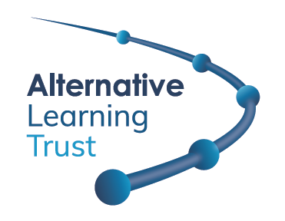

INFORMATION FOR APPLICANTS

Associate Assistant Headteacher

Thank you for your interest in the post of Associate Assistant Headteacher at The Limes College. This post is available to start as soon as possible on a permanent contract.

This is an exciting opportunity for an experienced practitioner to take on the role of Associate Assistant Headteacher and support the Senior Leadership Team in developing a stimulating learning environment for our students.

You will need to have a good understanding of issues affecting young people with emotional and behavioural difficulties, successful teaching experience in mainstream or special schools (preferably with secondary aged students) and experience of managing SEND at different key stages.

Background to Alternative Learning Trust

The Alternative Learning Trust became a multi-academy trust (MAT company number 11788031) in June 2019. There are now four schools within the Trust, The Limes College, North West Kent Alternative Provision Service (NWKAPS), Will Adams Academy, and Saffron Valley Collegiate. The Department for Education would like Alternative Learning Trust to consider other alternative providers.

The Trust has been established to work with Pupil Referral Units (PRUs) and alternative providers who support vulnerable students to access and engage with education. Many of our students have special educational needs and have been excluded from mainstream education.

As a Trust we have the following core set of values for our staff and the families we support:
- the need for people to flourish in all areas of their lives;
- we are stronger through a sense of community;
- social justice is vital.

The Sutton West Centre is the registered address for the Trust from where the Executive Team operate. This post will be based there; however, he/she will be expected to travel between the academies within the Trust, when required and carry out business on behalf of the Trust, for which expenses are reimbursed.

Background to The Limes College

The Limes College is a Pupil Referral Unit (PRU) which offers alternative education provision outside of a traditional schooling environment to key stages 1 to 4; it accepts students from mainstream schools in Sutton with educational and behavioural needs. The current roll of around 180 students consists of those who have been permanently excluded or those at risk of exclusion. Many students are with us for only a short time while some will remain on roll for their entire GCSE courses. We have 4 Core Values that run through everything we do; Belonging, Relationships, Achieving and then Moving On.

The Limes Primary is run on a nurture group based approach. There is a commitment to nurturing principles and a focus on using attachment theory; an area of psychology which explains the need for any person to be able to form secure and happy relationships with others in the formative years of their lives. The Limes Primary is a bridge between school and home; it is intended to be a welcoming and relaxing environment. Although academic progress is an important part of nurturing, emphasis is also put on emotional and social development, with plenty of opportunity for broader learning provided by the staff in the course of the day.

Some students at The Limes College have a range of needs. Additional support is provided through a strong pastoral team which includes tutors and Outreach Workers in order to engage them back into mainstream education.

We make a difference at The Limes College; we never give up. We change lives and futures.

Salary

The post-holder will be appointed on the Leadership Scale (L6 – L10).

Working Pattern

Requests for part-time working will be considered.

Checks

This appointment is subject to an enhanced DBS check, medical screening and confirmation of qualifications and references.

Further questions

If you have any further questions or would like to arrange a visit, please contact Soodesh Roopchund, Business Manager on 020 8652 1150.

Closing date

The closing date for applications is Sunday, 03 November 2024 at midnight. Interview date to be confirmed.

