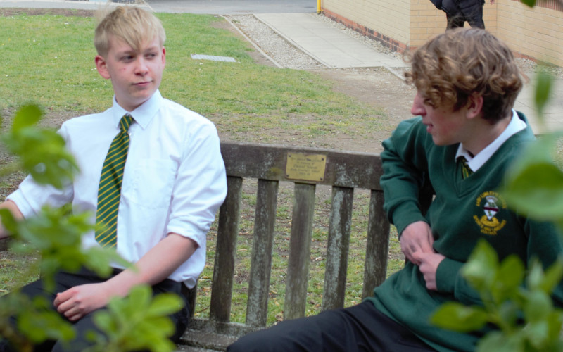

Attendance and Behaviour Officer
Closing Date: Friday 24th June 2022, 12noon
Recruitment Information Pack
Lady Lumley’s School
Swainsea Lane, Pickering, North Yorkshire
YO18 8NG

Contents

Welcome from the Headteacher 3-4
Our Visions and Values 4
Our schools 6-7
Application process and how to apply 8
Job Description/Person Specification 8-12

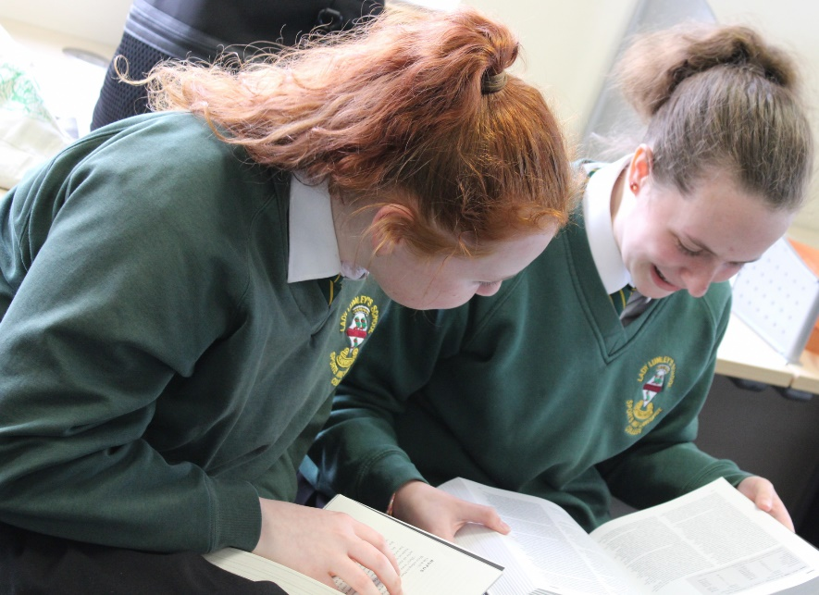

Dear Applicant

Thank you for taking an interest in joining our staff at Lady Lumley’s. I hope reading about our school gives you a sense of a driven community school, ambitious to do all we can to see staff and students thrive.

Lady Lumley’s school has a proud tradition and heritage of providing quality education. A trailblazer in the pursuit of education for all – welcoming the children of farming families and girls long before this was a requirement. Building on those foundations, Lady Lumley’s is a truly comprehensive school of 900 students drawing from the town of Pickering, surrounding villages and rurality as well as from Scarborough and all points in between.

‘Being our best’ signals Lady Lumley’s commitment to school improvement. We are ambitious for all our students and staff and strive to improve teaching and learning through constant evaluation and positivity. Our curriculum offer is broad and balanced, giving students a clear progression route through the school that builds the fundamental knowledge and understanding to allow them to specialise for Key Stage 4 then again at Key Stage 5. Lady Lumley’s curriculum gives all students the best chance of being successful at GCSE, A Level and Vocational Provision, ensuring our above national average outcomes open doors for life chances.

Our staff are integrated into thorough well-constructed CPD that looks to build strength in the classroom as well as modelling the pursuit of improvement. Ensuring all our strategic planning is built of evidential educational research is fundamental to ensuring we are investing staff time where it will reap rewards. A love of learning is a necessary mind-set to thrive at Lady Lumley’s.

Lady Lumley’s is equally ambitious for our students to experience an enriched learning journey with a diverse offer of experiences. From trips abroad to Bordeaux, Saint Émillion and Dune de Pyla in France and Weiz in Austria our students also visit Belgium and France in Year 10 for the GCSE Battlefields Experience and Krakow and Auschwitz in Year 11, 12 and 13 for Religious Education. There are numerous theatre and music trips and visits taking in everything from opera to pantomime. The excellent sporting facilities are always fully booked with traditional team sports running alongside rock climbing and table tennis. Our Duke of Edinburgh scheme is ever popular and Lady Lumley’s students show leadership in this testing qualification right through to the Gold Award. With regular orienteering, canoeing and mountain biking our students also contribute hundreds of hours to volunteering and raise thousands of pounds for charity. Nurturing the growth of students through enriching their experience enables Lady Lumley’s to prepare students to thrive locally or to move on to different cultures and experiences.

We value our pastoral staff and system as the cement that holds the school together. There are very high expectations of students conduct and a transparent and fair policy for rewards and consequences. All our students are supported through school with dedicated tutors and a Pastoral Officer with additional expertise available from the Pastoral Team and SLT. There are weekly ‘Life’ lessons to educate students with powerful knowledge to enable them to keep themselves safe and to have well placed confidence outside of school. Our staff and students deserve to feel safe and valued throughout their time at Lady Lumley’s.

Lady Lumley’s benefits from the knowledge and experience of Coast and Vale Trust as we are a unique school with a shared Trust vision. Through leadership development, collaboration, and investment Lady Lumley’s is enabled to maintain its identity whilst belonging to a larger family of schools.

If you have read this and are committed to joining a school that is driven by ambition to be better, values a comprehensive community school, and thrives on being part of a team, then we look forward to meeting you.

Yours sincerely

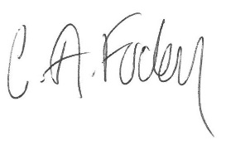
Clair Foden
Headteacher

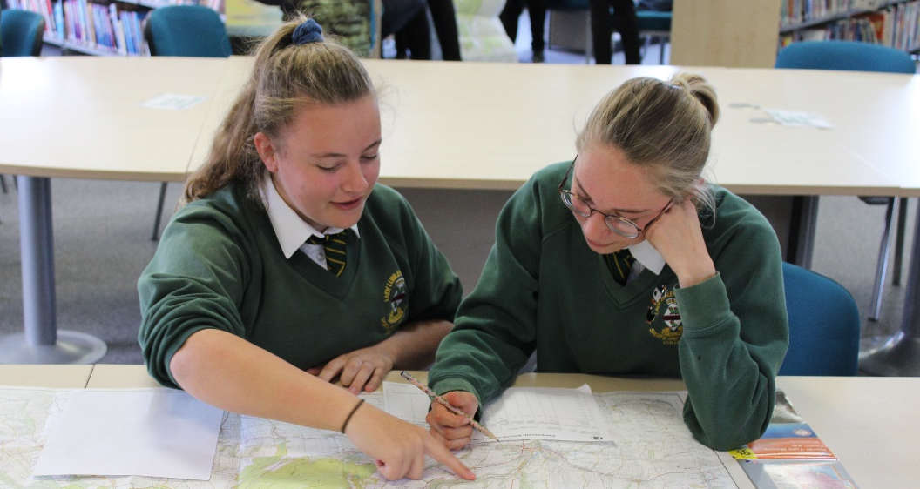

Visions and Values

Lady Lumley’s School is driven by the vision of ‘Being our best’. All staff and all students are asked to commit to our core values:

Learning
Lady Lumley’s core purpose is supporting our students and staff to make progress and continually adapt and develop to become lifelong learners.

Leading
Students and staff have regular opportunities to lead within and outside of the classroom to improve themselves and the community.

Ambition
We are relentlessly positive about improving and seeing all mistakes as ways to learn and improve and exceed our potential.

Progress
The journey through Lady Lumley’s for staff and students is a journey of improvement. Through striving to be our best we will face some setbacks but will build progress over time.

Our schools

Newby and Scalby Primary School

We are one of the schools of choice in our community and we are within commutable distance of Whitby, Teesside, York and surrounding areas. Ofsted in 2018 judged us to be ‘good’ in all areas and as a school we are very much outward facing both in terms of teaching and learning, and in constantly thinking about how we can improve.
Since our “good” Ofsted, we continue to build on our successes and we are a family and a team, where everyone is given the challenge and support to be the best they can possible be in a safe, welcoming and positive environment. Children and staff will work and play together developing skills so that we all become ambitious and reflective lifelong learners as well as being respectful and respected members of the community.
To learn more about us please visit us at:
Newby and Scalby Primary School - Home (coastandvale.academy)

Friarage Primary School
We are proud to serve the communities around the Castle Ward area of Scarborough as ‘Together we can’ make a real difference to the lives of children and young people in Scarborough.

Children and staff will work and play together developing skills so that we all become ambitious and reflective lifelong learners, as well as being respectful and respected members of the community.
We are committed to Restorative Practice Principles to nurture respect for all in our school community.

To learn more about us please visit us at: Friarage Community Primary School - Home (coastandvale.academy)

Scalby School
Scalby School is a successful and popular 11-16 community school, and in recent years we have become the school of choice in our local community. We were judged ‘good’ by Ofsted in 2019 and in 2019 we celebrated sustained results. Our provisional P8 score has placed us in the top 20% of schools nationally. We are proud of our broad and balanced GCSE based curriculum.
To learn more about us please visit us at: Scalby School - Home (coastandvale.academy)

Lady Lumley’s School
Lady Lumley’s School (11-18) in Pickering is on a transformational journey. We are a school that is popular with parents and is easily accessible across North Yorkshire, East Riding, and Wolds and Vale. The communities we serve around the Pickering, Ryedale, and the wider coastal area deserve and need our school to play a leading role in terms of teaching, learning, progress and outcomes.

In April 2020 we welcomed our new Headteacher Clair Foden who joined us at the same time we joined our Trust - Coast and Vale Learning Trust. Lady Lumley’s is on an ambitious journey of school improvement.

To learn more about us please visit us at Lady Lumley's School - Home (coastandvale.academy)

Useful Links
Lady Lumley's School - Home (coastandvale.academy)
Welcome to Pickering. Gateway to the North York Moors, Yorkshire

Scarborough University Technical College

Scarborough UTC is a growing University Technical College (year 9 to year 13) based in a new building, with fantastic technical facilities in the centre of Scarborough. As a University Technical College, we offer a high quality academic and technical education for our students through the specialisms of engineering, health and cyber security. Our unique approach provides students with an excellent range of opportunities, including; Combined Cadet Force (CCF Navy), strong links to our industrial partners, project-based learning, and our flagship Career Development Programme for our Sixth Form students.

Our work with employers and universities ensure we are able to deliver an innovative blend of technical, practical, and academic learning which ensures our students make good progress and go on to outstanding destinations.

Our staff are our greatest resource and we have invested in both our teaching and support staff teams which has ensured that educational standards have improved significantly. We have built a staff team of key support and teaching practitioners who are proud to work at our University Technical College.

To learn more about us please visit us at: https://www.scarboroughutc.co.uk

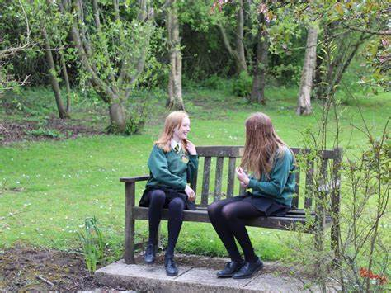

Application Process
The closing date for all applications is 12 noon Friday 24th June 2022

Interviews will be held shortly after the closing date.

Completed applications must be returned to Helen Poole at helen.poole@northyorks.gov.uk

If you think you’re the person for the job, please complete the enclosed application form and send to the email address above by the closing date.

An email will be sent to shortlisted candidates with details of the interview process. If you have not heard from us within a week of the closing date please assume your application has been unsuccessful.

Queries
Please contact Helen Poole at helen.poole@northyorks.gov.uk or on
07890 055186.

Job Description

JOB TITLE: Attendance and Behaviour Officer

GRADE: Grade E (37 hours per week term time only)

RESPONSIBLE TO: Assistant Head Teacher (Improving Engagement and Student Welfare)

RESPONSIBLE FOR: Whole School Attendance

JOB PURPOSE:
Attendance is an essential aspect of our vision of ‘Being Our Best’. The role of the Attendance and Behaviour Officer is to assist in the promotion of outstanding attendance by working in partnership with all stakeholders and the wider community. If attendance is outstanding, then students have improved life chances and will make more rapid progress both academically and socially.

The Attendance Manager will work directly with all stakeholders in an empathetic, understanding way. Encouraging, challenging, and supporting improvements in attendance at an individual, cohort and whole school level.
The Attendance and Behaviour Officer will provide key data both for attendance and behaviour to support students.

- To be the operational lead for student attendance and punctuality for Years 7 to 11, implementing the school’s attendance policy and improving the attendance of students
- To promote the importance of good attendance – ensuring that students, parents & carers understand that regular school attendance is a parental responsibility, and that attendance and attainment are inextricably linked.
- Responsible for recording, monitoring, evaluating, and reporting on attendance & behaviour data to support the students within the school.

Main Duties and Responsibilities:

- To be the operational lead for student attendance and punctuality for Years 7 to 11, implementing the school’s attendance policy and improving the attendance of students in line with school targets.
Punctuality
- Daily meet and greet at the front of the school
- Supervision of the ‘Late Desk’
- Liaise with parents regarding issues with punctuality
- In the case of persistent lateness, invite parent/carers to attend the school to discuss and formulate a plan.
Attendance
- Work alongside and as part of the wider Pastoral Team and Receptionists.
- Communicate with parents/carers to establish reason for unexplained absences and report the outcome of such calls to relevant parties.
- Lead on the Management Information System (currently SIMs) and Class Charts, ensuring all daily registers are accurate with correct coding.
- Fortnightly meetings with Pastoral Officers to discuss attendance issues within the year group.
- To support the Inclusion Team, instigating, and delivering strategies to target improvements in attendance for students recognised as being at particular risk of poor attendance and exclusion.
- To guide and support all Pastoral Officers on aspects of attendance and producing data for each year group.
- Using historic and current data to examine each group cohort to target those who need intervention.
- Create plans to hold Internal Student Attendance Panels, letters to be sent out and room booking.
- Record all those who did and did not attend and send out letters accordingly.
- Ensure that all interventions are logged appropriately.
- Meet with school staff, students, and parents to identify individual barriers to attendance and possible solutions.
- Monitor and evaluate the effectiveness of strategies with individual students.
- Carry out home visits either at the request of the year team or those you are concerned about.
- Liaise closely with and share information with other agencies as appropriate, including the Medical Education Service.
- Highlight persistent absence concerns and the possible repercussions should there be no improvement.
- To be active in policy development and work with Attendance Officers in other Trust Schools to improve attendance across the Trust.
- To initiate appropriate legal action with the Local Authority Education and to carry all paperwork for this to ensure the school is carrying out its statutory responsibility in respect of students’ attendance.
- To acquire and maintain a working knowledge of the statutory framework as well as local procedures relating to school attendance, elective home education, children missing education, medical education, child employment, and child protection in order to be able to offer informed advice, lead on interventions or to liaise with the right teams.
- Communicate with feeder schools to gain any relevant information about attendance of new students to ensure smooth transition between phases

- To promote the importance of good attendance – ensuring that students, parents & carers understand that regular school attendance is a parental responsibility, and that attendance and attainment are inextricably linked.

- To establish and implement best practice procedures and promote positive attitudes towards attendance within the school.
- Develop support materials and information to communicate clearly to students the school’s attendance and behaviour policies, raising the profile of attendance, punctuality, and good behaviour within the school
- Communicate with school staff to update them on student attendance.
- To liaise with Attendance Officers across the Trust and participate in Trust Attendance Strategies & meetings as appropriate.

- Responsible for recording, monitoring, evaluating, and reporting on attendance & behaviour data to support the students within the school.

- Create whole school data reports with close analysis. Including year on year whole school figures, year group comparison and at an individual student level or cohorts.
- To monitor and report on progress against attendance targets.
- Identify trends in order to prepare strategy at times of previous low attendance.
- Prepare reports for a range of audiences on attendance and punctuality.
- Examine key areas of SEND, PP, Gender, PA compared to previous data (school, local and national), sharing across school creating a sense of ownership and at times competition.
- Create a weekly data report with all attendance data within it for use in the Monday Pastoral meeting.
- Create case studies for students where there has been significant improvement, this can be beneficial in terms of evaluating impact and giving praise/feedback to individual students/families.
- Take all updated data to fortnightly line management meetings with Assistant Head Teacher.
Person Specification

POST TITLE: Attendance and Behaviour Officer

ATTRIBUTES | ESSENTIAL | HOW IDENTIFIED
EDUCATION AND TRAINING | - To possess GCSE English and Mathematics at Grade A*- C, or GCSE  - Level 4 - 9, or a Level 2 qualification in Literacy and Numeracy.  - Evidence of active involvement in professional development | - Letter/application form  - References  - Interview process
RELEVANT EXPERIENCE | - Experience or understanding of working with children and young people to overcome mental and physical barriers to their personal, social, or learning development.  - Has or is willing to work towards an understanding of current developments in School Attendance.  - Experience of using and maintaining databases or management information systems.  - Has or is willing to work towards an understanding of the management of referrals and liaising with external agencies.  - Understanding and preferably experience of Multi-agency support.  - Has experience of or is willing to work towards working with parents to secure better engagement for students with their school experience.  - Has experience of or is willing to work towards using data sets to plan effective strategies to improve attendance within a year group and identify possible barriers to learning.  - A measurable understanding of how removing barriers to learning can affect school attendance. | - Letter/application form  - References  - Interview process
SKILLS AND APTITUDES | - Excellent ICT skills including use of excel to analyse data.  - Initiative and creativity to develop a range of options/alternatives to support children and young people.  - Resolve problems in sometimes stressful situations.  - Effective organisational skills to manage conflicting deadlines and meet deadlines.  - Ability to use data to inform plans and strategies.  - Ability to keep accurate records and write reports.  - Ability to work effectively within a team.  - Knowledge of personal, social and educational topics which relate to adolescent concerns.  - Knowledge of potential barriers to learning and attending school faced by children/young people, as well as how these can be overcome.  - Ability to work with academic and pastoral staff in school to safeguard the best outcomes for all students, including those who are in key cohorts.  - Commitment to safeguarding and maintain confidentiality.  - To remain calm and measured when dealing with difficult situations and incidents.  - To be passionate about achieving the best for each student.  - To show a willingness to work flexibly to meet the best interests of the school.  - To be able to work well under pressure.  - To retain a sense of humour and an empathetic approach in working well with other colleagues.  - To be able to take initiative and work independently. | - Letter/application form  - References  - Interview process
CHARACTERISTICS | - To relate well to young people.  - Model and drive high expectations for all.  - An excellent practitioner with the ability to inspire students to become effective, self-directed learners.  - High levels of integrity and professionalism.  - Ability to work well in a team.  - Ability to think originally and creatively.  - Possess excellent written and verbal communication skills.  - Strong attention to detail.  - Ability to work under pressure and meet deadlines.  - Enthusiasm, energy, commitment and resilience.  - The ability to relate positively to students, parents and other stakeholders to engage them successfully in the life of the school.  - Be able to build constructive working relationships with local schools and colleges, external agencies, employers, the local community and the local authority.  - Appreciate the balance between the academic, social and emotional development of young people needed to create an excellent school.  - Ability to engender trust and respect from students and colleagues. | - Letter/application form  - References  - Interview process

