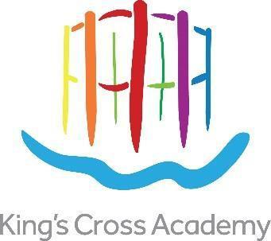

# Recruitment Pack – Attendance and Medical Officer

**CONTRACT TYPE:** Two year fixed term contract, term time only

**GRADE:** Scale 5 (point 12 to 15) FTE salary: £33,291 - £34,779). Pro rata: £17,085 - £17,849)

**REPORTS TO:** Headteacher

**RESPONSIBLE FOR:** Attendance and Medical   
**WORKING PATTERN:** 0.6 FTE (8:45am – 1:15pm, Monday to Friday) term time only

**Key Dates**

**Advertisement live**: Wednesday 3rd September

**Deadline for applications**: Wednesday 17th September

**Shortlisting**: Thursday 18th September

**Interview dates**: Friday 26th September

For further information or an informal conversation about the role:  
Stephen Mitchell, Headteacher

[headteacher@kingscrossacademy.org.uk](mailto:headteacher@kingscrossacademy.org.uk)



# Recruitment Pack – Attendance and Medical Officer

**Welcome to King’s Cross Academy**

Thank you for taking an interest in joining us at King’s Cross Academy. Ours is a warm and caring community where we are passionate about bringing out the full potential of each of our pupils.

We are proud of the strength of our many achievements and work tirelessly to build on our tradition of excellence both in and out of the classroom.

We are passionate about making sure that every child leaves King’s Cross Academy with the skills, passion and knowledge required to succeed in secondary education. As a team, we work hard to ensure our pupils know and appreciate what makes them a unique and special learner.

It is our hope to build a community of learners which fosters a culture where lifelong learning is truly embraced. You can see our infographic below which demonstrates the five pillars to our school vision – all the work we do is underpinned by these drivers.

We know that the successful candidate will love working with us. We look forward to hearing from you.



Kind Regards



Stephen Mitchell

**Headteacher**

**Introduction**

King’s Cross Academy is seeking to recruit an outstanding Attendance and Medical Officer, with the ability to build strong, trusting relationships with families, rigorously monitor and respond to attendance concerns, and support the effective management of pupils’ medical needs across the school. The successful candidate will work closely with senior leaders, external agencies, and the wider school community to ensure that every child is safe, supported, and able to thrive.

The ideal candidate will be proactive, highly organised, and passionate about improving outcomes for children. They will have a clear understanding of safeguarding, demonstrate excellent communication skills, and be confident navigating sensitive situations with empathy and professionalism.

This is a vital role within the school, combining strategic oversight with day-to-day responsiveness to ensure all pupils’ attendance and medical needs are met swiftly and effectively. You will support the implementation of care plans, coordinate medical training for staff where necessary, and play a key role in ensuring the school is fully compliant with statutory requirements around attendance, health, and safety.

If you are committed to making a tangible difference to children’s lives and want to be part of a dynamic, inclusive, and forward-thinking school community, we would love to hear from you.

## About King’s Cross Academy

We aim to prepare children for the modern world by helping them to become highly successful life-long learners.

King’s Cross Academy is a happy and friendly school where the children are safe, love learning, behave well and succeed, within a supportive, creative and exciting environment. We have and recruit qualified, inspirational and enthusiastic teachers and support staff who share this vision, to help children to develop their confidence, capacity, resilience and other learning skills.

Our motto, ‘**Love Learning Together’,** embraces our pupils, parents and teachers and our partnership working with incredible neighbours. Frank Barnes School for Deaf Children (with whom we will share our building), Central Saint Martins, Waitrose, Google UK, Camley Street Natural Park, Eurostar, the Guardian and the Francis Crick Institute are all on our doorstep, offering opportunities to broaden children’s experiences and raise their achievements and aspirations.

The historic guide frame of Gasholder No.8 is the inspiration for our school emblem. It encapsulates both the industrial past of King’s Cross and its new, creative future. The Academy sits at the heart of the King’s Cross community. This is a 21st Century school for 21st Century children and the Academy helps each and every one to become a highly successful learner and to make the most of his or her potential and talents.

King’s Cross Academy opened in September 2015 as a 2 form entry (426 place) primary school with a 26 place nursery for 3-4 year olds. In 2015 the intake was restricted to the nursery and two Reception classes. The Academy expanded each year until 2021 when it had up 446 children. The new premises have been designed with shared spaces for staff training and collaborative development and for children from both schools to play together. The schools’ community celebrate bilingualism: English, British Sign Language (BSL) and other community languages. We will have a wonderful and cultural mix with all children feeling a deep sense of belonging in the schools.

Stephen Mitchell took the post of Headteacher in 2023.

## Our priorities…

You can learn about our current priorities on the school website: <https://kingscrossacademy.org.uk/headteachers-welcome>

The below graphic gives a summary of our current aims and objectives:

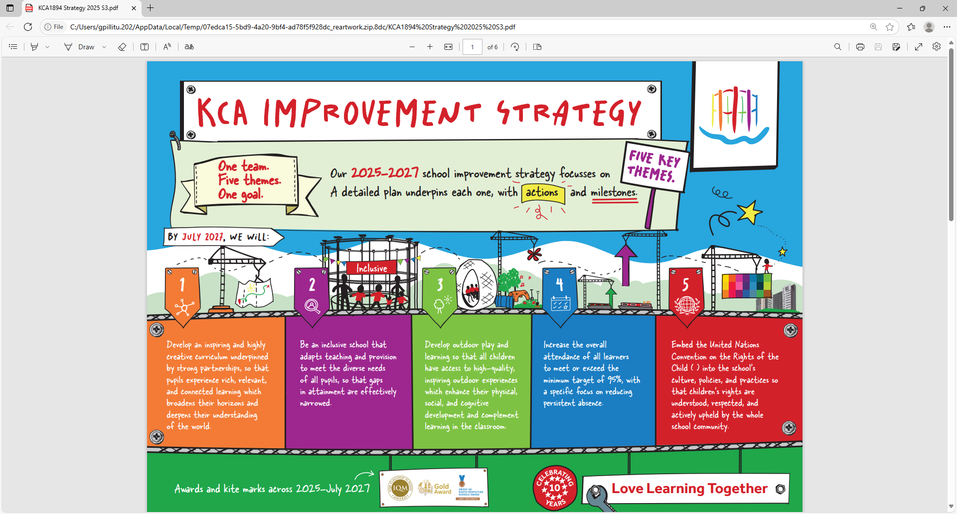

# Love Learning Together

**We are committed to safeguarding children and any appointment is subject to satisfactory checks and references. The position will require an Enhanced DBS check including barred list check. The post is exempt from the provisions of the Rehabilitation of Offenders Act 1974 (as amended in 2013 & 2020). This means that applicants are not required to disclose details of any youth cautions or ‘protected’ criminal convictions, adult cautions or bind-overs they may have incurred.**

**The Academy safeguarding policy is included with the application pack and we ask you to read this before applying for a post.**

**Application forms can be found on the recruitment section of our website.**

Completed applications should be sent to [bm@kingscrossacademy.org.uk](mailto:bm@kingscrossacademy.org.uk)

|  |  |  |  |
| --- | --- | --- | --- |
| **JOB DESCRIPTION** | | | |
| **Post Title:** | Attendance and Medical Officer | **Grade:** | 5 |
| **Contract:** | Two year fixed term contract | **Salary Range** | 12-15, pro rata term time only |
| **Responsible to:** Headteacher | | | |

PAGE 16

The Attendance and Medical Officer will be required to follow school policies and the staff code of conduct.

Please note that this is illustrative of the general nature and level of responsibility of the role. It is not a comprehensive list of all tasks that the employee will carry out. The postholder may be required to do other duties appropriate to the level of the role, as directed by the headteacher or line manager.

**PURPOSE OF THE JOB**

* To improve overall pupil attendance by working closely with families, staff and external agencies.
* To support the Lead First Aider in managing complex medical needs and care plans across the school.
* To ensure that allergens and medical needs are proactively considered across the lunch service and wider school systems.

**KEY RESPONSIBILITIES – ATTENDANCE AND MEDICAL OFFICER**

|  |  |
| --- | --- |
| **Attendance** | * Work directly with pupils and families to address and resolve attendance concerns. * Monitor and quality assure attendance systems (administered by the business team) to ensure statutory compliance. * Liaise with external agencies and coordinate casework for pupils with irregular attendance. * Initiate referrals and maintain accurate, up-to-date records of all interventions. * Conduct home visits where necessary to support families in improving attendance. * Collaborate with SLT to develop and implement school-wide attendance strategies. * Provide advice and training to staff and families on improving attendance. * Support enforcement processes, including Fixed Penalty Notices for persistent unauthorised absence. * Develop and maintain robust systems to improve punctuality and reduce absenteeism. * Represent the school in Camden learning networks focused on inclusive attendance improvement. |
| **Education Welfare** | * Participate in multi-agency case conferences and collaborative working groups. * Advise staff on exclusions and legal responsibilities. * Support borough-wide attendance initiatives. * Audit registers and report patterns to SLT. * Help secure provision for pupils missing education. * Lead sessions with parents on attendance, welfare, and wellbeing. |
| **Health and Medical Support** | * Act as Fire Marshal and follow Health & Safety policy. * Co-manage care plans and work closely with the Lead First Aider. * Communicate clearly with parents about incidents and health needs. * Maintain up-to-date logs of accidents and medicine administered. * Ensure first aid and medical information is accurate and confidentially managed. * Keep first aid kits and trip packs fully stocked. * Stay up to date with legislation and best practice. * Promote wellbeing initiatives to pupils and families. * Oversee medication checks and expiry tracking. * Meet regularly with the Lead First Aider to review procedures. |
| **Additional Duties** | * Develop professional practice and policies to enhance attendance and medical support. * Use IT systems for records and reporting. * Undertake performance reviews and relevant training. * Support other tasks as required, flexibly and professionally. * Line manage Midday Meal Supervisors safeguarding children with allergies. |
| **Performance Standards** | * Maintain confidentiality and discretion at all times. * Demonstrate commitment to inclusion and equality. * Act in accordance with the school’s Equal Opportunities and Safeguarding policies. |



|  |  |
| --- | --- |
| **PERSON SPECIFICATION** | |
| **Post Title:** | **Attendance and Medical Officer** |

You must demonstrate on your application form and during the selection process that you meet the following essential criteria: -

|  |  |
| --- | --- |
| **Factors** | **Essential** |
| **Qualifications & Training** | * GCSE or equivalent level, including at least a Grade 4 (previously Grade C) in English and maths * First-aid training, or willingness to complete it |
| **Experience** | * Experience working in a school environment or other educational setting * Experience working with children / young people * Experience planning and delivering learning activities * Experience of planning and leading teaching and learning activities (under supervision from a qualified teacher) |
| **Skills and knowledge** | * Good literacy and numeracy skills * Good organisational skills * Ability to build effective working relationships with pupils and adults * Skills and expertise in understanding the needs of all pupils * Knowledge of how to help adapt and deliver support to meet individual needs * Subject and curriculum knowledge relevant to the role, and ability to apply this effectively in supporting teachers and pupils * Excellent verbal communication skills * Active listening skills * The ability to remain calm in stressful situations * Knowledge of guidance and requirements around safeguarding children * Good ICT skills, particularly using ICT to support learning * Understanding of roles and responsibilities within the classroom and whole school context * Understanding of effective teaching methods * Knowledge of how to successfully lead learning activities for a group or class of children * Knowledge of how statutory and non-statutory frameworks for the school curriculum relate to the age and ability ranges of the learners they support * Knowledge of how to support learners in accessing the curriculum in accordance with the SEND code of practice |
| **Personal Qualities** | * Enjoyment of working with children * Sensitivity and understanding, to help build good relationships with pupils * A commitment to getting the best outcomes for all pupils, and promoting the ethos and values of the school * Commitment to maintaining confidentiality at all times * Commitment to safeguarding pupil’s wellbeing and equality * Resilient, positive, forward looking and enthusiastic about making a difference * Capacity to inspire, motivate and challenge children and young people |