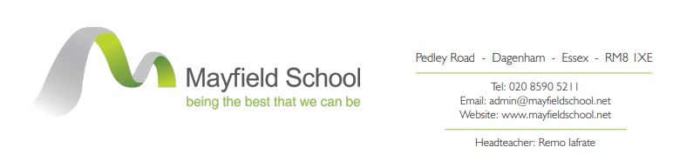
October 2021

Dear Candidate

Re: Vacancy – Attendance and Safeguarding Admin Assistant
36 hours pw term time (44.2 weeks)
Monday-Thursday 8am-4pm & Friday 8am-3.45pm
Scale 3 point 6, £19,146pa (actual)
FTE: £22,587pa

Contracted Hours: Please note that the successful candidate will be expected to be at work to commence work at the times noted above. An unpaid break of 30 minutes is included in the working hours (associate staff are not paid for breaks), and must be taken during the working day. Six hours per week will be allocated to working in Student Reception.

Thank you for your interest in the above post at Mayfield School.

Further information about the role can be found on the job description and the person specification. The successful candidate will be expected to attend courses applicable to the role as directed by the school, which includes compulsory Safeguarding training. They would also be expected to be a First Aider, and full training for this will be provided.

Please complete the Associate Application Form and the Recruitment Monitoring Form, which should be returned via email to, hr@mayfieldschool.net by Thursday 21 October 2021, 12:00 (noon). Please ensure that the form is sent as a Word document and not a PDF file, as to ensure unconscious bias is adhered to, as all application forms will be anonymised as part of the short-listing process.

Please ensure that you fully complete the application form, which must include the full name, address, postcode and email address of two referees.

References are taken up after short-listing. Please advise the named referees that you are using them on your application form as referees.

Should you have any questions or queries regarding the post, please contact Tina Vorley, Head of HR in the first instance, via an email to hr@mayfieldschool.net

Yours faithfully

Remo Iafrate
Headteacher

