

**Attendance and Well Being Officer**

# Contents

Headteacher’s Welcome. 4

The Recruitment Process. 5

Advertisement. 6

Post Overview. 8

Job Description. 9

Person Specification. 13

Our Ethos and Strategic Direction. 16

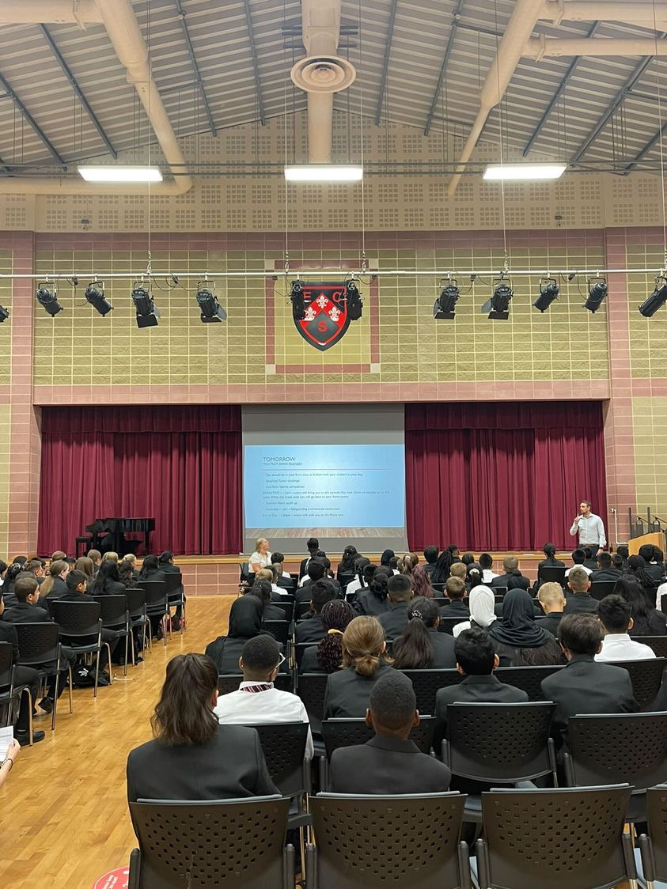

## Headteacher’s Welcome

Welcome to Eastbury Community School, and thank you for expressing an interest in applying for the position of Attendance and Well Being Officer.

For me, our school is where our young people are given the opportunities to allow them to realise their potential, and that potential can and does manifest itself in a range of ways.

Our young people need to see that success comes in a range of different forms, and ECS is where they can explore where and how they can and will be successful. Our pupils get some of the best progress results in GCSEs in the local area, our 6th Form- judged outstanding (March 2024) achieves some of the best results in the Barking and Dagenham, and over half of these young people go on to attend Russell Group universities.

Our young people need to have a voice in the school, the local community and the wider world. As part of our commitment to this belief we are a Rights Respecting School – Silver award at the moment, but we are confident that within the next year we will achieve Gold – one of the only 3-19 schools in London to do so.

Sir Tim Brighouse said “If a teacher makes the weather the school creates the climate.” and I firmly believe this. It is our role as a leadership team to create the best possible learning environment for our teachers to teach in. In return we expect the best possible teaching from them and our results show this over time. We have created systems and structures that support high quality learning, whilst minimising workload and maximising impact.

**Our recent Ofsted report – March 2024 stated:**

“*Pupils are proud to be part of this inclusive community where people respect and care for each other. They appreciate the support they receive from staff if they have a concern” .*

*“Leaders are ambitious for all pupils to achieve well”*

*“The school takes effective steps to address behaviour that does not meet its high expectations. Pupils conduct themselves well and enjoy their time at school. Low level disruption in lessons is rare”*

*“Staff, including early career teachers, said that leaders have carefully considered their workload and well-being. They value the many opportunities to improve their professional practice.”*

If you share our ethos and values and absolutely believe in the potential of all young people then we can offer you the chance to make a difference and change our community for the better, and look forward to receiving your application form and welcoming you to our school.

 **Sharon Gladman – Executive Headteacher**

**The Recruitment Process**

We are proud of our school, the staff and pupils and in normal times we would warmly welcome prospective applicants to visit us prior to application to learn more about the role and view the school in action.

**Key Dates**

**Closing Date for Applications Friday 1 November 2024**

**Interviews w/c Monday 11 November 2024**

Please note all dates are subject to change.

To arrange your visit please email**:** [**kdunnell@eastbury.bardaglea.org.uk**](mailto:kdunnell@eastbury.bardaglea.org.uk)

Completed applications should be sent to: [**kdunnell@eastbury.bardaglea.org.uk**](mailto:kdunnell@eastbury.bardaglea.org.uk)



**Advertisement**

**Advertisement**

**ATTENDANCE AND WELL BEING OFFICER**

**35 HOURS PER WEEK, TERM TIME ONLY**

**COMMENCING ASAP**

**PERMANENT CONTRACT**

**SALARY APT & C SCALE 6 £27,936 - £28,812 (Actual Salary)**

This is an excellent opportunity for a committed and innovative individual, in a successful, well ordered, and inclusive 3-19 all through school. We are at the heart of an ethnically diverse community in London East, an area undergoing significant regeneration and building affordable homes. We are a successful school, where academic outcomes and character development are at the heart of everything we do. We believe our students can achieve and give them the opportunities to realise their potential.

We foster a collaborative culture where talented individuals are empowered to produce their best work in brand new purpose built accommodation.

**About The Role:**

We are seeking an Attendance and Well-being officer to support the attendance team and lead on reducing persistent absence through all phases within the school. This work will support the attendance team in the school through working with students and families to promote positive attendance to school as well as to complete home visits as a means to improve student engagement and outcomes.

The successful candidate will:

* Be a dedicated team player who is committed to the happiness, well-being, self-esteem and progress of everyone at the school
* Be able to support the health and well-being of pupils thus enabling them to have a positive learning experience
* Work with staff in supporting pupils pastorally and demonstrate passion and enthusiasm
* Be able to and willing to make contributions to the wider school community

**Find out more about a career at ECS here:** [**Join Our Community**](https://www.eastbury.bardaglea.org.uk/Work-for-Us/index.asp)

ECS celebrates its diversity, and we positively welcome applications from all sections of the

community. If you are interested in making a difference in young people’s lives, whatever your background or history please apply.

In return we can offer:

* A pupil centred, progress focused ethos.
* A welcoming and supportive community.
* The opportunity to work with a passionate, hardworking and supportive staff.
* A commitment to develop your skills through continued professional development.
* A supportive and committed Leadership Team and Governing Body.
* A cohort of pupils with high aspirations and a willingness to learn.
* A school which understands the importance of staff well-being and workload management

*“Pupils value the opportunities that they have to work with leaders to further improve the*

*school, for example through the school council. Older pupils, and students in the sixth*

*form, help pupils in the primary phase with their reading. Pupils benefit from a range of*

*extra-curricular clubs, both at lunchtime and after school.” (Ofsted March 2024)*

Please click here to find out more information about what it is like to work at ECS:

<https://www.eastbury.bardaglea.org.uk/>

The school is located less than 10 minutes’ walk from Upney tube and 15 minutes from Barking mainline station.

To find out more about how teachers can secure rented accommodation at a discounted rate of 20% please contact: [**info@bdsip.co.uk**](mailto:info@bdsip.co.uk)

For full details of the post and an application form, please visit the school website [www.eastbury.bardaglea.org.uk](http://www.eastbury.bardaglea.org.uk) and return the application form to the Headteacher’s PA, Karen Dunnell [kdunnell@eastbury.bardaglea.org.uk](mailto:kdunnell@eastbury.bardaglea.org.uk). The closing date for applications is Friday 1 November 2024 and interviews will be held w/c Monday 11 November 2024.

ECS is committed to safeguarding and promoting the welfare of children and is an Equal Opportunities Employer.

This post is exempt from the Rehabilitation of Offenders Act 1974 and a comprehensive screening process, including Disclosure check, will be undertaken on all successful applicants.

**Attendance and Well-Being Officer Overview**

Pastoral care is immensely important and Eastbury. Strong support structures for the well-being of pupils foster better learning outcomes for pupils. The attendance and well-being officer would be joining an established team of staff, providing emotional support, as a means to improve pupil attendance and access to learning.

**Applicant Information**

* All applications will be seriously considered.
* The appointment is for a person who is organised, has an excellent knowledge and understanding of how to address non-attendance/persistent absence challenges
* The appointed person would be working closely with the attendance and safeguarding team as well as Year Co-ordinators and external professionals from Health Services to ensure that appropriate support is provided for all pupils.
* The person appointed will be expected to work well within a team, have a good sense of humour, and be a reflective practitioner who looks to improve their own practice.

|  |  |
| --- | --- |
| **POST TITLE**  **School Context**  **Department Context**  **Purpose:**  **Attendance / Punctuality Duties & Responsibilities** | **JOB DESCRIPTION**  **Attendance and Well-Being Officer 3-19**  Eastbury Community School (ECS) is an All-through School for pupils aged 3-19 in the London Borough of Barking and Dagenham  The Attendance Team is currently composed of 1 member of staff in Primary Phase, 4 in Secondary Phase and 1 in the Sixth Form. This team works alongside the Safeguarding Team, Year Co-ordinators and SLT to ensure positive attendance and that pupils receive quality pastoral support  Under the direction of the SLT Lead for attendance, to manage attendance/punctuality & persistent absence concerns at Eastbury Community all through school (3-19). This will include contributing to the school’s Safeguarding Team through welfare visits of persistent absentees as a means to support improved attendance.   * To contribute to the school meeting its statutory obligations and targets with regard to school attendance/punctuality. * To monitor and support the attendance of pupils though managing the school’s caseload of persistent absence and non-attendees across the school, all-through (3-19) and to assist and participate in the development and review of school attendance/punctuality policies and evaluate their operation and effectiveness. * To encourage, enable and, where necessary, enforce the school attendance procedures of all children of school age, working with the wider family, community and external agencies. * To promote the welfare, mental wellbeing, appropriate development and protection of children and young people. * To liaise with outside agencies and the running of early help interventions, formally CAF’s and TAF’s. * To act on behalf of Eastbury Community School in carrying out the provisions of relevant of attendance and punctuality legislation. Completing paperwork for court proceedings, ensuring that a stepped approach to attempting to improve attendance has been completed. This will also include completing regular home visits. * To contribute to raising achievement in all year groups by improving attendance/punctuality at school. * To contribute to a programme of regular monitoring of the school’s attendance/punctuality rates, take steps to secure the regular attendance of students. * To liaise with and bring areas of concern to the attention of the member of Senior Leadership Team who has the responsibility of addressing attendance and punctuality. * To plan and undertake task centred casework with children and their families to bring about improved school attendance. This will necessitate considering factors within and beyond the immediate educational environment, and signposting additional services required. * To make unaccompanied visits to students and/or parents at their homes (if necessary outside normal working hours) to formulate strategies and plans with the objective of securing improved attendance. * To line manage the school’s well-being mentor, ensuring that programmes of support are in place for both 1:1 and small group intervention to support improved well-being and attendance. * To review the effectiveness of support programmes regularly, updating the SLT team and school governors. * To work alongside the attendance teams in all phases having oversight of pupils who are persistent absentees and oversight of pupils who are at risk of becoming a persistent absence. * To attend and contribute to weekly vulnerable pupil meetings, supporting the safeguarding of pupils and families and to be prepared to update on specific cases regularly. * To attend, when required, professionals’ meetings (safeguarding) in order to ensure contextual safeguarding in considered for all pupils with poor attendance. * Under the direction of the SLT Attendance lead to prepare documents, using the LA framework in relation to Fixed Penalty Notices (irregular school attendance) on behalf of the School. * Under the direction of the SLT Attendance Lead, to prepare documents using the LA framework, for Court on behalf of the School/LA. * To attend all local authority training and updates relevant to attendance and punctuality. * To liaise with primary schools to enable early identification of students with a history of poor attendance/punctuality to enable intervention work to be started prior to the transition. * To contribute to the analysis of attendance data for the Governors report on a termly basis. |
|  |  |
| **Reporting to:** | Deputy Headteacher; The Inclusion Lead; Post-holders in the department |
|  |  |
| **Responsible for:** | The provision of a support for pupils with attendance concerns. |
|  |  |
| **Liaising with:** | Staff and students, parents, outside agencies, local authority. |
|  |  |
| **Working Time:** | 35 hours per week |
|  |  |
| **Salary/Grade:** | Scale 6 |
|  |  |
| **Disclosure level** | Enhanced |
|  |  |
| **Proposed Other Specific Duties**: | |
| **General Responsibilities and Duties:**   * To ensure that all work undertaken with children and young people places their views at the forefront, and reflects current legislation and good practice * To be a nominated First Aider (training given if required). * Assist with the implementation of Health and Safety/Fire warden duties as appropriate. * Be available to assist with personal and medical care for disabled students across the school when required (training available).   **General responsibilities and duties- Attendance/punctuality**   * To provide direct support and input to whole school attendance/punctuality policy and systems. * To contribute to the schools’ analysis of attendance/punctuality data in order to achieve improvements and individual school attendance/punctuality targets. * To prepare and present written updates and reports on the analysis of attendance/punctuality and Child protection for the school community, including to the Senior Leadership Team and the school Governors on a termly basis.      * To maintain accurate, concise and comprehensive case records including the use if ICT and various software packages. * To participate in planning and review meetings regarding school attendance, having contributed to making the decision to proceed using professional judgement. * To contribute to the design programmes of intervention and to assist with the preparation and enforcement of Education Supervision Orders and to fulfil the duties required by the supervising officer in relation to Education Supervision Orders. * To act on behalf of the school in contributing to the presentation of cases to Magistrates, Family Proceedings Courts and the High Court if required. * To contribute to, make recommendations and participate in decisions regarding the implementation of court proceedings. * To participate in joint initiatives on attendance/punctuality, including working with outside agencies such as the Police.   **Whole School responsibilities**   * To maintain receipts and documentation of any expenditure in order to facilitate the monitoring of the budget. * Be available to assist with personal and medical care for disabled students across the year group when required (training available). * To ensure compliance with and actively promote Health & Safety at Work Legislation, School and Council Health & Safety policies and procedures. * To ensure compliance with and actively promote the School and Council’s Equalities and Diversity policies and strategies, * To take a proactive approach towards the School’s ‘Best Value’ ethos and ensure compliance with appropriate legislation, School and Council policies and the Council’s Standing Orders and Financial Regulations. * Employees will be expected to comply with any reasonable request from a manager to undertake work of a similar level that is not specified in this job description. * Employees are expected to be courteous to colleagues and provide a welcoming environment to visitors and telephone callers. * Comply with the Data Protection Act 1990 and GDPR 2018.   The school will endeavour to make any necessary reasonable adjustments to the job and the working environment to enable access to employment opportunities for disabled job applicants or continued employment for any employee who develops a disabling condition. | |
|  | |
| This job description is current at the date shown, but following consultation with you, may be changed by Management to reflect or anticipate changes in the job which are commensurate with the salary and job title | |

Headteacher: …………………………………………………………….………………………………

Attendance and Well Being Officer 3-19 : ………………………………………………………

Date issued: ……………………………………………………………….…………………………………….

|  |  |
| --- | --- |
| Person Specification Attendance and Well-Being Officer **We are seeking to appoint an effective colleague who:** | **Assessment:**  **A = Application**  **IT = Interview task**  **I = Interview**  **R = Reference** |
| 1. is passionate about pupil attendance and pastoral care and is well qualified 2. is hardworking, well-motivated and positive 3. has the ability to provide support effectively as a means to improve pupil attendance 3-19. 4. can communicate effectively with pupils 5. is competent with the use of IT / school network systems 6. is committed to collaborative planning 7. delivers well-structured support plans for improved attendance 8. has appropriate and demanding expectations for pupils’ attendance across the age and ability range 9. communicates effectively with parents 10. understands the need to take responsibility for their own professional development 11. conducts effective working relationships with staff, parents / carers & pupils 12. understands the need to look after resources and use them effectively 13. has high standards and expectations of self and others 14. supports a collegiate management style 15. has a sense of humour | * + - 1. **A,IT,I,R**       2. **A,I,R**       3. **IT,I,R**       4. **IT,R**       5. **A,IT, I, R**       6. **I,R**       7. **A,IT,I,R**       8. **A,I,R**       9. **A,I,R**       10. **A,I,R**       11. **A,I,R**       12. **A,I,R**       13. **A,IR**       14. **A,I,R**       15. **A,I** |







**Job Description**

**Job Description**

**Our Ethos and Strategic Direction**

**Our Ethos and Strategic Direction**



