

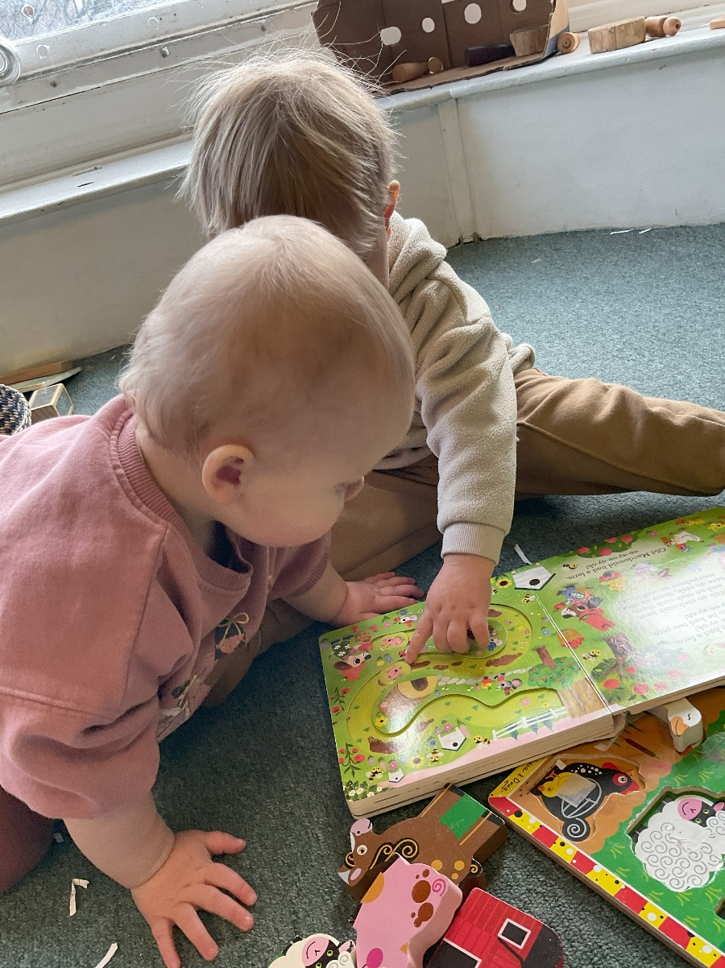

Baby Room Advanced Teaching Assistant
Childhaven Community Nursery School
Recruitment Information Pack



Contents

About the School 3
Application Process 4
Job Description and Person Specification 5 – 8
Applying for a job with North Yorkshire Council 9

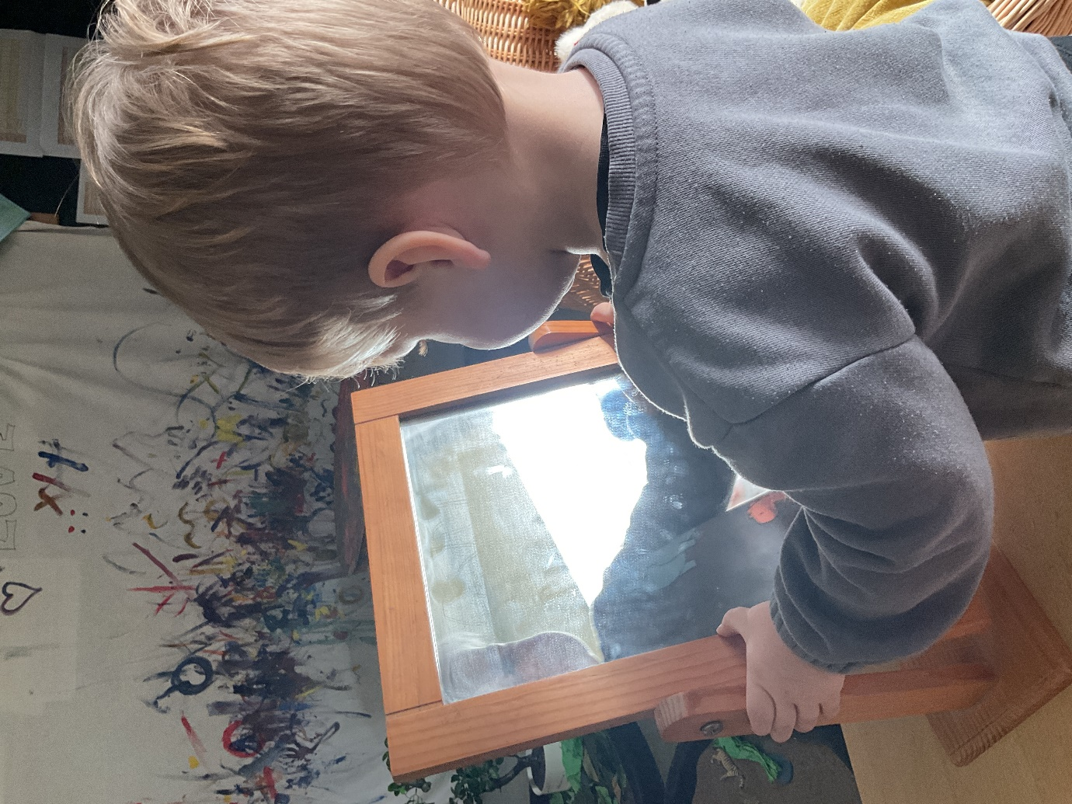

Childhaven Community Nursery School

Discover, Play, Learn – Providing Outstanding Early Education

An OUTSTANDING school in the heart of Scarborough, at Childhaven, we are committed to supporting our children develop into resilient, independent life-long learners. We were judged to be OUTSTANDING by Ofsted in 2012,2015, 2019, and then again in 2024!

We provide a vibrant, welcoming and inspirational setting and serve the communities around the Scarborough Town. We are one of only 3 maintained nursery schools in North Yorkshire and we offer children a unique start to their education. Children aged between 2 and 4 play and learn together in our wonderful Victorian building and garden.

As a designated DfE Early Years Stronger Practice Hub we share best practice and are committed to training the next generation of teachers and support staff.

Thank you for your interest in joining our team. This is an exciting time for us as we strengthen and develop our nurturing provision for our children, as we support children with a wide range of additional needs.

We look forward to receiving your application.



Application Process
Please apply via NYC Jobs

The closing date for all applications is 11:59pm Sunday 12th April

Interviews will be held week beginning 20th April

An email will be sent to candidates with details of the shortlisting process.
We do not accept CV’s.
Please get in touch if you require the form to be sent in a different format.

Queries
Please contact Chloe Bullen on 01609 536 964 or via chloe.bullen@northyorks.gov.uk
Chloe has been engaged to support us with recruiting to this exciting opportunity.



Job Description
Post title: | Advanced Teaching Assistant – Early Years
Grade: | E
Responsible to: | Head Teacher / Higher Level Teaching Assistant / Senior Advanced Teaching Assistant / SENCO/ Inclusion Manager
Staff managed: | None
Directorate: | Children’s and Young People’s Service
School name:
Job family: | E - Education/School
Date of issue: | August 2023
Context Statement
- This school is committed to safeguarding and promoting the welfare of our pupils and young people. We have a robust Child Protection Policy and all staff will received training relevant to their role at induction and throughout employment at the School. We expect all staff and volunteers to share this commitment. This post is subject to a satisfactory enhanced Disclosure and Barring Service criminal records check for work with children.
- The school is committed to supporting the needs of all children so that they can fulfil their full potential. This includes supporting children with their Social, Emotional and Mental Health (SEMH) needs and wellbeing. We expect all staff and volunteers to share this commitment.
- The school supports access to the curriculum for all children as part of NYC’s commitment to inclusive education.
- The school is inclusive to all children and will support their individual needs. In line with the school’s commitment to ensure access to education for all children, the school may require staff to support children/s medical needs (loco parentis) in line with a healthcare plan. When required, additional training will be provided as appropriate, and an additional allowance for supporting medical needs may be an entitlement whilst undertaking such duties. The medical needs allowance criteria / framework must be followed to determine whether allowance is payable.
- All school employees are responsible for contributing to a learning environment that is innovative, engaging, happy and fulfilling for all pupils, and for ensuring all pupils’ safety and welfare.

Job Purpose:
- To work with teachers and other school employees to support teaching and learning by working with individuals or small groups of pupils under the direction of teaching staff, and may be responsible for some learning activities within the overall teaching plan. May work in the classroom or appropriate location within the school, with access to support and guidance as required.
- To provide support to pupils including promoting pupils’ independence, self-esteem, and social inclusion

Operational management: | - Working under the direction of the headteacher, within the framework of the medium and short–term planning, plan learning activities, and adapt provision to meet the needs of pupils.  - Where required, under the direction of the headteacher/SENCO plan and lead group sessions, including “story groups”, key worker “island times” or focussed small groups for identified groups of children.  - As key workers, maintain learning stories and provide regular feedback on children’s learning, progress and development, using the agreed format.  - Engage with children to develop sustained, shared thinking, and promote the characteristics of effective learning, as defined in the EYFS.  - Support children in self-regulating their behaviour, as part of their personal, social and emotional development; encouraging children to become aware of the consequences of their actions for others and helping them to become aware of the needs and feelings of others.  - Develop positive relationships with parents and carers and enable them to contribute to children’s learning and celebrate children’s experiences and achievements at home and nursery.  - Support pupils in their social and emotional well-being, and develop and implement related social, health and physical programmes.  - Encourage and motivate pupils to promote independence and resilience and increase self-esteem.  - Support children on visits where the planning and risk assessments have been approved by the Headteacher(s).  - Be prepared to work flexibly, within the defined parameters of the post, to meet the needs of the setting, and the changing levels of occupancy throughout the year  - Promote inclusion and acceptance of all pupils
Communications: | - Establish rapport and respectful, trusting relationships and communicate effectively with pupils, their families and carers, and other agencies / professionals.  - Initiate appropriate and effective communication with the class teacher, and other professionals, forging and sustaining relationships across agencies.  - Support pupils in their social and emotional well-being, and develop and implement related social, health and physical programmes.
Resource management: | - Prepare and maintain the learning environment, with reference to planned provision and identified enhancements.  - Undertake routine clerical duties as required.  - Support the use of ICT and adhere to relevant policies.  - Participate in appraisal, training and other learning activities
Systems and information: | - Act as key worker – maintain “learning stories” and observational assessments so that children’s learning and progress can be tracked and recorded. E.g. 2-year-old progress checks.  - Participate in “integrated assessments” with Health Visitors.  - Hold termly meetings with parents following moderation/key worker meetings with the headteacher provide up-to-date assessments or reports for meetings as required (e.g. Child Protection Conferences, SEND reviews).  - Assist in the induction and development of classroom support staff, cascading information and good practice.  - Pay due regard to professional boundaries, maintaining appropriate levels of confidentiality.  - Participate in staff meetings.  - Share information confidentially about pupils with teachers and other professionals as required.
Safeguarding: | - Carry out tasks associated with pupil’s personal hygiene and welfare, including personal intimate care, physical and medical needs, whilst encouraging independence.  - Be responsible for promoting and safeguarding the welfare of pupils in line with policy and legislation, raising concerns as appropriate

Person Specification:
Essential | Desirable
Knowledge and Experience  - Good understanding of child/ young people’s development and learning processes  - Understanding of individual children and young people’s needs  - An understanding that children/Young people have differing needs and knowledge of inclusive practice  - Appropriate experience working with children in an educational setting | - Knowledge of Behaviour Management techniques  - Knowledge of Child Protection policies & Procedures  - Knowledge of Health & Safety legislation  - Experience in other relevant skills e.g. art/music/sport  - Experience of delivering evidence based interventions that accelerate learning
Occupational Skills  - Good written and verbal communication skills: able to communicate effectively and clearly and build relationships with a range of staff, children, young people, their families and carers  - Behaviour management  - Good reading, writing and numeracy skills  - Demonstrable interpersonal skills  - Ability to work successfully in a team  - Able to exercise judgement  - Confidentiality | - Demonstrable ICT skills and ability to use them as part of the learning process, or, the ability to develop ICT skills in a reasonable timeframe
Behaviours

- link
Professional Qualifications  - Relevant NVQ Level 3 or equivalent | - Appropriate first aid training
Other Requirements
- To be committed to the setting's policies and ethos
- To be committed to Continuing Professional Development
- Motivation to work with children and young people
- Ability to form and maintain appropriate relationships and personal boundaries with children and young people
- Emotional resilience in working with challenging behaviours and attitudes
- Ability to use authority and maintaining discipline
- An empathy for equality & diversity

APPLYING FOR A JOB WITH NORTH YORKSHIRE COUNCIL
IMPORTANT ADVICE ON COMPLETING THIS APPLICATION

Your application form plays an important part in your selection. Please ensure you address all the essential requirements listed in the specifications. The following advice should help you to complete the application form as effectively as possible.
Data Protection
The information that you state on this application form will be used by the school and the Council to consider you for a job vacancy. To find out about how we use your personal data for the purposes of recruitment please see our Privacy Notice at www.northyorks.gov.uk/working-us.

Rehabilitation of Offenders
The post you are applying for requires you to have an enhanced Disclosure and Barring Service criminal records check for work with children, with a barred list check if you work in regulated activity. This check for disclosure of criminal history will include spent convictions, pending prosecutions / current court proceeding and police enquiries.

Should you be shortlisted, you will be asked to disclose full details of your criminal history prior to your interview. This includes any information deemed relevant as part of Keeping Children Safe in Education which may arise in an online search undertaken on shortlisted candidates. This information may be discussed with you at your interview in order to assess job related risks, but we emphasise that your application will be considered on merit and ability and you will not be discriminated against unfairly. Failure to disclose this information will result in any offer of employment being withdrawn.

Please also see the policy statement on the Recruitment of Ex-offenders below.

Information in Support of your Application
Every post advertised is supported by a full person specification. The specification lists all the essential skills, experience and qualifications which are necessary for the job and the criteria against which you will be assessed, both through your application form and at interview.

As part of the application process, you may have been asked to demonstrate within this application form how you meet some or all of the criteria or key competencies outlined in the person specification. Rather than simply repeating your career history, look at the skills and experience required by the job and provide evidence that you possess them by giving specific and detailed examples which include a focus on outcomes and on your own contribution to the scenario. Try to use different and varied examples wherever possible.

When completing these sections, do not forget the skills and experience you have gained outside full-time work. Outlining your previous work experience or other responsibilities may help you to uncover skills which you have taken for granted and which are clear signs of your ability to do the job.

Canvassing
You must not try to influence an elected Council Member, any council employee or a member of the school governing body, to act in your favour, as this will disqualify you. If you are related to a Councillor, a Council employee or a governor you must indicate this in the relevant section of the application form.

Policy Statement on the Recruitment of Ex-offenders
(Source www.gov.uk)
- As an organisation assessing applicants’ suitability for positions which are included in the Rehabilitation of Offenders Act 1974 (Exceptions) Order using criminal record checks processed through the Disclosure and Barring Service (DBS), this school complies fully with the DBS code of practice and undertakes to treat all applicants for positions fairly.

- This school undertakes not to discriminate unfairly against any subject of a criminal record check on the basis of a conviction or other information revealed.

- This school can only ask an individual to provide details of convictions and cautions that it is legally entitled to know about. Where a DBS certificate can legally be requested (where the position is one that is included in the Rehabilitation of Offenders Act 1974 (Exceptions) order 1975 as amended, and where appropriate Policy Act Regulations as amended) this school can only ask an individual about convictions and cautions that are not protected.

- This school is committed to the fair treatment of its staff and potential staff, regardless of race, gender, religion, sexual orientation, responsibilities for dependents, age, physical/mental disability or offending background.

- This school has this written policy on the recruitment of ex-offenders, which is made available to all DBS applicants at the start of the recruitment process.

- This school actively promotes equality of opportunity for all with the right mix of talent, skills and potential and welcome applications from a wide range of candidates, including those with criminal records. Candidates are selected for interview based on their skills, qualifications and experience and criminal record information is only requested from short-listed candidates.

- A disclosure is only requested from the DBS after a thorough risk assessment has indicated that one is both proportionate and relevant to the position concerned. For those positions where a criminal record check is identified as necessary, all application forms, job adverts and recruitment briefs will contain a statement that a DBS certificate will be requested in the event of the individual being offered the position.

- This school ensures that all those who are involved in the recruitment process have been suitably trained to identify and assess the relevance and circumstances of offences.

- This school also ensures that they have received appropriate guidance and training in the relevant legislation relating to the employment of ex-offenders, e.g. the Rehabilitation of Offenders Act 1974.

- At interview, or in a separate discussion, this school ensures that an open and measured discussion takes place on the subject of any offences or other matter that might be relevant to the position. Failure to reveal information that is directly relevant to the position sought could lead to withdrawal of an offer of employment.

- This school makes every subject of a criminal record check submitted to DBS aware of the existence of the code of practice and makes a copy available on request.

- This school undertakes to discuss any matter revealed on a DBS certificate with the individual seeking the position before withdrawing a conditional offer of employment.

