**Baby Room Leader**

**Childhaven Community Nursery School**

**Recruitment Information Pack**



## Contents

About the School 3

Application Process 4

Job Description and Person Specification 5

Applying for a job with North Yorkshire Council 10

**Childhaven Community Nursery School**

*Discover, Play, Learn – Providing Outstanding Early Education*

 An OUTSTANDING school in the heart of Scarborough, at Childhaven, we are committed to supporting our children develop into resilient, independent life-long learners. We were judged to be OUTSTANDING by Ofsted in 2012,2015, 2019, and then again in 2024!

We provide a vibrant, welcoming and inspirational setting and serve the communities around the Scarborough Town. We are one of only 3 maintained nursery schools in North Yorkshire and we offer children a unique start to their education. Children aged between 2 and 4 play and learn together in our wonderful Victorian building and garden.

As a lead school within the Scarborough Teaching Alliance we share best practice and are committed to training the next generation of teachers and support staff.

Thank you for your interest in joining our team. This is an exciting time for us as we strengthen and develop our nurturing provision for our children, as we support children with a wide range of additional needs.

We look forward to receiving your application.

## Application Process

**Please apply via NYC Jobs**

The closing date for all applications is **11:59pm Thursday 4th September**

**Interviews will be held Friday 12th September**

An email will be sent to candidates with details of the shortlisting process.

We do not accept CV’s.

Please get in touch if you require the form to be sent in a different format.

**Queries**

Informal chats about the role are welcomed and encouraged. Informal chats about the role are welcomed and encouraged.

Please contact [NYES.Resourcing@northyorks.gov.uk](mailto:NYES.Resourcing@northyorks.gov.uk)

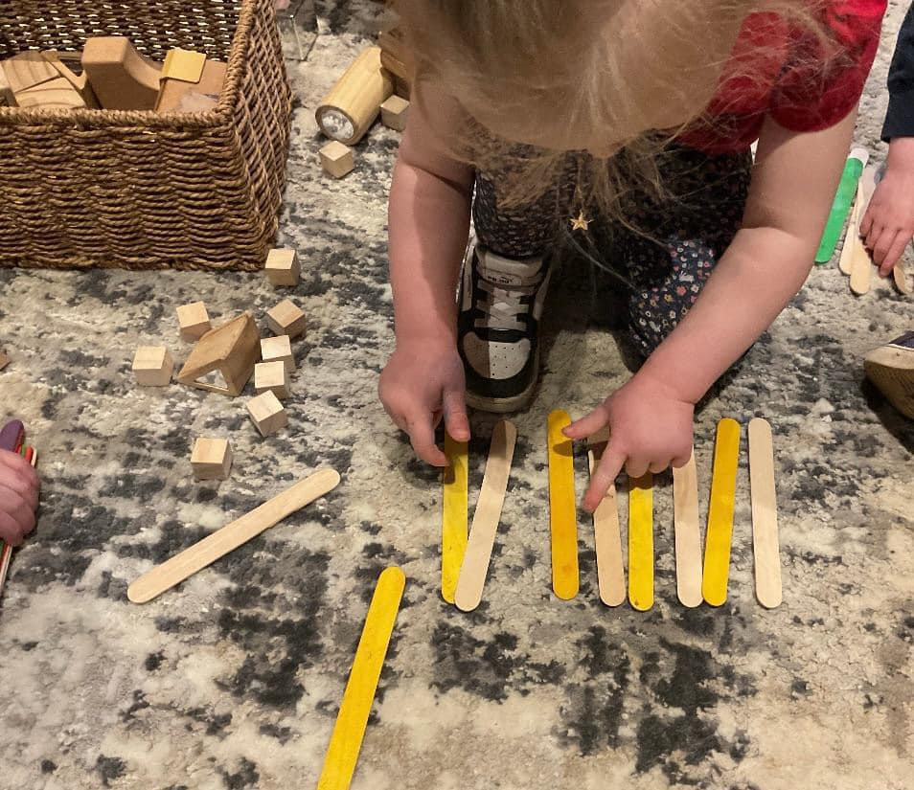

**Job Description**

|  |  |
| --- | --- |
| **Post title:** | Senior Advanced Teaching Assistant (SATA) |
| **Grade:** | F |
| **Responsible to:** | Head Teacher / Member of Senior Management Team/Higher Level Teaching Assistant / SENCO / Inclusion Manager |
| **Staff managed:** | ATAs, GTAs, and other support staff working in the classroom environment supporting the learning process |
| **Directorate:** | Children’s and Young People’s Service |
| **School name:** | Childhaven Nursery School |
| **Job family:** | E - Education/School |
| **Date of issue:** | June 2025 |

|  |
| --- |
| Context Statement |
| This school is committed to safeguarding and promoting the welfare of our pupils and young people. We have a robust Child Protection Policy and all staff will receive training relevant to their role at induction and throughout employment at the School. We expect all staff and volunteers to share this commitment. This post is subject to a satisfactory enhanced Disclosure and Barring Service criminal records check for work with children. |

|  |  |  |
| --- | --- | --- |
| Job purpose | | * Delivers learning activities for a significant number of individual pupils or groups (in the case of small primary schools, groups may constitute the whole class). Activities may involve assisting in the planning, preparing and delivering of learning activities as well as monitoring pupils, assessing, recording and reporting on pupils’ achievement, progress and development, under the direction of class/subject teacher. * Can be required to provide cover supervision for the short-term absence of teaching staff for whole classes. Can be responsible for working within a specific work area, e.g. Pastoral, Behaviour or SEN * To act as key worker for a group of children, supporting the learning and development of pupils under the overall direction of the headteacher/teacher. * Work collaboratively within the nursery team. |
| Supporting Learning and Development: | | * Working under the direction of the headteacher and teachers, within the framework of the medium and short–term planning, plan and prepare learning activities, and adapt provision to meet the needs of pupils. * Monitor, evaluate and record pupil responses to learning activities through a range of assessment and monitoring strategies against pre-determined learning objectives * Where required, under the direction of the headteacher/teachers plan and lead group sessions, including “story groups”, or other focussed small groups for identified groups of children. * As a key person, maintain learning stories and provide regular feedback on children’s learning, progress and development, using agreed formats. * Take account of the effects of different parenting approaches, backgrounds and routines, and be involved in home school liaison * Engage with children to develop sustained, shared thinking, and promote the characteristics of effective learning, as defined in the EYFS. * Support children in self-regulating their behaviour, as part of their personal, social and emotional development; encouraging children to become aware of the consequences of their actions for others and helping them to become aware of the needs and feelings of others. * Develop positive relationships with parents and carers and enable them to contribute to children’s learning and celebrate children’s experiences and achievements at home and nursery. * Support pupils in their social and emotional well-being, and develop and implement related social, health and physical programmes. * Encourage and motivate pupils to promote independence and resilience and increase self-esteem. * Support children on visits where the planning and risk assessments have been approved by the Headteacher(s). * Be prepared to work flexibly, within the defined parameters of the post, to meet the needs of the setting, and the changing levels of occupancy throughout the year * Promote inclusion and acceptance of all pupils   Cover short-term teacher absence and communication, work as planned by the classroom teacher and manage pupil behaviour |
| Communication: | | * Establish rapport and respectful, trusting relationships and communicate effectively with children, young people, their families and carers * Initiate appropriate and effective communication with the class teacher, and other professionals, forging and sustaining relationships across agencies |
| Sharing Information: | | * Act as key person – maintain “learning stories” and observational assessments so that children’s learning and progress can be tracked and recorded. E.g. 2-year-old progress checks. * Participate in “integrated assessments” with Health Visitors. * Hold regular meetings with parents following moderation/key worker meetings with the teacher / headteacher provide up-to-date assessments or reports for meetings as required (e.g. Child Protection Conferences, SEND reviews). * Assist in the induction and development of classroom support staff, cascading information and good practice |
| Safeguarding and Promoting the Welfare of Children and Young People: | | * Assist with pupils’ personal, hygiene (including personal intimate care), and welfare, including physical and medical needs, whilst encouraging independence * Be responsible for promoting and safeguarding the welfare of pupils in line with policy and legislation, reporting concerns as appropriate. |
| Administration / Other: | | * Organise and manage appropriate learning environment and resources * Support the use of ICT to advance pupils’ learning, use common ICT tools for own and pupils’ learning * Co-ordinate the activities of students entering the school for the purpose of work experience/ work placements * Assist with administrative support e.g. dealing with correspondence, compilation/ analysis, presentation of displays, making phone calls, reporting on attendance, exclusions etc. * Assist in the supervision, recruitment/ induction/ appraisal/ training/ mentoring of other support staff working across the school, where appropriate, sharing good practice * Under the guidance and supervision of a class teacher be responsible for marking the register or being a form tutor * Supervise and provide access arrangements for pupils sitting internal and external examinations ensuring that examinations comply with Examination Board Regulations * Participate in appraisal, training and other learning activities |
| Data Protection | | * To comply with the School’s policies and supporting documentation in relation to Information Governance this includes Data Protection, Information Security and Confidentiality |
| Health & Safety | | * Be aware of and implement your health and safety responsibilities as an employee and where appropriate any additional specialist or managerial health and safety responsibilities as defined in the Health and Safety policy and procedure * To work with colleagues and others to maintain health, safety and welfare within the working environment |
| Equalities | | * Promote inclusion and acceptance of all pupils * Ensure services are delivered in accordance with the aims of the equality Policy Statement * Develop own and team members understanding of equality issues |
|  | Whilst this job description provides a summary of the post, this may need to be adapted or adjusted to meet changing circumstances. Such changes would be commensurate with the grading of the post and would be subject to consultation. All staff are required to comply with School’s Policies and Procedures. | | |

|  |  |
| --- | --- |
| Person specification: |  |
| Essential | **Desirable** |
| Knowledge   * Good understanding of child/young people’s development and learning processes * Understanding of individual children and young people’s needs * An understanding that children/young people have differing needs and knowledge of inclusive practice * Knowledge of Behaviour Management techniques | * Knowledge of Child Protection legislation * Knowledge of Health & Safety legislation |
| Occupational Skills   * Demonstrable ICT skills and ability to use them as part of the learning process, or, the ability to develop ICT skills in a reasonable timeframe. * Good written and verbal communication skills: able to communicate effectively and build good relationships with all staff, children, young people, families and carers |  |
| Experience   * Experience of working with children in an early years setting | * Experience working with children aged 0-2 * Supervisory experience * Experience in a particular specialism relevant to the post e.g. Art/Music/Sport * Experience of delivering evidence based interventions that accelerate learning |
| Behaviours   * Demonstrable interpersonal skills * Ability to work successfully in a team * Able to exercise judgement * Confidentiality * Flexibility | * Creativity |
| Professional Qualifications   * Relevant NVQ level 3 qualification or equivalent | * Level 2 qualification or equivalent in English & Maths * Appropriate first aid training |
| Other Requirements   * Enhanced DBS clearance * To be committed to the school's policies and ethos * To be committed to Continuing Professional Development * Motivation to work with children and young people * Ability to form and maintain appropriate relationships and personal boundaries with children and young people * Emotional resilience in working with challenging behaviours and attitudes * Ability to use authority and maintaining discipline * An empathy for equality & diversity * The ability to converse at ease with customers and provide advice in accurate spoken English is essential for the post |  |

**APPLYING FOR A JOB WITH NORTH YORKSHIRE COUNCIL**

**IMPORTANT ADVICE ON COMPLETING THIS APPLICATION**

Your application form plays an important part in your selection. Please ensure you address all the essential requirements listed in the specifications. The following advice should help you to complete the application form as effectively as possible.

**Data Protection**

The information that you state on this application form will be used by the school and the Council to consider you for a job vacancy. To find out about how we use your personal data for the purposes of recruitment please see our Privacy Notice at [www.northyorks.gov.uk/working-us](http://www.northyorks.gov.uk/working-us).

**Rehabilitation of Offenders**

The post you are applying for requires you to have an enhanced Disclosure and Barring Service criminal records check for work with children, with a barred list check if you work in regulated activity. This check for disclosure of criminal history will include spent convictions, pending prosecutions / current court proceeding and police enquiries.

Should you be shortlisted, you will be asked to disclose full details of your criminal history prior to your interview. This includes any information deemed relevant as part of Keeping Children Safe in Education which may arise in an online search undertaken on shortlisted candidates. This information may be discussed with you at your interview in order to assess job related risks, but we emphasise that your application will be considered on merit and ability and you will not be discriminated against unfairly. Failure to disclose this information will result in any offer of employment being withdrawn.

Please also see the policy statement on the Recruitment of Ex-offenders below.

**Information in Support of your Application**

Every post advertised is supported by a full person specification. The specification lists all the essential skills, experience and qualifications which are necessary for the job and the criteria against which you will be assessed, both through your application form and at interview.

As part of the application process, you may have been asked to demonstrate within this application form how you meet some or all of the criteria or key competencies outlined in the person specification. Rather than simply repeating your career history, look at the skills and experience required by the job and provide evidence that you possess them by giving **specific and detailed examples** which include a focus on outcomes and on your own contribution to the scenario. Try to use different and varied examples wherever possible.

When completing these sections, do not forget the skills and experience you have gained outside full-time work. Outlining your previous work experience or other responsibilities may help you to uncover skills which you have taken for granted and which are clear signs of your ability to do the job.

**Canvassing**

You must not try to influence an elected Council Member, any council employee or a member of the school governing body, to act in your favour, as this will disqualify you. If you are related to a Councillor, a Council employee or a governor you must indicate this in the relevant section of the application form.

**Policy Statement on the Recruitment of Ex-offenders (Source** [**www.gov.uk**](https://www.gov.uk/government/publications/dbs-sample-policy-on-the-recruitment-of-ex-offenders/sample-policy-on-the-recruitment-of-ex-offenders)**)**

1. As an organisation assessing applicants’ suitability for positions which are included in the Rehabilitation of Offenders Act 1974 (Exceptions) Order using criminal record checks processed through the Disclosure and Barring Service (DBS), this school complies fully with the DBS [code of practice](https://www.gov.uk/government/publications/dbs-code-of-practice) and undertakes to treat all applicants for positions fairly.
2. This school undertakes not to discriminate unfairly against any subject of a criminal record check on the basis of a conviction or other information revealed.
3. This school can only ask an individual to provide details of convictions and cautions that it is legally entitled to know about. Where a DBS certificate can legally be requested (where the position is one that is included in the Rehabilitation of Offenders Act 1974 (Exceptions) order 1975 as amended, and where appropriate Policy Act Regulations as amended) this school can only ask an individual about convictions and cautions that are not protected.
4. This school is committed to the fair treatment of its staff and potential staff, regardless of race, gender, religion, sexual orientation, responsibilities for dependents, age, physical/mental disability or offending background.
5. This school has this written policy on the recruitment of ex-offenders, which is made available to all DBS applicants at the start of the recruitment process.
6. This school actively promotes equality of opportunity for all with the right mix of talent, skills and potential and welcome applications from a wide range of candidates, including those with criminal records. Candidates are selected for interview based on their skills, qualifications and experience and criminal record information is only requested from short-listed candidates.
7. A disclosure is only requested from the DBS after a thorough risk assessment has indicated that one is both proportionate and relevant to the position concerned. For those positions where a criminal record check is identified as necessary, all application forms, job adverts and recruitment briefs will contain a statement that a DBS certificate will be requested in the event of the individual being offered the position.
8. This school ensures that all those who are involved in the recruitment process have been suitably trained to identify and assess the relevance and circumstances of offences.
9. This school also ensures that they have received appropriate guidance and training in the relevant legislation relating to the employment of ex-offenders, e.g. the Rehabilitation of Offenders Act 1974.
10. At interview, or in a separate discussion, this school ensures that an open and measured discussion takes place on the subject of any offences or other matter that might be relevant to the position. Failure to reveal information that is directly relevant to the position sought could lead to withdrawal of an offer of employment.
11. This school makes every subject of a criminal record check submitted to DBS aware of the existence of the [code of practice](https://www.gov.uk/government/publications/dbs-code-of-practice) and makes a copy available on request.
12. This school undertakes to discuss any matter revealed on a DBS certificate with the individual seeking the position before withdrawing a conditional offer of employment.