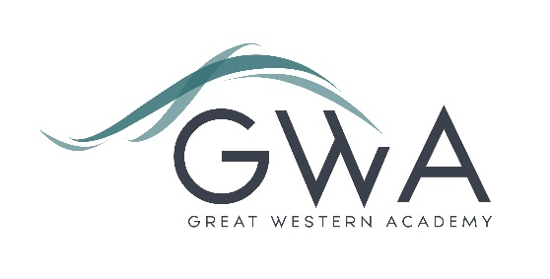

# Information for Applicants

**Behaviour for Learning Lead**

We are looking for a caring but focused person to join our pastoral team. Your role will be to support our students, teachers and pastoral team to promote strong Behaviour for Learning. This means being a point of contact for students and staff alike, supporting students whose learning in the classroom needs improvement. At GWA this is a small proportion of our students, but a little difference in this area can go a long way, and that’s why we are creating this new role.

Great Western Academy opened in September 2018 and now accommodates over 950 students in years 7 to 11 and the Sixth Form. The school is heavily oversubscribed in years 7 to 11 and the Sixth Form is flourishing. Our philosophy of Achievement, Care and Excellence permeates all we do, with Care firmly at the centre of this. We believe that to Achieve and Excel students need to be Cared for, but also need to Care for each other, for their local environment, and for the world they live in. We use the phrase “Work Hard, Be Kind” to summarise what we expect of students and to create a culture of positive support where students behave well and are able to thrive, whatever their needs.

Please contact [recruitment@gwacademy.co.uk](mailto:recruitment@gwacademy.co.uk) if you have any questions relating to the vacancy prior to applying.

Application process

Please complete the application form supplied and enclose a supporting letter, either in the space provided on the application form or as a separate document. The application form should be completed in full in black ink or type. A CV is not requiredand should not be submitted as part of the application.

Your supporting letter should be no more than 2 sides of A4 (with a font size no smaller than 11) and should enhance your application by providing further information, matched to the person specification, about your suitability for the post. This should include evidence of the impact of any previous work you have undertaken.

Electronic applications should be completed on Eteach or returned via email to [recruitment@gwacademy.co.uk](mailto:office@gwacademy.co.uk)

**References:** References will be taken up prior to interview.

**Closing Date:** 9am Monday 27th November 2023

**Interviews:**  Will take place soon after this.

*Great Western Academy is committed to safeguarding and promoting the welfare of children, young people and vulnerable adults and we expect all staff to share this commitment and undergo appropriate checks. All posts within the Trust are therefore subject to an Enhanced DBS and barred list check.*