ROLE: Behaviour & Inclusion Manager

START DATE: As soon as possible

CLOSING DATE: Friday, 2nd May 2025 at 12 noon

INTERVIEW DATE: 15th May 2025

SALARY SCALE: NJC Point Range 25 to 30 = £35,235 to £39,513 (depending

on experience)

CONTRACT TERM: Permanent – Full-Time

**Broughton Hall Catholic High School**

Founded in 1928 under the trusteeship of the Sisters of Mercy, Broughton Hall Catholic High School, an all-girls Catholic secondary school in Liverpool, provides the very best in modern education based on the Gospel values of mutual respect and care.

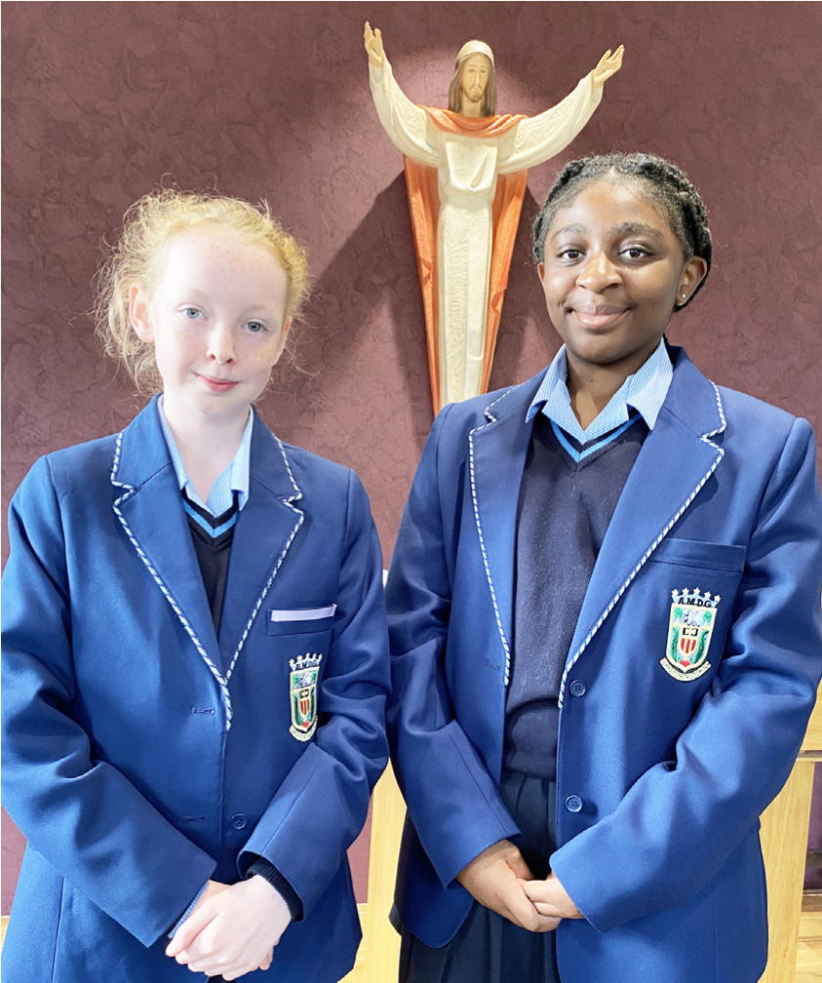

The central aim of our school is to provide excellent educational opportunities enabling each pupil to develop their God given talents, to grow in confidence and self-esteem and to fulfil their potential.

As a Catholic school Broughton Hall centres its mission on the person of Jesus Christ, and promotes the Gospel values throughout the school community and in all aspects of school life: spiritual, academic, pastoral, and personal. By proclaiming and living out the faith of the Catholic Church, we support each other in shared experiences of teaching and learning, prayer, worship and charity. Our mercy values permeate throughout our community.

Broughton Hall is Ofsted rated as a “Good” provider (November 2022).

Our facilities are bright, spacious, high tech and designed to meet the needs of all our pupils. We have a separate 6th Form facility, which is shared with our neighbouring boys school Cardinal Heenan Catholic High School. A full range of extra-curricular activities are provided to further the creative, sporting and academic talents of each pupil and offer Outward Bound and Duke of Edinburgh Award schemes as well as the opportunity to attend educational visits and residential trips.

We pride ourselves on our high expectations of all pupils and have an **‘Ambition for All’** policy. Whatever your role within the school, you will share these values and be able to encourage and motivate pupils with your passion, presence and personality.

Our school motto ‘**Cor Unum et Anima Una’** - One Heart and One Mind, reflects the strong sense of community amongst pupils, staff, parents and Governors.

School has a weekly Newsletter – please **click here** to view our latest edition. <https://www.broughtonhall.com/newsletter/>

**Welcome**

Thank you for your interest in the position of Behaviour and Inclusion Manager.

This pack has been designed to help you should you choose to submit an application form, which we sincerely hope you do. We hope it answers your initial questions, but if not, please do not hesitate to contact us and we will endeavour to help you through your application process.

Broughton Hall Catholic High School is the largest all-girls school in Liverpool and serves many different areas making us a vibrant a diverse school. Our aim is to be a good school in all areas and we are seeking staff to apply to work with to be of that journey. Ofsted rated the school as “Good” in November 2022.

We work hard to ensure Broughton Hall Catholic High School remains a friendly and welcoming environment for all those who work, study or visit here and hope that you are the person we are looking for to bring creativity and innovation to the role.

The school actively supports the training of staff and opportunities for professional development exist for all. Our staff are passionate about supporting our students to achieve their personal and academic potential.

We look forward to hearing from you.

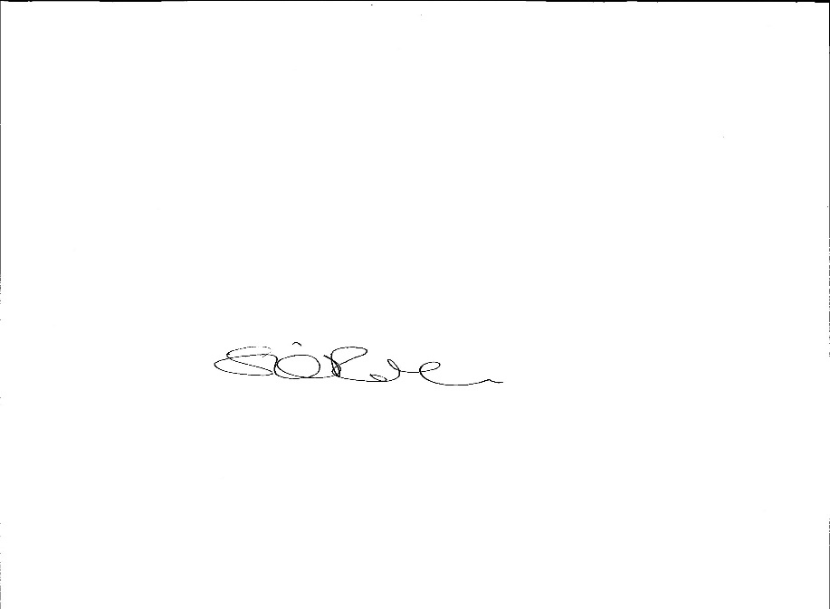

**Sarah O’Rourke**

**Head Teacher**

**We Offer**

* Pensions Scheme – Teacher Pension Scheme for teaching staff or Merseyside Pension Fund for support staff
* Regular training and development programme
* An enhanced Occupational Health & Well-Being App (Smart Clinic) with access to a wide variety of services e.g.
* Virtual GP
* 24 hour employee assistance line
* Physiotherapy
* Mental Health Services
* Self-support and guidance tools
* Cycle2Work Scheme
* Tax Free Childcare Vouchers
* Supportive work environment where all staff are valued
* Continuous professional development for all staff and follow a whole school approach to staff performance and development

And that’s not all, we place the outcomes of the children in our school at the heart of everything we do, so you’ll wake every day in the knowledge that your role will have a significant positive impact on the lives of others.

**Equal Opportunities**

Broughton Hall Catholic High school is an equal opportunities employer.

We welcome applicants from all backgrounds and value everyone as an individual. We are committed to organisational practices, which promote diversity and inclusion for all employees and volunteers regardless of age, gender reassignment, marriage or civil partnership status, pregnancy and maternity status, disability, race (including colour, nationality, ethnic or national origin), religion or belief, sex, or sexual orientation. Connecting these differences creates a productive environment in which everyone feels valued.

Monitoring information in relation to job applicants will be to assist us in equality monitoring. The recruitment panel will not have access to job applicant’s monitoring information.

To assist us in monitoring the operation of equal opportunities policy, and for no other reason, please ensure you complete and submit the Equal Opportunities Monitoring Form with your application form.

**Safeguarding & Enhanced DBS Checks**

Broughton Hall Catholic High School is committed to safeguarding and promoting the welfare of young people and expect all pupils, staff, volunteers and visitors to share this commitment

All posts are subject to an enhanced DBS check and full pre-employment checks to comply with the current Keeping Children Safe in Education statutory guidance for schools.

All staff will be expected to follow Broughton Hall Catholic High School’s child protection policies, code of conducts and managing allegations against staff procedures.

All roles in school, including this post, are exempt from the Rehabilitation of Offenders Act (ROA) 1974. The Ministry of Justice’s guidance on Rehabilitation of Offenders Act 1974 and the Exceptions Order 1975 provides information about which convictions must be declared during job applications and can be accessed [here](https://www.gov.uk/government/publications/new-guidance-on-the-rehabilitation-of-offenders-act-1974).

All applicants must therefore declare all previous convictions and cautions, including those which would normally be considered ‘spent’ except those received for an offence committed in the United Kingdom if it has been filtered in accordance with the DBS filtering rules. Information about filtering offences can be found in the DBC Filtering Guide, which can be accessed [here](https://www.gov.uk/government/publications/dbs-filtering-guidance).

By engaging in this recruitment process, shortlisted candidates consent to an online search in line with the Keeping Children Safe in Education Statutory Guidance 2022.

A copy of our Child Protection Policy and Procedures can be access at <https://www.broughtonhall.com/documents/BroughtonHall_CP_Policy.pdf>

**Advert**

**BEHAVIOUR AND INCLUSION MANAGER**

**SALARY:** NJC Scale Point Range 25 – 30 £35,235 TO £39,513 (depending on experience)

**CONTRACT TYPE:** Permanent/Full Time

**CLOSING DATE:** Friday, 2nd May 2025

**INTERVIEWS TO BE HELD:** 15th May 2025

**START DATE:** As soon as possible

**“One Heart, One Mind, in Faith, Hope and Love”**

Broughton Hall Catholic High School is seeking an inspirational and strategic **Behaviour & Inclusion Manager** to lead a transformational provision for students who struggle to access mainstream education.

This is an exciting opportunity to shape and deliver a holistic programme that blends academic challenge with personal development, rooted in trauma-informed and relational practice.

You will design and lead a bespoke inclusion pathway, working with teams across the school, external agencies and other educational providers to ensure the provision is impactful, sustainable, and fully integrated into our whole-school vision for inclusion.

**What We Are Looking For:**

* A passionate practitioner with experience supporting students with SEMH and behavioural needs
* A strategic thinker with the skills to lead long-term planning and sustainable change
* A confident communicator who can build strong partnerships with families and external agencies
* A team player who will collaborate across departments and contribute to whole-school improvement
* A leader who believes in every student’s potential and is committed to inclusive, compassionate education

**In Return, We Offer:**

* The chance to shape a brand-new, high-impact provision
* A supportive, values-driven school community
* Access to CPD, leadership support, and professional growth opportunities
* A genuine opportunity to make a difference in the lives of our most vulnerable learners

**Why Join Us?**

At Broughton Hall, you’ll be part of a vibrant, inclusive community that values excellence, compassion, and service. We are proud of our rich heritage, our commitment to Catholic values, and our ongoing drive to improve and innovate.

We also offer**:**

* A supportive leadership team and collaborative working environment
* Opportunities for professional development
* A chance to make a real impact on school life and student outcomes
* An enhanced Occupational Health & Well-Being App (Smart Clinic) with access to a wide variety of services e.g.
* Virtual GP
* 24 hour employee assistance line
* Physiotherapy
* Mental Health Services
* Self-support and guidance tools

**How to Apply:** Completed applications should be submitted outlining how your experience and vision align with this role. Please complete the school’s Application Pack and email to [recruitment@broughtonhall.com](mailto:recruitment@broughtonhall.com)

Visits to the school are warmly welcomed – please contact Mrs G Smith at smithg@broughtonhall.com to arrange a tour and conversation with our Headteacher.

Our Trustees are the Sisters of Mercy.

***Broughton Hall Catholic High School is committed to safeguarding and promoting the welfare of children and we expect all staff and volunteers to share this commitment to keeping children safe. Any offer of employment will be subject to statutory pre-employment checks including satisfactory references and Enhanced DBS and Barred List checks. This post is exempt from the provisions of the Rehabilitation of Offenders Act 1974 (as amended in 2013 & 2020) and shortlisted candidates will be required to disclose any relevant criminal history prior to interview.***

***‘By engaging in this recruitment process, shortlisted candidates consent to an online search in line with the Keeping Children Safe in Education Statutory Guidance 2024’***

**Job Description**

**Our Mission**

Broughton Hall Catholic High School is a caring and inclusive community guided by Gospel values. We are proud to live by our motto:  
**“One Heart, One Mind, in Faith, Hope and Love.”**

We are committed to developing the whole person and ensuring every student is equipped for future success, regardless of their starting point.

|  |  |
| --- | --- |
| **ROLE SUMMARY** | |
|  | We are seeking to appoint a dynamic, forward-thinking **Behaviour & Inclusion Manager** to lead a bespoke provision for students who struggle to access mainstream education. This is an exciting opportunity to shape and deliver a holistic, trauma-informed programme that integrates academic challenge with personal development and behavioural support.  The successful candidate will lead on the strategic development and delivery of the provision, ensuring its long-term sustainability and impact. They will work closely with students, staff, families, external agencies, and other educational providers to create a truly inclusive learning experience. |
| **REPORTS TO** | |
|  | Headteacher/Senior Leadership Team (SLT). |
| **KEY RESPONSIBILITIES** | |
| **Strategic Leadership & Development:** | * Design and implement a clear vision and long-term strategy for the inclusion and behaviour provision, aligned with the school's improvement plan. * Establish robust systems to ensure the sustainability and continual refinement of the provision. * Monitor and evaluate the impact of provision through data, feedback, and outcomes, using this to inform ongoing development. |
| **Provision Oversight** | * Lead the planning and day-to-day running of a dedicated provision for students facing barriers to mainstream learning. * Ensure the provision delivers high-quality academic support, behavioural guidance, and opportunities for personal growth. * Create a nurturing environment built on trauma-informed, relational and restorative practices. |
| **Student Support & Development** | * Identify students who require additional behavioural or emotional support and oversee their personalised plans. * Support student development in self-regulation, social-emotional learning, and behaviour for learning. * Facilitate successful reintegration into mainstream classrooms or alternative, appropriate pathways. |
| **Collaboration & Staff Development** | * Work collaboratively with SEND, safeguarding, pastoral and academic teams to ensure coordinated and effective support. * Provide professional development, training and coaching for staff to enhance inclusive classroom practice and early intervention strategies. |
| **External Partnerships & Community Links** | * Establish and maintain strong partnerships with external agencies (e.g. CAMHS, social care, education welfare services) and alternative educational providers. * Engage with families and carers to build trust, promote shared goals, and ensure continuity of support. * Represent the school at multi-agency meetings and contribute to wider strategic planning in local educational and wellbeing networks. |

|  |
| --- |
| Whilst every effort has been made to explain the main duties and responsibilities of the post, each individual task undertaken may not be identified. |

|  |
| --- |
| This job description is current at the date shown, but, in consultation with you, may be changed by the Head Teacher to reflect or anticipate changes in the job commensurate with the grade and job title. |

**Person Specification**

**BEHAVIOUR & INCLUSION MANAGER**

|  |  |  |
| --- | --- | --- |
| **Abilities** | **Essential** | **Desirable** |
| Experience working with students with SEMH and behavioural needs | **✓** |  |
| Strong knowledge of trauma-informed and relational approaches | **🗸** |  |
| Proven leadership experience or capacity to lead a team and drive strategic change | **🗸** |  |
| Experience developing and evaluating educational or inclusion-based interventions | **🗸** |  |
| Ability to work with multi-disciplinary teams and external stakeholders | **🗸** |  |
| Excellent interpersonal, communication, and organisational skills | **🗸** |  |
| Relevant qualification in education, behaviour support, or inclusion |  | **🗸** |
| Experience managing internal inclusion provision |  | **🗸** |
| Familiarity with restorative practices and therapeutic behaviour approaches |  | **🗸** |
| **Motivation** | **Essential** | **Desirable** |
| Willing to be fully engaged in the whole life of the school | **🗸** |  |
| Committed to the personal professional development of themselves and of others. | **🗸** |  |
| Committed to teamwork and working collaboratively with colleagues. | **🗸** |  |
| A commitment to the safeguarding and welfare of all pupils. | **🗸** |  |
| Genuine belief in the potential of every student. | **🗸** |  |
| **Attributes** | **Essential** | **Desirable** |
| The ability to enthuse and inspire others. | **🗸** |  |
| Passion, resilience, maturity and optimism to lead through day-to-day challenges while maintaining a clear strategic vision and direction. | **🗸** |  |
| Confidence and self-motivation to work well and be decisive under pressure. | **🗸** |  |



