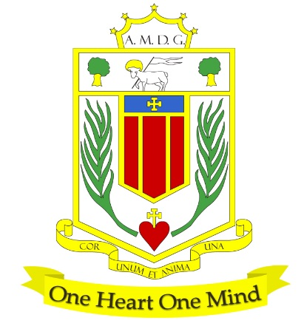
BROUGHTON HALL CATHOLIC HIGH SCHOOL
Yew Tree Lane

Liverpool, L12 9HJ

Telephone 0151 541 9440 / Fax 0151 259 8448
Email: smithg@broughtonhall.com
Head Teacher: Mrs S O’Rourke, B.A. (Hons), PGCE

BEHAVIOUR & INCLUSION MANAGER

SALARY: NJC Scale Point Range 25 – 30 £35,235 TO £39,513 (depending on experience)
CONTRACT TYPE: Permanent/Full Time
CLOSING DATE: Friday, 2nd May 2025
INTERVIEWS TO BE HELD: 15th May 2025
START DATE: As soon as possible

“One Heart, One Mind, in Faith, Hope and Love”
Broughton Hall Catholic High School is seeking an inspirational and strategic Behaviour & Inclusion Manager to lead a transformational provision for students who struggle to access mainstream education.
This is an exciting opportunity to shape and deliver a holistic programme that blends academic challenge with personal development, rooted in trauma-informed and relational practice.

You will design and lead a bespoke inclusion pathway, working with teams across the school, external agencies and other educational providers to ensure the provision is impactful, sustainable, and fully integrated into our whole-school vision for inclusion.

What We Are Looking For:
- A passionate practitioner with experience supporting students with SEMH and behavioural needs
- A strategic thinker with the skills to lead long-term planning and sustainable change
- A confident communicator who can build strong partnerships with families and external agencies
- A team player who will collaborate across departments and contribute to whole-school improvement
- A leader who believes in every student’s potential and is committed to inclusive, compassionate education

In Return, We Offer:
- The chance to shape a brand-new, high-impact provision
- A supportive, values-driven school community
- Access to CPD, leadership support, and professional growth opportunities
- A genuine opportunity to make a difference in the lives of our most vulnerable learners

Why Join Us?
At Broughton Hall, you’ll be part of a vibrant, inclusive community that values excellence, compassion, and service. We are proud of our rich heritage, our commitment to Catholic values, and our ongoing drive to improve and innovate.

We also offer:
- A supportive leadership team and collaborative working environment
- Opportunities for professional development
- A chance to make a real impact on school life and student outcomes
- An enhanced Occupational Health & Well-Being App (Smart Clinic) with access to a wide variety of services e.g.
- Virtual GP
- 24 hour employee assistance line
- Physiotherapy
- Mental Health Services
- Self-support and guidance tools

How to Apply: Completed applications should be submitted outlining how your experience and vision align with this role. Please complete the school’s Application Pack and email to recruitment@broughtonhall.com

Visits to the school are warmly welcomed – please contact Mrs G Smith at smithg@broughtonhall.com to arrange a tour and conversation with our Headteacher.

Our Trustees are the Sisters of Mercy.

Broughton Hall Catholic High School is committed to safeguarding and promoting the welfare of children and we expect all staff and volunteers to share this commitment to keeping children safe. Any offer of employment will be subject to statutory pre-employment checks including satisfactory references and Enhanced DBS and Barred List checks. This post is exempt from the provisions of the Rehabilitation of Offenders Act 1974 (as amended in 2013 & 2020) and shortlisted candidates will be required to disclose any relevant criminal history prior to interview.

‘By engaging in this recruitment process, shortlisted candidates consent to an online search in line with the Keeping Children Safe in Education Statutory Guidance 2024’

