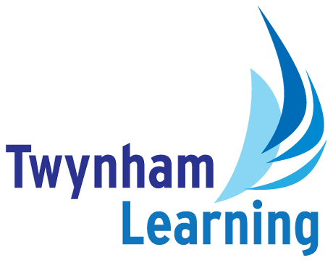**Job Description:**

**Behaviour Intervention and Inclusion Manager**

|  |  |
| --- | --- |
| **Post Details** |  |
| **School:** | The Grange School |
| **Post type:** | Support Staff |
| **Grade/Pay Level:** | Grade 9 |
| **Weeks per year:** | Term Time plus INSET |
| **Duration:** | Permanent |
| **Responsible to:** | Assistant Head Teacher |

|  |
| --- |
| **Main Purpose** |
| To lead the strategic development and implementation of behaviour intervention systems across the school, with a clear focus on reducing suspensions and supporting students at risk of repeated exclusions.  This role includes the line management of the Behaviour Manager and the coordination of an inclusive internal alternative provision programme.  The postholder will work closely with class teachers, senior leaders, and external agencies to embed a culture of high expectations, inclusive practice, and proactive behaviour support.  A key aspect of the role is recognising the impact of SEND on behaviour and ensuring that all interventions are tailored, supportive, and restorative.  The role also involves delivering staff CPD, supporting classroom practice, and using data to inform targeted interventions and referrals. |

|  |
| --- |
| **Duties and Responsibilities** |
| **Main Responsibilities and Duties:**   * Lead and coordinate the Learn and Behave provision, ensuring it is a calm, purposeful space that supports students in regulating behaviour and re-engaging with learning. * Develop and implement a robust internal alternative provision pathway for students at risk of suspension or disengagement. * Line manage the Behaviour Manager, ensuring consistency and high standards in the day-to-day running of behaviour systems. * Monitor, analyse, and report on behaviour data to identify patterns, inform interventions, and evaluate impact—particularly for vulnerable and SEND students. * Work collaboratively with teaching staff to model and embed inclusive behaviour strategies in the classroom, including coaching and CPD delivery. * Support the development of a whole-school culture of high expectations and positive behaviour through consistent systems, communication, and staff training. * Coordinate referrals and work in partnership with external agencies and stakeholders to provide wraparound support for students with complex needs. * Oversee the school’s centralised detention and behaviour monitoring systems (e.g., Arbor), ensuring accurate tracking and timely communication with staff and families. * Lead reintegration planning for students returning from suspension or extended absence, ensuring appropriate support and follow-up. * Promote restorative approaches and positive relationships with students, fostering a culture of respect, inclusion, and accountability. * Contribute to the strategic review and development of the school’s behaviour policy and practice, ensuring alignment with national guidance and best practice. |

|  |
| --- |
| **Safeguarding Duties and Responsibilities** |
| * Promoting and safeguarding the welfare of children and young people in accordance with the school’s Safeguarding and Child Protection policies. |

|  |  |
| --- | --- |
| **Twynham Learning Attributes for all Staff** | |
| * Ambition for excellence * Professionalism * Humility * Championing change | * Inclusiveness * Positivity * Community-mindedness * Being collaborative |

|  |
| --- |
| **Knowledge, Skills and Attributes** |
| **Education, Training & Qualifications**  **Essential:**   * 5 GCSE’s Grade C or above, including Maths and English   **Desirable:**   * Level 3 or higher qualifications * Evidence of recent and relevant training   **Experience & Knowledge**  **Essential:**   * Experience of working with young people aged 11-16 * Able to work independently and autonomously as well as within a team   **Desirable:**   * Experience and a good understanding of the working environment of a state secondary school * Understanding of principles of child development and learning processes and in particular, barriers to learning * Developing knowledge of Local Authority, Outside Agencies, local and national organisations which can provide services and activities to support pupils and broaden and enrich their learning * Knowledge of evidence-based strategies for supporting young people in relation to behaviour and emotional wellbeing   **Self-Management Skills & Abilities**  **Essential:**   * Anticipate problems, develop creative solutions * Set and achieve ambitious, challenging goals and targets for self * Has the ability to communicate effectively with a wide range of different people and organisations * Strong level of ICT skills * Prioritise, plan and organise self * Is highly organised with meticulous attention to detail * Prepared to undertake professional training as necessary to carry out tasks effectively * Can maintain issues of confidentiality in the working environment   **Desirable:**   * Use of school-based MIS such as Arbor   **Motivation and Personality**  **Essential:**   * An interest in educational issues * Enjoys the company of young people and others * Positive attitude * Relentless optimism * Initiative and self-motivator   **Personal**  **Essential:**   * Calm disposition * Willing to accept the demands and challenges of the post and respond in a flexible manner * Excellent time-management and multi-tasking skills * Ability to work under pressure and to tight deadlines * Is committed, resilient, robust, resourceful, keen and enthusiastic * Can demonstrate fairness, honesty and integrity in existing practice and conduct as a professional * Can show positive commitment to organisational principles |

|  |
| --- |
| **Other Duties** |
| All Twynham Learning staff may periodically be expected to carry out tasks and duties within their area of competence that are not listed herein, as directed, to meet the needs of the Trust. The particular duties and responsibilities may vary from time to time. |

|  |
| --- |
| **Notes** |
| * This job description may be amended at any time in consultation with the postholder. |

|  |  |
| --- | --- |
| **Key to Acronyms Used/Glossary of Terms Used in this Job Description** | |
| * TL = Twynham Learning * ICT= Information and Communication Technology * MIS=Management Information System |  |