
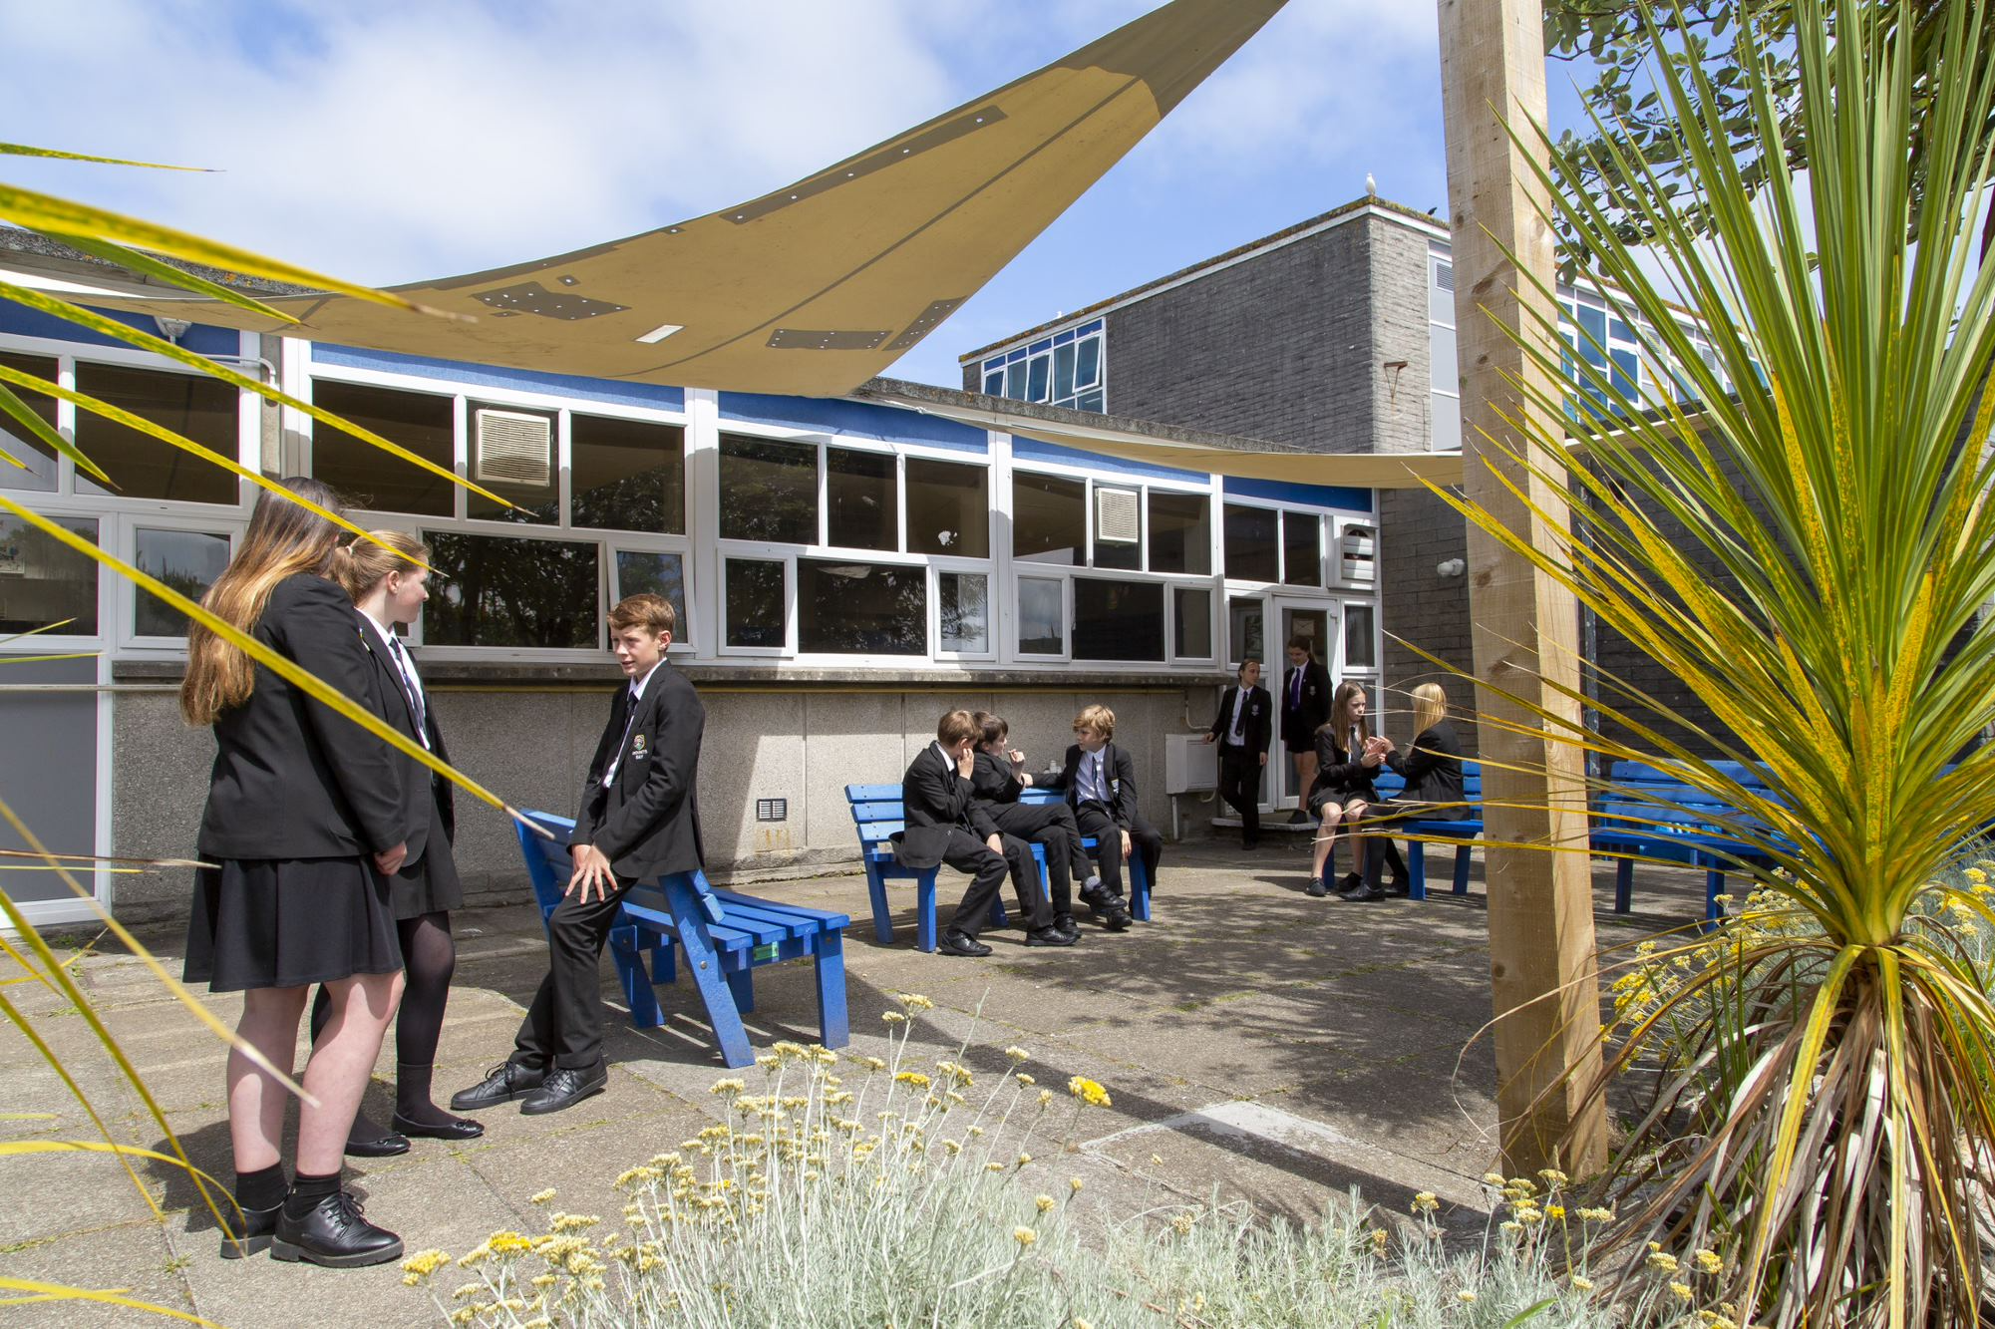
Behaviour Mentor
Application Pack

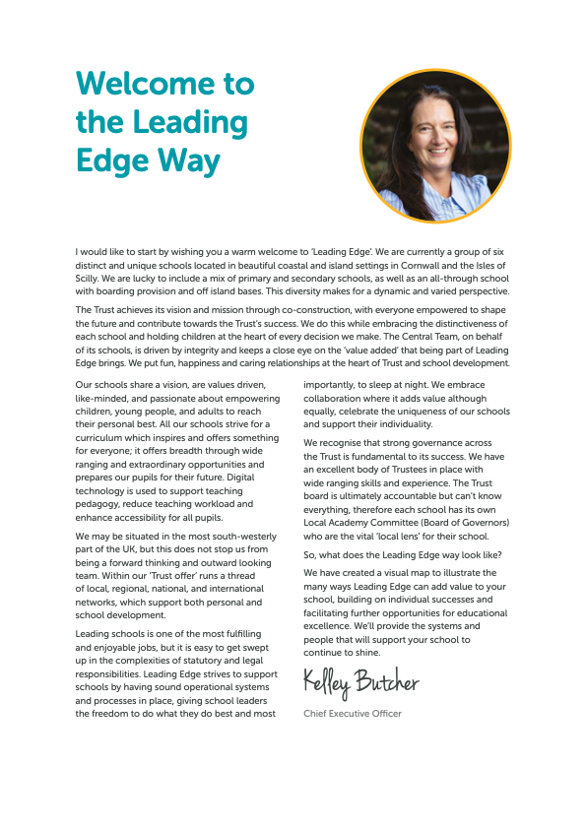

Principal – Mr S Royle BA (Hons) PGCE NPQH
Mounts Bay Academy
Boscathnoe Lane
Heamoor
Penzance
TR18 3JT
www.mountsbay.org

Salary scale: G
Contract Type: 1 x full time role. Term Time Only.
Contract Term: Fixed Term Contract 1 Year.

Behaviour Mentor

We are looking for a Behaviour mentor to join our thriving Academy in supporting the students needs.

Ideally the post would suit an experienced individual, but we would also welcome applications from someone willing to learn and develop in the role. Applicants should be flexible, organised and able to work on their own initiative. Attention to detail and accurate record keeping are essential along with competent IT skills and ability to relate well to young people and their learning. Applications must be able to work in a team environment. This is a term time only position so the successful post holder will benefit from the school holidays.

The successful candidate will also work proactively alongside a highly motivated team of professionals, to ensure that the classes are covered appropriately.

Mounts Bay Academy is a caring and dynamic Academy where students are placed at the centre of everything we do. We provide a broad and balanced curriculum to all our students, who are set challenging academic and personal targets and given the inspiration to succeed.

The successful candidate will also contribute to the strategic goals of the Academy and be able to support a vision within which students are well prepared for the modern world.

Application forms and an information pack are available via our school website or on request by telephoning the Academy.
For further information, please contact Malvina Jenkin HR Manager at Mounts Bay Academy 01736 352399 or email: mjenkin@mountsbayacademy.org

Closing date for applications: 28/10/2025
Interviews: TBC
Start date: Asap

MBA is committed to safeguarding and promoting the welfare of students and expects all staff to share this commitment

Please send your completed application form to Malvina Jenkin mjenkin@mountsbayacademy.org
The successful candidate will be subject to reference checks with previous employers and an enhanced DBS disclosure check.

Welcome

Dear Applicant,

Thank you for expressing an interest in this post at Mounts Bay Academy, a member of the Multi Academy Trust called Leading Edge Academies Partnership (Leading Edge). I hope you find this information pack helpful and that in due course we shall receive an application from you.

Mounts Bay Academy is located in Penzance, West Cornwall with 950 students aged 11-16 years. This is a beautiful part of the world, enjoying a varied coastline surrounding rugged hills and moorland and it is a wonderful place to live and work.

Mounts Bay school converted to Academy status in 2011 and a year later was awarded an Outstanding grade in a full Ofsted Inspection. In November 2017 the Academy was inspected by Ofsted to review its safeguarding arrangements and the HMI visitors noted that the Academy had a fully inclusive culture and provided excellent support for vulnerable students. Since then, we were awarded a good grade in 2021 under the new Ofsted Framework introduced in 2019.

I have been the proud Principal of Mounts Bay since March 2024, and I am passionate about the Academy and the path that we need to follow. Whilst enjoying an enviable reputation in the local area, there is work to do in terms of outcomes, attendance and the quality of teaching and learning. Our priorities are explicit, and my style is very open and honest – there are no hidden agendas here!

We have recently introduced a new behaviour policy which is having very positive effects and our teaching and learning policy has been stripped back to provide very clear expectations of staff and students. All strategies are supported by a comprehensive evidence-based programme of CPD, both internal, and through external bodies such the PTI, the Cornwall Research School, which we are delighted to lead, and the Challenge Partner network, where we are delighted to be the lead school in the Cornwall hub.

The Academy enjoys a range of impressive physical resources including a purpose-built science area, subject specific teaching areas in the Creative Arts as well as a lively and bouncing Music block. Sports facilities are strong, including a large sports hall, a 3G pitch and extensive outside field areas, all of which have significant community use. Plans are currently being made with Cornwall Council for an on-site ARB to provide further support to learners.

Mounts Bay Academy is an Apple Distinguished school, and each student and staff member is provided with a digital device to support their learning and work. We believe that students should be prepared for the world in which they will live when they leave the Academy and strive daily to ensure that we update our knowledge accordingly.

We are a learning community that aspires to success for all without exception, convinced that everyone can learn at the highest level, when presented with learning experiences that are as engaging as they are adventurous. We believe that all young people can achieve; it is our job to nurture the very best in each person by identifying their strengths and talents and removing any barriers to learning.

Mounts Bay is a caring and dynamic community where students are placed at the centre of everything that we do.

We provide a broad and balanced curriculum which is delivered by a team of skilled and dedicated staff, with the MBA way visible throughout the school, putting ‘Relationships, Respect and Responsibility’ at the centre of everything. Talent is celebrated, curiosity is nurtured, and every individual is given the chance to shine. We help to develop young people with a positive attitude to learning and life, ready to take on the challenges of our fast-changing world and to make a creative contribution to their community.

The successful candidate will be a brave, creative and visionary person, to join our staff to enable all to thrive in this ever-changing world. We are looking for a professional with a spirit of adventure who understands that high personal and academic standards and exciting learning can combine to change young people’s lives.

Mounts Bay Academy is committed to safeguarding and promoting the welfare of young people and we expect the candidate to share this commitment.

Since I joined the Academy, I have felt safe, I have been happy, I have felt challenged, and I have been genuinely welcomed into the Mounts Bay community. Is this not what all of us want from a school?

Please do get in touch if you would like to come and visit. I look forward to meeting you.

Yours sincerely

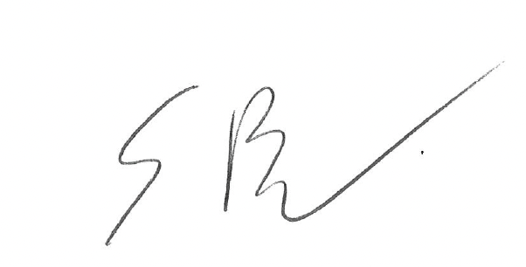

Simeon Royle

PRINCIPAL
Job Description

Post Title: | Behaviour Room Mentor
Purpose | The Behaviour Room Mentor oversees the operation of the behaviour room, ensuring that students placed in this room to reflect on and follow school rules and complete their assigned academic work. The role involves maintaining a calm, orderly, and structured environment, promoting positive behaviour, and supporting students to reflect on their actions to reintegrate into the school community successfully.
Main Duties and Responsibilities: | Key Responsibilities:  - Supervision and Management:  - Supervise students who have been assigned to reflect for behaviour-related reasons.  - Ensure that students adhere to the rules and expectations of the behaviour room, including maintaining a quiet and focused atmosphere.  - Manage and de-escalate situations where students display challenging behaviour, using appropriate strategies.  - Academic Support:  - Ensure that students have access to the necessary learning resources to continue their learning during their time in Reflection.  - Monitor the completion of work and provide support where necessary, ensuring students remain engaged in their learning.  - Behaviour and Reflection:  - Provide opportunities for students to reflect on their behaviour and the consequences of their actions.  - Facilitate restorative conversations or reflection exercises to help students understand the impact of their behaviour and how to improve moving forward.  - Encourage students to develop better coping strategies and improve their behaviour through positive reinforcement.  - Record Keeping and Reporting:  - Maintain accurate and up-to-date records of students attending the isolation room, including reasons for isolation, length of stay, and any incidents that occur.  - Provide regular reports to the Head of Behaviour or Pastoral Team regarding student progress and any concerns.  - Collaboration and Communication:  - Work closely with the Pastoral Team, SENCO, and SLT to support the overall behaviour management strategy within the school.  - Communicate regularly with teachers to ensure that students receive appropriate academic work and support.  - Where necessary, communicate with parents or guardians to provide updates on student progress and behaviour during their time in Reset.  - Restorative Practice and Reintegration:  - Support the reintegration of students back into the classroom by working with the behaviour team to set clear expectations and action plans for improvement.  - Use restorative practices to help students build positive relationships with staff and peers.  Qualifications and Skills:  Education: Relevant qualification or experience in behaviour management, education, or working with young people.  Experience:  Previous experience working in a school or educational setting, particularly with students exhibiting challenging behaviour.  Experience managing small groups of students or working in a behaviour support role is desirable.  Skills:  Strong behaviour management skills, including de-escalation techniques and a calm approach to challenging situations.  Excellent communication skills, both written and verbal, with the ability to engage and support students effectively.  Good organisational skills and the ability to maintain accurate records.  Patience, empathy, and resilience in dealing with students with complex behavioural needs.  Unable to load the shape  Personal Attributes:  A commitment to promoting positive behaviour and student well-being.  A calm and authoritative presence, capable of managing potentially challenging situations with confidence.  An understanding of the need for confidentiality and professionalism when dealing with sensitive student information.  Ability to work both independently and as part of a team to achieve behaviour management goals.  Unable to load the shape  Working Conditions:  Full-time role based within a school environment.  May involve working with students exhibiting a wide range of challenging behaviours.  The role requires patience, resilience, and a firm but fair approach to discipline.

Other Specific Duties
- To remain and adhere to the Trust’s Safeguarding Policy and child protection procedures.
- To play a full part in the life of the Academy community, to support its distinctive mission and ethos and to encourage staff and students to follow this example.
- To actively promote the Trust’s and Academy’s corporate policies.
- Be responsible for your own continuing self-development, undertaking training as appropriate.
- To be aware and adhere to applicable rules, regulations, legislation and procedures e.g. the Trust Equality and Diversity Policy, Staff Code of Conduct, national legislation and GDPR Data Protection Regulations.
- To comply with the Academy’s Health and Safety Policy and undertake Risk Assessments as appropriate.

As a restorative organisation we:
- Apply the principles of mutual respect and responsibility in all our internal and external relationships.
- Actively work to prevent, address and repair harm.
- Engage in continuous learning to further develop our communication and problem-solving skills.

Reporting to: | Vice Principal: Academic Development
Responsible for: | Behaviour
Liaising with: | Senior Leaders, staff, students.
Working time: | Full time
Salary/Grade: | G
Disclosure level: | Enhanced DBS

Please note that this is illustrative of the general nature and level of responsibility of the role. It is not a comprehensive list of all tasks that the postholder will carry out. The postholder may be required to do other duties appropriate to the level of the role, as directed by the Principal. This job description may be amended in consultation with the postholder.

