

SCIENCE FACULTY: Biology, Chemistry and Physics departments

Director of Science: Ms Debbie Russell

Subject Leader Physics: Mrs E Austin

Subject Leader Biology: Mrs C Scott

Subject leader Chemistry: Mrs T Suthakaran

This is an opportunity to join a lively, enthusiastic and developing faculty of 21 science teachers. All our staff are highly qualified and there is a good balance of teaching experience, age and gender within the department.

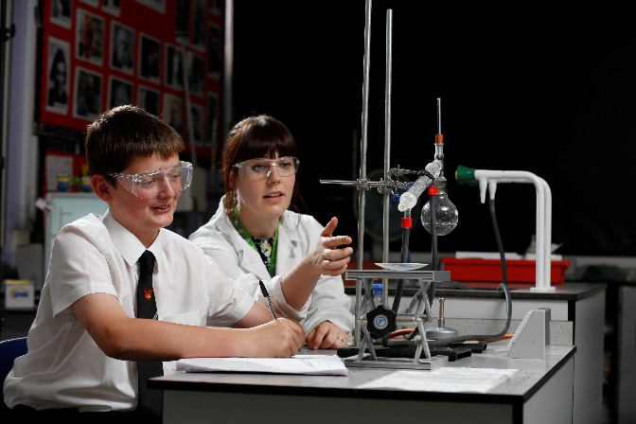There is a strong leadership structure within the Science Faculty, which consists of the three department areas of Biology, Chemistry and Physics. Each Department is led by the Subject Leader, working closely with the Director of Science, and is supported by other TLR holders within the department.

There is a dedicated Science support staff team, made up of a team leader, a science curriculum officer and four technicians; this team services all three subject departments. In addition, there are a number of specialist LSAs jointly attached to the Science and Mathematics departments.

We have a strong team spirit, with a friendly and open atmosphere within the Faculty and a large Faculty office for all Science staff to use. Staff are very supportive of one another. New members of staff will receive mentoring during the first term as well as plenty of informal help from all members of the Faculty. Newly qualified teachers receive a wide range of additional support as part of their induction year.

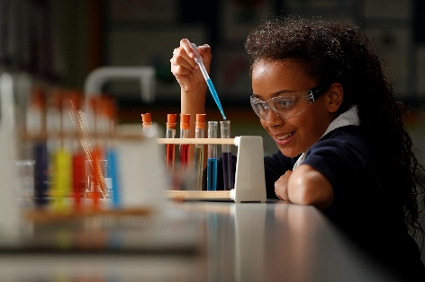

There is a strong teamwork ethos in the Faculty. We meet as a faculty and in departments regularly and all team members are encouraged to contribute towards the discussion, formulation and implementation of future plans. Each department constantly reviews its schemes of work and assessments, aiming to improve the quality of teaching and learning by sharing good practice. There are two faculty/department briefing sessions a week.

Within the Faculty, there is a Science Leadership Team chaired by the Director of Science, and incorporating the Subject Leaders as well as the Science post holder with the overview of staff development. In addition, there are the Subject Leadership teams. All these meet regularly to both ensure the smooth running of the faculty as well as share best practice across the sciences. There are many opportunities for personal and professional development as instanced by internal promotions.

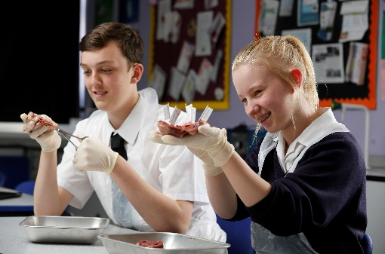The subject departments, working closely with the Director of Science, have a clear educational direction for raising achievement through the quality of teaching and learning. Each department aims to use a wide variety of approaches so that our students enjoy their lessons as well furthering their knowledge and understanding. Student response to Science is very positive; students enjoy learning the different subjects and understand the importance of them to their future. Increasingly students are entering the school with a good grounding in science from their primary schools. The department aims to build on their previous experience and uses prior attainment data to ensure an appropriate level of challenge.

We aim to teach a five year curriculum and there is the opportunity to teach the full age and ability range:

* In Years 7 & 8 we teach our own tailor made KS3 curriculum designed to engage and inspire students, as well as prepare them for the skills and knowledge they need for the GCSE curricula. Biology, Chemistry and Physics are given equal weighting.
* At Key Stage 4 (Years 9-11) all students are taught Biology, Chemistry and Physics with two hours per week in each subject. Students take the AQA Combined GCSE course or separate Science GCSEs in Chemistry, Physics and Biology.
* At Key Stage 5, we run A-levels in Biology, Chemistry and Physics as well as Level 3 BTEC Courses in Applied Science. There is strong uptake for all courses.

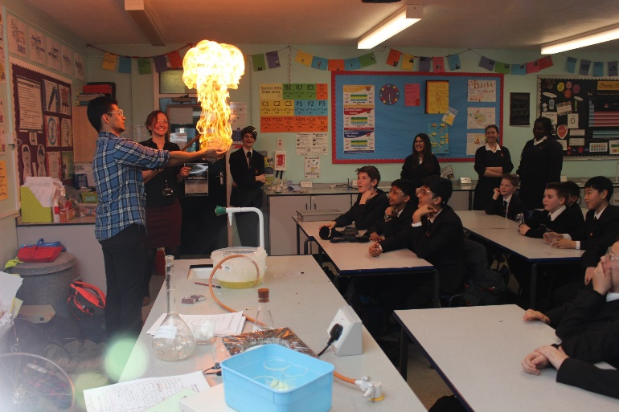

The Faculty has excellent facilities all situated in the Science building. These include eleven laboratories, three computer suites, five classrooms, and five preparation rooms. Ipads can be booked for use in lessons. In addition, all rooms and laboratories are fitted with an interactive whiteboard allowing creative interaction with learning resources. Every member of teaching staff is provided with a laptop.

### What are we looking for in a colleague within the department?

We are looking for a committed, enthusiastic and hard-working colleague to join our Faculty. We want you to be passionate about teaching your subject, be an ambassador for Science and have high expectations for yourself and your students. You will be expected to contribute to the continued raising of achievement through a focus on students’ learning using strategies that support students to make good and outstanding progress. In return, we will support you to become a highly effective teacher and give you opportunities for career development and progression.