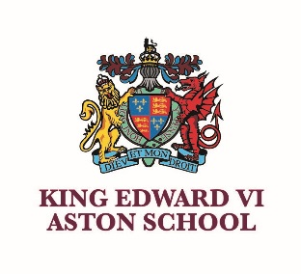 | KING EDWARD VI ASTON SCHOOL  Frederick Road, Aston,  Birmingham B6 6DJ  A selective grammar school for boys  and one of the eleven Schools of King Edward VI in Birmingham | 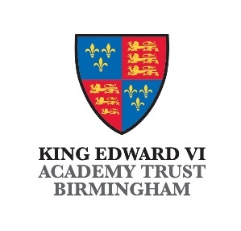
 | NOR: 998

TEACHER OF BIOLOGY

REQUIRED FROM 1st SEPTEMBER 2024
PERMANENT, FULL TIME
MPS1 – UPS3

We are seeking to appoint a permanent, full time, teacher of Biology to teach in our school. The successful applicant will be required to teach Biology throughout the age range. Applications are welcome from teachers at any stage in their career.
All students complete separate sciences at GCSE and large numbers go on to thrive at A-level in a well-respected and supportive department.
As a grammar school, we are privileged to work with able learners with a thirst for knowledge. However, it is equally important to note that successful applicants would join a school with kindness and integrity at the heart of our values system. We pride ourselves on being a friendly and inclusive school in which you can develop the love for your subject and share it with keen learners. Further benefits of working at Aston include a tailored CPD programme, opportunities for secondment with the MAT, a first-class free fitness studio and inspirational colleagues who share a passion for teaching.
If you have any questions before submitting an application please do not hesitate to contact us on 0121 327 1130 or vacancies@keaston.bham.sch.uk
King Edward VI Aston School is one of the six King Edward VI Grammar Schools in Birmingham and a member of the King Edward VI MAT. The school is committed to safeguarding the wellbeing of its students and the successful candidate will be required to undertake DBS and Prohibition checks.

Applicants should send a completed school application form, including the names and addresses of two referees, to the Headteacher at vacancies@keaston.bham.sch.uk . No covering letter is needed. A shortened (300 words appx) personal statement as part of the application form would be acceptable given the timeframe.

Applicants are welcome to visit the school for a tour, but there is no expectation to do so.

Further details and an application pack can be downloaded from our website
www.keaston.bham.sch.uk

Closing date: 9.00am on 23rd May 2024
Interview date: 24th May 2024

King Edward VI Aston School is committed to safeguarding and promoting the welfare of children and young people and expects all staff and volunteers to share this commitment.
The successful applicant will be required to undergo DBS and Prohibition checks.

