**Teaching Assistants**

**Recruitment Information Pack**



## Contents

Welcome from the Headteacher 3

Application Process 4

Job Description and Person Specification 5

Applying for a job with North Yorkshire Council 8



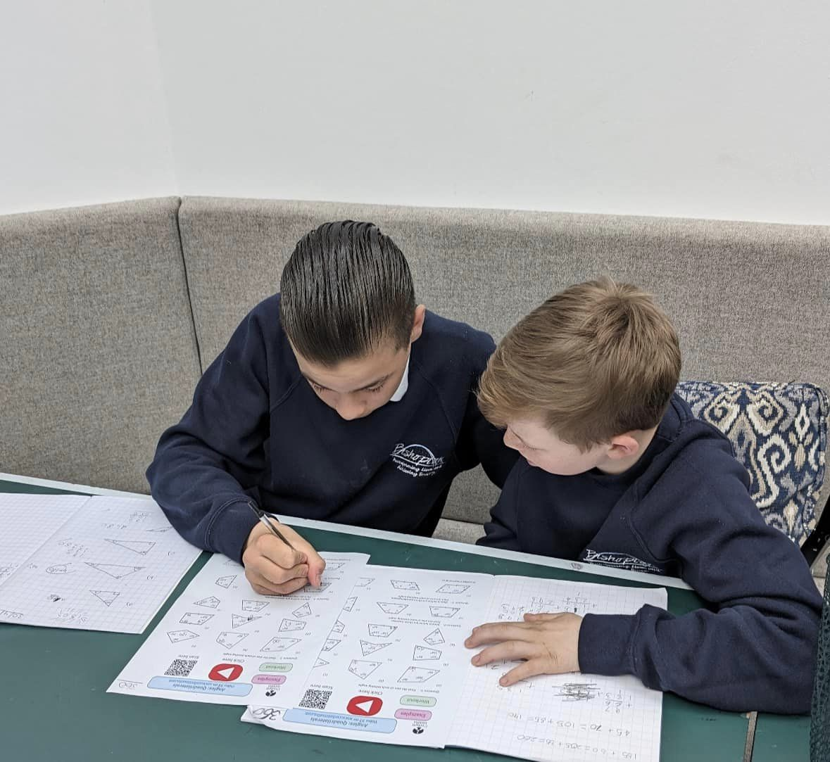

**Welcome from the Headteacher**



Welcome to Bishopton Centre, where we are proud to work collaboratively to ensure every student makes progress, enjoys learning and develops skills for life.

We provide a safe, nurturing learning environment for students to support them to maximise their potential. Each student has a unique pathway, which may involve a well-planned transition back to mainstream, or a differentiated route. We offer a broad and balance curriculum, which has a strong emphasis on English and mathematics and vocational subjects, to enable students to progress to Further Education, apprenticeships or employment.

To be successful we will work closely with the students that come to us and their families/ carers. We will identify what success will look like for the young person and plan a pathway of academic, therapeutic, and social activities.

Students will be taught in a small group of usually 10 or less with a teacher and teaching assistant. Relationships with their teachers will be strong. There is a great deal of emphasis placed on pastoral support and good behaviour will be rewarded. Each student will also have the opportunity to take part in our Outdoor education programme.

We work closely with our colleagues in other services to form a strong team of support around young people and families. This may include Educational Psychologists, Social care, youth support, SEND colleagues to name a few.

We hope that you find the website useful but if you have any further questions, please do not hesitate to contact us,

Gill Warby

[[You can find out more on our website.](https://www.atomix.ac.uk/)](https://bishopton.tvc.ac.uk/)

## Application Process

The closing date for all applications is **11:59pm Thursday 13th March 2025**

Interviews will be held shortly after the closing date.

**Completed applications must be returned to** **[NYES.Resourcing@northyorks.gov.uk](mailto:NYES.Resourcing@northyorks.gov.uk)**

Please contact us if you need an application form in a different format.

Please note this post is in regulated activity and exempt from the rehabilitation of Offenders Act 1974 and therefore subject to an enhanced DBS certificate and barred list check. An online search may be conducted for successfully shortlisted applicants.

Unfortunately we do not accept CVs.

An email will be sent to shortlisted candidates with details of the interview process.

**Queries**

Please contact [NYES.Resourcing@northyorks.gov.uk](mailto:NYES.Resourcing@northyorks.gov.uk)

NYES Resourcing Solutions has been engaged to support us with recruiting to this exciting opportunity.

**Job Description**

**Place of Work:** Bishopton PRU

**Grade:** Local Authority Spine Points 7 - 8

**Responsible to**: Teaching/Senior Staff

**Job Purpose**

To work under the instruction/guidance of teaching/senior staff, to undertake work/care/support programmes, to enable access to learning for pupils, including those with SEN and to assist the teacher in the management of pupils and the classroom. Work may be carried out in the classroom or outside the main teaching area.

**Main Duties and Responsibilities:**

**SUPPORT FOR THE PUPIL:**

* Supervise and provide individualised support for pupils, including those with special needs, ensuring their safety and access to learning activities
* Be aware of and implement Individual Education/Behaviour Plans and Personal Care programmes
* Establish constructive relationships with pupils and interact with them according to individual needs
* Promote the inclusion and acceptance of all pupils
* Encourage pupils to interact with others and engage in activities led by the teacher
* Set challenging and demanding expectations and promote self-esteem and independence
* Provide feedback to pupils in relation to progress and achievement under guidance of the teacher
* Ensure the behaviour reward system is updated at the end of each lesson

**SUPPORT FOR THE TEACHER:**

* Create and maintain a purposeful, orderly and supportive environment, in accordance with lesson plans and assist with the display of pupils’ work
* Use strategies, in liaison with the teacher, to support pupils to achieve learning goals
* Monitor pupils’ responses to learning activities and accurately record achievement/progress as directed
* Provide detailed and regular feedback to teachers on pupils’ achievement, progress, problems etc.
* Promote good pupil behaviour, dealing promptly with conflict and incidents in line with established policy and encourage pupils to take responsibility for their own behaviour
* Establish constructive relationships with parents/carers under teacher guidance
* Provide clerical/administrative support e.g., photocopying, typing, filing, money, administer coursework etc.

**SUPPORT FOR THE CURRICULUM:**

* Support the use of ICT in learning activities and develop pupils’ competence and independence in its use
* Prepare, maintain and use equipment/resources required to meet the lesson plans/relevant learning activity and assist pupils in their use

**SUPPORT FOR THE SCHOOL:**

* Be aware of and comply with policies and procedures relating to Child Protection, safeguarding, health, safety and security, confidentiality and data protection reporting all concerns to an appropriate person
* Be aware of and support difference and ensure all pupils have equal access to opportunities to learn and develop
* Contribute to the overall ethos/work/aims of the school
* Appreciate and support the role of other professionals
* Attend and participate in relevant meetings as required
* Assist with the supervision of pupils out of lesson times
* Accompany teaching staff and pupils on visits, trips and out of school activities as required and take responsibility for a group under the supervision of the teacher
* Participate in training and other learning activities and performance development as required
* Show a duty of care and take appropriate action to comply with Health & Safety requirements at all time
* Demonstrate and promote commitment to Equal Opportunities and to the elimination of behaviour and practices that could be discriminatory

**SAFEGUARDING - PROMOTING THE WELFARE OF CHILDREN AND YOUNG PEOPLE**

1. To demonstrate a commitment to safeguarding and promoting the welfare of children and young people, staff and volunteers.
2. To demonstrate a thorough understanding of safeguarding and safer recruitment policies and procedures, and their application within an educational setting/environment.

This job description recognises the current requirements of Bishopton PRU. The duties may be varied to meet the changing needs and demands of the school at the discretion of the Headteacher in consultation with you.

Due to the nature of this setting and the potential challenging behaviours of the young people who attend this school it is expected that all staff will undertake regular Team Teach training and will provide support in challenging circumstances unless medical aliments prevent this. In these cases, the Co-Headteachers should be made aware immediately.

|  |  |
| --- | --- |
| **Person Specification – Level 2 Teaching Assistant** |  |

|  |  |  |
| --- | --- | --- |
|  | **Essential** | ***Desirable*** |
| **Qualifications** | * Level 2 Qualifications relating to the role of TA / working with young people.  1. Strong academic record **including** Maths and English GCSE grade C (or equivalent) or better. (Please include this information in your application form). | 1. First Aid qualifications. |
| **Knowledge and Experience** | * Experience of supporting children within key stage 3 and key stage 4.  1. Excellent literacy knowledge and skills. | 1. Experience of teaching and supporting children with SEN. 2. Working with and supporting children with challenging behaviour. 3. Running intervention programmes. 4. Experience of working in a PRU, special school or equivalent. |
| **Personal** | * Enjoy working with children.  1. Able to have a good rapport with children. 2. Dedicated to safeguarding and promoting the welfare of children. 3. Enthusiastic 4. Hardworking, flexible and motivated. 5. Team player and excellent interpersonal skills. 6. Good verbal communication skills including ability to communicate effectively with carers and parents. 7. Able to take the initiative. 8. Confidentiality and sensitivity. | 1. Good IT skills. 2. Skills and interests that could help enrich children’s learning e.g. cooking, gardening, music and so on. |
| **Other** | * Willingness and ability to undertake lunchtime duties. |  |

**APPLYING FOR A JOB WITH NORTH YORKSHIRE COUNCIL**

**IMPORTANT ADVICE ON COMPLETING THIS APPLICATION**

Your application form plays an important part in your selection. Please ensure you address all the essential requirements listed in the specifications. The following advice should help you to complete the application form as effectively as possible.

**Data Protection**

The information that you state on this application form will be used by the school and the Council to consider you for a job vacancy. To find out about how we use your personal data for the purposes of recruitment please see our Privacy Notice at [www.northyorks.gov.uk/working-us](http://www.northyorks.gov.uk/working-us).

**Rehabilitation of Offenders**

The post you are applying for requires you to have an enhanced Disclosure and Barring Service criminal records check for work with children, with a barred list check if you work in regulated activity. This check for disclosure of criminal history will include spent convictions, pending prosecutions / current court proceeding and police enquiries.

Should you be shortlisted, you will be asked to disclose full details of your criminal history prior to your interview. This includes any information deemed relevant as part of Keeping Children Safe in Education which may arise in an online search undertaken on shortlisted candidates. This information may be discussed with you at your interview in order to assess job related risks, but we emphasise that your application will be considered on merit and ability and you will not be discriminated against unfairly. Failure to disclose this information will result in any offer of employment being withdrawn.

Please also see the policy statement on the Recruitment of Ex-offenders below.

**Information in Support of your Application**

Every post advertised is supported by a full person specification. The specification lists all the essential skills, experience and qualifications which are necessary for the job and the criteria against which you will be assessed, both through your application form and at interview.

As part of the application process, you may have been asked to demonstrate within this application form how you meet some or all of the criteria or key competencies outlined in the person specification. Rather than simply repeating your career history, look at the skills and experience required by the job and provide evidence that you possess them by giving **specific and detailed examples** which include a focus on outcomes and on your own contribution to the scenario. Try to use different and varied examples wherever possible.

When completing these sections, do not forget the skills and experience you have gained outside full-time work. Outlining your previous work experience or other responsibilities may help you to uncover skills which you have taken for granted and which are clear signs of your ability to do the job.

**Canvassing**

You must not try to influence an elected Council Member, any council employee or a member of the school governing body, to act in your favour, as this will disqualify you. If you are related to a Councillor, a Council employee or a governor you must indicate this in the relevant section of the application form.

**Policy Statement on the Recruitment of Ex-offenders (Source** [**www.gov.uk**](https://www.gov.uk/government/publications/dbs-sample-policy-on-the-recruitment-of-ex-offenders/sample-policy-on-the-recruitment-of-ex-offenders)**)**

1. As an organisation assessing applicants’ suitability for positions which are included in the Rehabilitation of Offenders Act 1974 (Exceptions) Order using criminal record checks processed through the Disclosure and Barring Service (DBS), this school complies fully with the DBS [code of practice](https://www.gov.uk/government/publications/dbs-code-of-practice) and undertakes to treat all applicants for positions fairly.
2. This school undertakes not to discriminate unfairly against any subject of a criminal record check on the basis of a conviction or other information revealed.
3. This school can only ask an individual to provide details of convictions and cautions that it is legally entitled to know about. Where a DBS certificate can legally be requested (where the position is one that is included in the Rehabilitation of Offenders Act 1974 (Exceptions) order 1975 as amended, and where appropriate Policy Act Regulations as amended) this school can only ask an individual about convictions and cautions that are not protected.
4. This school is committed to the fair treatment of its staff and potential staff, regardless of race, gender, religion, sexual orientation, responsibilities for dependents, age, physical/mental disability or offending background.
5. This school has this written policy on the recruitment of ex-offenders, which is made available to all DBS applicants at the start of the recruitment process.
6. This school actively promotes equality of opportunity for all with the right mix of talent, skills and potential and welcome applications from a wide range of candidates, including those with criminal records. Candidates are selected for interview based on their skills, qualifications and experience and criminal record information is only requested from short-listed candidates.
7. A disclosure is only requested from the DBS after a thorough risk assessment has indicated that one is both proportionate and relevant to the position concerned. For those positions where a criminal record check is identified as necessary, all application forms, job adverts and recruitment briefs will contain a statement that a DBS certificate will be requested in the event of the individual being offered the position.
8. This school ensures that all those who are involved in the recruitment process have been suitably trained to identify and assess the relevance and circumstances of offences.
9. This school also ensures that they have received appropriate guidance and training in the relevant legislation relating to the employment of ex-offenders, e.g. the Rehabilitation of Offenders Act 1974.
10. At interview, or in a separate discussion, this school ensures that an open and measured discussion takes place on the subject of any offences or other matter that might be relevant to the position. Failure to reveal information that is directly relevant to the position sought could lead to withdrawal of an offer of employment.
11. This school makes every subject of a criminal record check submitted to DBS aware of the existence of the [code of practice](https://www.gov.uk/government/publications/dbs-code-of-practice) and makes a copy available on request.
12. This school undertakes to discuss any matter revealed on a DBS certificate with the individual seeking the position before withdrawing a conditional offer of employment.