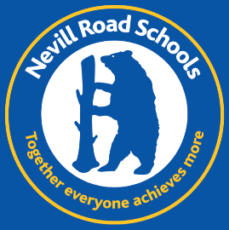
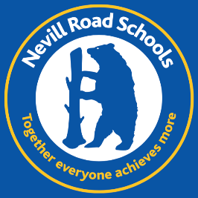
Nevill Road Infant School
Permanent Breakfast & After School Club Manager
NJC 12-17
Hours 7-9am / 3-6pm
(Monday to Friday, term-time only with possibility of negotiating holiday club activities)

We are looking for someone who is:
… a top toast taster
… a nurturing ‘Nevill Roader’
… a brilliant ball bouncer
… fun, fair, firm and fantastic
… a perfectly proficient, passionate play-leader

We are looking for someone who is:
- An outstanding practitioner
- Knowledgeable and experienced in working within Early Years, Key Stage 1 and 2
- Exciting, creative, motivating and playful
- Nurturing and passionate about education and play
- A real team player but also a leader
- Able to go the extra mile for our children and families

We can offer:
- Outstanding behaviour and pupil attitudes
- Bright, motivated and engaged children
- Supportive and interested parents
- A focused, dedicated and inspiring team
- A place in our Nevill Road family

We are looking for a passionate and self-motivated individual to join our hard-working and dedicated team.
We would love to show you around, please contact us to arrange this.

Nevill Road Infant School is committed to safeguarding and promoting the welfare of children and young people and expects all staff and volunteers to share this commitment. The successful applicant will be required to have an Enhanced Disclosure from the Disclosure and Barring Service.

For further information and an application pack, please contact:

Mrs. Sharon Kyne
School Business Manager
Nevill Road Infant School
Closing Date: 6th December 2022
Shortlisting Date: 6th December 2022
Interview Date: 8th December 2022
Nevill Road
Stockport SK7 3ET
0161 4394817

www.nevillroadinfant.co.uk admin@nevillroad-inf.stockport.sch.uk

