**Breakfast Club Assistant**

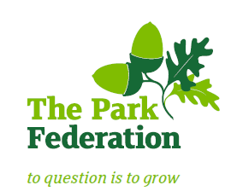

**Salary (actual):** £3,213 - £3,259

**Grade:** 2, SCP 3-4

**Hours:** 5 hours per week, Monday to Friday

**Work Pattern:** term time only

**Contract**: permanent

Wood End Park Academy is home to over 900 children, including a 60-place nursery. It serves the children and families of the richly diverse and welcoming community of Hayes in West London.  The academy is part of The Park Federation Academy Trust, allowing us to benefit from a wealth of expertise across our eight academies, as well as enabling us to provide opportunities for sharing of good practice and high-quality training.

Our partnership with The Park Federation Academy Trust means there are a host of professional development opportunities that will further your own skills, knowledge and expertise.

**For the right candidate, we will offer**

* extensive support and CPD;
* the opportunity to work with other professional colleagues across the Multi-Academy Trust;
* a welcoming school, with friendly, enthusiastic and supportive staff team;
* an ambitious and dynamic Senior leadership Team;
* a dedicated Governing Body;
* supportive parents and children who are keen to learn;
* an employee assistance programme (EAP).

Please contact the school to arrange a visit. Please visit the school website to complete an application form. We do not accept CV’s.

**Closing date:** As and when we receive successful applications.

**“The school is committed to safeguarding and promoting the welfare of children and young people and expect all staff and volunteers to share in this commitment. The successful applicant will be required to undertake an Enhanced DBS Check with a check of the DBS Barred List”.**