

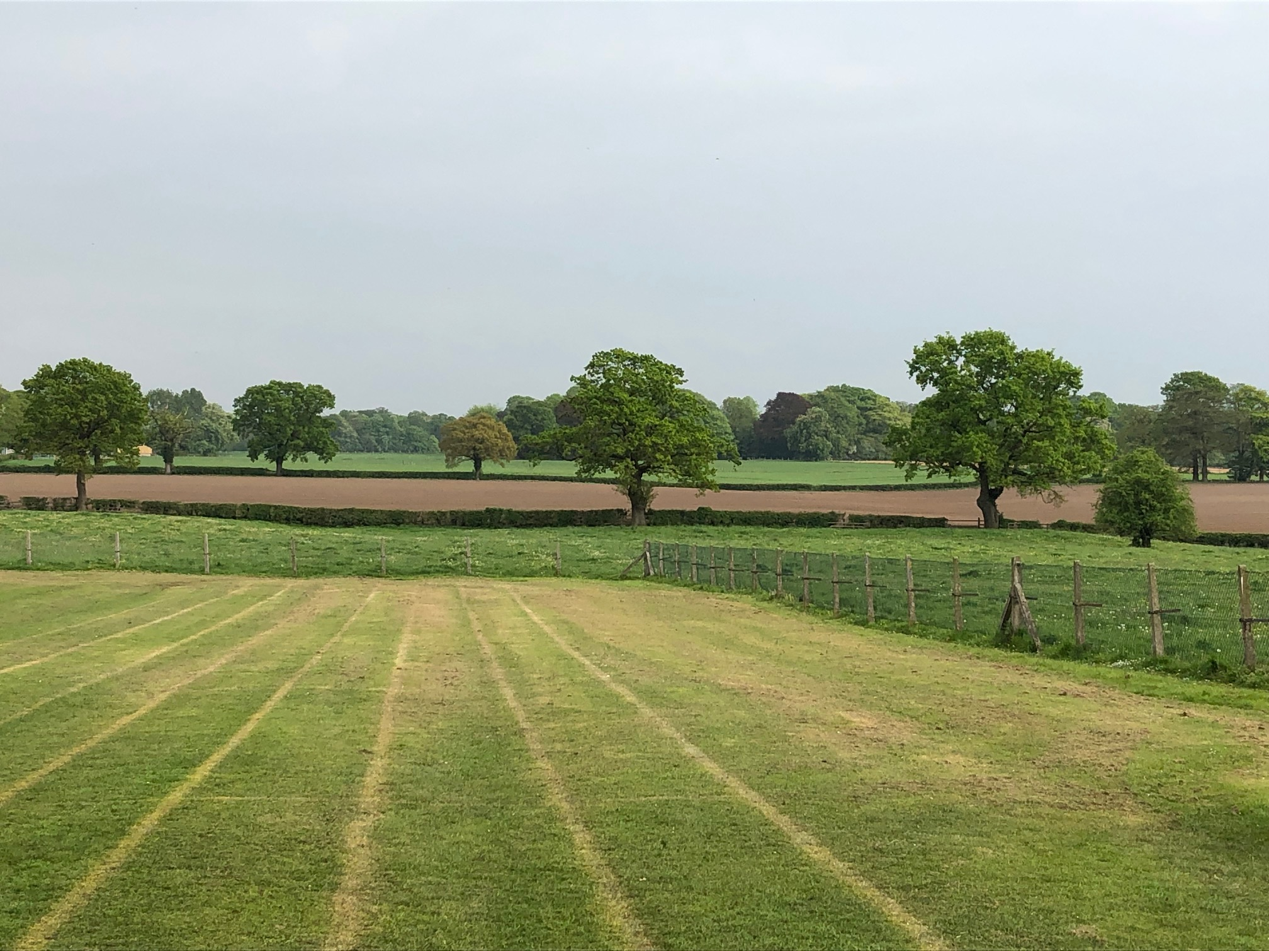




MOBBERLEY CHURCH OF ENGLAND PRIMARY SCHOOL
Church Lane, Mobberley, Cheshire, WA16 7RA
Headteacher: Mr D Stenson B.Ed NPQH
T: 01625 800 920 • E: admin@mobberley.cheshire.sch.uk • W: www.mobberley.cheshire.sch.uk

“Ask and it will be given to you; seek and you will find; knock, and the door will be opened to you”
Matthew 7:7



Welcome from the Headteacher

A warm welcome to Mobberley C.E. Primary School. At Mobberley, we firmly believe that all our children should enjoy their learning through stimulating and meaningful experiences. We ensure our children feel safe and valued as part of our school community, growing in an atmosphere where Christian Values are at the heart of our provision.

We have an incredibly strong team of teachers and support staff who care and support all children and we are proud of the partnerships we have developed with parents and extended families in the community to support our children to achieve their very best.

We look forward to welcoming you aboard as an integral part of our team at this exciting time for the school, following on from last year’s highly successful Ofsted and SIAMs inspections.

Damien Stenson

Headteacher

Mobberley C.E. Primary School are looking to appoint a suitably qualified and skilled School Bursar to lead our non-teaching operations. We are looking for a reliable, organised professional, who has a self-driven approach to problem solving and high-level communication, literacy and numeracy skills.

This is a fantastic opportunity for someone with enthusiasm and drive to join the team of this high performing school. The successful post holder will work alongside committed and like-minded colleagues, as part of our office team. They must enjoy working in a busy, child-centred environment and can be a positive point of contact for our school community through all in person/online interactions.

Our new Bursar will take a lead at whole school level regarding all aspects of finance, administration, HR, and operational support. They will work with the Senior Leadership Team/Governors and maintain a strong relationship with the Cheshire East Budget Officer to ensure the school’s business and financial procedures deliver the highest possible standards.

Whilst you may not have experience of all areas of the role or working in an educational environment, you will have transferrable skills from existing employment and a desire to learn and take advantage opportunities to develop. You will be able to work within a collaborative management organisation; supporting the Senior Leadership Team with sound financial advice and guidance, whilst taking responsibility for your own area of work.

In addition to being a valued member of our fantastic team, we can offer:

• Permanent contract (following successful 6-month probationary period)
• Term Time Working (195 days requirement)
• An individualised, funded, training plan
• Membership of the Local Government Pension Scheme
• Annual Flu Jab
• Local Authority Salary Sacrifice Schemes

Please read our job description and person specification closely. If you think you may be the candidate we are looking for and would like further information, or an informal discussion, please contact our Headteacher, Damien Stenson - email head@mobberley.cheshire.sch.uk.

We would like to offer all potential candidates the opportunity to visit our school and find out more about the role. Visits will take place by appointment please contact the school to make an appointment on 01625 800 920 or email admin@mobberley.cheshire.sch.uk.

To apply for this role please complete the application form and email to head@mobberley.cheshire.sch.uk along with a supporting letter (no more than 2 sides A4) detailing your skills, qualifications and experience, aligned to the job description and person specification. We do not accept C.V.’s and will not consider applications submitting a C.V.

Mobberley CE Primary School is committed to safeguarding and promoting the welfare of children and young people and expect all staff, volunteers and other third parties to share this commitment. Safer recruitment practice and pre-employment background checks will be undertaken before any appointment is confirmed. This includes a request for references, prior to interview.

Shortlisted candidates are expected to provide evidence of qualifications at interview and a satisfactory, enhanced DBS check will be undertaken before final confirmation to the successful candidate. We warmly welcome applications from every suitably qualified member of our local community. We regret that we are unable to provide feedback on the shortlisting process.

Closing Date: Friday 9th January 2026

Interviews: Wednesday 14th January 2026

