

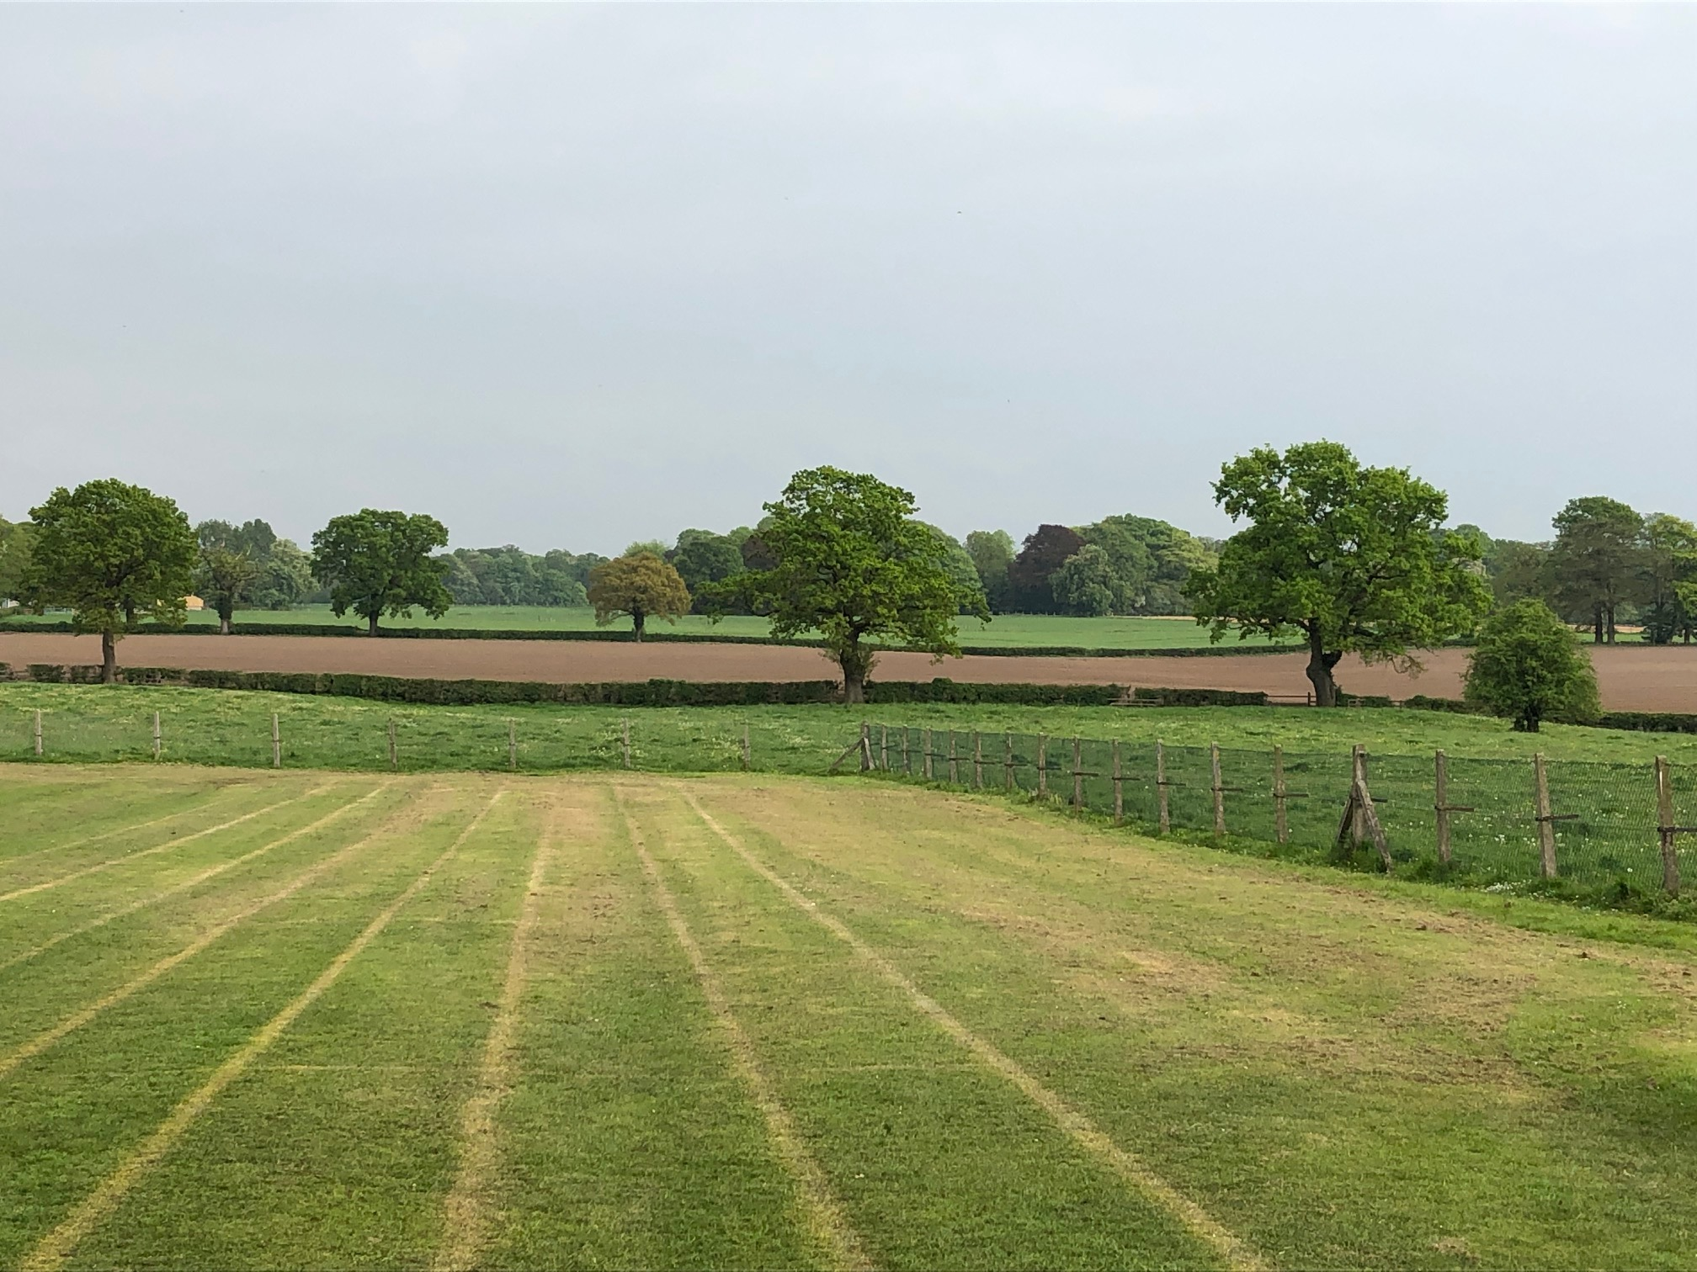




MOBBERLEY CHURCH OF ENGLAND PRIMARY SCHOOL
Church Lane, Mobberley, Cheshire, WA16 7RA
Headteacher: Mr D Stenson B.Ed NPQH
T: 01625 800 920 • E: admin@mobberley.cheshire.sch.uk • W: www.mobberley.cheshire.sch.uk

“Ask and it will be given to you; seek and you will find; knock, and the door will be opened to you”
Matthew 7:7

School Bursar Vacancy

Salary: Grade 7 Salary Range: £31,537 - £34,434 FTE
Job type: Permanent (37 hours per week, 39 week contract)
Start date: Jan/Feb 2026
Apply by: Friday 9th January
Interviews: 14th January

Job overview

Mobberley C.E. Primary School are seeking to appoint a Bursar to join our staff team at an exciting time in the development of our lovely, village school.

The current vacancy responsibilities will include, but are not limited to:

- Management of the School budget - annual budget setting/monthly monitoring and reconciling expenditure/forecast year end projection/3 year planning
- Attend termly finance meetings with the school budget officer and governors to update financial projections and set allocations
- Process orders and invoices in line with financial procedures
- Update the Manual of Internal Financial Procedures
- Complete the SFVS return (Schools Financial Value Standard)

We are looking for a dynamic individual who shares our vision and commitment to ensuring the very best for every child in our care. We are looking for someone with a sense of humour who is self-motivated, organised and flexible and able to maintain a high degree of confidentiality and professionalism.

The successful candidate needs to have excellent organisational skills, possess excellent numeracy and literacy skills and have a passion for developing the best opportunities for the children of Mobberley.

Closing date for applications is Friday 9th January 2026.
Enquiries to: admin@mobberley.cheshire.sch.uk or
School website: https://mobberley.cheshire.sch.uk/
Applications returned to: head@mobberley.cheshire.sch.uk

