**🌟 Join Our Team at The Colleton Primary School! 🌟**

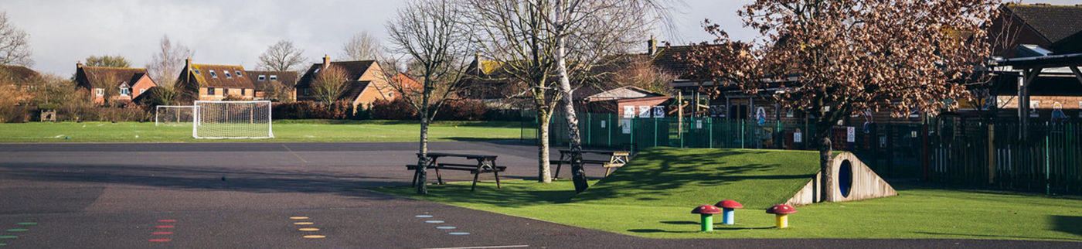

**Role:** Business Assistant

**Salary:** Grade 4 SCP 7

Part-time, 24 hours per week, Term Time Only

Fixed Term until 31st August 2026

At The Colleton Primary School, we’re more than just a school—we’re a vibrant, creative, and nurturing community where children thrive, families feel welcome, and staff love to work. We are looking for a proactive and enthusiastic Business Assistant to join our friendly team and help keep our school running smoothly behind the scenes.

## ✨ About the Role

This is a varied and rewarding role where no two days are ever the same! You’ll be providing essential financial and administrative support, ensuring our staff and families get the best support possible.

## 🌱 About You

✔ Organised, with a keen eye for detail  
✔ Flexible, adaptable, and able to juggle priorities  
✔ Experienced in admin or finance (school experience is a bonus!)  
✔ Always professional, but with a good sense of humor too!

## 📅 How to Apply

If this sounds like the perfect role for you, we’d love to hear from you! Visit our website to view the job spec and application form: 👉 <https://colleton.wokingham.sch.uk/>

For an informal chat or visit, please contact the School Office—we’d be delighted to show you around.

💡 Safeguarding Statement 💡  
The Colleton Primary School is committed to safeguarding and promoting the welfare of children. All appointments are subject to enhanced DBS clearance and satisfactory references. We value diversity and are an equal opportunities employer. We welcome applications from all suitably qualified candidates regardless of age, disability, gender, gender identity, marital status, pregnancy or maternity, race, religion or belief, or sexual orientation.