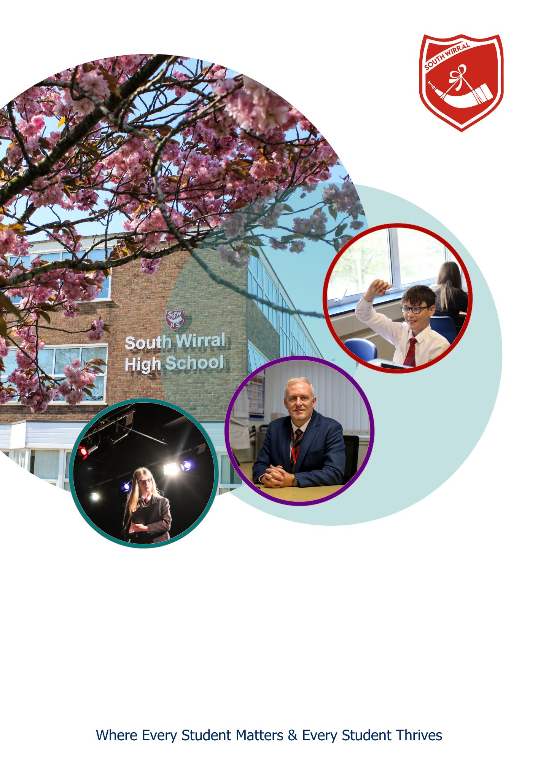

**BUSINESS SUPPORT OFFICER**

Job Description and Person Specification

**POST OVERVIEW**

**Business Support Officer**

**Start date: 01 September 2025 (an earlier start date may be considered for the right candidate)**

**36 hours per week / Term Time Only Plus 1 Week**

**Band F - NJC scp 12 (£24,047) to scp 17 (£26,085)**

**Location:** South Wirral High School, Eastham, Wirral, CH62 8EH

Are you a highly organised, detail-focused professional with experience in both finance and HR? Do you enjoy working as part of a supportive team in a busy and rewarding school environment?

South Wirral High School is seeking a Business Support Officer to join our dedicated support team. You will join a team of four finance and HR colleagues. This is a key role with a 50/50 split between finance and HR functions, providing essential operational support that helps the school run smoothly and efficiently.

**About the Role**

You’ll be involved in a wide range of activities, including:

* Producing financial reports and management accounts
* Preparing payroll checks and managing absence claims
* Supporting recruitment and onboarding
* Maintaining accurate staff and financial records
* Providing cover within the finance or HR team during staff absence e.g. Processing orders, invoices, and payments

You’ll work closely with the School Business Manager and play a key role in upholding compliance with school policies and statutory regulations.

**About You**

We’re looking for someone who is:

* AAT qualified (or has equivalent finance qualifications)
* Experienced in finance and/or HR roles, ideally within an education setting
* Highly organised, with excellent attention to detail
* A confident communicator and team player
* Committed to maintaining confidentiality and upholding school values

*****What we offer:**

We are part of The Challenge Academy Trust, to learn more about the trust please visit [www.tcat.uk.com](http://www.tcat.uk.com).

For more information on this role, please contact Sharon Jones – HR Manager – [recruitment@southwirral.wirral.sch.uk](mailto:recruitment@southwirral.wirral.sch.uk)

The Challenge Academy Trust is committed to promoting the safeguarding and welfare of children and young people and expects all staff and volunteers to share this commitment. All appointments are made subject to an Enhanced DBS check. We are an Equal Opportunities Employer, and our employment policies, procedures and practices are regularly reviewed to ensure compliance with legislation. We are committed to creating a workplace culture that is inclusive, positive, and fair with opportunity for all.

**Closing Date – 18th June 2025**

**Interviews**

Interviews will take place week commencing 23rd June 2025

**Method of Application**

Download an application form from our website here: <https://southwirral.wirral.sch.uk/vacancies/>

Please send completed application forms and a letter of application to [recruitment@southwirral.wirral.sch.uk](mailto:recruitment@southwirral.wirral.sch.uk)

**JOB DESCRIPTION**

|  |  |
| --- | --- |
| **NAME:** |  |
| **JOB TITLE:** | **Business Support Officer** |
| **HOURS:** | **36** |
| **SALARY BAND:** | **Band F** |
| **CONTRACT TYPE:** | **Full-time** |
| **REPORTS TO:** | **School Business Manager** |
| **RESPONSIBLE FOR:** | **N/A** |

**MAIN PURPOSE**

The Business Support Officer will play a central role in supporting the smooth operation of the school’s finance and HR functions. This is a dual-role position, evenly split between financial administration and human resources support. The postholder will work closely with the Business Manager and relevant team members to ensure the accurate processing of financial transactions, support HR procedures, and provide reliable cover during periods of staff absence within either team.

**DUTIES & RESPONSIBILITIES**

**Finance Responsibilities**

* Produce accurate and timely financial reports and management accounts on a monthly basis.
* Process purchase orders, invoices, and payments in line with school procedures in the absence of the finance assistant.
* Reconcile supplier statements and resolve invoice queries
* Produce ad hoc invoices for suppliers
* Prepare monthly accruals and prepayment schedules
* Support the Business Manager with budget monitoring and financial forecasting
* Maintain accurate financial records and assist with internal and external audits
* Ensure adherence to financial procedures and compliance with regulatory requirements

**HR Responsibilities**

* Support the administration of the full recruitment cycle, including advertising roles, shortlisting coordination, interview arrangements, and onboarding
* Check and verify payroll reports for accuracy and liaise with payroll provider as needed
* Maintain up-to-date and confidential employee records, ensuring compliance with GDPR and safeguarding standards
* Monitor staff absence records and submit claims for reimbursement through the school’s staff absence insurance provider

**General Duties**

* Provide flexible support across both HR and finance teams as required
* Act as a point of contact for staff and external agencies relating to finance and HR queries
* Provide cover during periods of absence within the finance or HR team
* Uphold confidentiality, integrity, and professionalism in all aspects of the role
* Contribute to a positive, collaborative working environment and support the values of the school
* Participate in training and other learning activities as required.
* Participate in the school appraisal process.

The job description is not necessarily a comprehensive description of the duties required but outlines the main responsibilities of the post and you may be asked to undertake any duties commensurate with the grade of the post.

The Headteacher or postholder may seek a modification of the job description at any time.

An Enhanced DBS check will be required for this post.

**PERSON SPECIFICATION – BUSINESS SUPPORT OFFICER**

|  |  |  |  |  |
| --- | --- | --- | --- | --- |
| **Criteria** | | **Essential** | **Desirable** | **Assessment Method** |
| **Relevant experience / qualifications** | | | | |
| 1 | AAT qualified (or equivalent accounting qualification) | X |  | A/I/T |
| 2 | Evidence of continuing professional development in finance, HR, or school business management | X |  | A/I/T |
| 3 | Experience working in a finance or HR administrative role, preferably within an educational setting | X |  | A/I/T |
| 4 | Experience in producing financial reports, management accounts, and supporting budget monitoring | X |  | A/I/T |
| 5 | Experience supporting HR functions including recruitment, maintaining staff records, and handling absence processes |  | X | A/I/T |
| **Knowledge & understanding** | | | | |
| 6 | Sound understanding of financial procedures and best practice | X |  | A/I/T |
| 7 | Awareness of payroll processes and budget monitoring requirements |  | X | A/I/T |
| 8 | Good working knowledge of finance and HR systems (e.g. CIVICA) |  | X | A/I/T |
| 9 | Strong IT skills, particularly in Microsoft Excel and Word | X |  | A/I/T |
| 10 | Understanding of confidentiality, data protection (GDPR), and safeguarding responsibilities | X |  | A/I/T |
| **Competencies** | | | | |
| 11 | Strong numeracy, analytical, and problem-solving skills | X |  | A/I/T |
| 12 | Excellent attention to detail and accuracy in all work | X |  | A/I/T |
| 13 | Able to interpret and present financial and HR information clearly and appropriately | X |  | A/I/T |
| 14 | Highly organised and able to manage time effectively under pressure | X |  | A/I/T |
| 15 | Able to work independently and take initiative, as well as collaborate effectively in a team | X |  | A/I/T |
| 16 | Adaptable and flexible to support different aspects of the school’s operations as needed | X |  | A/I/T |
| 17 | Committed to upholding the values, vision, and ethos of South Wirral High School | X |  | A/I/T |
| **Commitment to Equal Opportunities** | | | | |
| 18 | Understanding of and commitment to the principles and practice of equality, diversity, and inclusion, both in relation to employment issues and to service delivery | X |  | A/I/T |

**Key: A = Application; I = Interview; T = Task**

**NOTE TO APPLICANTS**: Whilst all points on the specification are important, those marked as ‘essential’ are the key requirements for the role. You should pay particular attention to these points and provide evidence of meeting them. Failure to do so may mean that you will not be invited for interview.