

**Careers Coordinator**

**Recruitment Pack**

Dear Applicant,

Thank you for your interest in the position of Careers Coordinator at Chislehurst & Sidcup Grammar School. This is a fantastic opportunity for a passionate and organised individual to support our student’ future pathways.

Chislehurst & Sidcup Grammar School is one of the top performing grammar schools in the South East, based in the London suburb of Sidcup. We are a heavily oversubscribed mixed selective school where students excel, with many going on to Oxbridge or other Russell Group universities.

My vision for this School is to make Chislehurst and Sidcup Grammar School the very best place for a young person to grow up. To achieve this, it is essential that I meet three key targets.

Firstly, to ensure that all students are safe and feel safe at all times. Safeguarding is a priority at this school. Secondly that students are happy and ready to learn. Finally, that all students maximise their academic potential to enable them all to achieve their goals in life. Clear and committed professional advice and guidance is part of daily life for the students on their individual pathways to their chosen university, apprenticeships or employment.

If our vision is one you share then please do read on. We are ambitious about diversity and inclusion and very much look forward to receiving applications from candidates whose personal qualities and values reflect those in the person specification. We encourage applications from all candidates who would like to play their part in our work.

I look forward to welcoming you in person at Chislehurst & Sidcup Grammar School soon.



Nigel Walker, Headteacher



**Our school**

The school opened in the Autumn Term of 1931 and has been at three different sites since then. CSGS has been at the current site for over fifty years and has undergone considerable building development, ensuring that we have purpose-built buildings for Art and Design, Performance and Sixth Form study. There has also been the development of sporting facilities with flood lit netball courts and full gym equipment (which staff are able to use after school).

CSGS aims to educate and prepare for life, able students from all backgrounds.  This mission is dynamically carried forward within a caring, happy and supportive community.  We look to develop the character of our students focusing on resilience, intellectual curiosity, courage, creativity, commitment, responsibility, gratitude and compassion. The ingrained idea of excellence in school life allows students to reach the highest academic, sporting, cultural and aesthetic standards.

The special quality of learning in the classroom is equally matched by the richness of teaching that students experience. We aim to help our students to leave the school fully prepared for the future ahead of them and, as our school motto states, we believe that ‘from hard work character grows’. *Abeunt studia mores*.

Whilst healthy academic competition is central to the CSGS ethos, there are also many opportunities for students to enter into the wider life of the school.  Service to the school and community is enthusiastically performed and high levels of leadership and responsibility are actively taken on by students at all levels.  There is a supreme belief that building CSGS’s tradition of excellence comes not from dwelling on yesterday’s successes but performing tomorrow’s tasks.

Take a tour of our school.  <https://virtualschooltour.co.uk/chisandsidgrammar/>

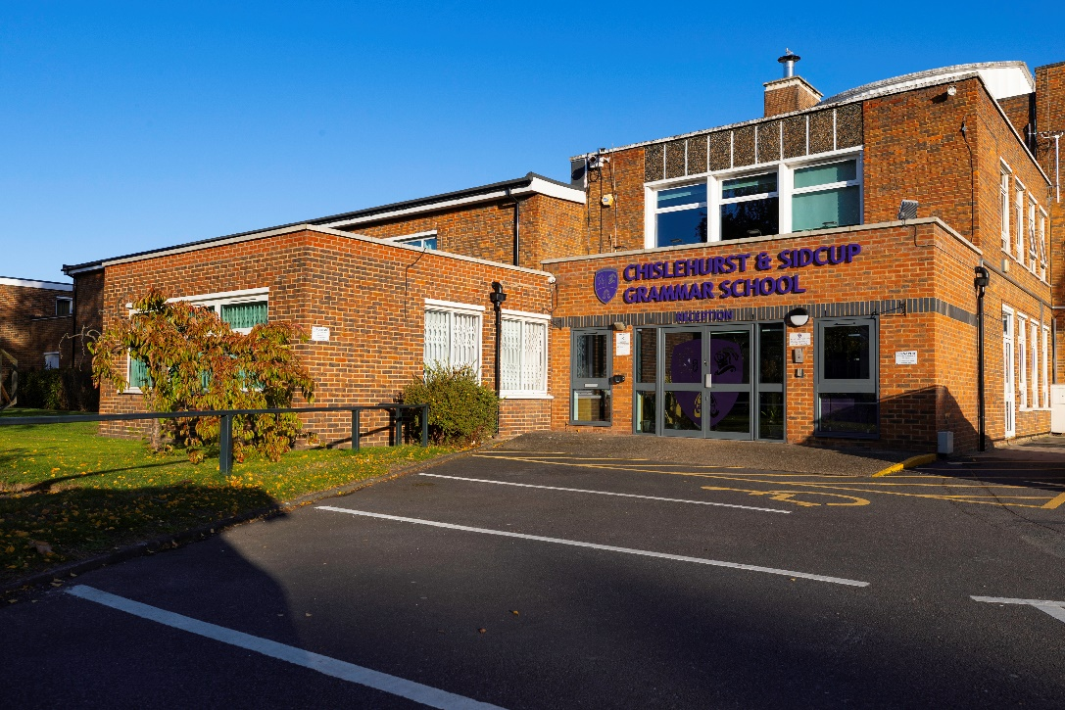

**Why join the teaching staff of Chislehurst and Sidcup Grammar School?**

**Academic success**

CSGS is one of four grammar schools in Bexley and as such our students all pass an entrance examination in order to attend the school. Our results reflect both the hard work of the students and the teachers with the GCSE results for 2024 giving us a Progress 8 score of 0.82 and our A level students continuing to move on to top institutions.

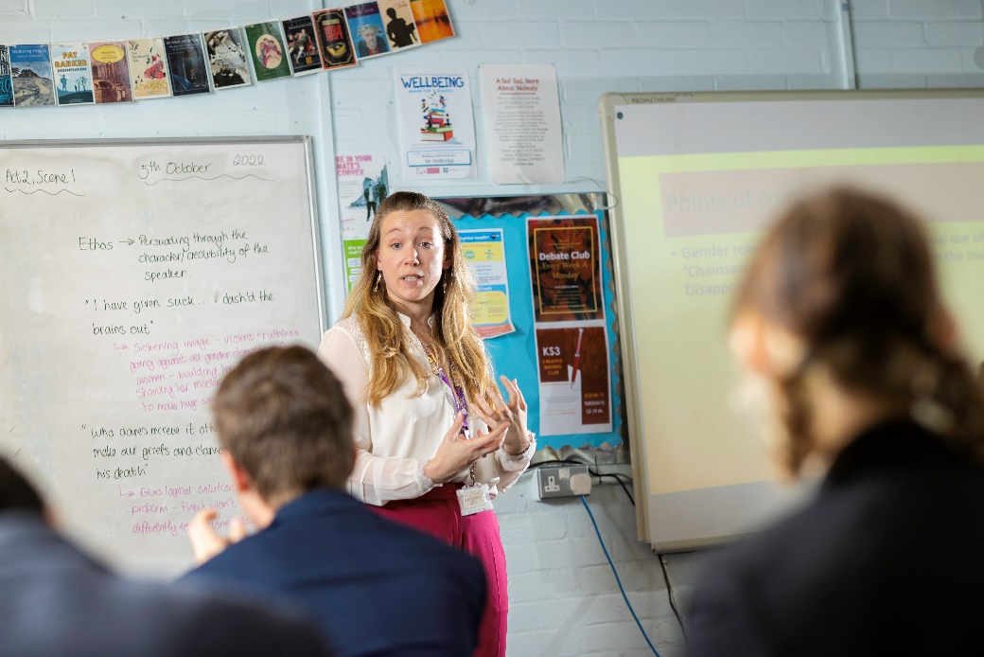The focus on the academic progress that the students make in the school is evident from the school’s priority to ensure that the academic and pastoral support is on offer with the role of Head of Learning for each year group and a Learning Manager to provide a key link with parents.

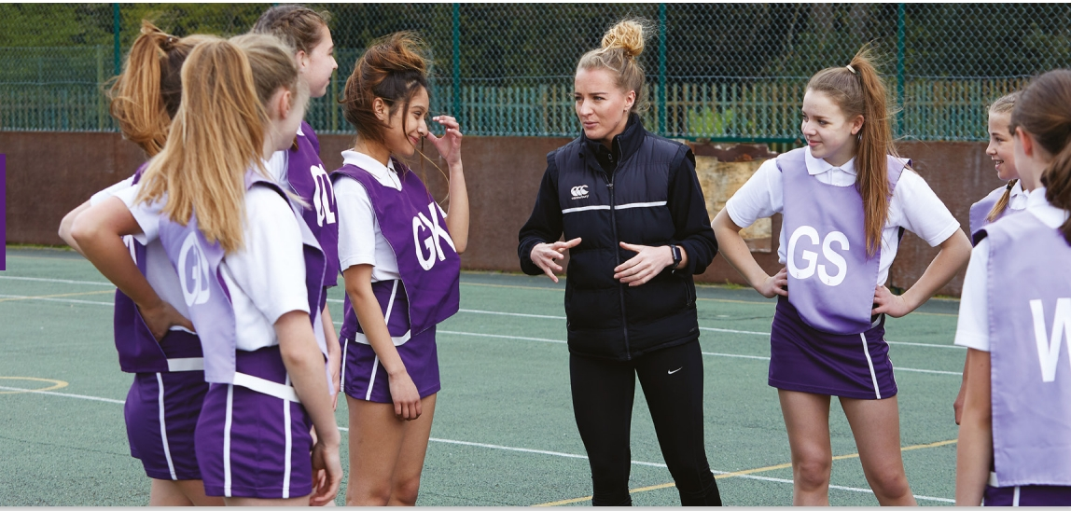

**Continuing Professional Development**



“Students… are given many opportunities to lead and be listened to.”

**Ofsted**

As well as outstanding students who are keen to learn we look to have a happy staff who are able to develop professionally.

We offer an internal CPD programme that is personalised for a teacher’s needs and considers the needs and wants of the teaching staff. There is a clear focus on Teaching and Learning with staff delivering thoughtful and thought-provoking sessions that always include opportunities for sharing of good practice and working together collaboratively. This sharing of good practice is encouraged further through all teaching staff being given time to visit another school to share ideas which can be brought back to their curriculum areas. There is also a specific training programme for any Early Career Teachers.

All new staff are also given a mentor to enable them to have a member of staff that they can go to for any additional support or questions that they may have as well as a member of the Senior Leadership Team being responsible for the Induction of New Staff. Working parties have also been used when staff are looking to develop a key issue.

**Wellbeing**

It is of vital importance to us that our staff are happy and enjoy coming to work. In order to enhance this, we offer wellbeing sessions where staff have the opportunity to learn a new skill and spend time with other staff. Staff here at CSGS are also a close community with free gym access to onsite facilities. The staff society also organise a Christmas party every year.

Our continued commitment to the wellbeing of our staff and students is further evidenced by achieving a Wellbeing Award for the support of the wellbeing of our staff and students.

We offer a comprehensive Wellbeing employee assistance programme 24/7.

**Additional benefits**

Further to this, we offer a competitive pay and pension scheme and to support parents we offer a priority to children of members of staff to join this school (subject to passing the 11+ examinations). All staff will also receive a tailored induction programme as well as a professional development scheme (as mentioned above) with the possibility of funding for additional qualifications. We offer discounted local gym membership (in addition to free use of our on-site facilities), free car parking on site, cycle to work and on-site dining with superb food.



**Job Description**

**The role: Careers Coordinator**

**Start date: ASAP**

**Salary: Bexley 06.1-06.4 (£30,288 - £31,611) FTE per annum. Actual £25,383 - £26,492 per annum**

**Contract: Part Time, Permanent**

**Hours: 36 hours per week, Term Time Only**

**PURPOSE**

The Careers Coordinator will work with the Assistant Headteacher responsible for Careers to develop engaging and informative careers provision in line with the Gatsby Benchmarks, organise impactful events and meaningful employer interactions and encounters. To work closely with external providers and internal colleagues to provide high-quality careers education.

**REPORTING TO** Assistant Headteacher

**HOURS:** Term Time Only

**MAIN RESPONSIBILITIES**

* Support delivery of the school’s careers provision, communicating effectively with external organisations, staff, pupils and parents.
* Ensure the school’s careers programme aims to meet the Gatsby Benchmark set out in DfE’s guidance
* Work with curriculum leaders to embed careers learning into subject areas
* Coordinate careers events and initiatives across all year groups, including National Careers Week, mock interviews, careers fairs, employer-led workshops, work experience, employer and employment encounters.
* Support the development of students’ employability skills through structured programmes, workplace experiences, and targeted interventions.

1. **Careers**

* Support Year 11 students with Post 16 applications.
* Coordinate the delivery of careers education to students from year 7.
* Organise annual careers conference for year 9
* Organise assemblies, group discussions and taster events for pupils to meet a range of local providers and have discussions about the opportunities they offer.
* Monitor and manage students access to and use of the Unifrog platform to maximise engagement & experience
* Support use of Compass +
* Support regular reviews and evaluations of careers provision
* Organise and conduct mock interviews for students.
* Develop Alumni network to support current students
* Effectively manage data and records including destinations data and WEA.
* Produce careers communications for students, parents and wider school community.

1. **Work related Learning**

* Establish, maintain and develop links with further education colleges, universities and apprenticeship providers where appropriate
* Establish, maintain and develop links with employers to allow the coordination of work experience opportunities for pupils
* Organise and monitor appropriate work experience for relevant pupil’s year groups.
* Manage pupil requests for work experience, ensuring students have prepared CV’s and providing feedback
* Liaise with parents, pupils and hosts regarding work experience
* Provide key documents for each placement before and after work experience
* Compile references for former students

1. **General responsibilities**

* Any relevant administration related to student services including exams, correspondence, SEND, support with UCAS, careers, etc.
* Obtain a First Aid qualification and assist with First Aid as and when required
* Assist with exam invigilation as and when required
* To undertake any other reasonable requests as and when required

*The school is committed to safeguarding and promoting the welfare of children and expect all staff and volunteers to share this commitment. Offers of employment are subject to a satisfactory enhanced DBS disclosure and other employment checks.*

**Person Specification**

|  |  |  |
| --- | --- | --- |
|  | ESSENTIAL | DESIRABLE |
| QUALIFICATIONS | * 5 GCSEs A* to C (or equivalent) including English and Maths |  |
| EXPERIENCE , SKILLS & KNOWLEDGE | * Strong literacy, numeracy, ICT (i.e., MS Word), and communication skills * Experience of working in an office environment orientated towards public and in-house needs * Maintaining office systems (electronic and paper based) * Evidence of strong organisational and record keeping skills * Good understanding of office and school health and safety requirements * Experience of working with students from KS3 to 5 | * Previous experience of website administration * Previous School Office experience * Proficient in use of SIMS, MS Excel and Outlook * Experience of Work experience * Experience of Careers IAG within schools * Appropriate first aid training (or willingness to be trained) |
| PERSONAL QUALITIES | * Capacity to learn about new software packages * Professionalism to work in a busy and complex office environment * Strong service orientation * Interpersonal and communication skills allowing successful liaison with all stakeholders and members of the public from a cross-section of backgrounds * A Project Manager who is a lateral and creative thinker with innovative ideas and practical solutions * Flexible, diplomatic and balanced in approach allowing successful interviewing and coaching of students * Willing and able to share skills and knowledge within the workplace * Able to work under pressure, balancing individual and team activities * Able to demonstrate appropriate initiative and work unsupervised * Self-motivated, with a “can do” approach to problem solving and an ability to work autonomously using own initiative * Problem solver at an operational level | * Good decision-making ability * CV writing skills * Willingness to learn about other colleagues’ roles |
| SAFEGUARDING | * Suitable to work with children. All positions subject to a satisfactory enhanced DBS disclosure. |  |

**How to apply**

Further details together are available either from the school website [www.csgrammar.com](http://www.csgrammar.com) (Vacancies) or by emailing [csgshr@csgrammar.com](mailto:csgshr@csgrammar.com). Please complete your application form via [www.TES.com](http://www.TES.com). Applications will be considered on receipt and interviews may occur at any stage.

If you have any questions, please contact [csgshr@csgrammar.com](mailto:csgshr@csgrammar.com)

**References**

Please note that it is our practice to take up references before shortlisting for interview.

Current and previous employers will be contacted as part of the verification process pre-appointment checks.

When an applicant is short-listed, any discrepancies or anomalies in the information provided or issues arising from references will be taken up at interview. Your referees should include your current/most recent employer. References from relatives or friends are not acceptable.

**Safeguarding**

The school is committed to safeguarding and promoting the welfare of children and expect all staff and volunteers to share this commitment. Offers of employment are subject to a satisfactory enhanced DBS disclosure and other employment checks.

CSGS is an Equal Opportunity Employer. We do not discriminate on the basis of age, disability, sex, race, religion or belief, gender reassignment, marriage/civil partnership, pregnancy/maternity or sexual orientation.

We are fully inclusive and actively promote equality of opportunity for all. We welcome all applicants from a wide range of candidates.

Selection for roles will be based on individual merit alone.

**How to find us**

The school is located within a 5-minute walk from Sidcup train station which provides a quick connection to London, has local bus services and is close to both the A2 and M25.

[**https://www.google.co.uk/maps/dir//Chislehurst+%26+Sidcup+Grammar+School%2CDA15+9AG**](https://www.google.co.uk/maps/dir//Chislehurst+%26+Sidcup+Grammar+School%2CDA15+9AG)