
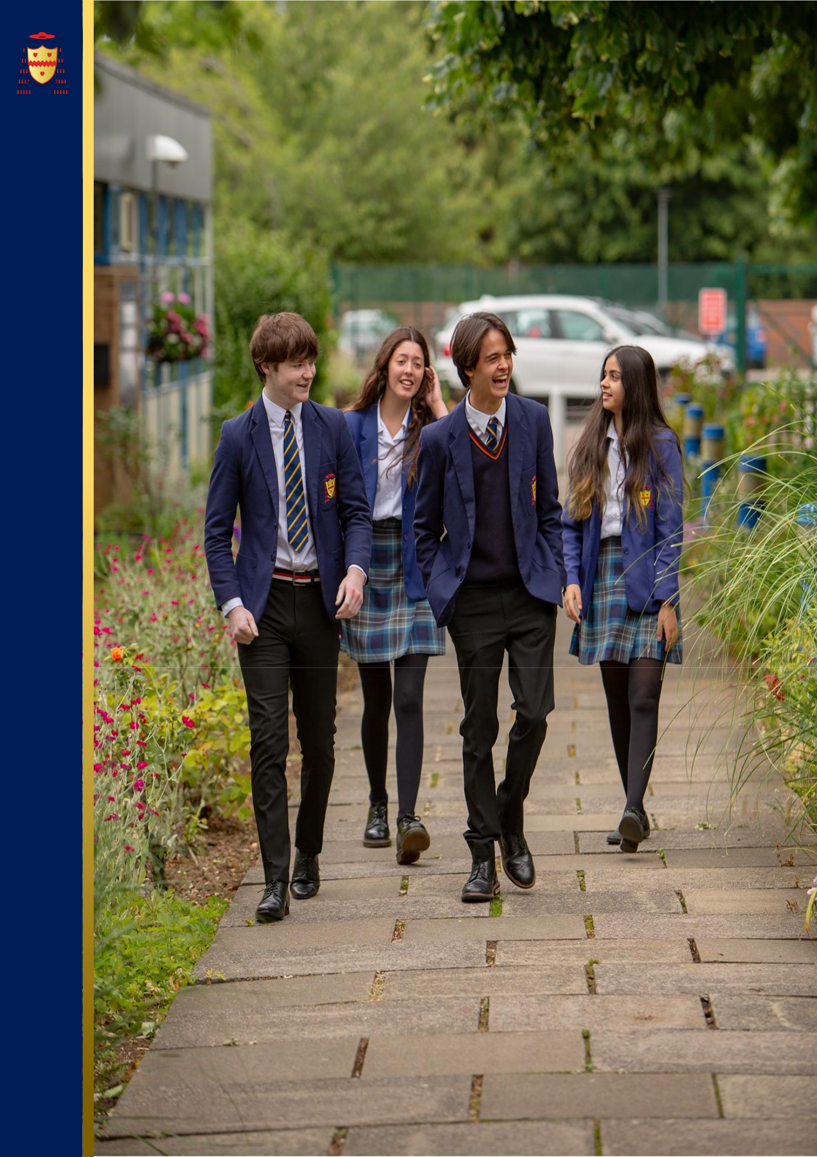
THE SAINT JOHN HENRY NEWMAN
CATHOLIC SCHOOL
Applicant Pack

Careers Lead
June 2025

Welcome from our Headteacher

Dear Applicant,

Thank you for your interest in working at the Saint John Henry Newman School. I hope you find this information pack a useful introduction to our school. We are delighted that you see our school as a place where you can make an impact.

The Saint John Henry Newman Catholic School is a very distinctive community which unequivocally works to be a living Christian community in which each child and young adult is known and loved for who they are. We want our students to enjoy their education – to be happy, safe and secure and to grow in God’s love so that when they leave the school, they are equipped to change the world and make it a better place.

We firmly believe that our parents are the ‘prime’ educators and that our success is a result of the collaboration between parents, school and child working together for the good of the child. Our parents are encouraged to be fully engaged in their children’s education and there are many opportunities for parents to visit the school and contribute to their children’s adult formation and academic success.

This academic success is highlighted by the high rate of progress our students make. The school’s progress 8 score of 0.71 places the school in the top 8% of schools in the country, whilst at Sixth Form our students continue to achieve in excess of national standards. This success at key stage 4 and 5 means that the Saint John Henry Newman Catholic School continues to be officially recognised as one of the highest-achieving schools in the country.

We are however very clear that our ‘Mission’ is to create an environment in which children can discover who they are and what their role in this life is. In the words of our patron, the Blessed John Henry Newman, we believe that “God has created us to do Him some definite service”.

Thank you for your interest in Saint John Henry Newman School. My colleagues and I look forward to reviewing your application.

Yours faithfully,
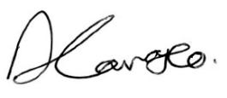

David Carrasco
Headteacher

Introduction of Our School

The Saint John Henry Newman school serves the North Hertfordshire Catholic community but our catchment area extends to Bedfordshire, East Hertfordshire and parts of Cambridgeshire. Originally, a 6-form entry School, the intake was increased to 210 in 1999 and increased to 8 form entry in September 2015. There is a high retention rate in the Sixth Form and many students apply to join our Sixth Form from other establishments. Consequently, the School has grown in size from 830 in 1993 to approximately 1600 in September 2023, with 400 students in the Sixth Form. The School became an academy as part of the Diocese of Westminster Academy Trust in 2012 and has benefitted from considerable investment in its buildings as a result, including a £3.5 million Sports and Performing Arts block (The Pavilion).

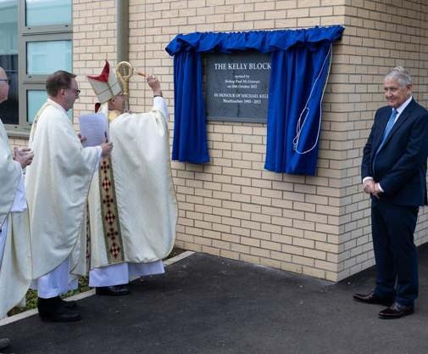
A major refurbishment of the school estate is currently being undertaken with the provision of two new blocks which are open and operational. These home new teaching accommodation, a dedicated sixth-form suite, a greater number of computer rooms and improvements to the Library, Dining and Hall facilities. The existing main block is being demolished as part of the final phase of the works. Following the demolition of the old teaching block the school will landscape the grounds to create a new prayer garden. The first of the new facilities was opened by former Headteacher Mr Kelly in October 2022. The second phase of the work which includes the opening of the new main block known as the Mathew Block will have its formal grand opening in January 2024.

Our Mission Statement emphasises the practical nature of our religious character. We seek to offer a living Christian experience as a community in which each pupil is valued as an individual and is encouraged to achieve success in school life. Our Chapel is a central part of school life but it is in the day-to-day operation of school life that the School sees its aims being fulfilled. We want Students and students to enjoy the experience of being part of the Saint John Henry Newman Catholic School community, to gain in self-confidence and to become young adults instilled with a sense of personal responsibility, social commitment and, hopefully, an awareness of their own distinctive spirituality. We want them to be equipped to change their world.

The pupil population is mostly Catholic and the School is heavily oversubscribed for places. Although not all staff are Catholic (teaching staff 45.9% are Catholics), all maintain and support the distinctive Catholic nature of the School and support the Headteacher in implementing the School Mission Statement. There is presently 90 members of teaching staff and there is a generous complement of support, technical, clerical and maintenance staff.


In years 7 to 9 Students follow a broad and balanced curriculum based on the National Curriculum. Students in Year 10 and 11 follow a core curriculum of English, Maths, Science and RE with three subject choices. At Key Stage 4 we encourage students to follow the EBAC where this is appropriate, but we offer a wide range of GCSEs and the creative subjects (Art, Drama, Dance and Music) are very popular option. We offer a range of vocational courses for Students for whom this is appropriate.

Our current provision offers vocational courses in Child Development, Catering and Sport. We have a large sixth form of approximately 400 students and there is a very wide range of A-level provision. Advanced Vocational courses are also offered in Art and Design, Production Arts, Digital Music Production, Music Performance. Applied Science, Sport and Health and Social Care.

The School has an excellent academic reputation. In 2022/23 the students achieved: 86% GCSE English and Maths at 9-4, 37% of all GCSE grades achieved were 9-7, 56% A Level at A*, A and B. At A-level the pass rate for the last three years has been over 99%.
The pass rate for Vocational courses has consistently been 100%. We are, however, conscious that we have the capacity to improve further and we are determined to do this on behalf of our Students and students. Exam results, important though they are for opening doors for Students in the future, do not determine success and happiness.

Therefore, we have a strong enrichment and well-being program that encompasses every student and a comprehensive career curriculum. We have been awarded with the Kitemark for emotional health and wellbeing for our work supporting students, their families and staff.


The number of Students entitled to free school meals is relatively low (7%) with 7.4% of Students receiving Pupil Premium. The ethnic composition of the School’s population reflects the community which it serves. It is predominately white British (46%) but with significant proportions of ethnic minorities reflecting the Church’s worldwide mission and the growing number of new migrants employed primarily in health care and scientific research. Attendance is above the national average with very low unauthorised absence figures.

A Diocesan Section 48 inspection in November 2019 concluded that we are an “Outstanding Catholic School”.

The 2018 Short OFSTED inspection concluded; ‘We were immediately struck by the many smiling faces of Students, who enjoy coming to school. When speaking to them, Students universally highlighted how their teachers ‘go above and beyond’ to help them achieve well. Students display a real pride in their school. They talk enthusiastically about their strong relationships with staff and the sense of community where ‘everyone goes out of their way to be friendly and make you feel welcome’. Consistent with its aim of encouraging everyone to reach their full potential, the School places great emphasis on its pastoral care.

We operate at a very human level and recognise that it is our good and caring staff who sustain and develop our school. Our challenge is to maintain high-quality provision, hopefully, to continue to make changes to improve this, but above all, to honour the promise we make to every parent who chooses to send their child to our School - that each child will be recognised and loved for who they are and that they will be offered excellent learning opportunities in a safe, caring and inspirational environment.

We are looking to appoint individuals who will enjoy being part of this distinctive community and who will contribute to it by sharing their individual talents, character and commitment and, hopefully, sense of humour!

The Saint John Henry Newman School is committed to safeguarding and promoting the welfare of children and young people.

All appointments are subject to a satisfactory enhanced DBS check.



Our Vision & Values

OUR MISSION IS TO BE A LIVING, CHRISTIAN EXPERIENCE


Inspired by
- Love of the creator
- Faith in Jesus Christ
- Hope from the holy spirit

In service to

- The needs of our Students and students
- The parents and guardians of our Students and students
- The educational mission of the catholic church

We believe
- In the goodness and beauty of god's creation
- In the goodness, dignity and worth of each person
- That everyone has a unique spiritual identity which they are called to fulfil
- In loving one another and yourself for the person that you are
- That all have rights, roles and responsibilities for which they are accountable
- In discovering and nurturing our god -given gifts
- In celebrating the personal development of each individual
- That the quality of teaching and learning is of fundamental importance
- In developing informed minds capable of making informed and considerate decisions
- That everyone thrives in a secure, safe and structured environment
- In forgiveness and being forgiven
- In celebrating and living our faith, and reaching out to others
- And that learning is a life-long journey through which each person should aspire to make the world a better place

Our Community Values Statement

- We belong to a community where everyone is valued, as we do not prejudge or discriminate.

- We belong to a community where everyone feels safe, as we do not threaten, intimidate or harm others.

- We belong to a community where diversity is respected, as we celebrate difference and treat everyone equitably.

- We belong to a community where success is celebrated, as we encourage and support others to succeed.

- We belong to a community where we can communicate our thoughts, feelings and ideas, and we do this with integrity and sensitivity to the feelings of others.

- We belong to a community where we can make mistakes, and we seek dialogue and reconciliation to restore relationships.

- We belong to a community which respects the environment around us, and we take pride in and look after the school buildings and outdoor spaces.

- We belong to a community which extends beyond the school walls, as we live by these values out of school.

Our Catholic Life

O Lord and Saviour, in your arms I am safe.
Keep me and I have nothing to fear.
I know nothing about the future, but I rely upon you.
I leave it all to you, because you know and I do not.
Help me to know you,
to believe in you,
to love you,
to serve you,
to always aim at bringing you glory,
to live to you and for you,
and to set a good example to all around me.
Amen.

Source: John Henry Newman, 1801-1890 (Adapted)

The Catholic life of our school community continues to be at the core of everything that we do and to be the reason why our school exists. Our Students shine in every aspect of their lives; they are spiritual, powerful, creative and individual, each one of them inspired by God and talented beyond our comprehension and their own expectations. This is their time to discover who they are and what they could become, and our belief is that they could become anything that they wish to be - the page is blank. That is not to say that we have unrealistic expectations or aspirations for them, but it is to say that we believe that God’s plans for them far exceed anything that they can imagine for themselves at this young age.

We believe that each child has his or her unique set of talents – these talents have been entrusted to him or her to be nurtured, developed and multiplied – not to be buried and forgotten. Each child must be given the time and support to become the person that God intended him or her to be. We believe in the need for developing self-respect – valuing our own identity and uniqueness and taking pride in ourselves and our achievements – learning to love ourselves as the person God created us to be.

A great challenge to which we aspire every day...

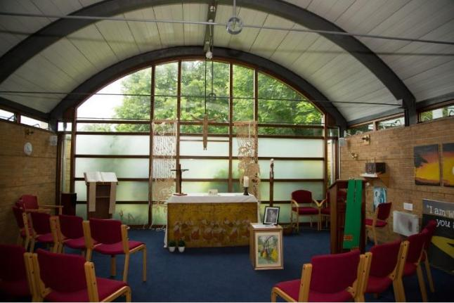

Benefits of working at The Saint John Henry Newman Catholic School
SUPERB WORKING CONDITIONS  - Excellent transport links – close to the A1 and 30 miles to central London. Stevenage to London is just over 20 minutes on the train.  - Stevenage is an area with more affordable housing, than other areas of Hertfordshire. Staff also choose to live in the beautiful villages and market towns of North Hertfordshire.  - Secure free car parking for all members of staff  - Excellent staff facilities including free tea and coffee and microwaves and fridges in the staffrooms  - Staff association which provides gifts, flowers and cards for leavers and staff with significant life events  - Social activities e.g. Friday after school football, staff choir, staff book group, running club, Christmas party, informal nights out, staff pantomime  - Child care voucher scheme  - Flu vaccinations for all staff  - Excellent teaching facilities with the new and refurbished buildings  - Supportive of flexible working  - Ensuring equality and diversity is a priority    - Governors focused on Staff wellbeing | A THRIVING COMMUNITY WHERE YOU CAN ENJOY TEACHING  - Oversubscribed school with close link with the community and supportive parents  - Exemplary student behavior which is always commented on by visitors  - Extensive range of extracurricular activities and enrichment  - All teachers are issued with a laptop  - Workload is constantly being reviewed e.g. email protocols to reduce number of emails, assessment policy to reduce time spent marking  - Generous non-contact time  - Very large sixth form so many opportunities to teach this age group  - Lessons are taught by subject specialists  - Many opportunities to work with students and participate and support in local, national and international fundraising and awareness opportunities  A SERIOUS COMMITMENT TO PROFESSIONAL DEVELOPMENT  - New staff induction program – September-November  - Performance Management that is focused on developing teacher’s careers in the areas that they wish  - Bespoke professional development opportunities – Masters, NPQs, Educator Led Development Program, exam board training, in school opportunities to develop teaching and leadership, ECT and ECT + 1 program  - Whole school CPD focuses on teaching and learning and there are many opportunities for staff to become in involved in the design and facilitating of INSET

Application Process

How to apply:

This recruitment is managed by The Saint John Henry Newman School, in line with the latest guidance on safer recruitment. Please apply online at www.teachinherts.com or send your completed application form to hr@jhn.herts.sch.uk. You can also contact us on 01438 314 643.

Application Form:

Applicants must use the standard application form provided (CVs are not accepted). Please complete all aspects of the form fully. Include your full work history with no unexplained gaps since leaving your education. Include all the training you have completed. Application is done by Teach in Herts, CES or DfE application. However, we will ask successful applicants to backfill an official CES application form.

Person Specification and Personal Statement:

When writing your personal statement, you must address each of the requirements in the person specification. Be sure to evidence additional aspects such as training and qualifications together with your background and experience.

References:

Please make sure your referees are aware of your application and that they are able to provide a swift turnaround. Preferred referees are your last two employers, and you should provide their official organisation email address for us to contact. If you have worked in a school previously one referee should be your last Headteacher.

School Visits:

School tours are a standard part of the interview process. However, School visits are welcomed by prior arrangements. To arrange this, please contact Megan Mcdevitt, HR Manager hr@jhn.herts.sch.uk or by phone 01438 314643.

Please Note:

Please note any job description is not necessarily a comprehensive definition of the post. The duties and responsibilities listed in the job description describe the post as it is at present, the post holder is expected to accept any reasonable alterations that may from time to time be necessary.

The job description will be updated regularly in line with school’s development plan.

JOB DESCRIPTION FOR CAREERS LEAD

Job title: | Careers Lead
Pay Scale: | H7 (£29,777 - £32,076) FTE – Pro Rata (£16,150 - £18,097)
Hours: | 24 Hours Per Week – Term Time Plus 1 INSET
Start Date: | September 2025
Reports to: | Deputy Head, Mrs Howard
This job description is not necessarily a comprehensive definition of the post. The duties and responsibilities listed below describe the post as it is at present, the post holder is expected to accept any reasonable alterations that may from time to time be necessary.
The job description will be updated regularly in line with school’s development plan.

- INTRODUCTION

  - You are accountable to the Governing Body through the line management structure shown in the Staff Handbook.

  - You are required to maintain and develop the Catholic character of the School in accordance with the direction given by the Governors and expressed in the Mission Statement. You are required to support the Headteacher in implementing the Mission Statement and in maintaining the distinctive Catholic nature of the School.
- The role of An CAREERS LEAD at the saint John Henry Newman School

2.1 Under the direction of the Deputy Headteacher (Pastoral & Life Skills), the Careers Lead is responsible for the planning, delivery, and evaluation of a high-quality, impartial careers education, information, advice and guidance (CEIAG) programme across the school.

The postholder will play a central role in:

- Designing and maintaining an outstanding careers provision that reflects both local and national priorities.
- Raising aspirations and ambition among all pupils and students.
- Embedding employability and career readiness across the curriculum and wider school culture.
- Ensuring clear and effective communication with students, parents, staff, and governors.
- Guaranteeing that every pupil and student benefits from a careers programme that prepares them for life beyond school.

The Careers Lead will ensure the school’s careers strategy is inclusive, forward-looking, and
impactful for all learners at every stage of their educational journey.

Key Areas of Responsibility:

A Stable Careers Programme
- Work collaboratively with senior leaders to plan, implement, and evaluate a structured and progressive whole-school careers programme.
- Coordinate with subject leaders, PSHCE coordinator, and the Deputy Director of Sixth Form to embed CEIAG across Years 7–13.
- Use Unifrog as the primary platform to map, deliver, and track careers education, ensuring all students have meaningful access and engagement.
- Ensure that the school’s careers programme and policy are published on the school website and reviewed on a half-termly basis.

Learning from Career and Labour Market Information
- Research and disseminate accurate and up-to-date labour market information (LMI) to inform student choices.
- Promote the use of the Unifrog Careers Library to help pupils explore a wide range of career pathways.
- Plan and deliver a Year 10 mock interview programme involving external partners and employers.

Addressing the Needs of Each Pupil
- Provide impartial 1:1 and group careers guidance tailored to individual student needs and aspirations.
- Prioritise support for students with additional needs, including those who are disadvantaged (PP), have SEND, or are Looked After (LAC).
- Support students in creating action plans and tracking progress toward career goals.
- Monitor and contribute to the analysis of student destination data to improve outcomes and inform programme development.
- Support students and tutors in logging career activities and building competencies on Unifrog.

Linking Curriculum Learning to Careers
- Collaborate with curriculum leaders to ensure subject-specific career links are clearly communicated to pupils.
- Support staff in identifying opportunities to embed career learning into schemes of work and classroom delivery.

Encounters with Employers and Employees
- Organise and lead a diverse programme of employer engagement activities, including alumni events, careers fairs, and guest speaker visits.
- Provide structured support for Years 10–13 students to develop CVs, personal statements, and applications using Unifrog.

Experiences of Workplaces
- Coordinate and track meaningful work-related experiences, including Year 10 work experience placements and workplace visits across key stages.

Encounters with Further and Higher Education
- Plan and lead visits to universities, colleges, and training providers to promote a wide range of post-16 and post-18 options.
- Work with key staff to support students applying to competitive university courses and high-level apprenticeships.
- Promote and facilitate access to post-16 and post-18 pathway tools within Unifrog.

Personal Guidance
- Deliver high-quality careers guidance to individuals and groups, prioritising students at risk of becoming NEET.
- Maintain accurate records of guidance sessions and follow-up support.
- Ensure that students receive appropriate support at key transition points (KS3 options, post-16, post-18).
- AccountabilITIES

3.1 You are required to:
- Undertake all reasonable precautions to safeguard the health and safety of students and staff at all times.
- Ensure that all students are treated fairly, consistently and with respect, that opportunities for reinforcing positive self-images are sought, that gender and race discrimination are actively discouraged.
- Encourage an environment and ethos which underpins and enhances students; learning and rewards students; achievements.
- Take active responsibility for formulating fair and consistent standards of discipline and follow up concerns according to the school’s procedures

- EQUALITIES

  - Be aware of and support school policies that promote equality within and beyond the school community.

- HEALTH AND SAFETY

  - Be aware of and comply with policies and procedures relating to child protection, health, safety and security, confidentiality and data protection; and report all concerns to an appropriate person.

- DISCLOSURE & BARRING SERVICE

  - This post is classed as having a high degree of contact with children or vulnerable adults and is exempt from the Rehabilitation of Offenders Act 1974. An enhanced disclosure will be sought through the Disclosure and Barring Service as part of the pre-employment checks.

- safeguarding Children and Safer Recruitment

7.1 You will ensure that child protection and the safeguarding of students are given the highest
priority at all times.
7.2 The Saint John Henry Newman School is committed to safeguarding and promoting the welfare of
children and young people as required under the Education Act 2002 and expects all staff and
volunteers to share this commitment.

Person Specification

Essential | Desirable
Qualifications & Skills
- Level 6 Diploma in Career Guidance and Development (QCF) or Level 7 Qualification in Career Development (QCD).  - Strong knowledge of the Gatsby Benchmarks and their implementation in schools.  - GCSEs English and Maths Grade C/Grade 5 and above  - High standard of written and oral communication  - Proficiency in Microsoft Word & Excel  - A strong commitment to equality, inclusion, and supporting all students to reach their potential. | - Experience of working in an educational environment  - Strong numeracy skills  - Holds a first aid qualification
Personal
- Genuine passion and a belief in the potential of every pupil
- Self-motivated
- Attention to detail
- Ability to adapt to changing priorities
- Ability to communicate effectively and relate well to others
- Good collaborator who can contribute positively to teams
- Effective time management and organisational skills
- Commitment to inclusion, equity and the safeguarding and welfare of all pupils
- Demonstrate excellent attendance, punctuality and professional appearance

