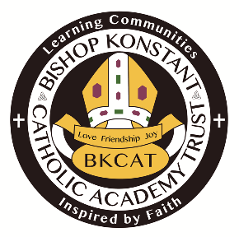
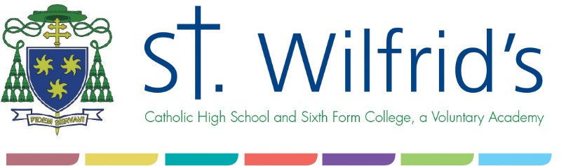

Job Description

Post Title: | Catering Assistant
Reporting to: | Catering Manager
Location: | St.Wilfrid’s Catholic High School & Sixth Form College
Grade: | 3
Overall Purpose of the Post:

- To work as part of a team to prepare, cook and serve a given number of meals for a set time and in accordance with the work structures
Date of last review: | January 2017

Knowledge, skills and experience requirements for the post
 | Essential |  |  | Desirable
Qualifications/ Training | - Food, Health and Hygiene level 2
Skills/Knowledge | - Knowledge of preparing vegetables, potatoes, sauces and gravy  - Knowledge of preparing salads as instructed by the person in charge  - Serve meals as attractively and hygienically as possible  - Good communication skills  - Cleaning dining hall & kitchen |  |  | Nutritional Training.  Experience of cash handling procedures  Ability and interest to put into practice good food handling and service  Previous Kitchen experience
Experience | - Ability to read and understand written instructions.  - Ability to perform mental arithmetic |  |  | Experience in handling cash and till operating  Experience in a catering establishment

Responsibilities and accountabilities

Main Duties:

Carry out other duties commensurate with the grade (or below) of a post, as directed by the line manager, Senior Leaders or their representatives.

  - To prepare vegetables, potatoes, sauces etc. Prepare salads and any other hot or cold dishes as instructed by the person in charge

  - To cook and serve a given number of meals for a set time and in accordance with needs of the school

  - To receive and record cash tendered for meals

  - To understand the importance of a school meal and encourage students to eat a well-balanced diet by endorsing and promoting a healthy lifestyle

  - To be responsible for the day to day decisions of a minor nature relating to the collection of cash and tokens and the efficient production of the meal

  - To accurately complete all required bookwork with in time constraints

  - To clean and store away all equipment used during preparation cooking and service

  - To prepare dining room for service at specified times each day

  - Wipe and clear dining tables, trays and service counters during service or in between sittings as required, mopping any spillages as required

  - Contribute to and be supportive of the Catholic ethos of the school

  - Provide a friendly and efficient service to pupils, staff and visitors

  - Work as part of a team or be able to work on their own in a school facility

  - Respond to the needs of a busy school being resourceful, flexible and to show initiative as the situation demands.

  - Attend cleaning days – general cleaning of kitchen

  - Attend training courses as necessary

  - Adhere to management guidelines, quality, personnel and hygiene policies

  - Responsible for Oneself and working colleagues for the high standard of hygiene and safety under the General Food Hygiene

Responsibilities for resources
People: N/A |  | Budgets: N/A | Physical Resources:  Kitchen equipment

Characteristics of the post:

Employees are encouraged to participate in training activities in order to enhance their own personal development.

- All employees of the school have a responsibility for promoting and safeguarding the welfare of children and young people.
- Be aware of and comply with policies and procedures relating to child safeguarding, health and safety, data protection, security and confidentiality, reporting all concerns to an appropriate person.
- Contribute to and uphold the overall ethos/work/aims of the school.
- Follow and uphold the Trust Code of Conduct.
- Attend relevant meetings as required.
- Treat all users of the school with courtesy and consideration.
- Support the role of other professionals in school.
- To be flexible in approach and be available to work outside normal hours as and when required.
- Participate in training and other learning activities and performance development as required.
- Present a positive personal image, contributing to a welcoming school environment which supports equal opportunities for all.

The employment checks required of this post are:
- Evidence of entitlement to work in the UK and identity
- Evidence of essential qualifications
- Two satisfactory references
- Evidence of a satisfactory safeguarding check e.g. An Enhanced DBS with a barred list check
- On line search
- Confirmation of medical fitness for employment
- Completion of a self disclosure form declaring convictions and cautions under the Rehabilitation of Offenders Act 1974 (Exemptions) Order 1975
- Overseas check (where applicable)

Date completed: | January 2017

