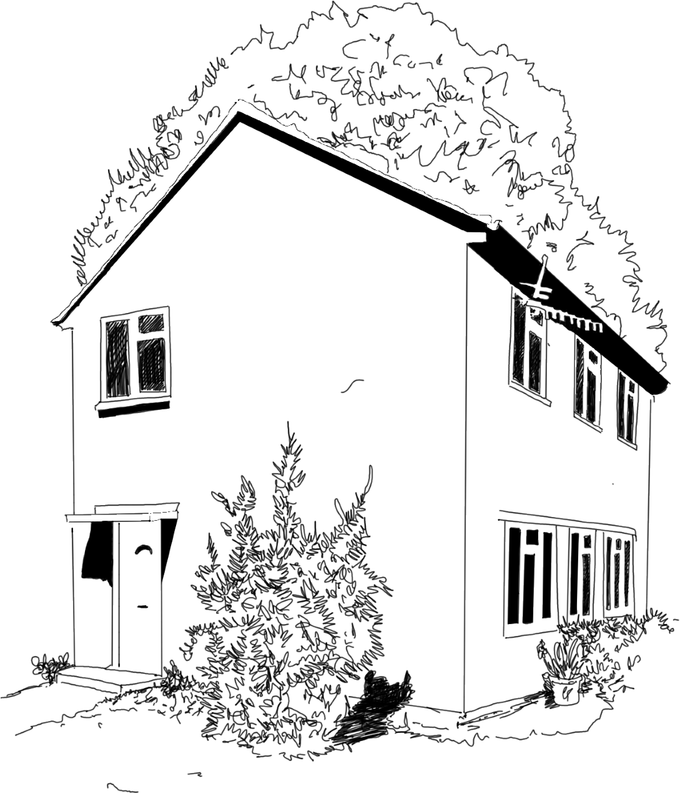

What We Do

The Caretaker’s Cottage team provides professional

evidence-based mental health support for children and

their families drawing on services embedded in the local

community. Interventions are focused on preteens to

reduce the escalation of need in adolescence. The service

is intended to provide a safe space built around the needs

of the community.

Our Aims

•To provide a safe, accessible, appropriate and sustainable mental

health support for children and their families.

•To provide a welcoming space where children and their families

can be supported and guided to access appropriate services. services.

•To adopt a culturally sensitive approach to providing these services

to diverse local communities with a commitment to working

This Can Look Like

•Information, advice and signposting to

existing social prescribing programmes

•Psychoeducation

•Attachment-based interventions

•Play therapy

•Psychodynamic interventions

•Cognitive behavioural strategies

•Social and family interventions

•Community based programmes

These can be offered in groups sessions

or one-to-one.



Contact us

Phone: 02085666446

Email: mkelly@dwhs.co.uk

Website: www.thecaretakerscottage.co.uk

and civic engagement.

and their families that builds their skills, confidence

•To offer holistic mental health support to children

together in partnership and collaboration.

Friday 9am-4pm TBC

Monday: 9am-4pm TBC

Drop-in times for Southall Community Alliance

Thursday: 2-7pm TBC

Wednesday: 2-7pm TBC

Tuesday: 2-7pm TBC

Appointments by referrals

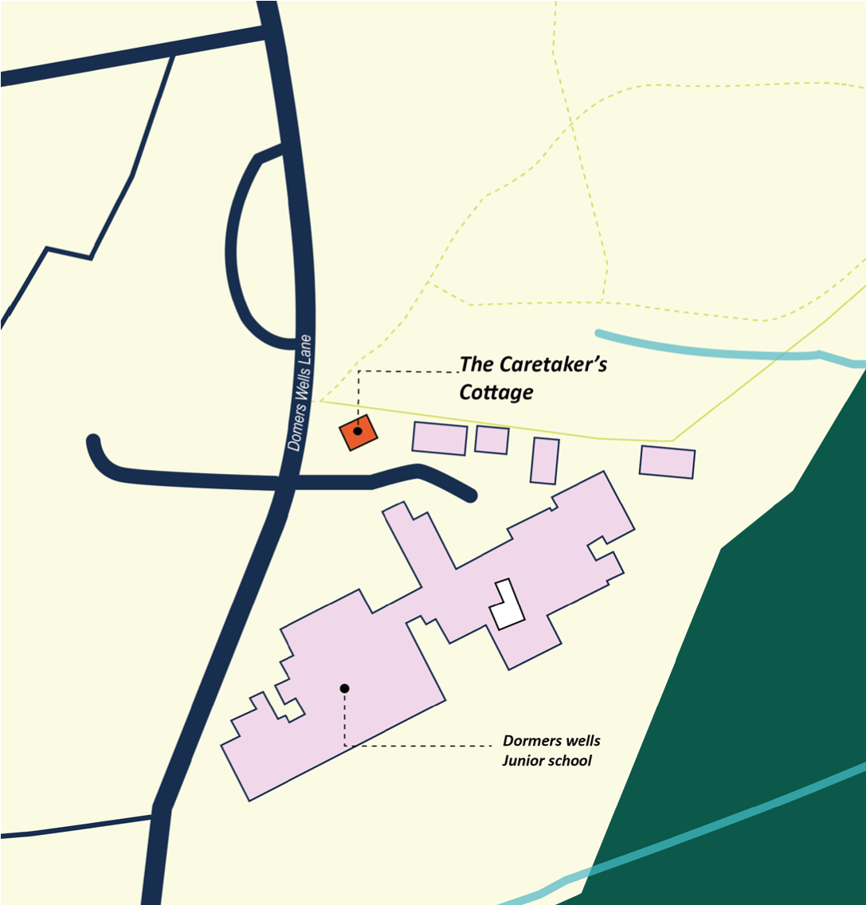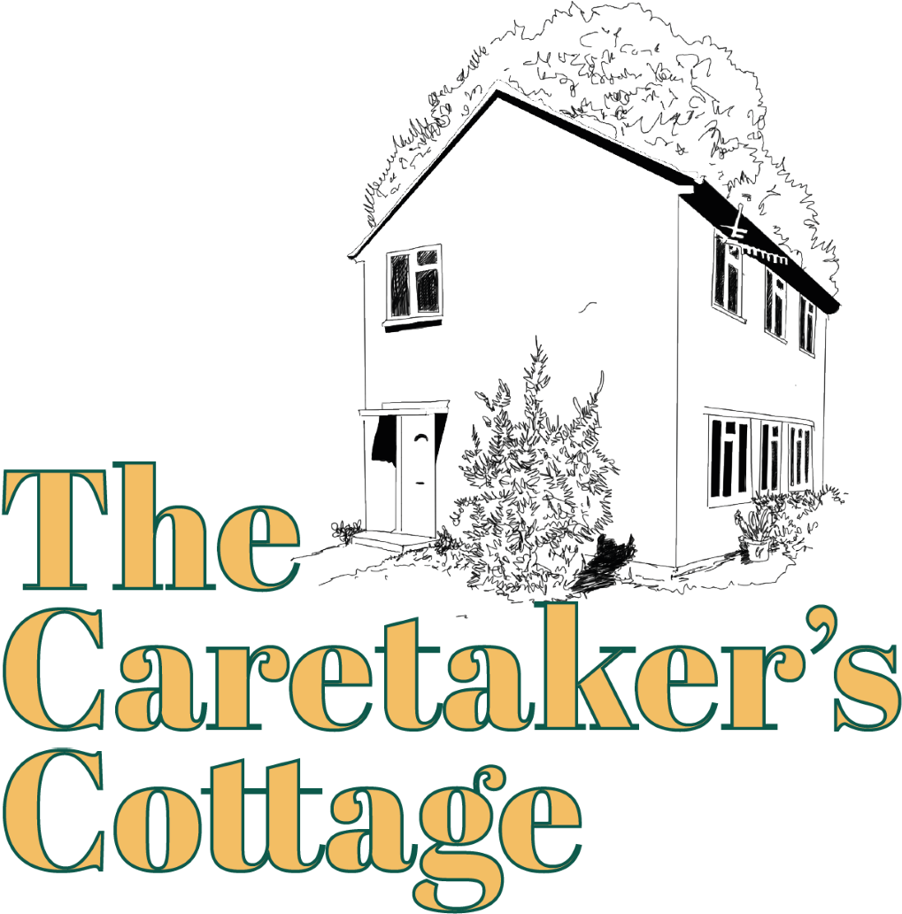

The Caretaker’s Cottage is a mental health

and wellbeing space in the heart of the

Southall community. The cottage is run by

the Dormers Wells Learning Trust and the

Southall Community Alliance with support

from the John Lyon’s Charity. The cottage is

a welcoming and non-judgemental space

set in a home environment that offers early

intervention and support for children aged

5-12

and their families.

Who We are

Where to find us

The Caretaker’s Cottage

Dormers Wells Lane,

Southall,

UB1 3HX

