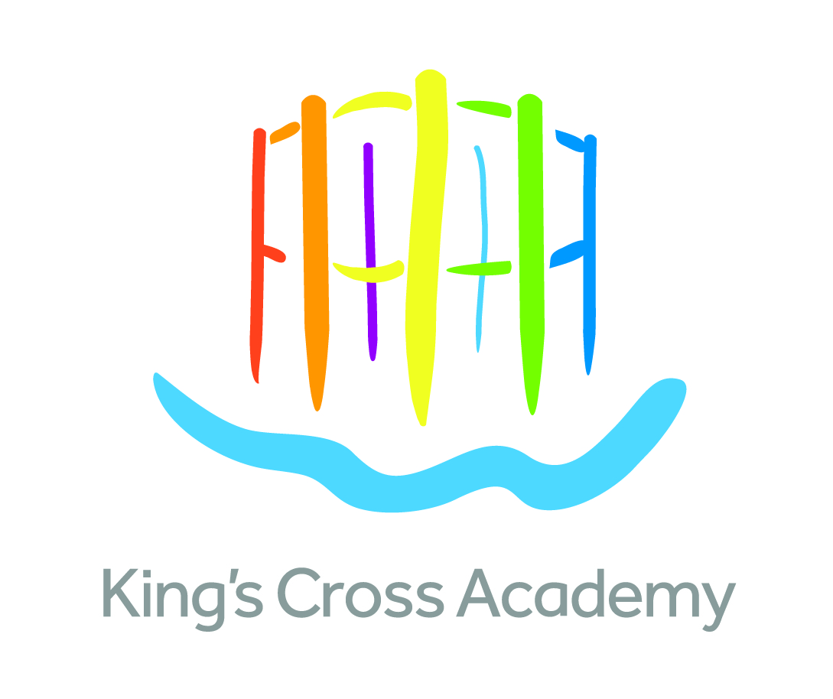

An exceptional opportunity for an exceptional challenge Teacher (KS 1/2) – floating position (non-class based) working with teachers and targeted groups of pupils

Salary Range: Main Pay Scale

The transformation of King’s Cross is one of the largest, most significant urban regeneration projects in the UK. At its heart is a brand new, purpose-built primary Academy.

King’s Cross Academy opened in September 2015, sponsored by the King’s Cross Academy Trust.

The Academy is part of a unique education campus, co-located with Frank Barnes School for Deaf Children. The wider development includes housing, commercial and retail properties, higher education institutions, leisure and social amenities in the heart of London, set around thriving new streets and successful public spaces.

We want to appoint an outstanding teacher who will take up post in September 2021 and help develop the Academy in its founding years. The post will involve supporting teachers and pupils in ensuring they are appropriately challenged across the curriculum.

Our vision is that every aspect of King’s Cross Academy should be the best it can possibly be. We believe every child is entitled to the highest quality learning. This means maximising children’s communication, creativity, thinking, physical learning and social and emotional skills as well as helping them to learn about learning itself.

We need a highly skilled, experienced and enthusiastic person to join our team and to help us achieve our aims.

You will be recognised as someone who is:

- Positive and inspirational
- Keen to make a real impact
- Able to work in partnership with parents and carers to provide high quality learning and care for the children in our school
- A team player with good interpersonal skills

We can offer:

- An amazing new building in an inspirational location
- A positive, supportive and friendly team of staff and governors
- Great resources and facilities to help with learning
- Great professional development opportunities in our expanding school

To arrange an informal discussion with the acting head teacher regarding this post, please email – kay.baxter@kingscrossacademy.org.uk

We are committed to safeguarding children and any appointment is subject to satisfactory checks and references. The position will require an Enhanced DBS check including barred list check. The post is exempt from the provisions of the Rehabilitation of Offenders Act 1974 (as amended in 2013 & 2020). This means that applicants are not required to disclose details of any youth cautions or ‘protected’ criminal convictions, adult cautions or bind-overs they may have incurred.

The Academy safeguarding policy is included with the application pack and we ask you to read this before applying for a post.

For an application pack please download this from the TES website and submit your completed Kings Cross Academy application form with a covering letter of application. Completed applications must be received by 9am on Monday 28th June 2021.

Interviews will be held on Thursday 1st July

