CONFIDENTIAL
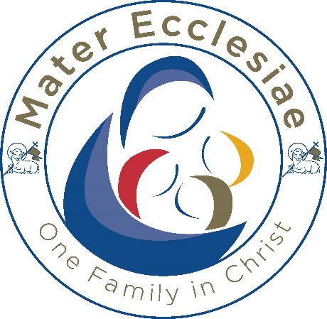
RECRUITMENT MONITORING INFORMATION FORM
THE INFORMATION PROVIDED BY YOU WILL BE USED FOR MONITORING AND STATISTICAL PURPOSES ONLY AND WILL NOT SUPPLEMENT OR FORM PART OF YOUR APPLICATION, THE SELECTION CRITERIA USED OR THE SELECTION PROCESS GENERALLY.
You are not obliged to complete this form but, if you do so, it will help us to fulfil our duties under the Equality Act 2010 to eliminate unlawful discrimination, harassment and victimisation, to promote and advance equality of opportunity and to foster good relations between people who share a relevant “protected characteristic” and those who do not. “Protected characteristics”, as defined by the Equality Act 2010, are age, disability, gender reassignment, marriage and civil partnership, pregnancy and maternity, race, religion or belief, sex and sexual orientation.
Post title:
School:
Date of birth:
GENDER
My gender is: or: I Prefer not to say ☐
COUNTRY OF BIRTH
My country of birth is:

ETHNIC ORIGIN
I would describe my ethnic origin as:
- White
British ☐ English ☐ Scottish ☐ Welsh ☐
Irish ☐ European ☐ Non-European ☐
Any other White background (please specify):
2. Black or Black British
African ☐ Caribbean ☐
Any other Black background (please specify):
3. Mixed Background
White and Asian ☐ White and Black Asian ☐ White and Black Caribbean ☐
Any other mixed background (please specify):
4. Asian and Asian British
Bangladeshi ☐ Indian ☐ Pakistani ☐
Any other Asian background (please specify):

5. Chinese and Chinese British

Chinese ☐
Any other Chinese background (please specify):

6. Other ethnic group

Please specify:
RELIGION
I would describe my religion as:
None ☐ Catholic ☐ Other Christian ☐ Buddhist ☐
Hindu ☐ Jewish ☐ Muslim ☐ Sikh ☐
Any other (please specify):
DISABILITY
The legal definition of disability is ‘a physical or mental impairment which has a substantial and long-term adverse effect on a person’s ability to carry out normal day to day activities. Some specific conditions deemed to be disabilities include HIV, cancer, multiple sclerosis and severe disfigurements.
Do you have a disability, long-term illness (mental or physical), and/or on-going medical condition that we should be aware of:
Yes: ☐ No: ☐
Request for Your Consent to Process Your Data
In compliance with the General Data Protection Regulation (GDPR), we wish to ensure you are aware of the purpose for which we are requesting your consent to collect and process the data we have asked you to provide on this form. Please note that the completion of this form is voluntary and is not part of your application. There is no requirement for you to provide the information requested on this form.
Important information regarding your consent
- We are Mater Ecclesiae Multi-Academy Trust, The Education Centre, Balmoral Road, Lancaster, LA1 3BT.

- Being a Catholic education provider, we work closely with the Diocese of Lancaster with whom we may share the information you provide on this application form. The reason for this is to enable the Diocese of Lancaster to fulfil its role in supporting its schools and exercising the Bishop’s and Trustees’ responsibilities (including oversight of its provision).

- Lancashire County Council is the responsible agency for data protection within our organisation and you can contact them with any questions relating to our handling of your data. You can contact them by dataprotection@lancashire.gov.uk.

- We require the information we have requested on this form in order to fulfil our duties under the Equality Act 2010, namely for statistical and equal opportunity monitoring purposes. As part of our duties under the Equality Act 2010 we will share the information you provide with the Diocese of Lancaster.

- To the extent that you have shared any special categories of personal data this will not be shared with any third party except as detailed in paragraphs 2 and 4 above, unless a legal obligation should arise.

- We shall retain the information you have provided on this form for a period of 6 months to enable equal opportunity monitoring to take place.

- We will keep a record of your consent as evidence that we have obtained your consent to collect and process the data you have provided on this application form.

- You have the right to withdraw your consent at any time and can do so by informing our organisation’s Data Protection Officer (see paragraph 3 above) that you wish to withdraw your consent.

- To read about your individual rights you can refer to our fair processing notice and data protection policies.

- If you wish to complain about how we have collected and processed the information you have provided on this form, you can make a complaint to our organisation through Mater Ecclesiae Catholic Multi-Academy Trust complaints procedure. If you are unhappy with how your complaint has been handled you can contact the Information Commissioner’s Office via their website at www.ico.org.uk.

Request for your consent
Please ensure that you read paragraphs 1-10 above and raise any relevant questions before providing your consent below:
- I confirm that I have read and understood paragraphs 1-10 above and that I have been offered the opportunity to raise any relevant questions: Yes ☐ No ☐
- Please check this box if you have any objection to our collecting and processing your personal information as described in paragraphs 1-10 above ☐
- I agree to my personal data being shared as stated in paragraphs 2 and 4 above: Yes ☐ No ☐

Article 9(1) GDPR sets out the special categories of personal data as follows: “personal data revealing racial or ethnic origin, political opinions, religious or philosophical beliefs, or trade union membership, and the processing of genetic data, biometric data for the purpose of uniquely identifying a natural person, data concerning health or data concerning a natural person’s sex life or sexual orientation….”

