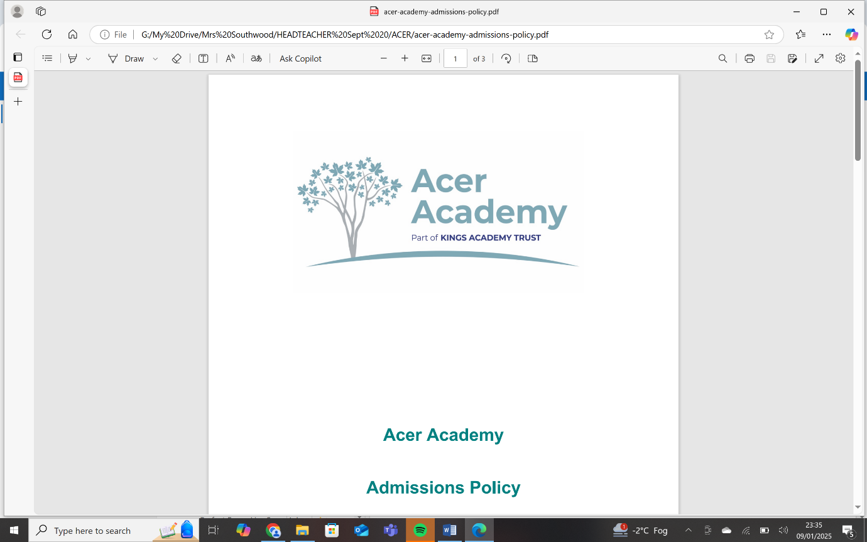
Person Specification Class SEND Teacher
Attributes | Essential | Desirable | Application | interview
Qualifications | - Qualified teacher status
Experience | - Experience or expertise of working with students with SEN  - Experience of delivering a number of subjects including all core subjects  - Experience of delivering KS3 and KS 4 National Curriculum | - Evidence of qualifications or relevant SEN experience.  - Experience of delivering at KS 2 level to meet the needs of the lower attaining pupils
Professional Understanding, Knowledge and skills | - Knowledge of how the National Curriculum can be adapted to meet the needs of pupils with ASD and a range of complex needs including SEMH relevant to the age range of the school.  - Knowledge of assessment recording and reporting  - Experience of creating and maintaining effective partnerships with parents to support pupil’s learning and pastoral needs  - Knowledge of commonly used resources to support pupils with ASD and a range of special educational needs.  - Experience or knowledge of the different qualifications taught in the department.
Specific Knowledge Understanding and skills | - Awareness of the Education Acts and the SEN code of Practice | - Evidence of working towards EHCP targets
Teaching and Learning | - Practical understanding of effective teaching and evaluation strategies for pupils with ASD and other complex needs.  - Able to flexibly deliver a creative primary model of teaching and learning for pupils with a range of needs who require a nurturing approach.  - Knowledge and understanding of the relevant curriculum requirements  - Able to manage pupil behaviour effectively  - Experience or understanding of the different qualifications taught within the department. | - Experience of monitoring and evaluating teaching  - Experience of planning a curriculum area relevant to the needs of pupils including relevant courses
Leadership and Management | - Able to deploy teaching assistants/support staff effectively.  - Able to motivate pupils and staff, setting high standards and provide a focus for improvement
Professional values, qualities and skills | - Able to establish and develop good relationships with all involved in the school  - Able to work effectively as a team member  - Ability to communicate effectively in writing and orally. Competent in the use of ICT  - Flexible and approachable  - Resilient under pressure and motivated by challenge.  - Able to deal sensitively with people and resolve conflicts  - Positive and energetic approach to work | - Bring personal interests and enthusiasms to the school community

