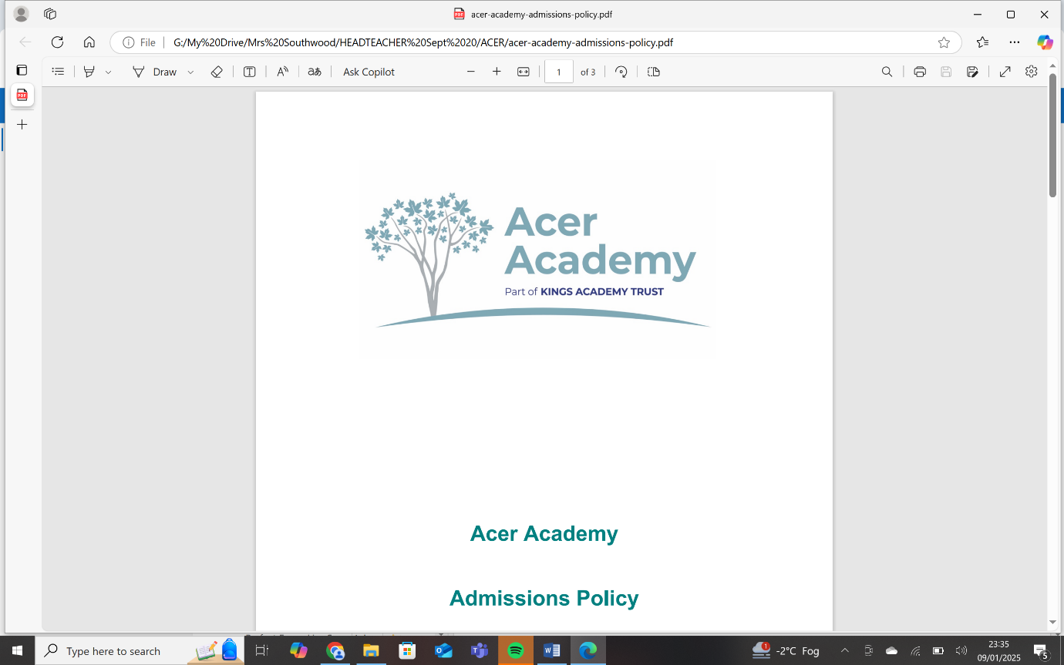

Job Title: Class SEND teacher

Salary: MPS range plus SEN1, ECT’s welcome to apply
Working Pattern: Permanent, full time

Closing date: Friday 25th April 2025, 9:00am
Short listing: Friday 25th April 2025
Interview process to begin: Week commencing 28th April 2025

Executive Headteacher: Mrs L Southwood
To start September 2025.
We are seeking talented SEND Class Teachers to join our team at our brand new school, Acer Academy opening in September 2025. The roles will focus on delivering a range of lessons aligned with the Key Stage 3 and 4 National Curriculum, with the curriculum being adapted for lower attaining pupils as and when required. The curriculum will support the academic and personal development of our students with diverse learning needs; in particular Autism and Social and Emotional Mental Health.

Acer Academy is a new special school for pupils aged 11-16 years who have a diagnosis of Autism/SEMH; we are part of Kings Academy Trust.

We offer a broad and balanced curriculum for all pupils with cutting-edge facilities in a nurturing environment.

At Acer Academy we understand the enormous responsibility of preparing our pupils for their future lives. Our hope is that we can help children to become responsible citizens who will make a positive contribution to our ever changing society.

The school is also part of a MAT, which will provide opportunities to work alongside colleagues in other schools. We welcome applications from both ECT’s and experienced teachers alike.

We invite applications from excellent practitioners with primary or secondary SEND experience. The successful candidates will:
- Be excellent practitioners with the commitment and motivation to inspire pupils’ learning and development
- Be able to demonstrate a commitment to continuous improvement and innovation through imaginative and differentiated lessons which meet individual needs
- Have specific experience / interest in working with pupils with SEND
- Have the ability to foster good relationships with other staff, pupils, parents and the wider community
- Will have had experience of planning and delivering a wide range of National Curriculum subjects with a focus on English, Maths and Science

We offer:
- Friendly, well-behaved and enthusiastic pupils eager to learn
- A leadership team that is committed to staff development and pupil outcomes
- Parents and carers who are supportive of their children's education
- Planning and working as part of a strong and established team
- An inclusive school striving for high standards of attainment for all.
- A dedicated and motivated staff team who strongly believe in team work and building positive relationships across the school
The school is committed to safeguarding and promoting the welfare of children and young people and expects all staff and volunteers to share this commitment. This post is subject to a fully enhanced DBS check.
Please send all applications for the attention of:
Mrs Lisa Southwood
Executive Headteacher
Acer Academy
Kintyre Avenue
Salford
M5 5DP

Email: lsouthwood@oakwoodacademy.co.uk
OR email: enquiries@kingsacademytrust.co.uk

