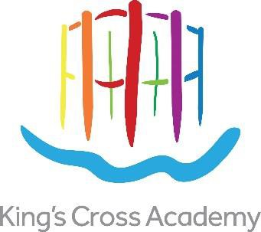

Recruitment Pack – Class teacher

Contract type: Permanent

(TLRs available for the right candidate)

MPS/UPS
Salary: £38,766 - £60,092

Key Dates

Advertisement live: Tuesday April 1st

Deadline for applications: Tuesday April 29th

Shortlisting: 30th April & 1st – 2nd May

Interview dates: Wednesday 7th – 8th May

Tours with Headteacher available at the following times

Thursday 3rd April 3:45pm

Wednesday 23rd April 2:00pm

Thursday 24th April 10:00am

To book onto a tour, contact Giovanni.Pillitu@kingscrossacademy.org.uk

Recruitment Pack – Class Teacher


Welcome to King’s Cross Academy

Thank you for taking an interest in joining us at King’s Cross Academy. Ours is a warm and caring community where we are passionate about bringing out the full potential of each of our pupils.

We are proud of the strength of our many achievements and work tirelessly to build on our tradition of excellence both in and out of the classroom.

We are passionate about making sure that every child leaves King’s Cross Academy with the skills, passion and knowledge required to succeed in secondary education. As a team, we work hard to ensure our pupils know and appreciate what makes them a unique and special learner.

It is our hope to build a community of learners which fosters a culture where lifelong learning is truly embraced. You can see our infographic below which demonstrates the five pillars to our school vision – all the work we do is underpinned by these drivers.

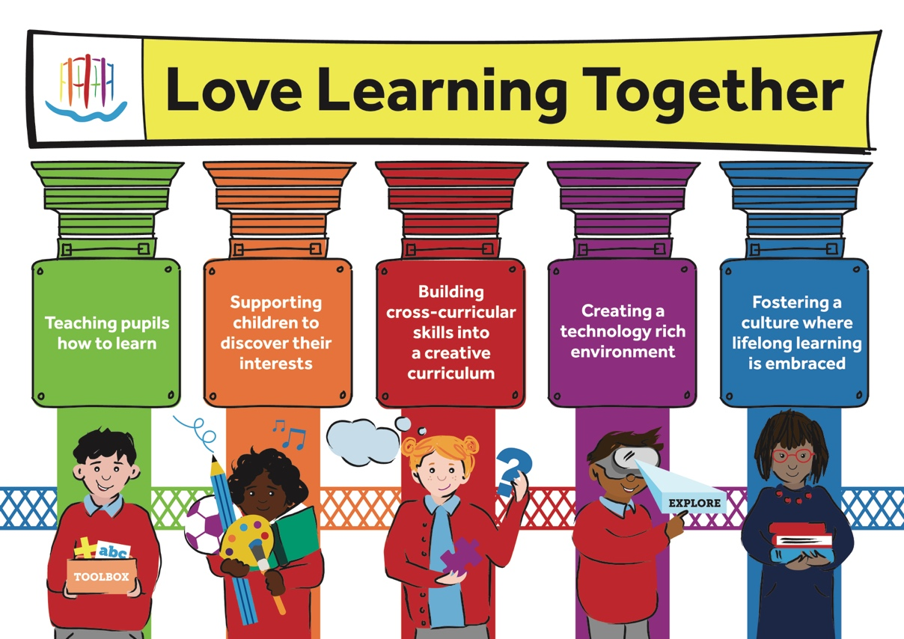
We know that the successful candidate will love working with us. We look forward to hearing from you.
Kind Regards



Stephen Mitchell
Headteacher


Introduction
King’s Cross Academy is seeking to recruit outstanding class teachers, with a track record of excellent teaching in all subjects. These positions can be placed in EYFS, KS1 or KS2 with TLRs available for the right candidates. We are seeking enthusiastic and reflective candidates who are keen to work within a supportive, creative and committed learning environment. The successful candidates will participate fully in the forward-thinking and ambitious life of KCA, taking responsibility for the education and wellbeing of all pupils within their classes.

About King’s Cross Academy

We aim to prepare children for the modern world by helping them to become highly successful life-long learners.

King’s Cross Academy is a happy and friendly school where the children are safe, love learning, behave well and succeed, within a supportive, creative and exciting environment. We have and recruit qualified, inspirational and enthusiastic teachers and support staff who share this vision, to help children to develop their confidence, capacity, resilience and other learning skills.

Our motto, ‘Love Learning Together’, embraces our pupils, parents and teachers and our partnership working with incredible neighbours. Frank Barnes School for Deaf Children (with whom we will share our building), Central Saint Martins, Waitrose, Google UK, Camley Street Natural Park, Eurostar, the Guardian and the Francis Crick Institute are all on our doorstep, offering opportunities to broaden children’s experiences and raise their achievements and aspirations.

The historic guide frame of Gasholder No.8 is the inspiration for our school emblem. It encapsulates both the industrial past of King’s Cross and its new, creative future. The Academy sits at the heart of the King’s Cross community. This is a 21st Century school for 21st Century children and the Academy helps each and every one to become a highly successful learner and to make the most of his or her potential and talents.

King’s Cross Academy opened in September 2015 as a 2 form entry (426 place) primary school with a 26 place nursery for 3-4 year olds. In 2015 the intake was restricted to the nursery and two Reception classes. The Academy expanded each year until 2021 when it had up 446 children. The new premises have been designed with shared spaces for staff training and collaborative development and for children from both schools to play together. The schools’ community celebrate bilingualism: English, British Sign Language (BSL) and other community languages. We will have a wonderful and cultural mix with all children feeling a deep sense of belonging in the schools.

Our priorities…

You can learn about our current priorities on the school website: https://kingscrossacademy.org.uk/headteachers-welcome

The below graphic gives a summary of our current aims and objectives:

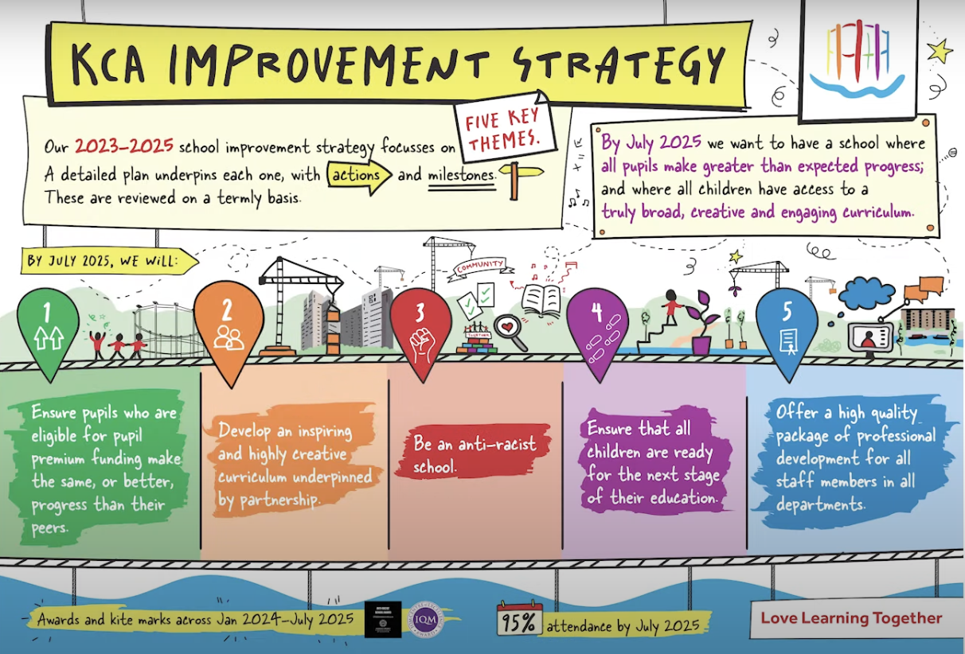

King’s Cross Academy Trust

KCCLP is the owner and developer of the King’s Cross regeneration project (including King’s Cross Academy) together with Michael and Clara Freeman.
This is a Single Academy Trust which has been approved as a sponsor by the Department for Education. After an open competition by Camden Council, King’s Cross Academy Trust was selected to sponsor King’s Cross Academy. There are five members of King’s Cross Academy Trust: Stephen Hubbard, Alexandra Woolmore, Robert Evans, Ross McCall and Coline McConville.

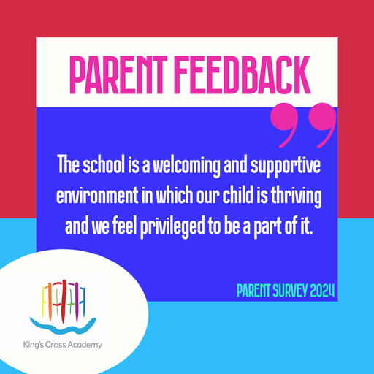

Love Learning Together

We are committed to safeguarding children and any appointment is subject to satisfactory checks and references. The position will require an Enhanced DBS check including barred list check. The post is exempt from the provisions of the Rehabilitation of Offenders Act 1974 (as amended in 2013 & 2020). This means that applicants are not required to disclose details of any youth cautions or ‘protected’ criminal convictions, adult cautions or bind-overs they may have incurred.

In line with KCSIE 2024 and safer recruitment practices, the school will conduct an online search for all shortlisted candidates. The online search is part of our safeguarding checks and will seek publicly available information on candidates’ suitability to work with children. Shortlisted candidates will be provided with further guidance and will be asked to clarify their online presence.

The Academy safeguarding policy is included with the application pack and we ask you to read this before applying for a post.

Application forms can be found on the recruitment section of our website.
Completed applications should be sent to giovanni.pillitu@kingscrossacademy.org.uk

JOB DESCRIPTION

Post Title: | Class Teacher (ELTS welcome) | Grade: | MPS/UPS
Contract: | Permanent contract | Salary Range | Dependent on experience
Responsible to: Assistant Headteacher, Deputy Headteacher, Headteacher

This job description should be read alongside the range of duties of teachers set out in Part XI of the annual School Teachers’ Pay and Conditions Document.

Members of staff should at all times work within the framework provided by the Academy’s Policy statements to fulfill the general aims and objectives of the School Development/Improvement Plan.

The post holder will agree their major objectives with the Headteacher. These objectives will include:
- Achieving the highest possible standard of education for pupils in the allocated class
- Supporting the creation and development of whole school policies, programs and practice to meet the needs of pupils and to improve the level of achievement within an allocated class and across the Academy.

PURPOSE OF THE JOB
- Fulfil the professional responsibilities of a teacher, as set out in the School Teachers’ Pay and Conditions Document
- Meet the expectations set out in the Teachers’ Standards
- Contribute towards the values, vision and ethos of the King’s Cross Academy Trust:
‘love learning together’

KEY RESPONSIBILITIES – Class Teacher

Teaching and Learning | - Plan and teach well-structured lessons to assigned classes, following the school’s plans, curriculum and schemes of work  - Assess, monitor, record and report on the learning needs, progress and achievements of assigned pupils, making accurate and productive use of assessment  - Adapt teaching to respond to the strengths and needs of pupils  - Adapt teaching to respond to the needs of pupils with SEN/D  - Set high expectations which inspire, motivate and challenge pupils  - Promote good progress and outcomes by pupils  - Demonstrate good subject and curriculum knowledge  - Participate in arrangements for preparing pupils for external tests
Whole school organisation, strategy and development | - Contribute to the development, implementation and evaluation of the school’s policies, practices and procedures, so as to support the school’s vision and values  - Make a positive contribution to the wider life and ethos of the school  - Work with other on curriculum and pupil development to secure coordinated outcomes
Health, safety and discipline | - Promote the safety and wellbeing of pupils  - Maintain good order and discipline among pupils, managing behaviour effectively to ensure a good and safe learning environment
Professional development | - Take part in the school’s appraisal procedures  - Take part in further training and development in order to improve own teaching  - Take part in the appraisal and professional development of others, where appropriate
Communication | - Communicate effectively with pupils, parents and carers
Personal and professional conduct and Safeguarding | - Uphold public trust in the profession and maintain high standards of ethics and behaviour, within and outside school  - Have proper and professional regards for the ethos, policies and practices of the school and maintain high standards of attendance and punctuality  - Understand and act within the statutory frameworks setting out their professional duties and responsibilities  Safeguarding  - Work in line with statutory safeguarding guidance (e.g. Keeping Children Safe in Education, Prevent) and our safeguarding and child protection policies  - Work with the designated lead (DSL) to promote the best interests of pupils, including sharing concerns where necessary  - Promote the safeguarding of the all pupils in the school
Note: Please note that this is illustrative of the general nature and level of responsibility of the role. It is not a comprehensive list of all tasks that the employee will carry out. The postholder may be required to do other duties appropriate to the level of the role, as directed by the headteacher or line manager.


PERSON SPECIFICATION

Post Title: | CLASS TEACHER

You must demonstrate on your application form and during the selection process that you meet the following essential criteria: -

Factors | Essential | Desirable
Qualifications & Training | - Qualified teacher status (QTS)  - Degree in relevant subjects | - Additional qualifications in teaching/learning (NPQ)
Experience | - Successful primary teaching experience/ECT welcomed to apply
Skills and knowledge | - Knowledge of the National Curriculum  - Knowledge of effective teaching and learning strategies  - A good understanding of how children learn  - Ability to adapt teaching to meet pupils’ needs  - Ability to build effective working relationships with pupils  - Knowledge of guidance and requirements around safeguarding children  - Knowledge of effective behaviour managements strategies  - Good ICT skill, particularly using ICT to support learning
Personal Qualities | - A commitment to getting the best outcomes for all pupils and promoting the ethos and values of the school  - High expectations for children’s attainment and progress  - Ability to work under pressure and confidentiality at all times  - Commitment to safeguarding and equality  - Equal opportunities and to assisting the school in enabling all its learners to fulfil their potential  - Commitment to the school’ Mission, Vision and priorities  - Commitment to school policies and practices  - A healthy lifestyle to support regular attendance in school  - Commitment to working in an open, consultative manner  - Commitment to Health and Safety in the workplace and how to implement it  - Commitment to following the schools’ bilingual ethos and be willing to implement the language and communication policy  - Commitment to promoting positive attitudes towards deaf children and staff

