ST JOHN THE BAPTIST CATHOLIC PRIMARY SCHOOL

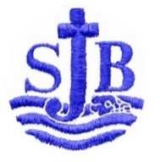

Learning and Growing Together, Unique in God’s Eyes

SCHOOL INFORMATION 2020-21

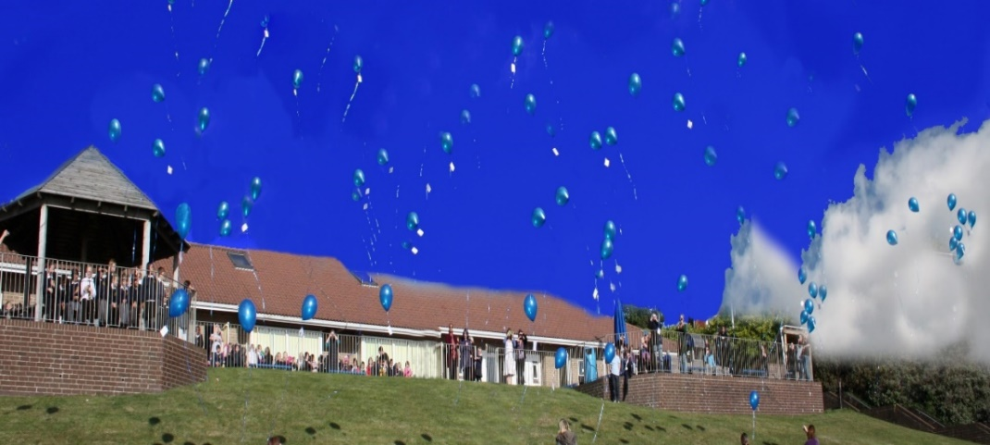

Dear Applicant,

Our location at the top of Whitehawk hill road, earned it the title ‘the school at the top of the world!’ when it first opened in 1989. The photo above was taken at our silver jubilee celebrations in 2014.
The views from every classroom and from the children’s playgrounds are breathtaking; a constant reminder of the wonder and beauty of God’s creation. Our children are delightful; we have a committed staff team and supportive governors and parents.

Our strengths include the creative arts – music in particular is a strength. PE, health and fitness is also a strength – we have a running track on our field and all children do a 10-minute dash – rain, hail or snow! For a small school we have collected many awards over the years for football, netball and swimming,
We have a secret ‘nature trail’, which is used for forest school and outdoor learning, a garden and pond area.
We are also a very nurturing school; We all recognise that children learn only when they are feeling safe, happy and supported and we prioritise this above all else.
Our children come from very diverse backgrounds and we have a high percentage of languages spoken. We are proud of our inclusive nature and celebrate our diversity in many ways including a spectacular ‘One World Week’ every autumn. It is wonderful to see parents proudly sharing food from all over the world on our international evening!
The best way to really appreciate our school is to visit. So please do make an appointment and we will guide you around, following our health and safety guidelines for the current situation.

Tina Davidson
Headteacher

Some Information about our School

St John the Baptist is a one-form entry Catholic Primary school in the Diocese of Arundel and Brighton and the local authority of Brighton & Hove. The school is of average size, with 197 pupils currently on role, aged 4-11 years. The school was built in 1988-89 to continue to provide a Catholic education for the children of St John the Baptist church and parish; we also include children from the surrounding areas including Whitehawk, Kemptown and Queens Park.
Approximately 45% of the pupils are Catholic; 22% are Christian; 27% are recorded as having no specific religion.
As a Catholic school, our aims and our mission statement 'Learning and Growing Together, Unique in God’s Eyes’ is centred on Gospel values and celebrate the uniqueness of each member of the school community.
Central to our vision and mission is the celebration of the diversity within our school and the commitment to teaching our children respect and tolerance for other faiths and beliefs.

Statistical Information (Ref. School Census 2020):

- 31% of our families are currently accessing free school meals (FSM)
- 35% of our families are listed as disadvantaged
- 32% of our children come from minority ethnic groups; this is an increasing trend.
- 45% of our children have a first language that is not English; this is also an increasing trend.

The School deprivation indicator (School Data 2020) indicates that:

81% of our children live in the 30% most deprived areas of the country.
65% live in the 20% most deprived areas.
37% live in the 10% most deprived areas.

Catholic Families

Currently, 45% of our pupils are Catholic; the majority of our Catholic families come from the parish of St John the Baptist.

Other Faiths

Christian: 22%
Other religion: 1%
Muslim 3%
Hindu: 2%
No recorded religious affiliation: 27%

We have close links with our parish church, St John the Baptist in Kemptown and also with our local Brighton and Hove deanery group comprising of six local primary schools and Cardinal Newman secondary school.
We also work closely with our local cluster of twelve schools.
Further information can be found in our school prospectus and school website.

April 2021

