Additional information
Visits strongly recommended—this is a totally unique school.
Applications must be received by 12.00pm on 24th March 23 Applications (using the Solihull MBC application form)
may be sent electronically
(office@smithswoodpri.solihull.sch.uk) or be sent as a hard copy.
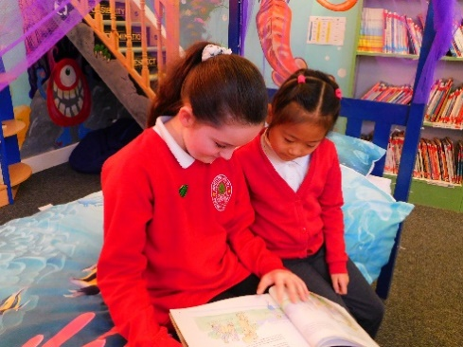
In the “other information” section, candidates should ex- plain why they wish to work at Smith`s Wood Primary Academy.

Please ensure reference details are fully complete.
(including email addresses)

Candidates selected for interview will be informed with- in 12 hours of the closing date. Interviews will take place the week beginning 27th March 2023

An enhanced DBS clearance is required for this position. Smith’s Wood Primary Academy has a responsibility for, and is committed to, safeguarding and promoting the welfare of children, young people and vulnerable groups.
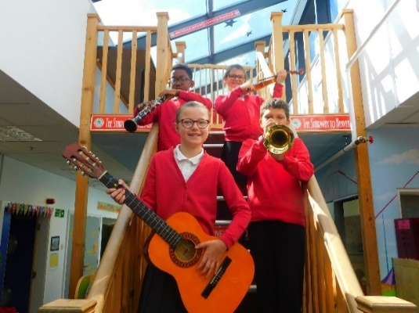
Candidates are advised to make their application stand out; imagination and creativity is actively encouraged.

The post is advertised as a position across any phase of Primary Education
Applications are welcome from both experienced teachers and ECTs.

Smith’s Wood Primary Academy welcomes applications from all

